|  |  |
| --- | --- |
| Nama | : SIDIQ ZAINUDIN |
| NIM | : L200170058 |
| Kelas | : C |
| Matkul | : Praktikum Sistem Operasi |

MODUL 8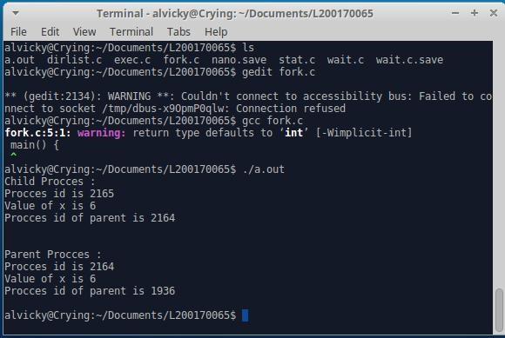

Fork.c

Source Code Fork.c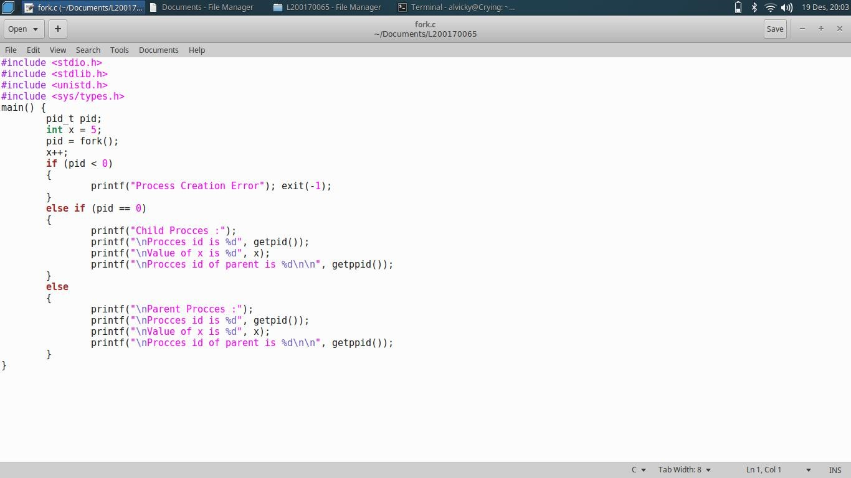

Wait.c

Source Code Wait.c 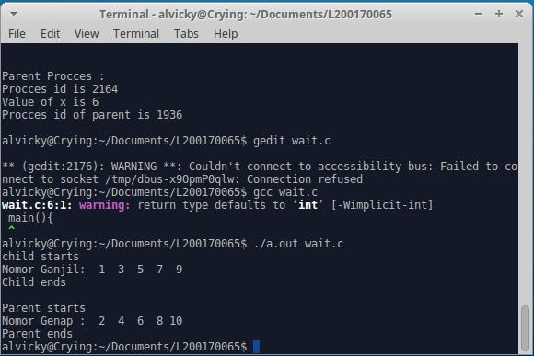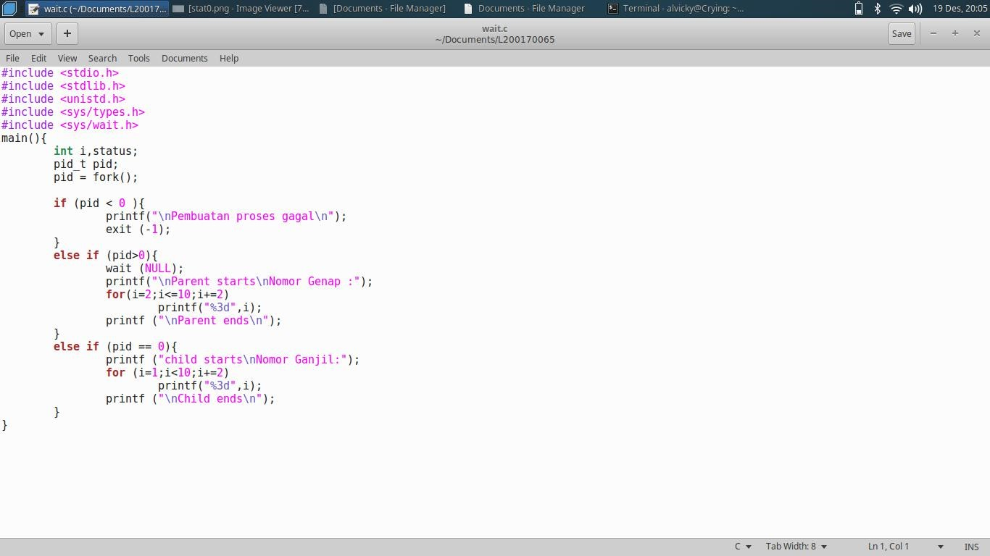Exec.c

Source Code Exec.c 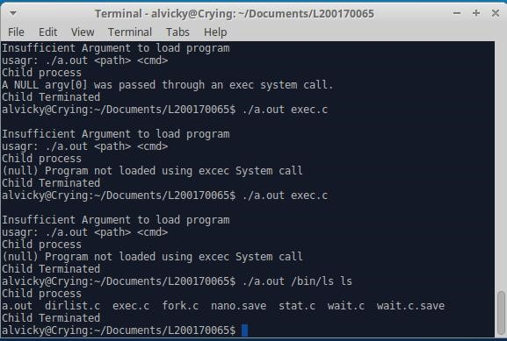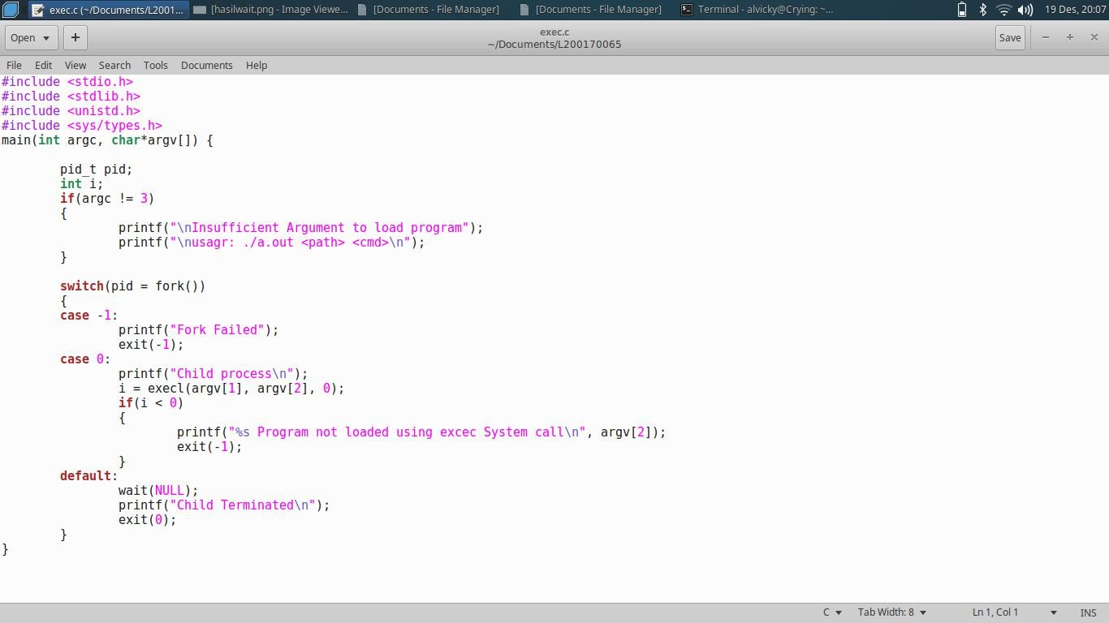Stat.c 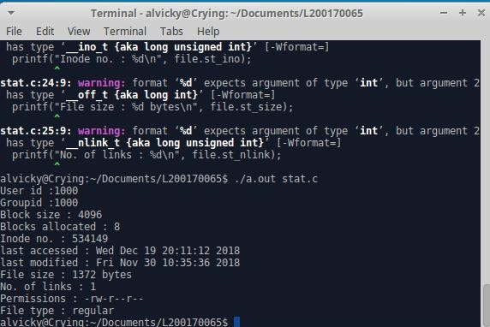Dirlist.c

S

o

u

r

c

e

C

o

d

e

S

t

a

t

.

c

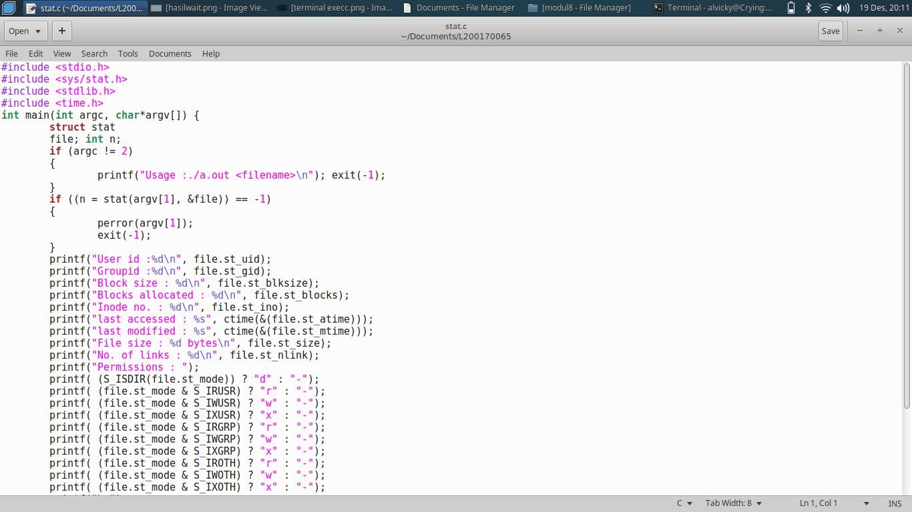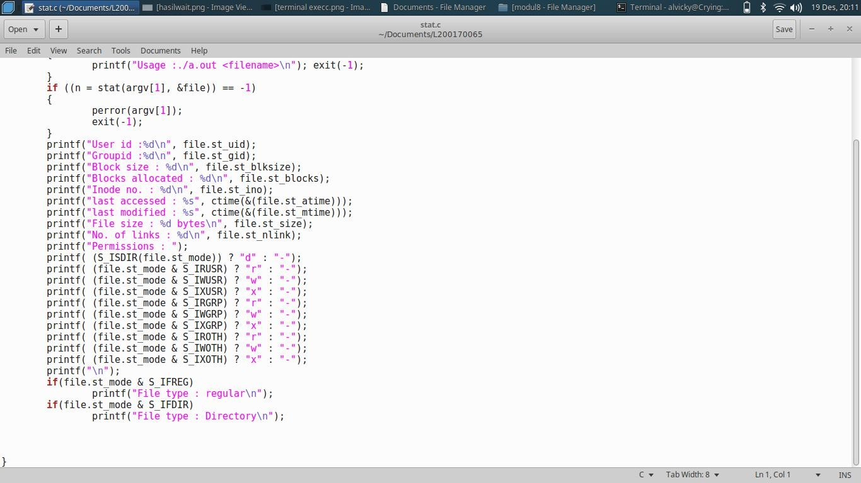

Source Code Dirlist.c