Nama : Nauvval Aviv

NIM : L200170060

Kelas : B

**MODUL 6 SPANING**

**TREE PROTOCOL**

1. Kegiatan 1

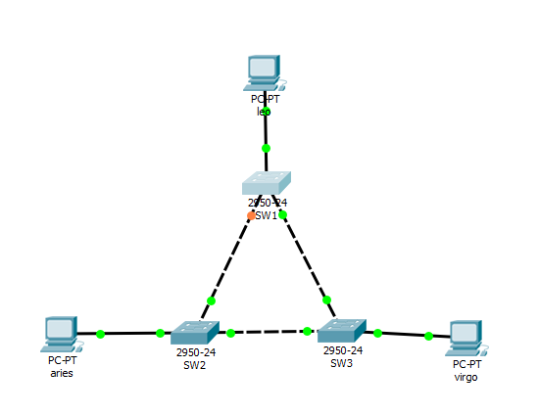

* Melihat spanning tree pada masing server.

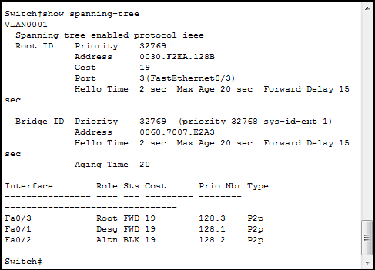

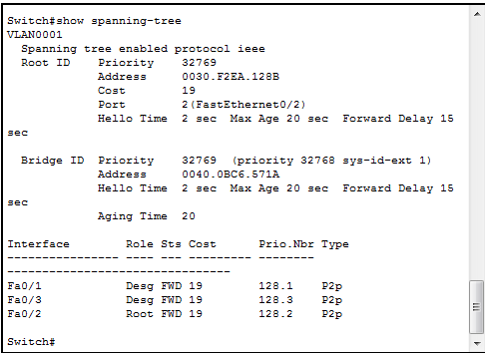

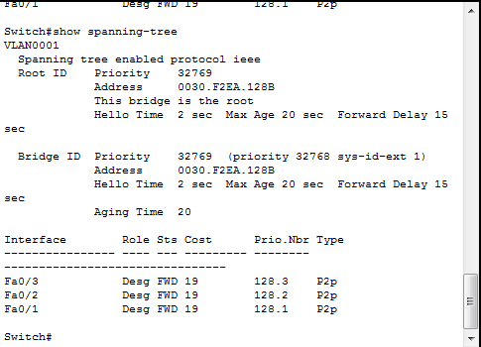

* Tabel status STP pada masing-masing Switch :

SW1

|  |  |  |
| --- | --- | --- |
| No | variable | nilai |
| 1 | Root ID | 32769 |
| 2 | Priority | 32769 |
| 3 | MAC Adrress | 0030.F2EA.128B |
| 4 | Bridge ID | 32769 |
| 5 | Cost(0/1;0/2;0/3) | 19 |
| 6 | Hello Time | 2 sec |
| 7 | Max Age | 20 sec |
| 8 | Forward Delay | 15 |

SW2

|  |  |  |
| --- | --- | --- |
| no | variable | nilai |
| 1 | Root ID | 32769 |
| 2 | Priority | 32769 |
| 3 | MAC Adrress | 0030.F2EA.128B |
| 4 | Bridge ID | 32769 |
| 5 | Cost(0/1;0/2;0/3) | 19 |
| 6 | Hello Time | 2 sec |
| 7 | Max Age | 20 sec |
| 8 | Forward Delay | 15 |

SW3

|  |  |  |
| --- | --- | --- |
| no | variable | nilai |
| 1 | Root ID | 32769 |
| 2 | Priority | 32769 |
| 3 | MAC Adrress | 0030.F2EA.128B |
| 4 | Bridge ID | 32769 |
| 5 | Cost(0/1;0/2;0/3) | - |
| 6 | Hello Time | 2 sec |
| 7 | Max Age | 20 sec |
| 8 | Forward Delay | 15 |

* Hasil ping dari leo ke virgo

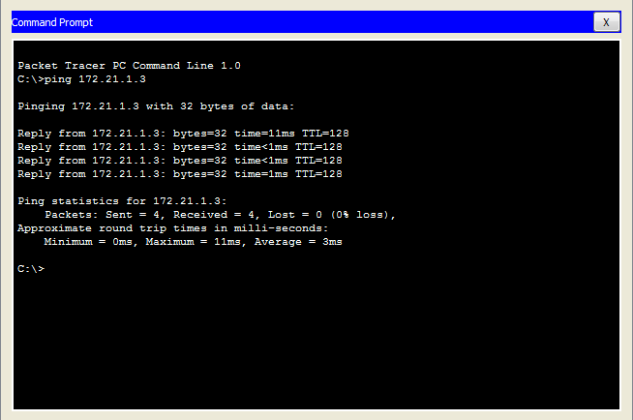

1. Kegiatan 2

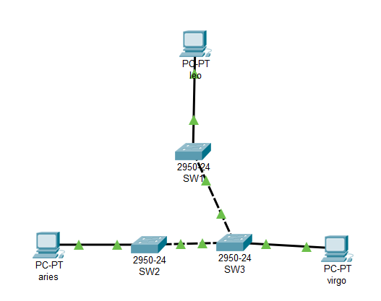

* Melihat masing2 server

SW 1

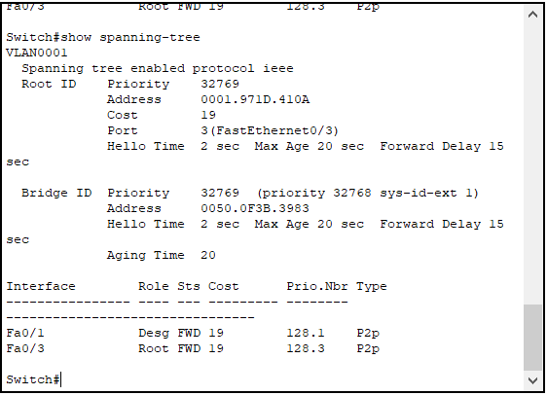

SW 2

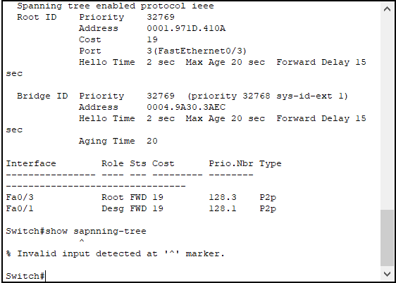

SW 3

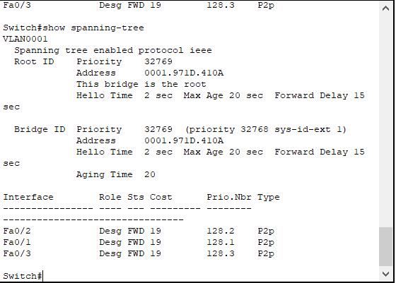

* Tabel status STP pada masing-masing Switch :

SW 1

|  |  |  |
| --- | --- | --- |
| no | variable | nilai |
| 1 | Root ID | 32769 |
| 2 | Priority | 32769 |
| 3 | MAC Adrress | 0001.971D.410A |
| 4 | Bridge ID | 32769 |
| 5 | Cost(0/1;0/2;0/3) | 19 |
| 6 | Hello Time | 2 sec |
| 7 | Max Age | 20 sec |
| 8 | Forward Delay | 15 |

SW 2

|  |  |  |
| --- | --- | --- |
| no | variable | nilai |
| 1 | Root ID | 32769 |
| 2 | Priority | 32769 |
| 3 | MAC Adrress | 0001.971D.410A |
| 4 | Bridge ID | 32769 |
| 5 | Cost(0/1;0/2;0/3) | 19 |
| 6 | Hello Time | 2 sec |
| 7 | Max Age | 20 sec |
| 8 | Forward Delay | 15 |

SW 3

|  |  |  |
| --- | --- | --- |
| no | variable | nilai |
| 1 | Root ID | 32769 |
| 2 | Priority | 32769 |
| 3 | MAC Adrress | 0001.971D.410A |
| 4 | Bridge ID | 32769 |
| 5 | Cost(0/1;0/2;0/3) | - |
| 6 | Hello Time | 2 sec |
| 7 | Max Age | 20 sec |
| 8 | Forward Delay | 15 |

* Hasil ping dari leo ke virgo

