Nama : Muhammad Huda Fatoni

NIM : L200170062

Kelas : b

Modul : 4

**Modul 4**

**Kegiatan 1**

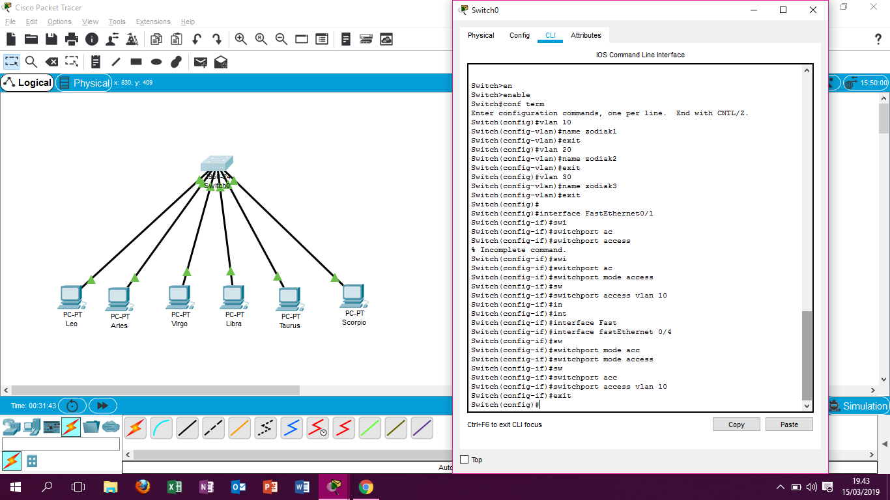

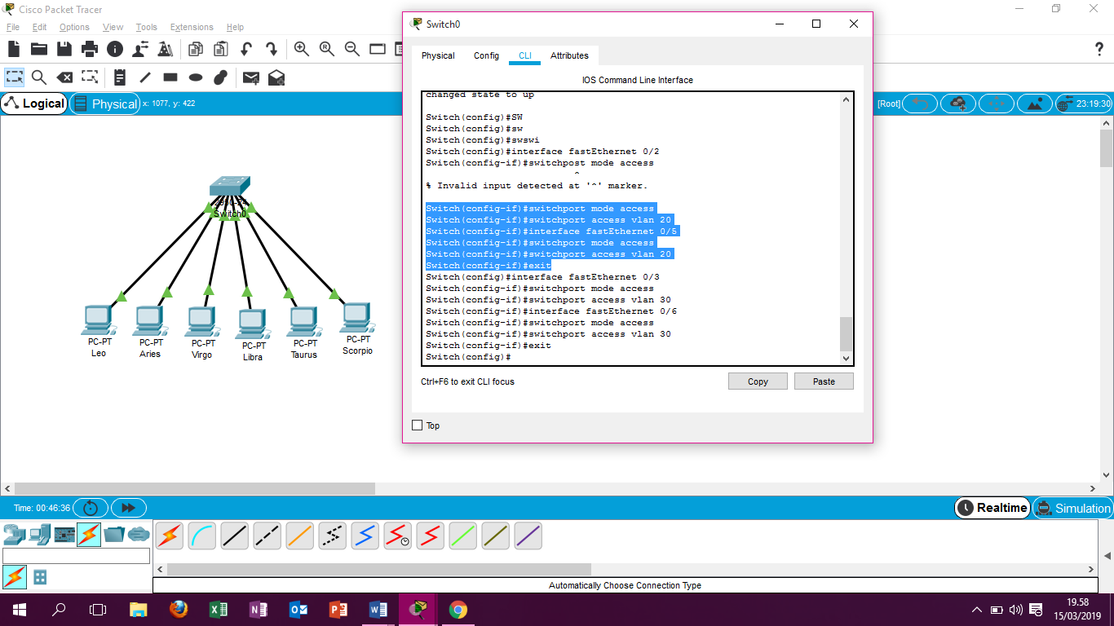

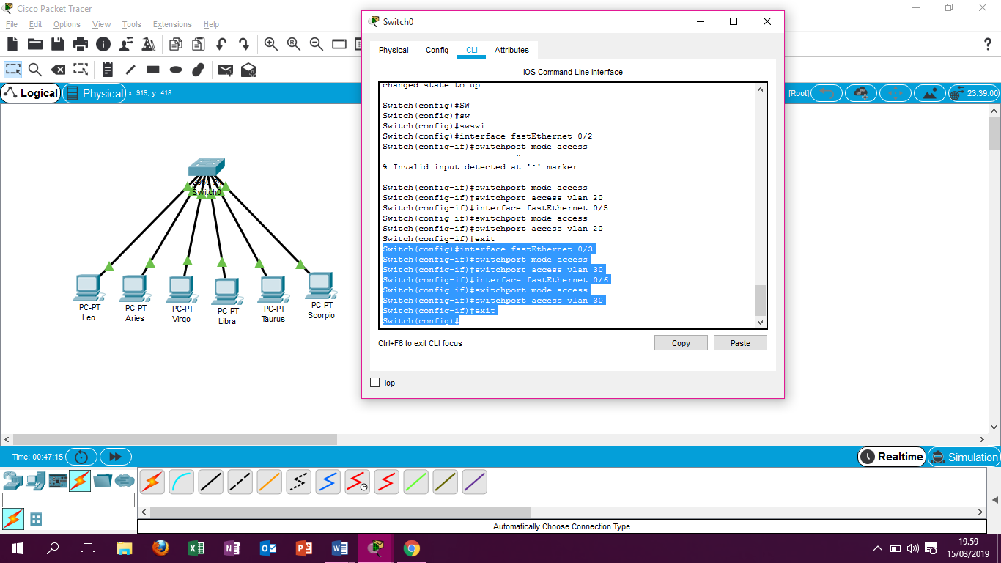

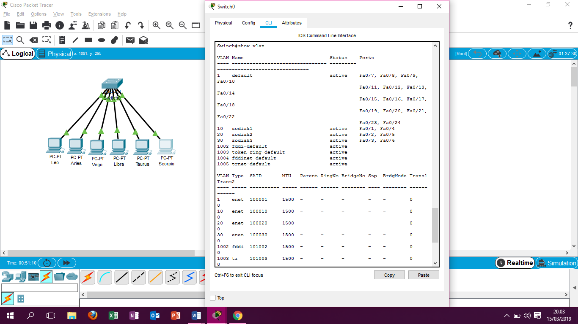

|  |  |  |  |  |
| --- | --- | --- | --- | --- |
| No | Variable | Nilai Vlan 10 | Nilai Vlan 20 | Nilai Vlan 30 |
| 1 | Nomer Vlan | 10 | 20 | 30 |
| 2 | Nomer Vlan | Zodiak1 | Zodiak2 | Zodiak3 |
| 3 | Port | Fa 0/1, Fa 0/4 | Fa 0/2, Fa 0/5 | Fa 0/3, Fa 0/6 |
| 4 | Status | Active | Active | Active |

**Kegiatan 2**

