|  |  |
| --- | --- |
| Nama | : Majid Narendra |
| NIM | : L200170063 |
| Kelas | : C |
| Matkul | : Praktikum Sistem Operasi |

**MODUL 9**

**Fcreate.c**

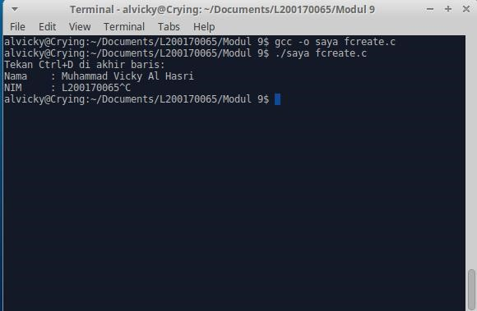

**Fread.c**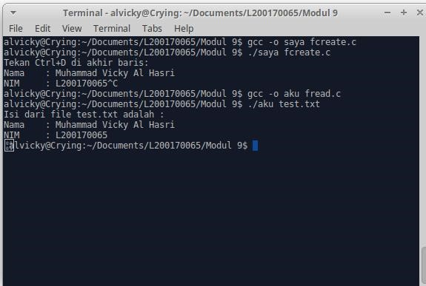

https://github.com/L200170065

**Fappend.c**

