Nama : Roni Ardianzah

NIM : L200170050

Kelas : B

**MODUL 3 SUBNETTING**

1. **Kegiatan Praktikum**

**Kegiatan 1. Desain dan Konfigurasi Subnetting**

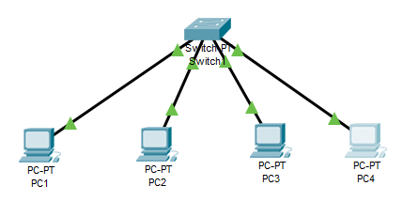

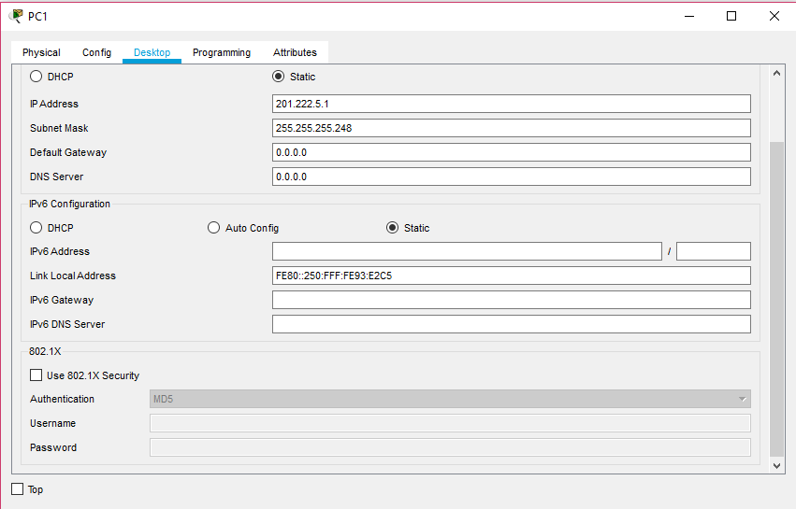

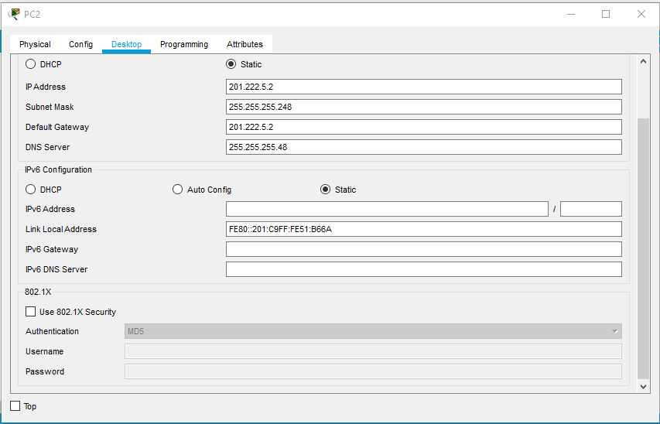

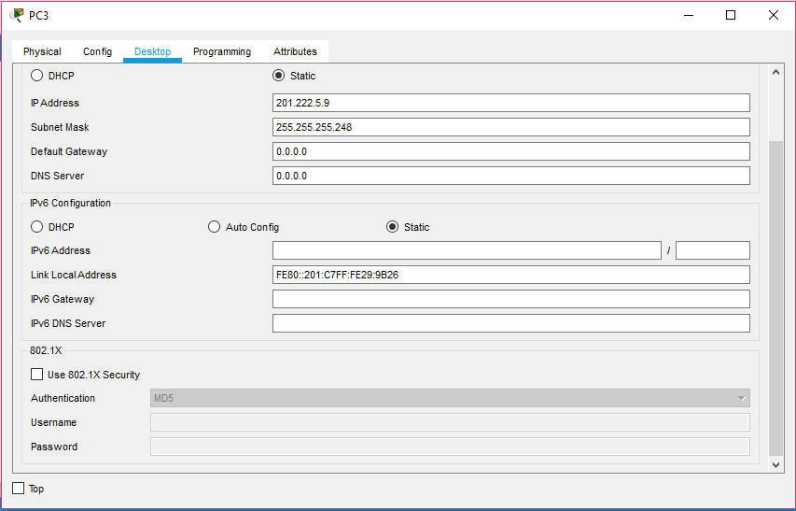

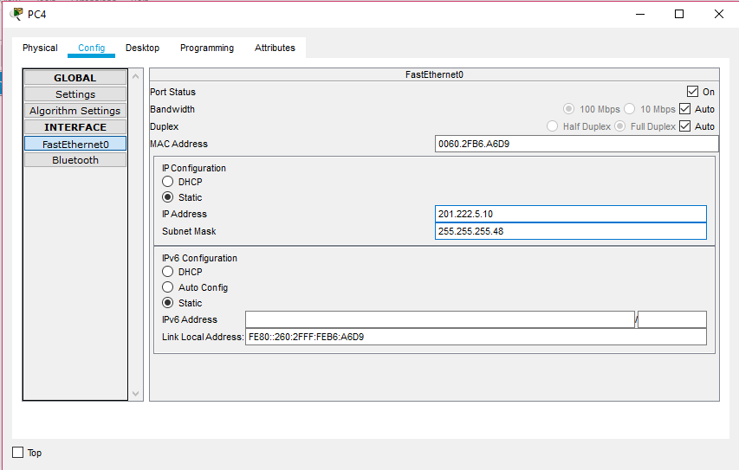

1. **Tugas Modul**

**Tugas :**

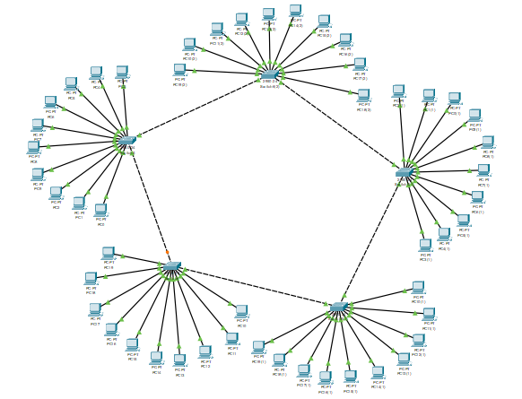

202.155.19.0

11001010.10011011.00010011.00000000

255.255.255.0

11111111.1111111.11111111.00000000

Jumlah Subnet = 20 = 1

Jumlah Host per-Subnet = 28 – 2 = 256 – 2 = 254

Blok Subnet = 256 – 0 = 256

Tabel Subnet :

|  |  |
| --- | --- |
| **Network** | 202.155.19.0 |
| **Host Pertama** | 202.155.19.1 |
| **Host Terakhir** | 202.155.19.254 |
| **Broadcast** | 202.155.19.255 |

