Nama : Puji Nugroho

NIM : L200170123

Kelas : C

**2.2 Latihan**

1.

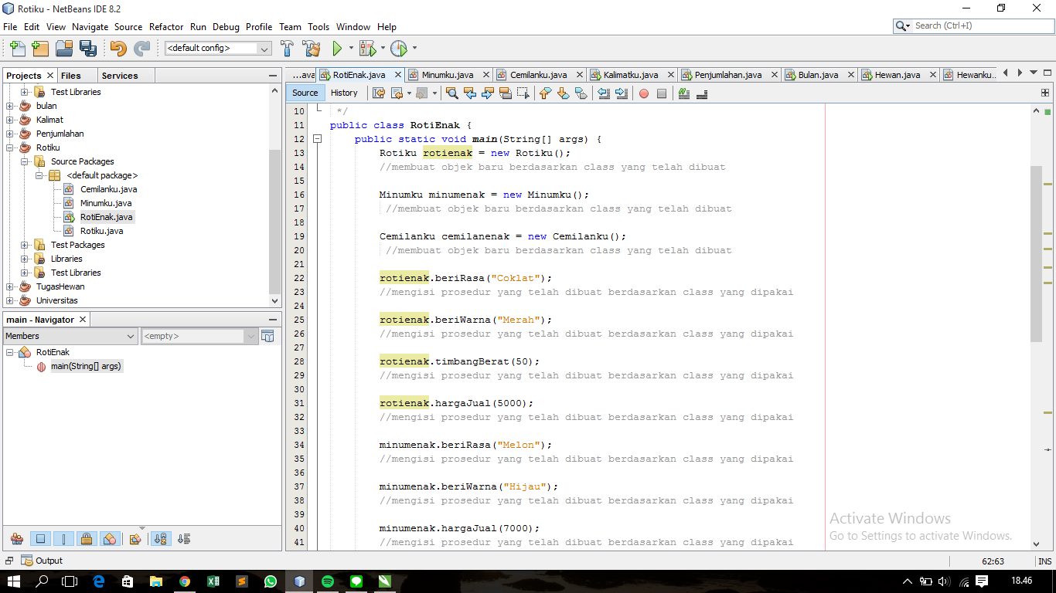

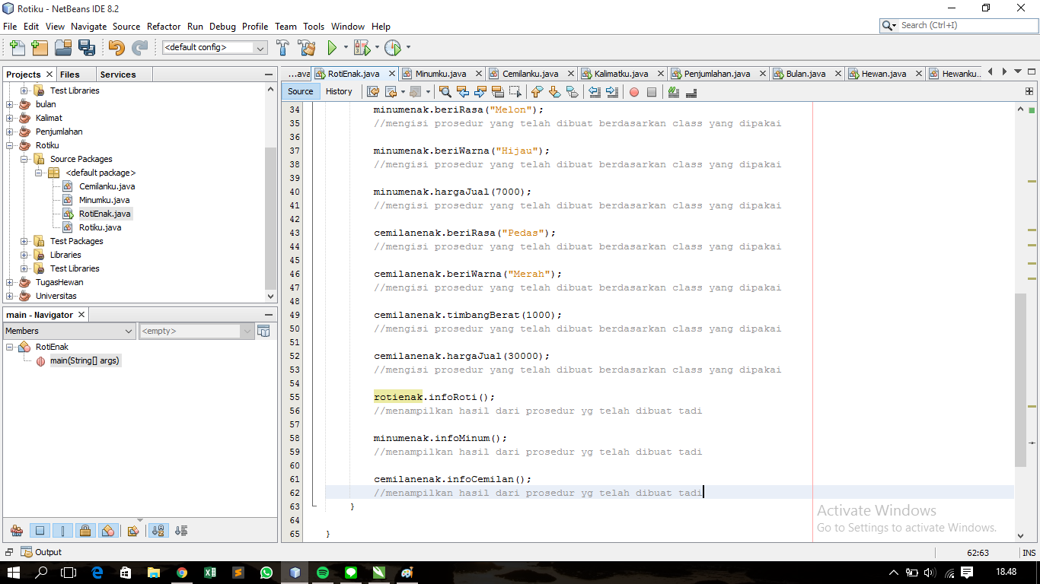

2.

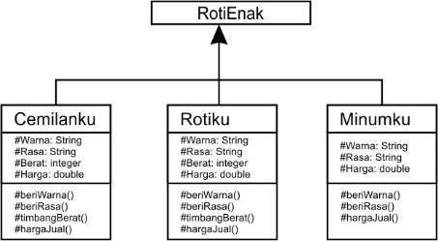

3.

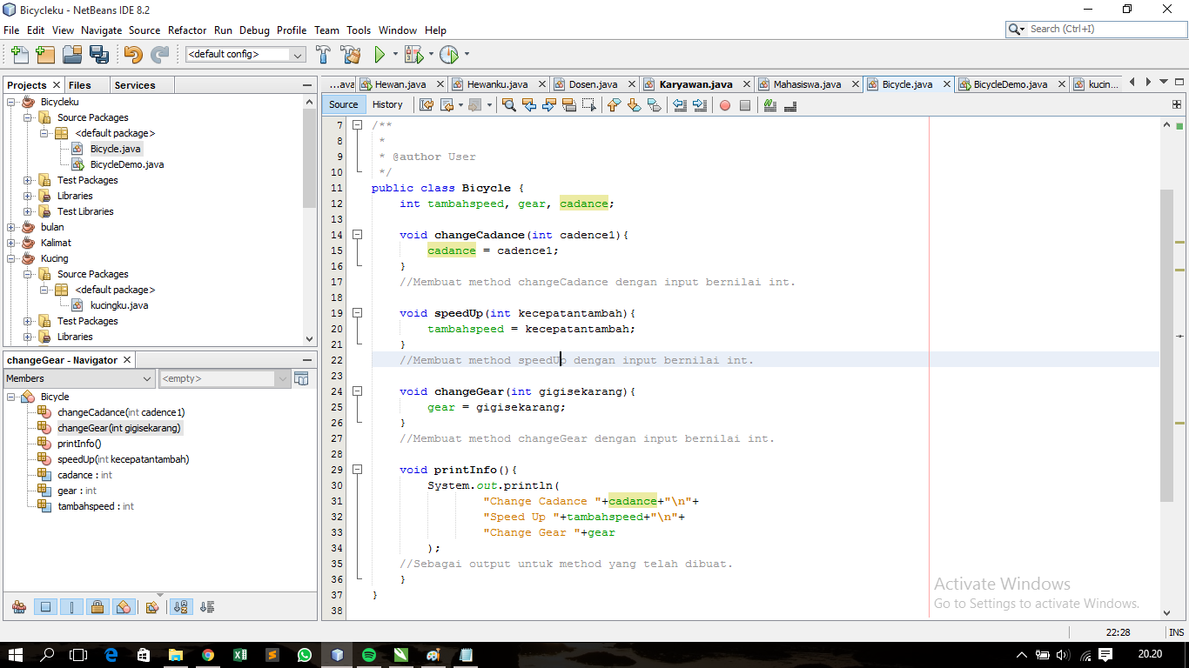

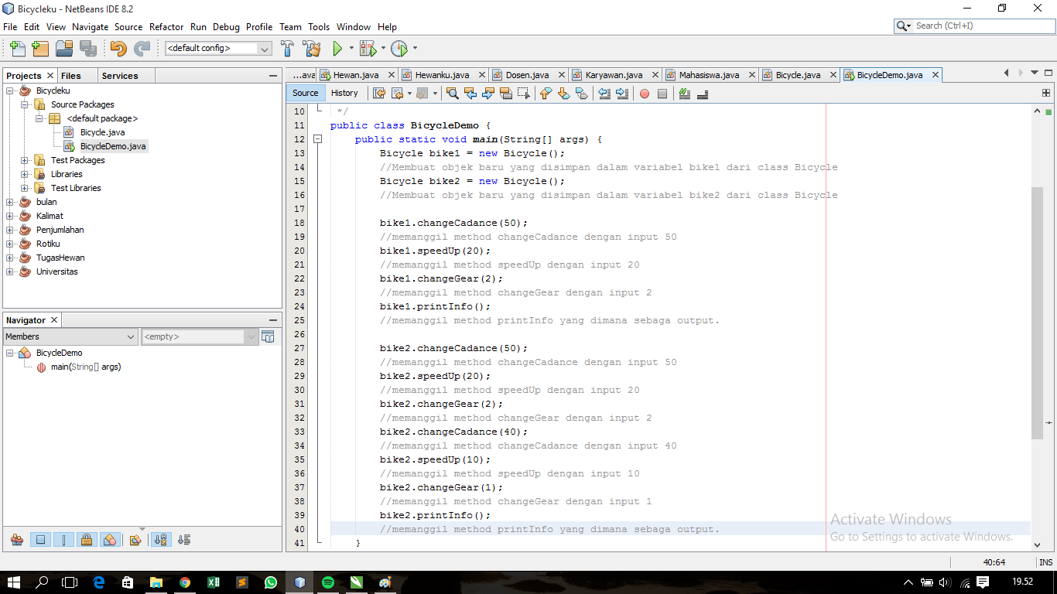

4.

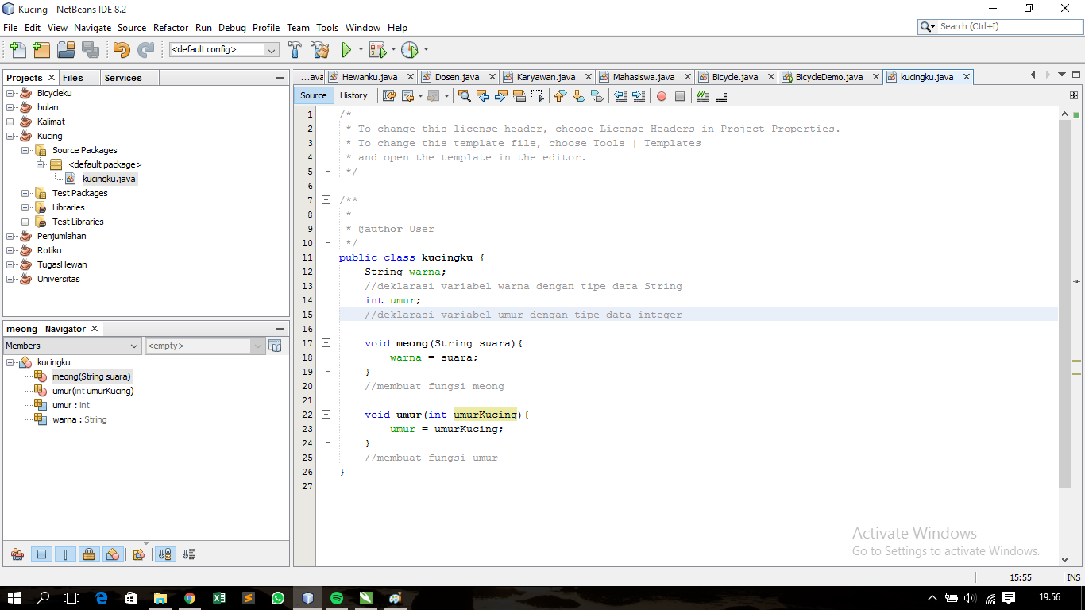

5. Berikut adalah daftar metode yang didukung oleh kelas String:

* Char charAt (int index)
* int compareTo (Object o)
* int compareTo (String anotherString)
* int compareToIgnoreCase (String str)
* String concat (String str)
* contentEquals boolean (StringBuffer sb)
* statis String copyValueOf (char [] data)
* statis String copyValueOf (char [] data, int offset, int count)
* boolean endsWith (String suffix)
* boolean equals (Object anObject)
* boolean equalsIgnoreCase (String anotherString):
* getBytes byte ()
* byte [] getBytes (String charsetName)
* int hashCode()
* int indexOf (int ch)
* int indexOf (int ch, int fromIndex)
* int indexOf (String str)
* int indexOf (String str, int fromIndex)
* String intern ()
* int lastIndexOf (int ch)
* int lastIndexOf (int ch, int fromIndex)
* int lastIndexOf (String str)
* int panjang ()
* String [] split (String regex)
* String [] split (String regex, batas int)
* boolean startsWith (String prefix, int toffset)
* String substring (int beginIndex)
* String substring (int beginIndex, int endIndex)
* char di [] toCharArray ()
* String toLowerCase ()
* String toLowerCase (lokal Lokal)
* String toString ()
* String toUpperCase ()
* String toUpperCase (lokal Lokal)
* String lis ()
* statis String valueOf (primitif tipe data x)

**2.3 Pekerjaan Rumah**

1.

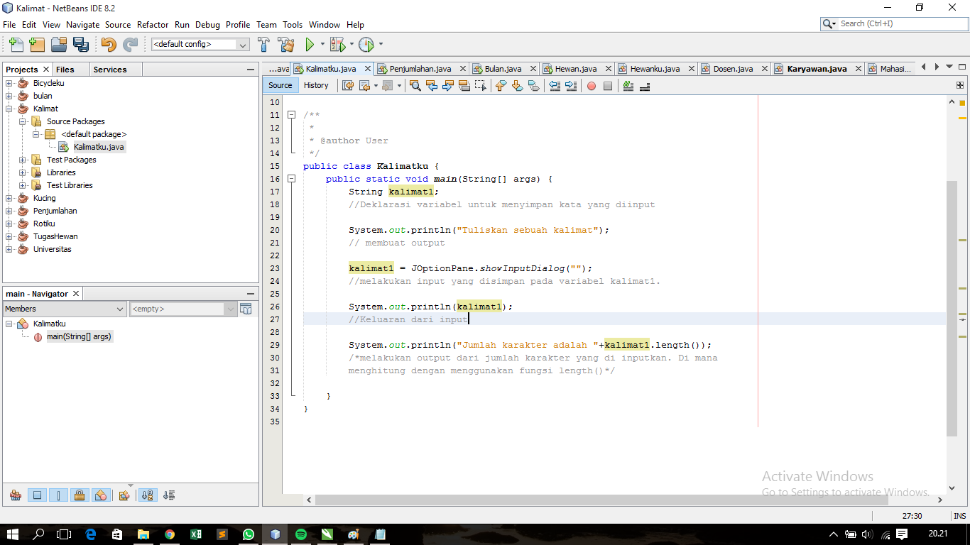

2. 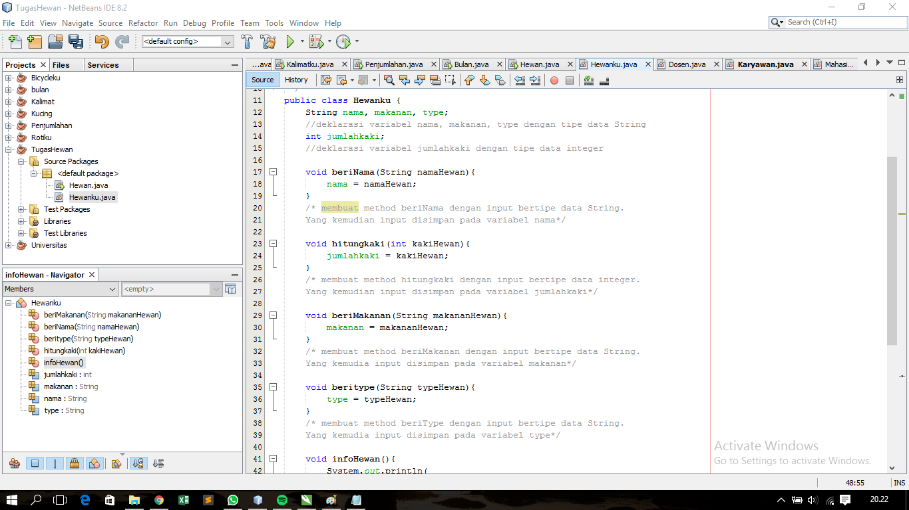

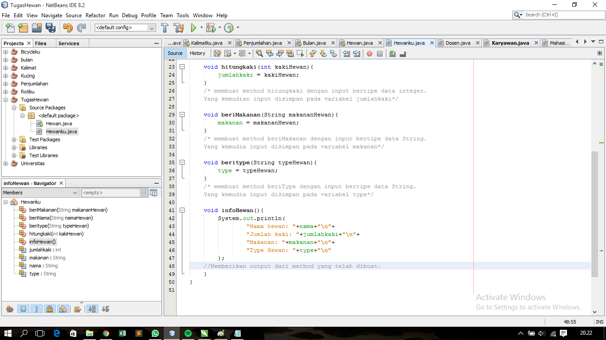

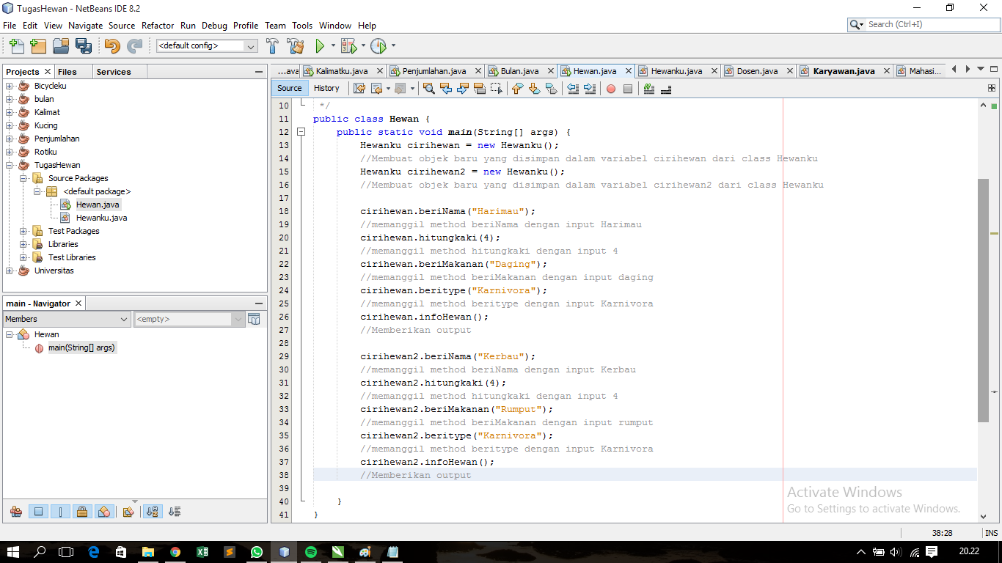

3.

