Nama : Tino Arif Priyanto

NIM : L200170131

Kelas : C

**LATIHAN**

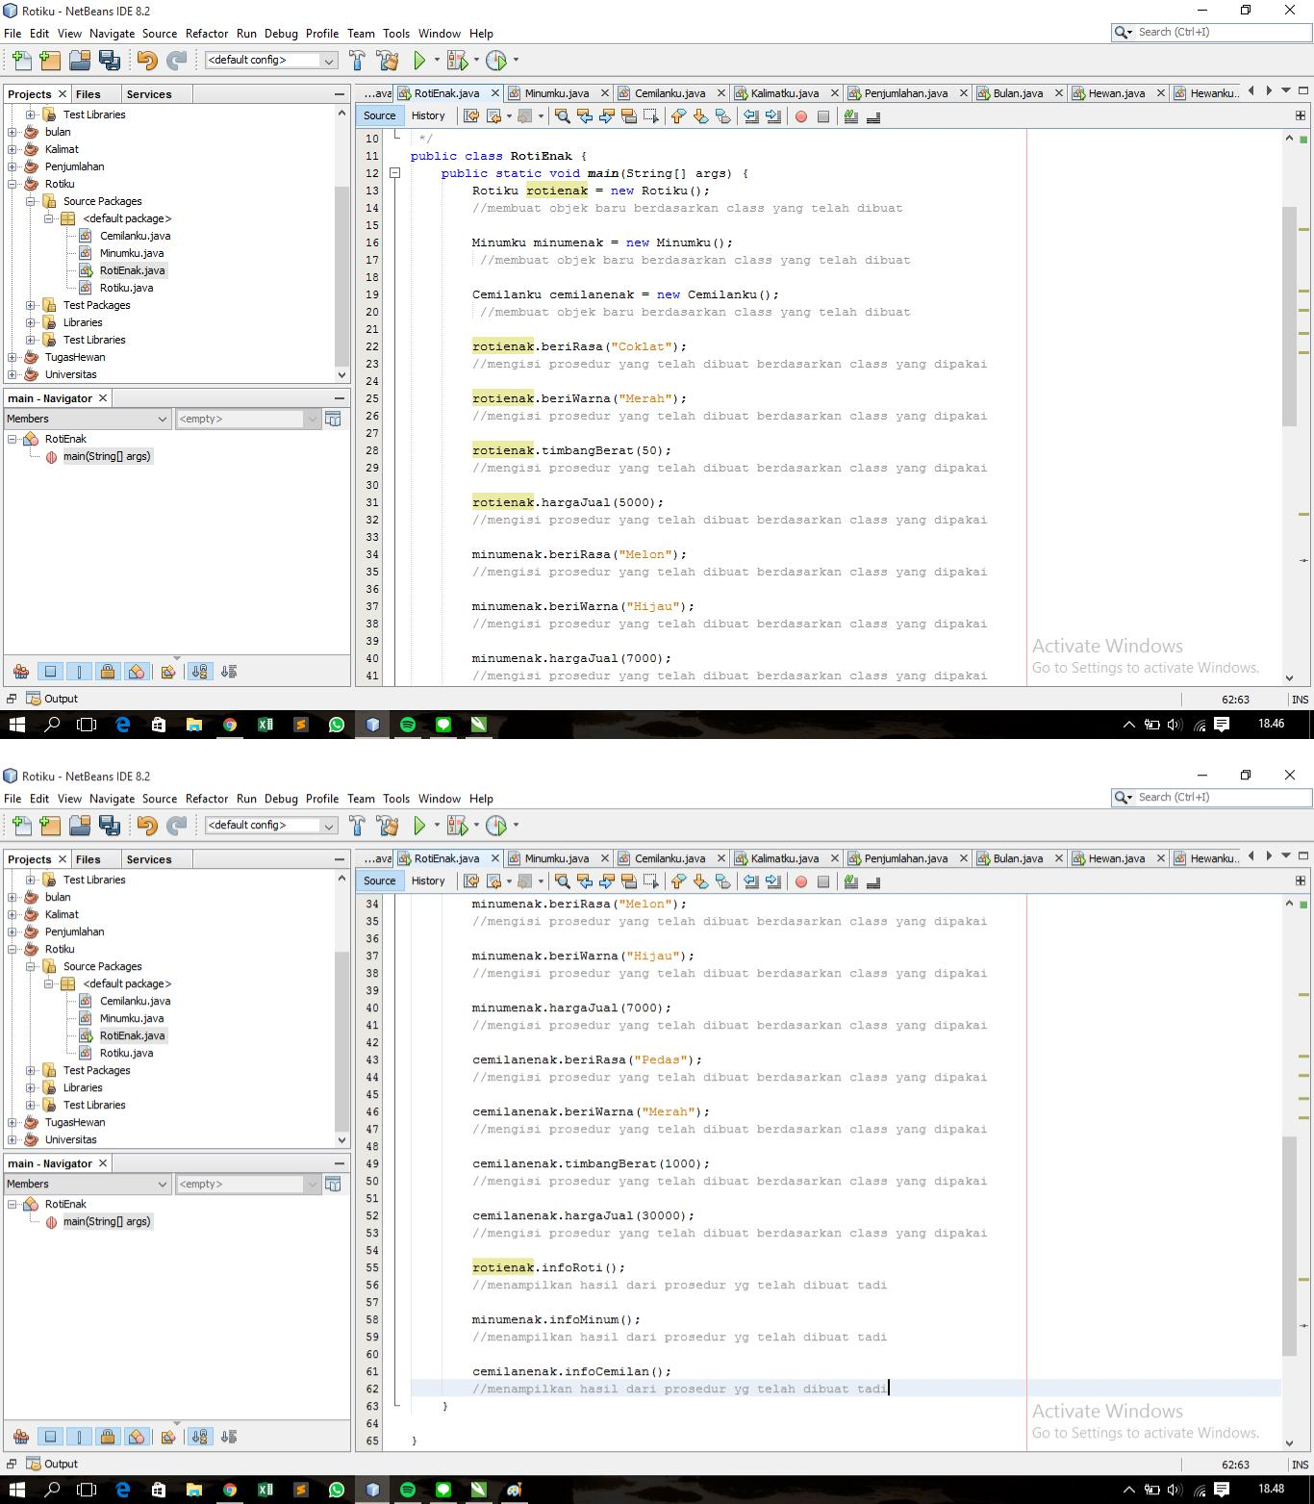

2.

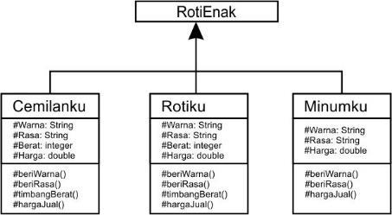

3.

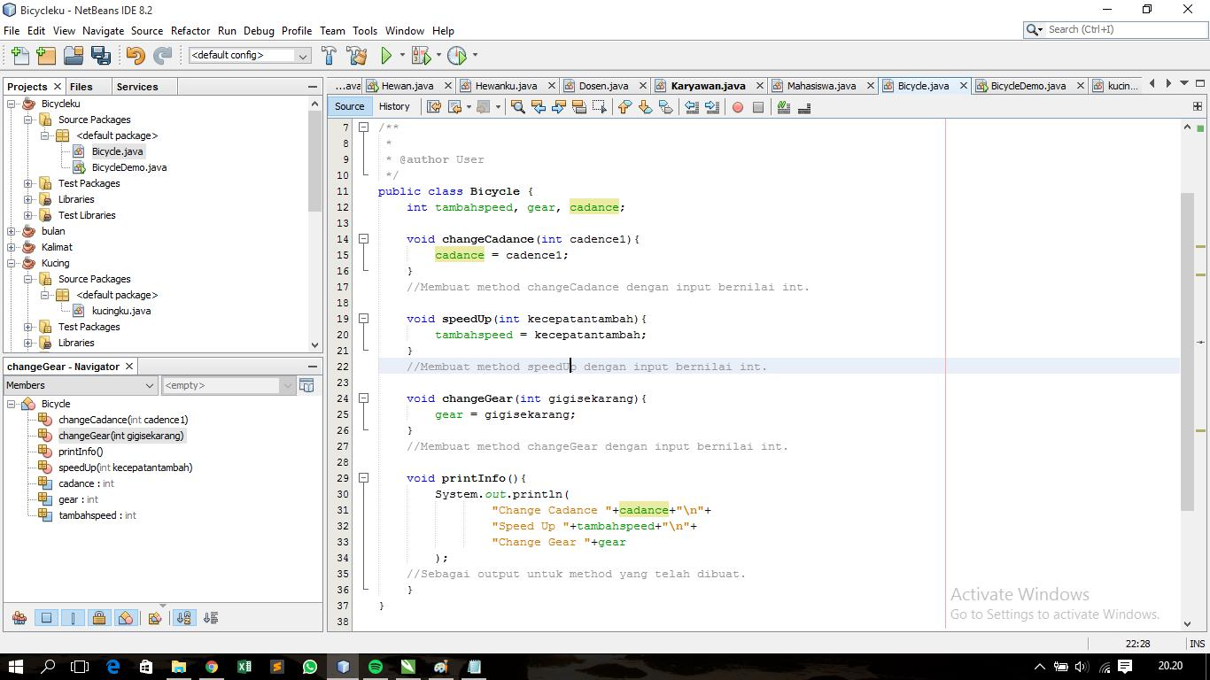

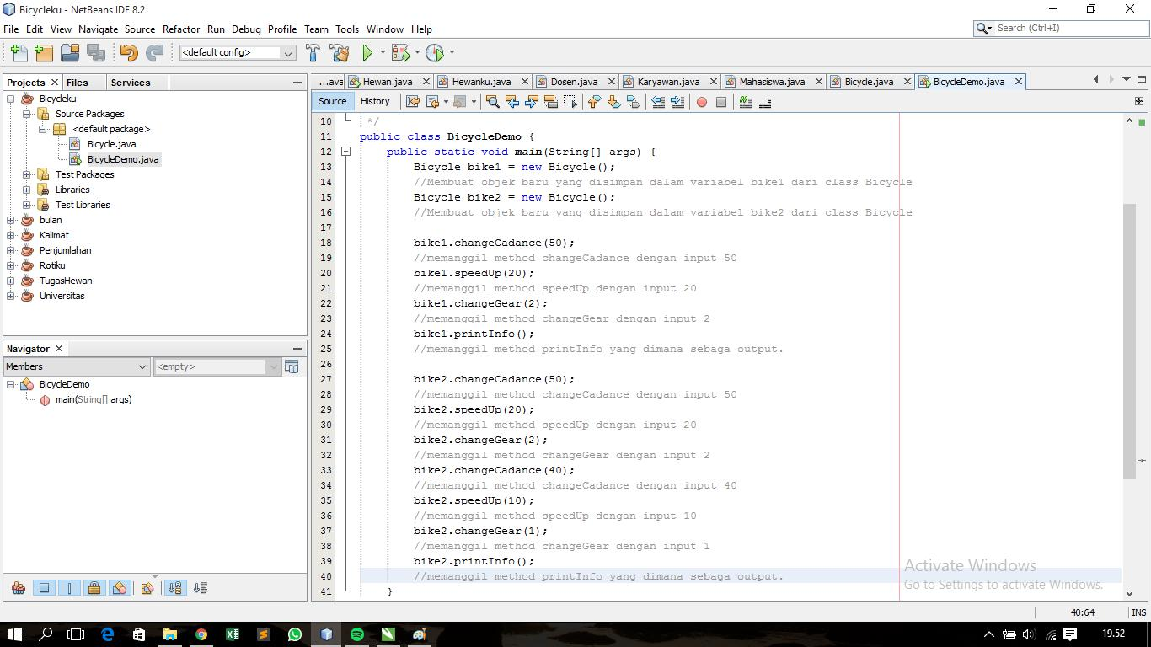

4.

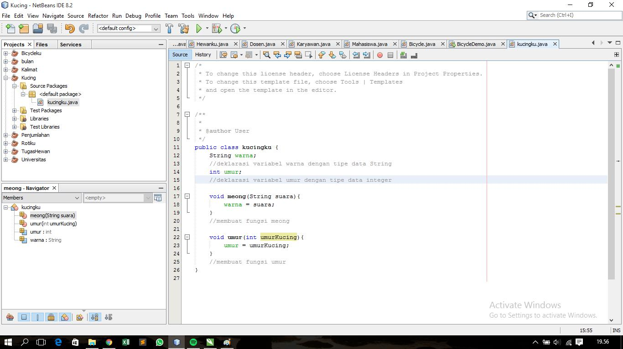

1. Berikut adalah daftar metode yang didukung oleh kelas String:
   * Char charAt (int index)
   * int compareTo (Object o)
   * int compareTo (String anotherString)
   * int compareToIgnoreCase (String str)
   * String concat (String str)
   * contentEquals boolean (StringBuffer sb)
   * statis String copyValueOf (char [] data)
   * statis String copyValueOf (char [] data, int offset, int count)
   * boolean endsWith (String suffix)
   * boolean equals (Object anObject)
   * boolean equalsIgnoreCase (String anotherString):
   * getBytes byte ()
   * byte [] getBytes (String charsetName)
   * int hashCode()
   * int indexOf (int ch)
   * int indexOf (int ch, int fromIndex)
   * int indexOf (String str)
   * int indexOf (String str, int fromIndex)
   * String intern ()
   * int lastIndexOf (int ch)
   * int lastIndexOf (int ch, int fromIndex)
   * int lastIndexOf (String str)
   * int panjang ()
   * String [] split (String regex)
   * String [] split (String regex, batas int)
   * boolean startsWith (String prefix, int toffset)
   * String substring (int beginIndex)
   * String substring (int beginIndex, int endIndex)
   * char di [] toCharArray ()
   * String toLowerCase ()
   * String toLowerCase (lokal Lokal)
   * String toString ()
   * String toUpperCase ()
   * String toUpperCase (lokal Lokal)
   * String lis ()
   * statis String valueOf (primitif tipe data x)

**2.3 Pekerjaan Rumah**

1.

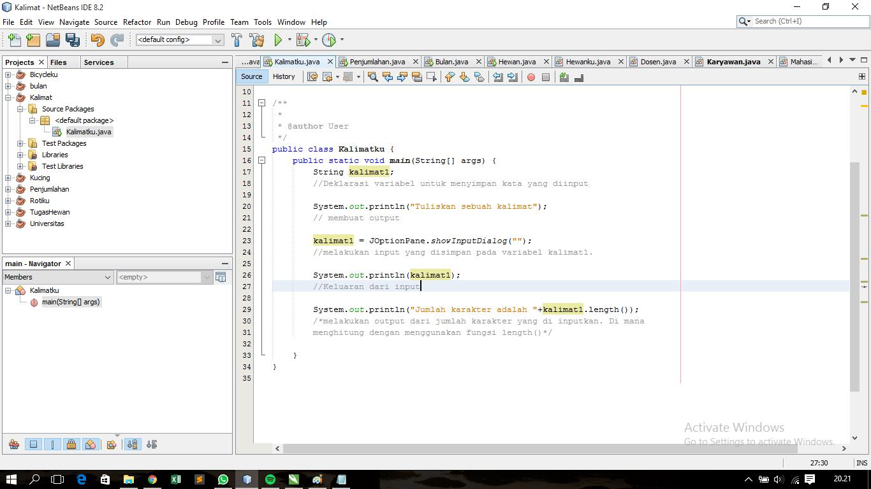

2.

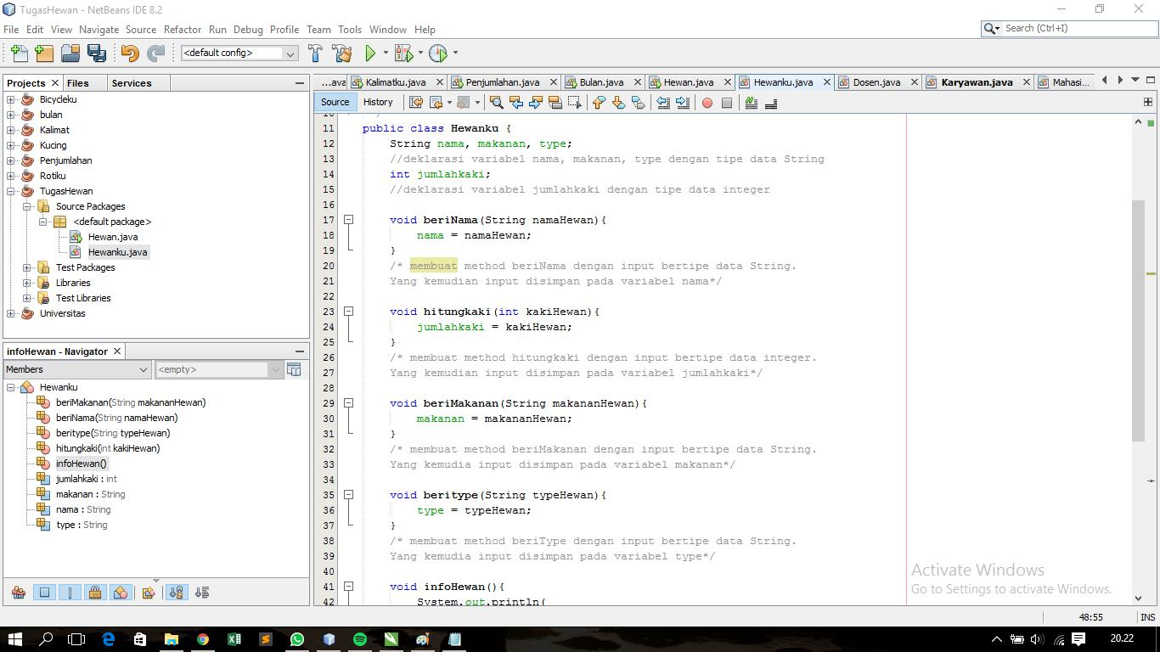

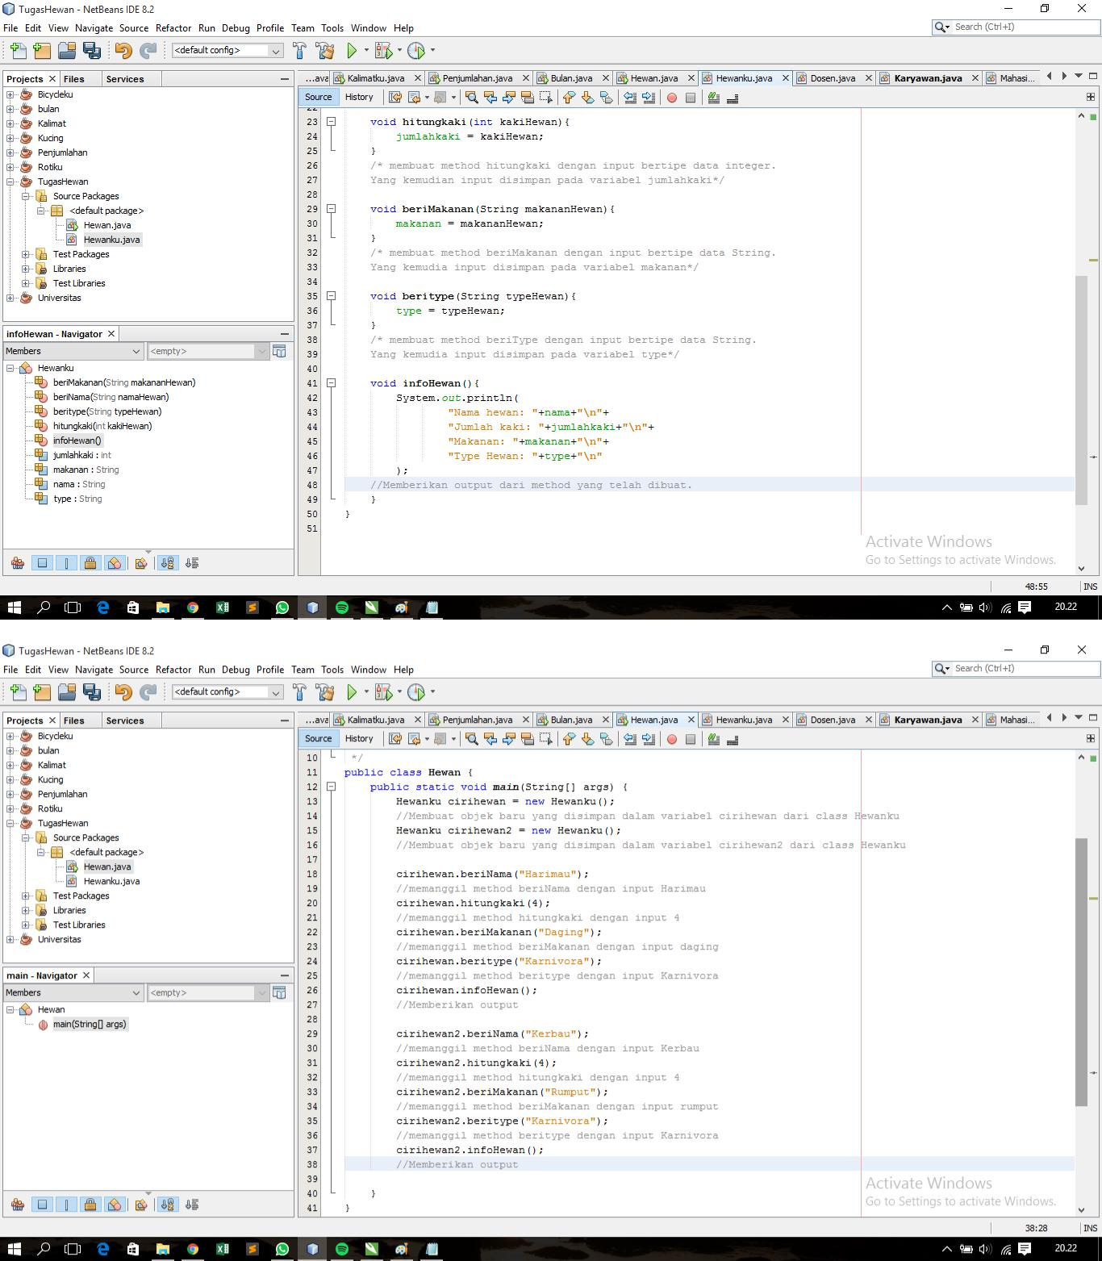

3.

