**Laporan Praktikum Pemrograman Berorientasi Object**

Nama : Lail Nur Rachman

NIM : L200170137

Kelas : C

* **Class Dosen**

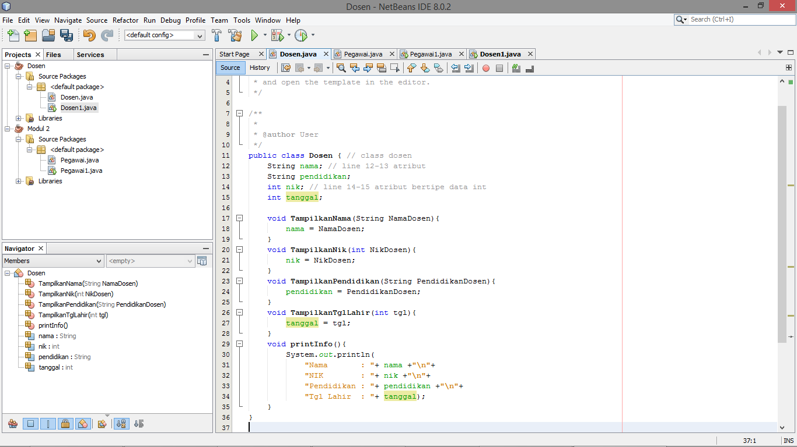

* **Class Dosen1**

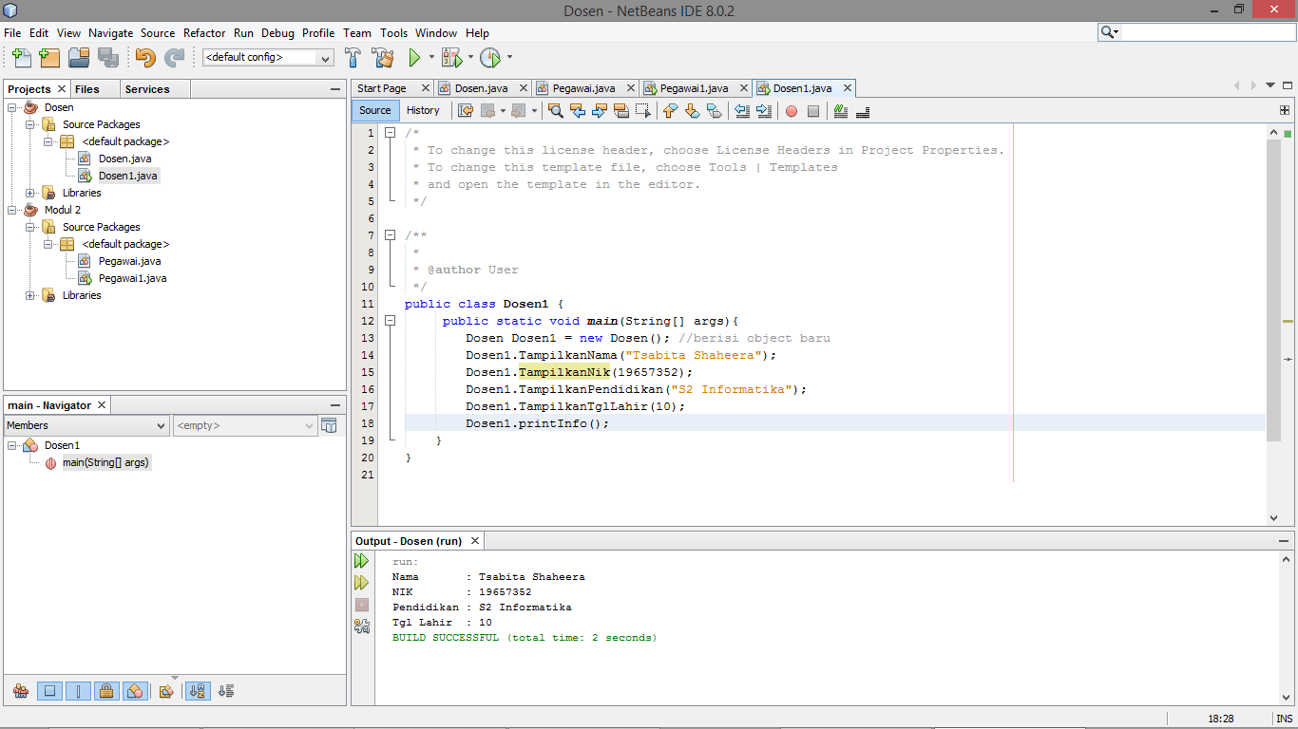

* **Class Mahasiswa**

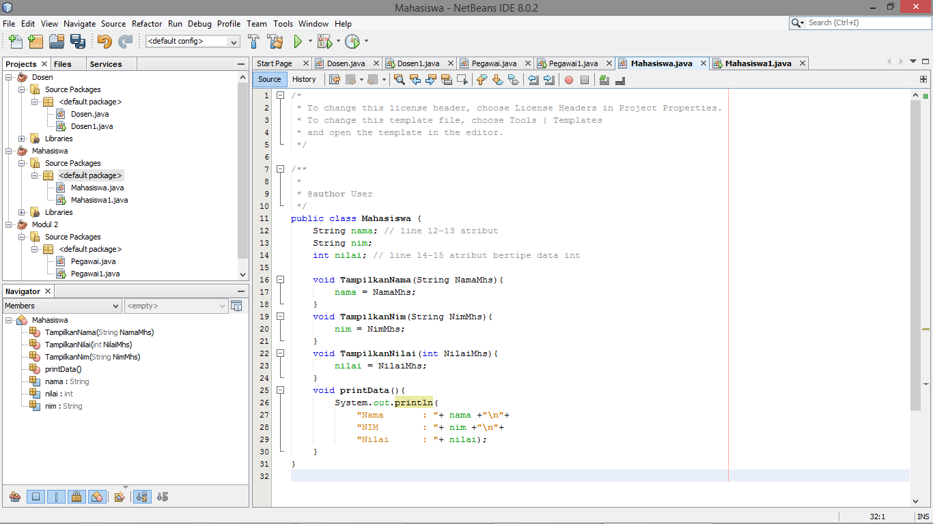

* **Class Mahasiswa1**

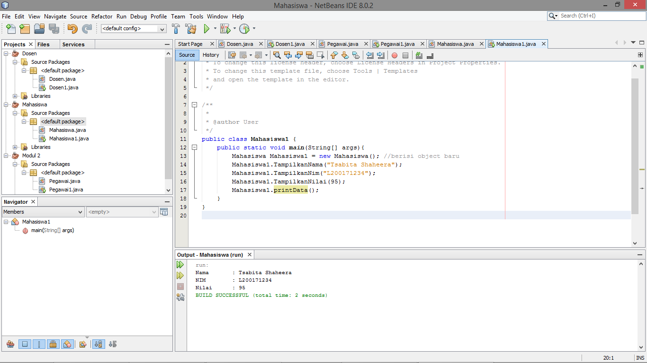

* **Class Pegawai**

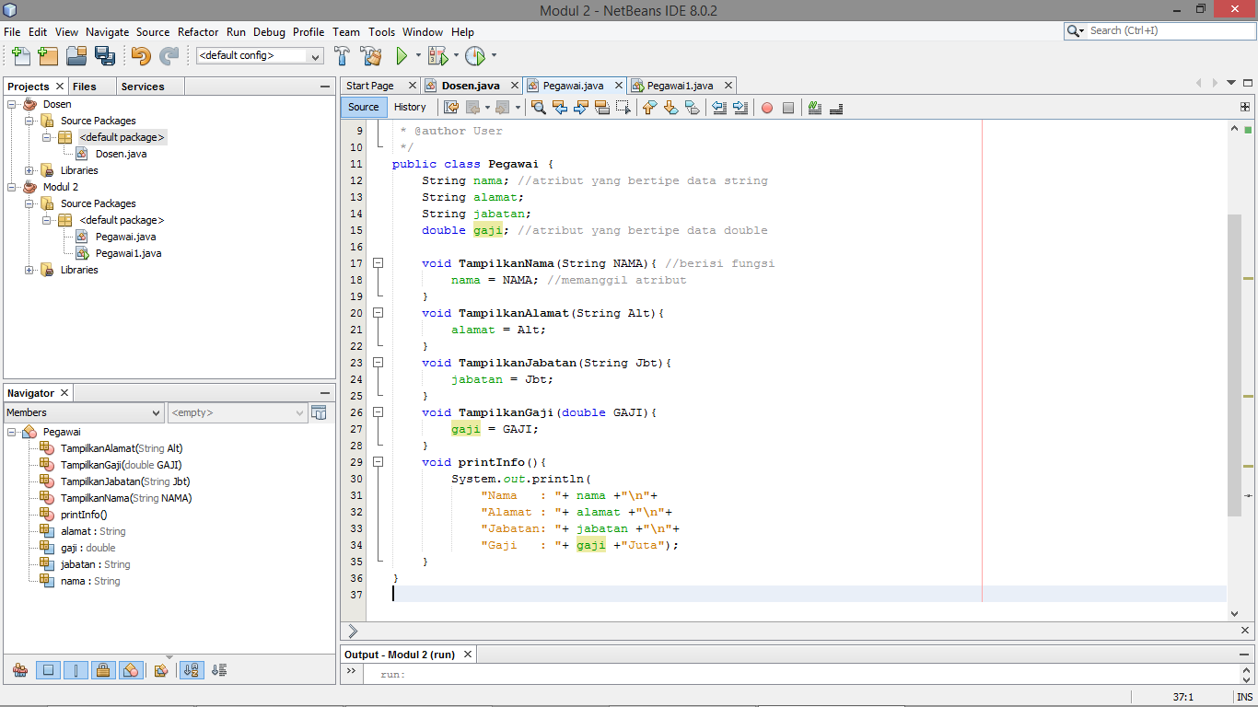

* **Class Pegawai1**

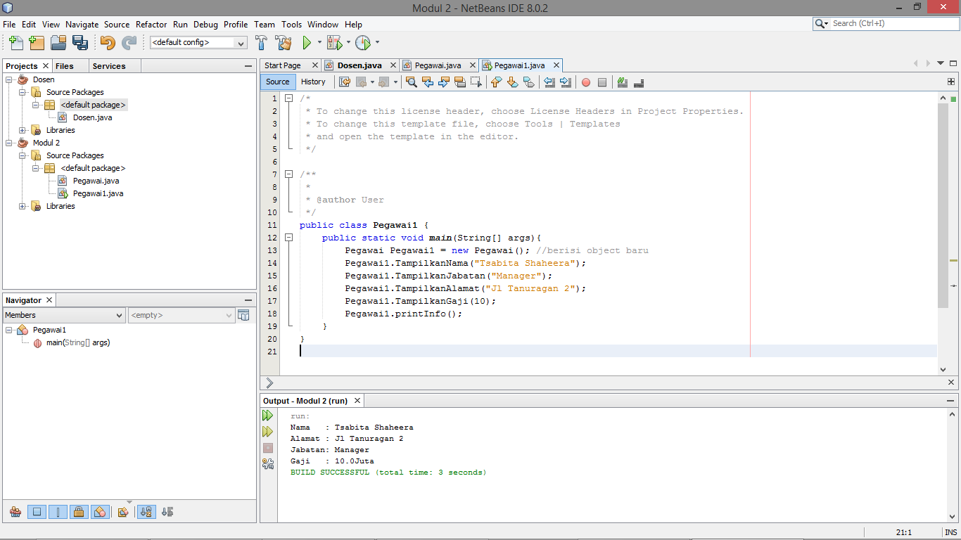

* **PEKERJAAN RUMAH**
* **Class TugasRumah**

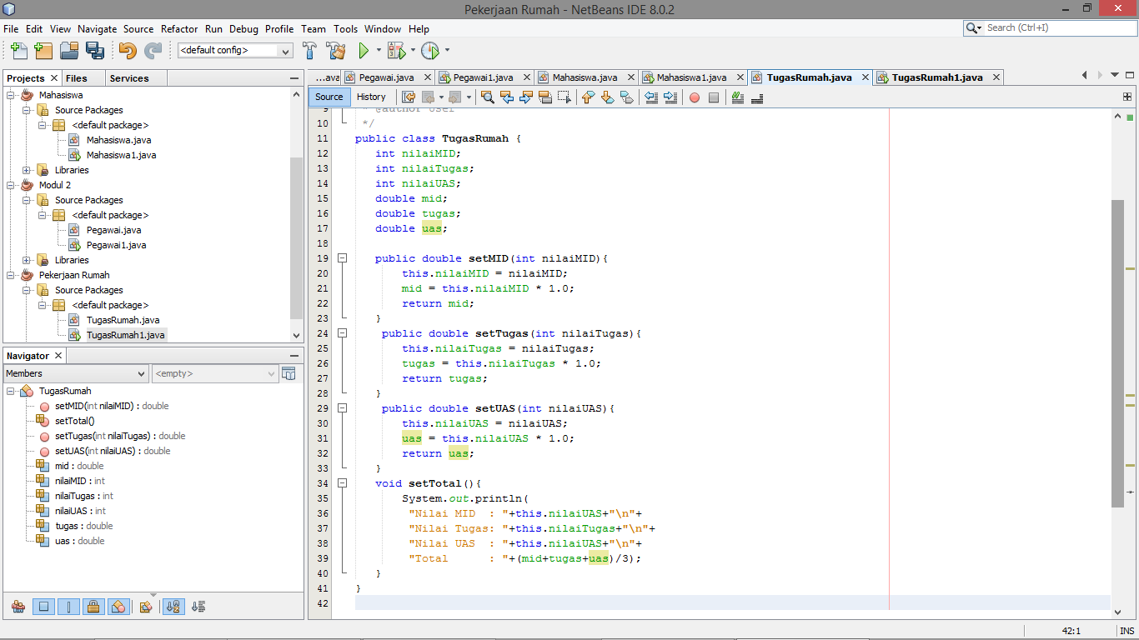

* **Class TugasRumah1**

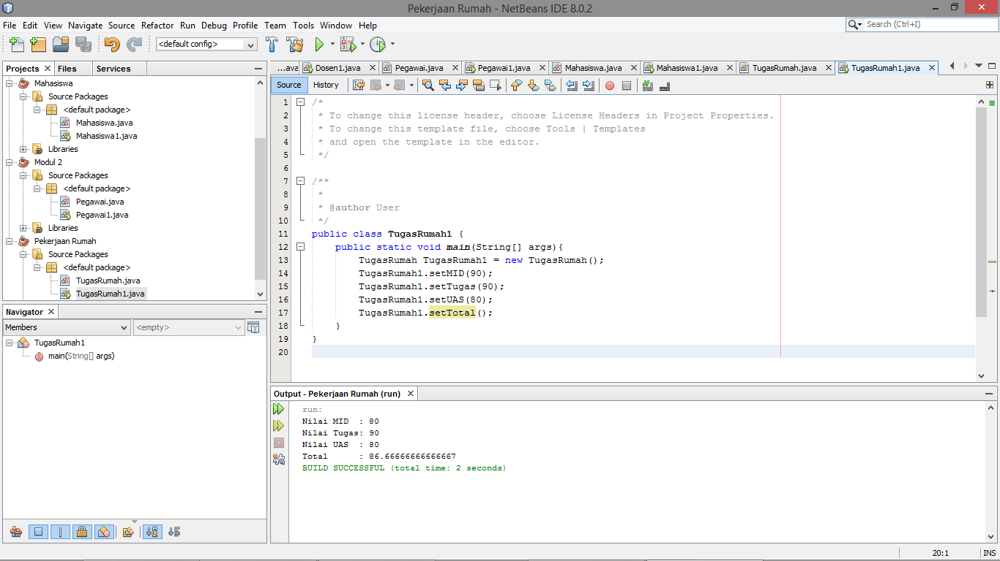

* **Source Code**
* **Class TugasRumah**

public class TugasRumah {

int nilaiMID;

int nilaiTugas;

int nilaiUAS;

double mid;

double tugas;

double uas;

public double setMID(int nilaiMID){

this.nilaiMID = nilaiMID;

mid = this.nilaiMID * 1.0;

return mid;

}

public double setTugas(int nilaiTugas){

this.nilaiTugas = nilaiTugas;

tugas = this.nilaiTugas * 1.0;

return tugas;

}

public double setUAS(int nilaiUAS){

this.nilaiUAS = nilaiUAS;

uas = this.nilaiUAS * 1.0;

return uas;

}

void setTotal(){

System.out.println(

"Nilai MID : "+this.nilaiUAS+"\n"+

"Nilai Tugas: "+this.nilaiTugas+"\n"+

"Nilai UAS : "+this.nilaiUAS+"\n"+

"Total : "+(mid+tugas+uas)/3);

}

}

* **Class TugasRumah1**

public class TugasRumah1 {

public static void main(String[] args){

TugasRumah TugasRumah1 = new TugasRumah();

TugasRumah1.setMID(90);

TugasRumah1.setTugas(90);

TugasRumah1.setUAS(80);

TugasRumah1.setTotal();

}

}