|  |  |  |  |
| --- | --- | --- | --- |
| **NO_SISWA** | **NAMA** | **LAMA BELAJAR(JAM)** | **NILAI** |
| S-101 | JOKO | 15 | 783 |
| S-102 | AGUS | 18 | 877 |
| S-103 | SUSI | 7 | 505 |
| S-104 | DYAH | 9 | 860 |
| S-105 | WATI | 15 | 968 |
| S-106 | IKA | 17 | 793 |
| S-107 | EKO | 10 | 752 |
| S-108 | YANTO | 5 | 571 |
| S-109 | WAWAN | 8 | 667 |
| S-110 | MAHMUD | 15 | 723 |

**Nama : Aldias Ibnu Habib**

**NIM : L200170166**

Model

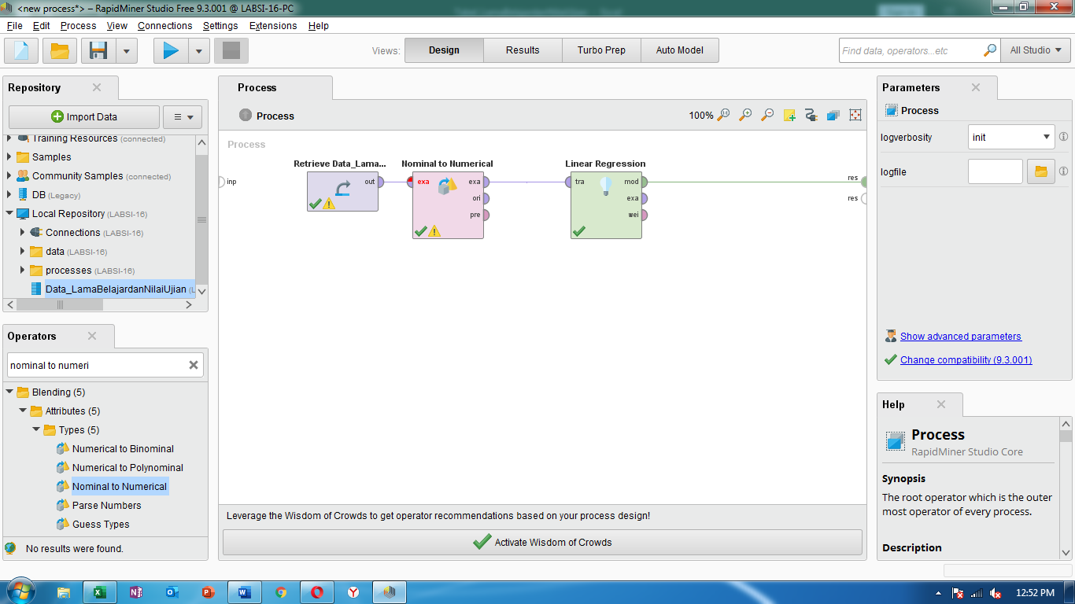

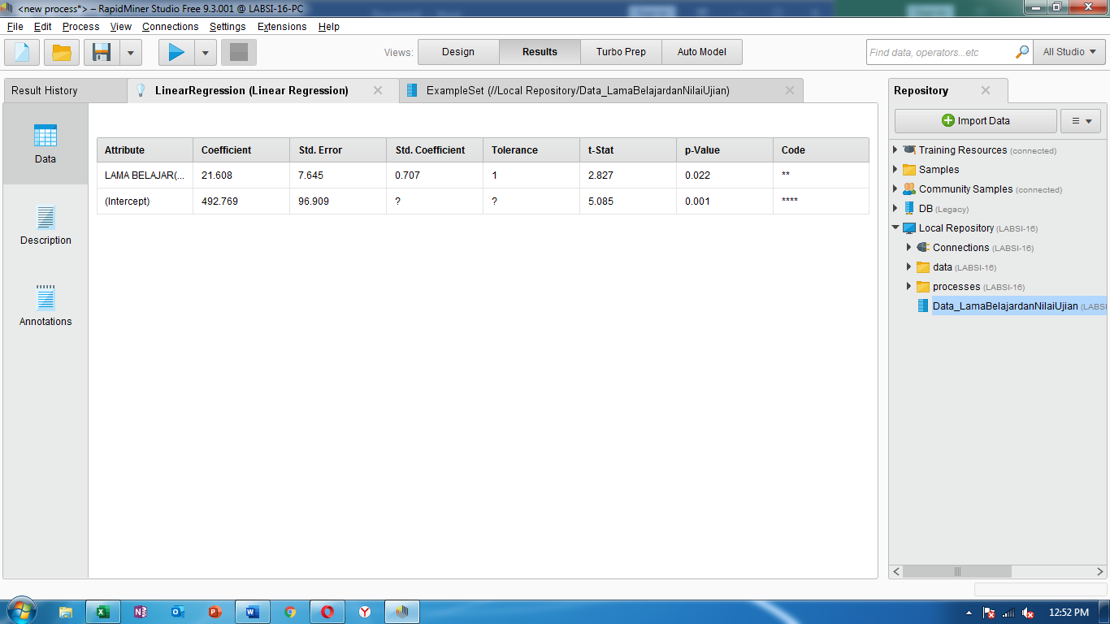

**LinearRegression**

21.608 * LAMA BELAJAR(JAM)

+ 492.769

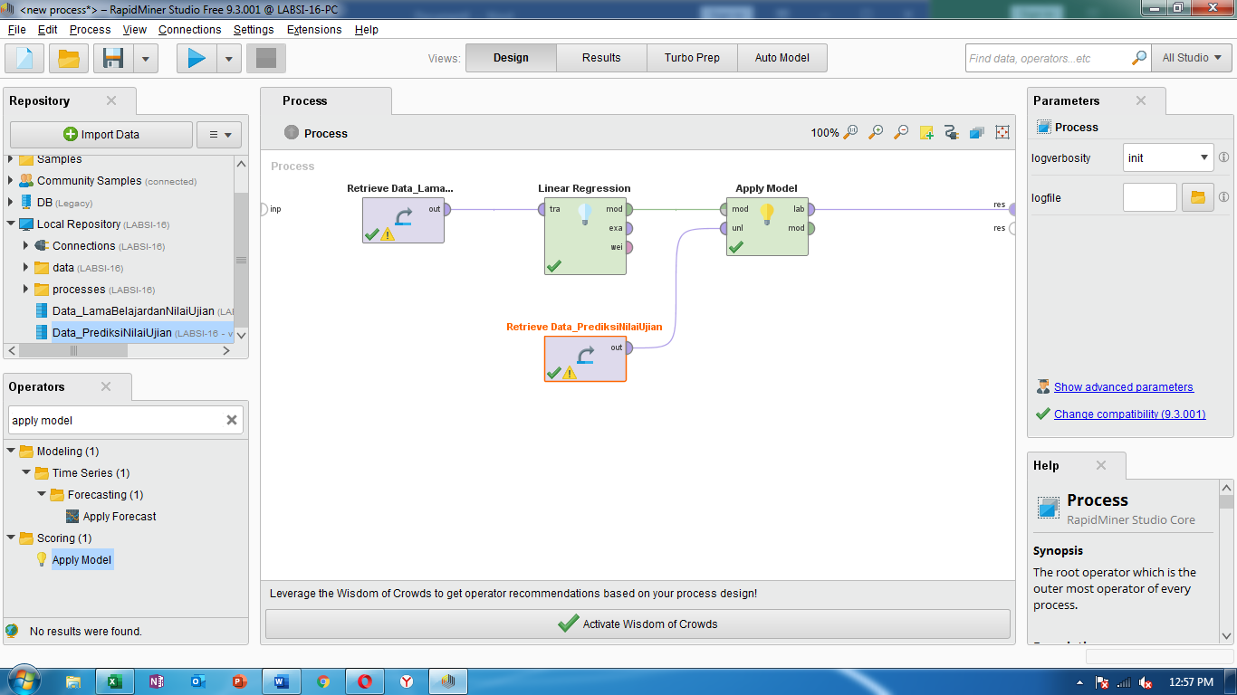

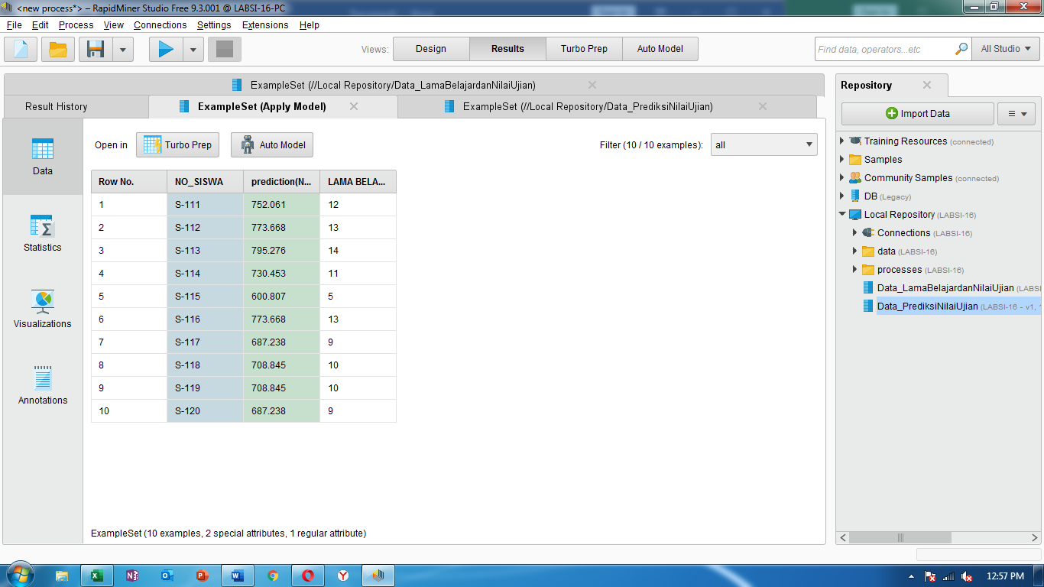

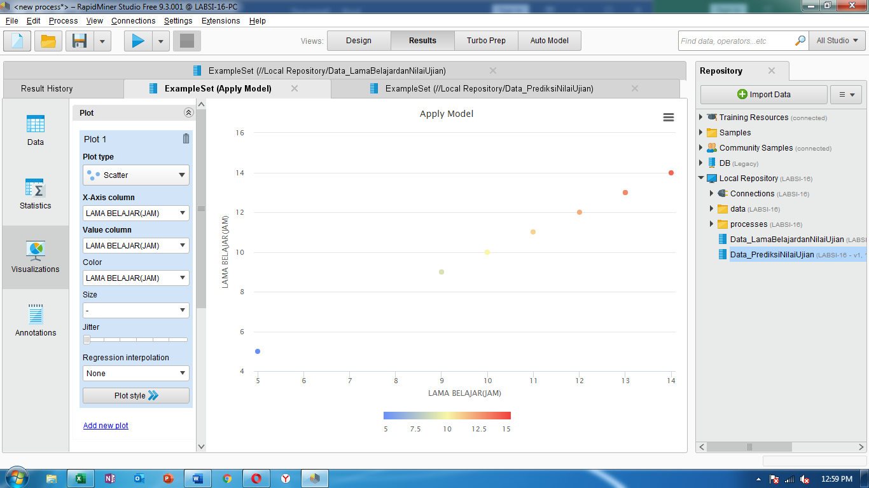

Hasil prediksi

|  |  |  |  |  |
| --- | --- | --- | --- | --- |
| **NO_SISWA** | **NAMA** | **LAMA BELAJAR(JAM)** | **Prediction (NILAI)** | **Prediction (NILAI)** |
| **Tabel** | **Model Regresi** |
| S-111 | BUDI | 12 | 752.0607648 | 752.065 |
| S-112 | SANTI | 13 | 773.6684128 | 773.673 |
| S-113 | DIAN | 14 | 795.2760608 | 795.281 |
| S-114 | DANI | 11 | 730.4531168 | 730.457 |
| S-115 | AHMAD | 5 | 600.8072289 | 600.809 |
| S-116 | BAYU | 13 | 773.6684128 | 773.673 |
| S-117 | RISA | 9 | 687.2378209 | 687.241 |
| S-118 | RANI | 10 | 708.8454688 | 708.849 |
| S-119 | YANI | 10 | 708.8454688 | 708.849 |
| S-120 | RATIH | 9 | 687.2378209 | 687.241 |

