Ahmad Faizal Al Amin

L200170183

Prak_DWDM Modul_14

G

1. KEGIATAN
2. Design

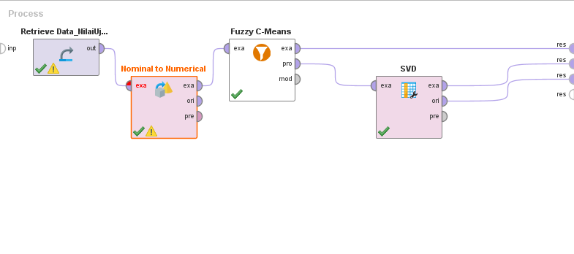

1. Output Nominal to Numerical

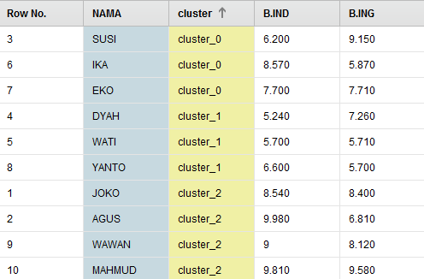

1. Fuzzy C_Means

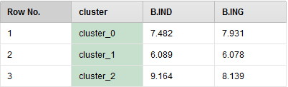

1. TUGAS
2. Design

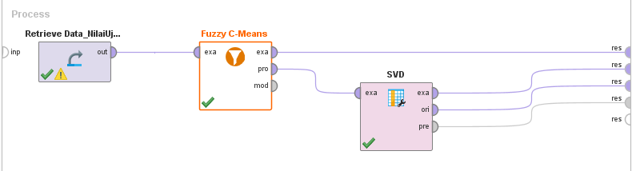

1. Output Fuzzy C-Means

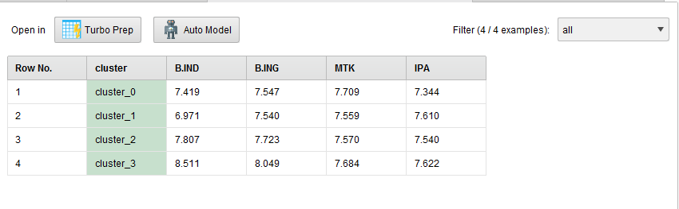

1. SVD

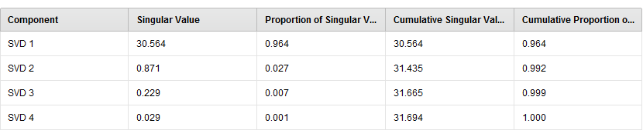

1. ExampleSet SVD

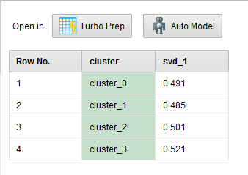

1. ExampleSet Retrive Data_NilaiUjianTugas

