Ahmad Faizal Al Amin

L200170183

F

Modul 11

1. KEGIATAN 1
2. Decission Tree 9.0.003

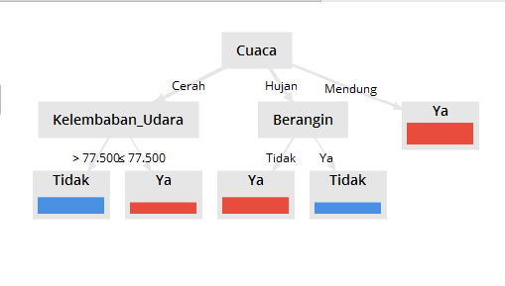

1. Design

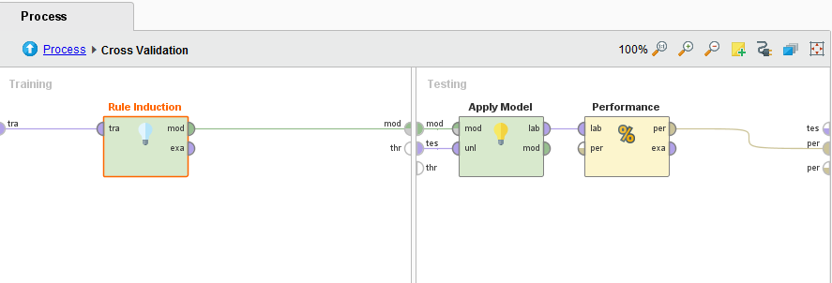

1. Performance Vector

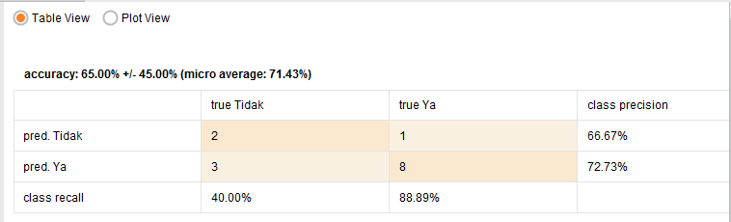

1. Rule Model

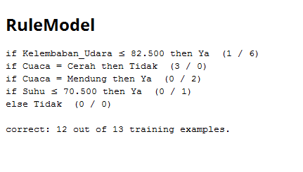

1. KEGIATAN 2
2. Frequent Item Set (FP-Growth)

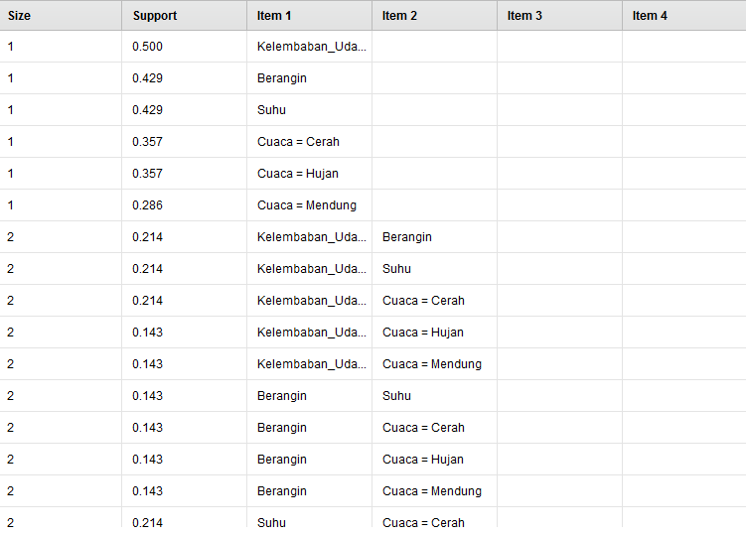 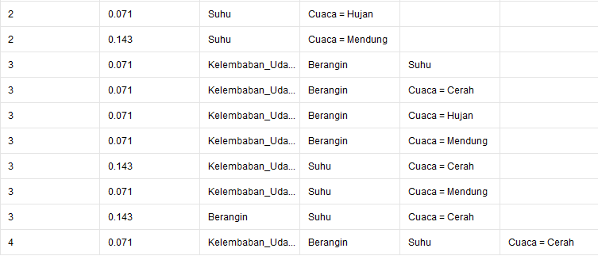

1. Design
2. Process

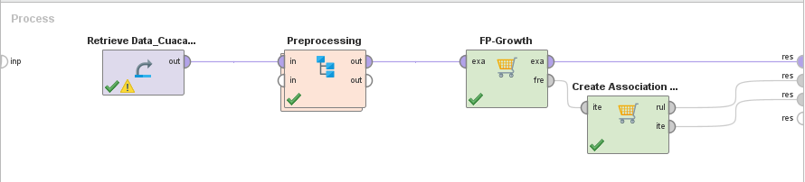

1. Preprocessing

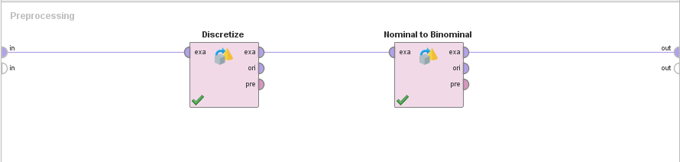

1. Association Rules

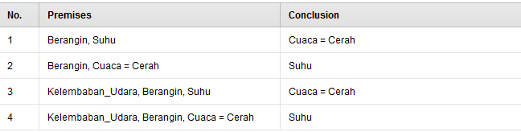 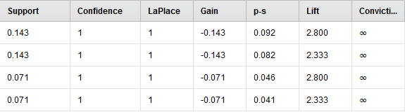

1. Graph View

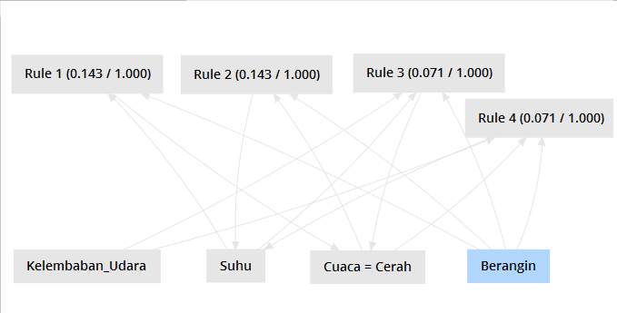

1. Example Set

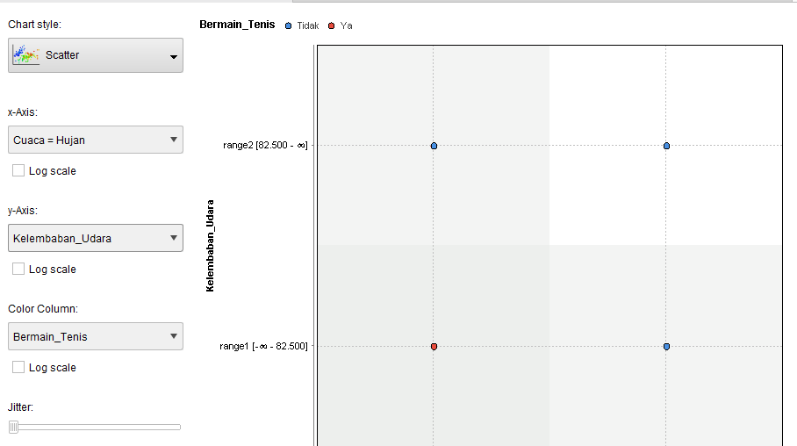

1. TUGAS
2. **Data Menggunakan Tugas Modul 6 No.1**
3. Decission Tree

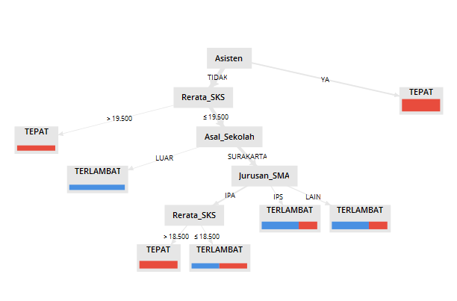

1. Design

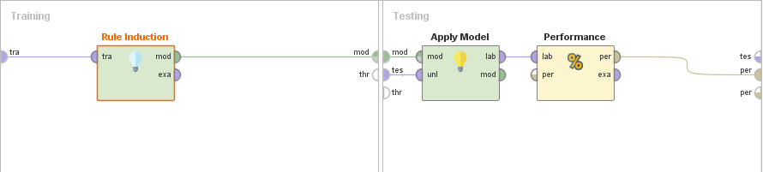

1. Performance Vector

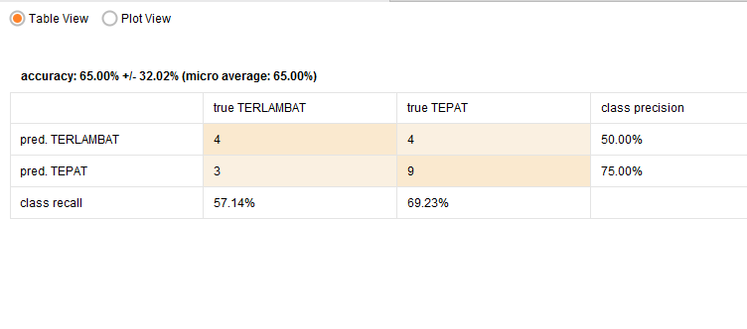

1. Rule Model

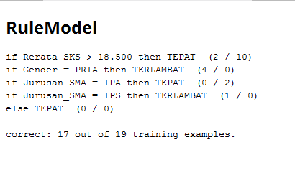

2a. Number of bins = 2

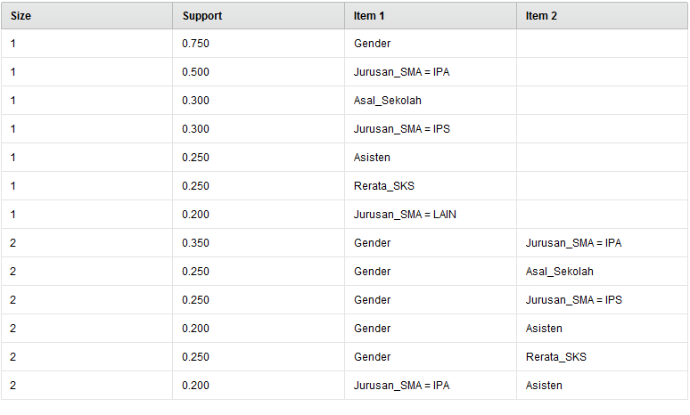

b. Number of bins = 3

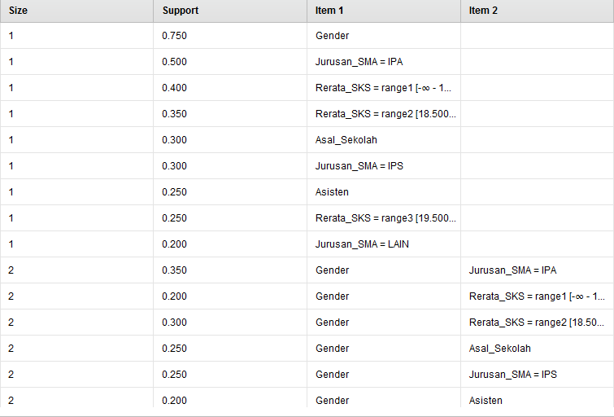 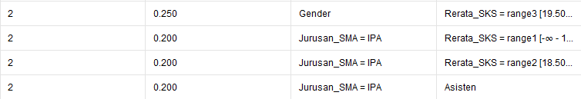

1. Jumlah set aturan asosiasi bins = 2

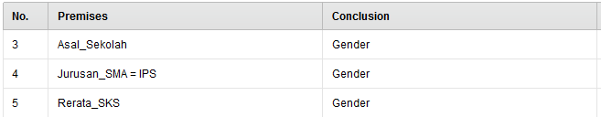 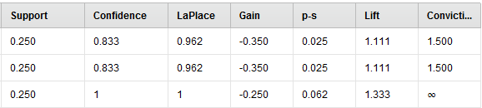

Jumlah set aturan asosiasi bins = 3

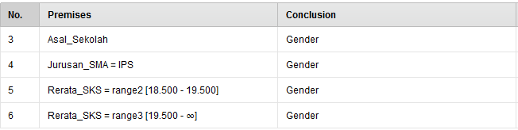 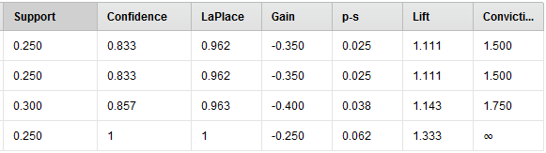

1. Graph view bins = 2

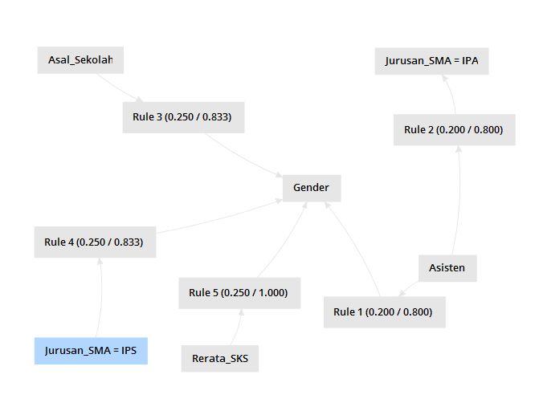

Graph view bins = 3

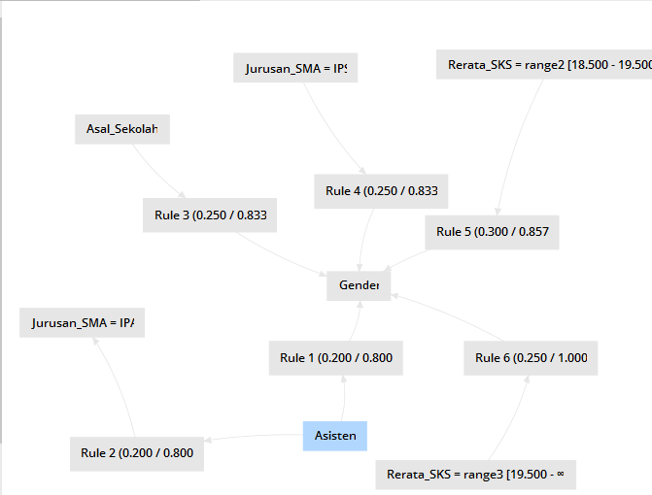

1. Example Set bins = 2

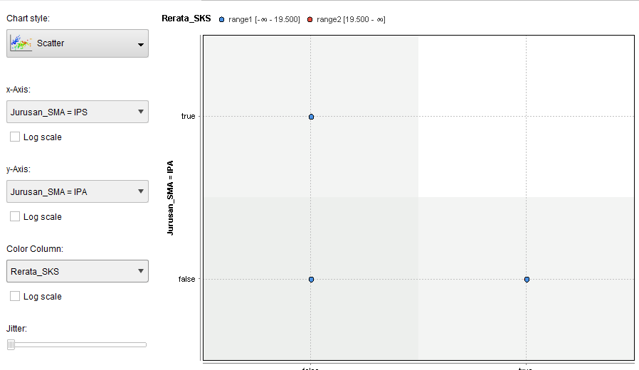

Example Set bins = 3

