**NAMA : Oscar Satria Utama**

**NIM : L200180001**

Percobaan 1.

1. Kombinasi gerbang logika

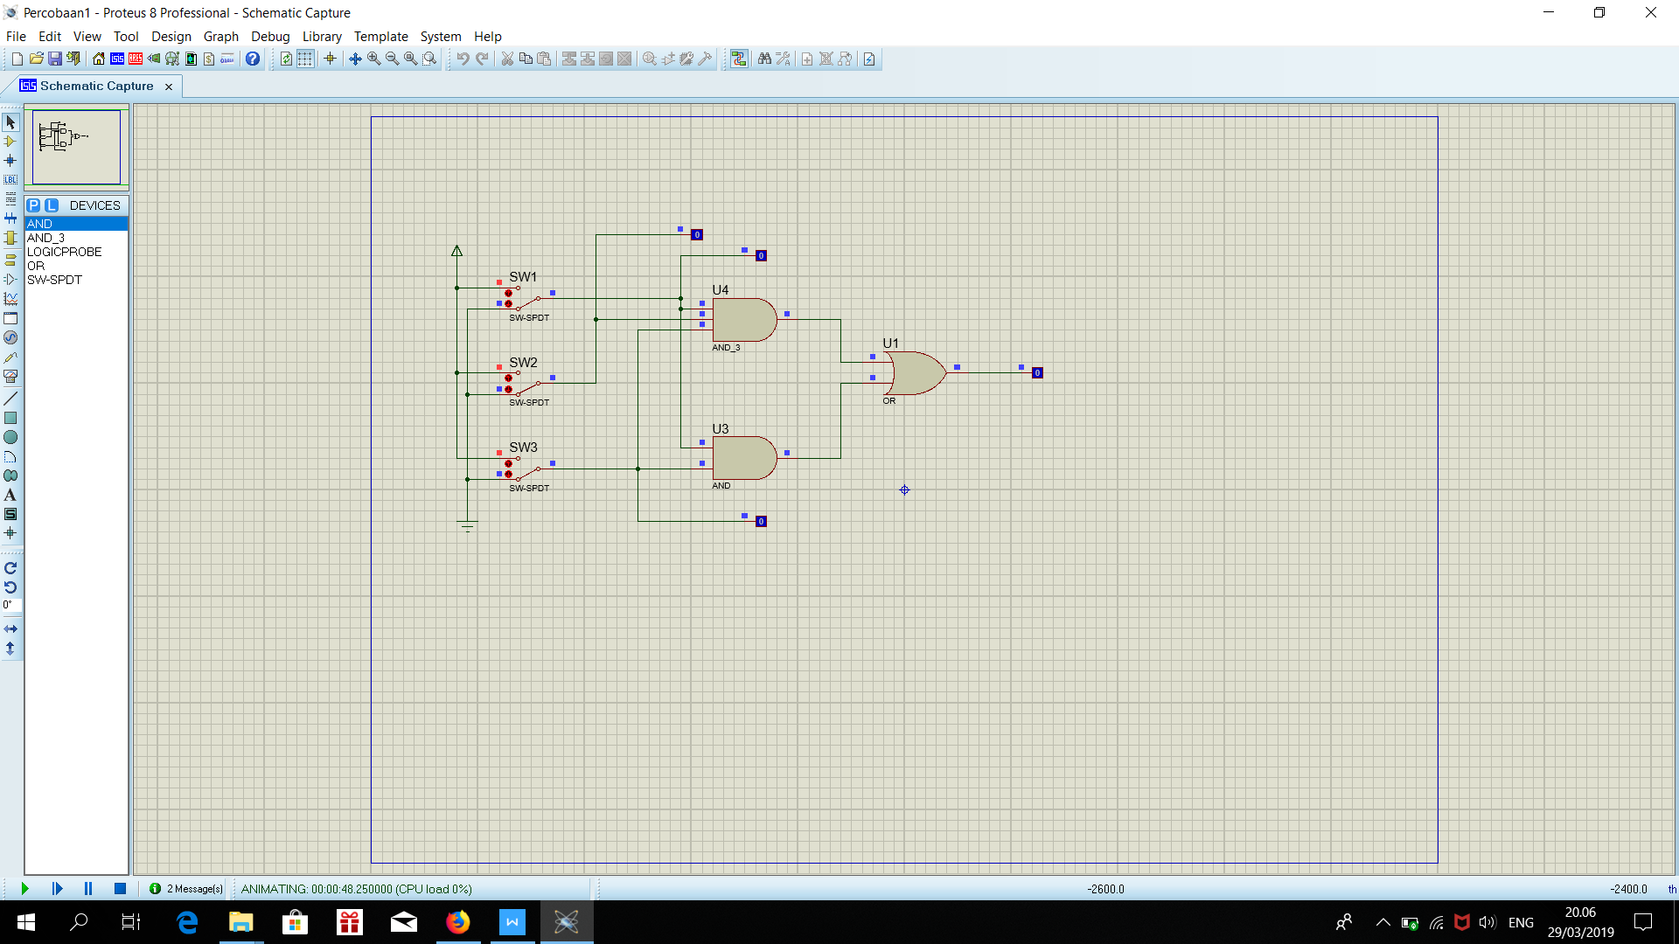

1. Fungsi Boolean F = ABC + AC
2. Titik-titik dalam tabel

|  |  |  |  |
| --- | --- | --- | --- |
| **A** | **B** | **C** | **F** |
| 0 | 0 | 0 | 0 |
| 1 | 0 | 0 | 0 |
| 0 | 1 | 0 | 0 |
| 1 | 1 | 0 | 0 |
| 0 | 0 | 1 | 0 |
| 1 | 0 | 1 | 1 |
| 0 | 1 | 1 | 0 |
| 1 | 1 | 1 | 1 |

1. Titik-titik dalam Karnaugh map

|  |  |  |  |  |  |
| --- | --- | --- | --- | --- | --- |
|  | | AB | | | |
| 00 | 01 | 11 | 10 |
| C | 0 |  |  |  |  |
| 1 |  |  | 1 | 1 |

1. Bentuk sederhana fungsi Boolean berdasarkan Karnaugh map F = AC
2. Kombinasi gerbang logika berdasarkan fungsi Boolean baru

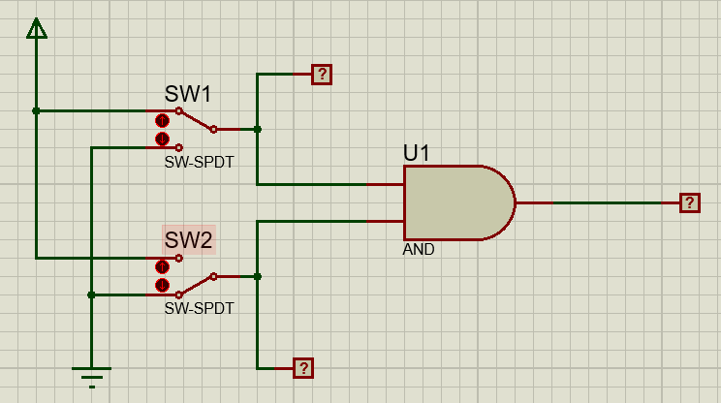

Percobaan 2.

1. Kombinasi gerbang logika

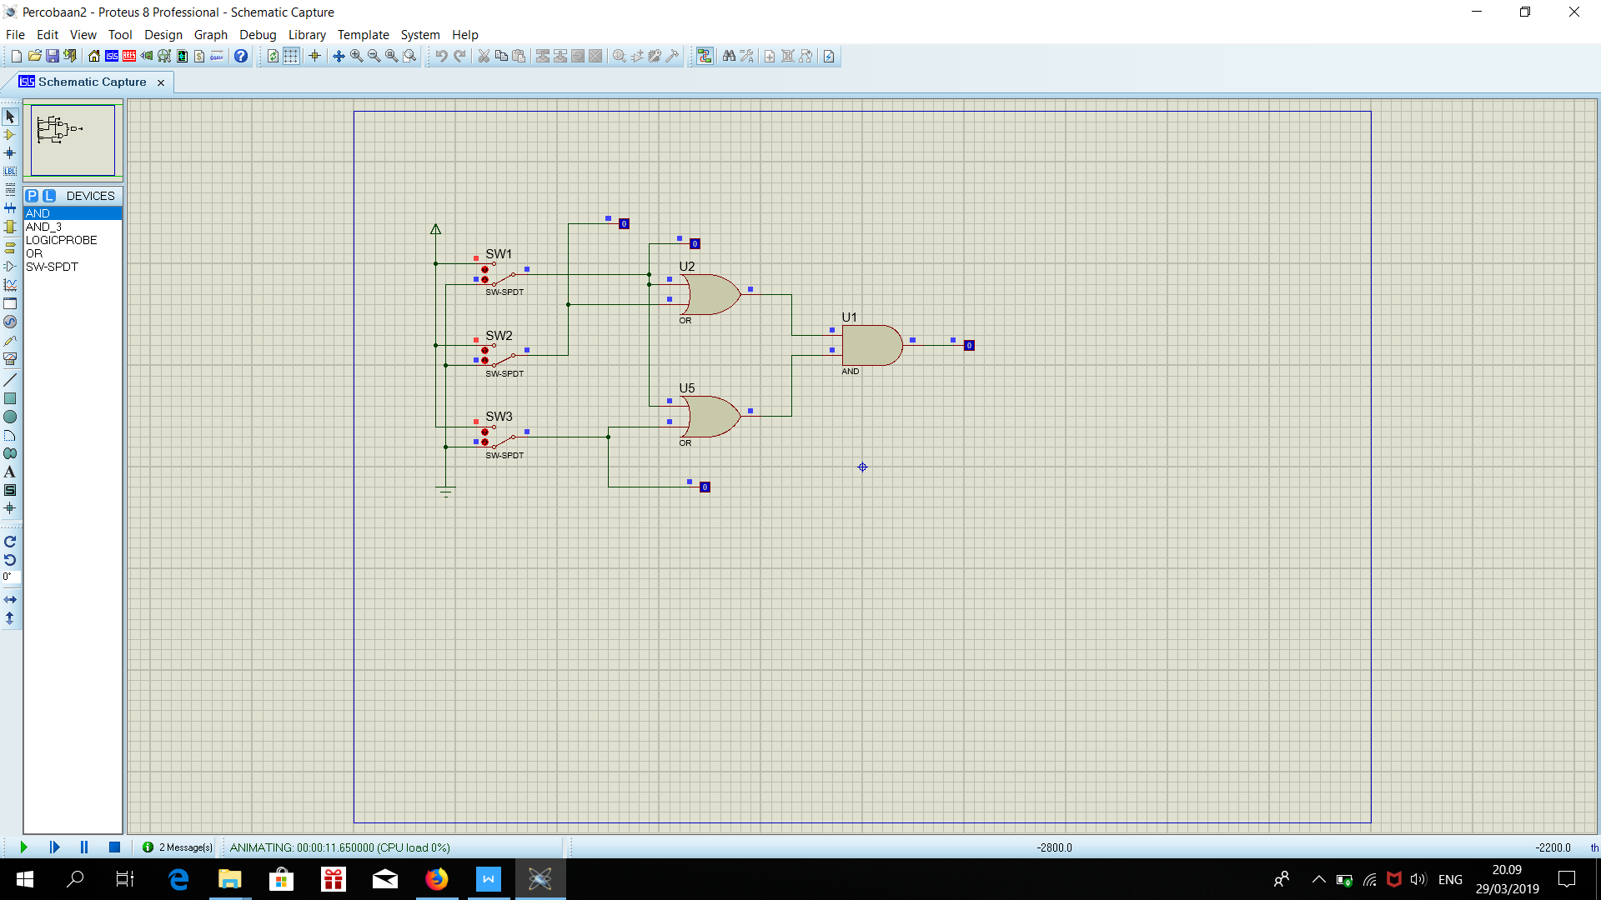

1. Fungsi Boolean F =(A + B). (A + C)
2. Titik-titik dalam tabel

|  |  |  |  |
| --- | --- | --- | --- |
| **A** | **B** | **C** | **F** |
| 0 | 0 | 0 | 0 |
| 1 | 0 | 0 | 1 |
| 0 | 1 | 0 | 0 |
| 1 | 1 | 0 | 1 |
| 0 | 0 | 1 | 0 |
| 1 | 0 | 1 | 1 |
| 0 | 1 | 1 | 1 |
| 1 | 1 | 1 | 1 |

1. Titik-titik dalam Karnaugh map

|  |  |  |  |  |  |
| --- | --- | --- | --- | --- | --- |
|  | | AB | | | |
| 00 | 01 | 11 | 10 |
| C | 0 |  |  | 1 | 1 |
| 1 |  | 1 | 1 | 1 |

1. Bentuk sederhana fungsi Boolean berdasarkan Karnaugh map F = A + BC
2. Kombinasi gerbang logika berdasarkan fungsi Boolean baru

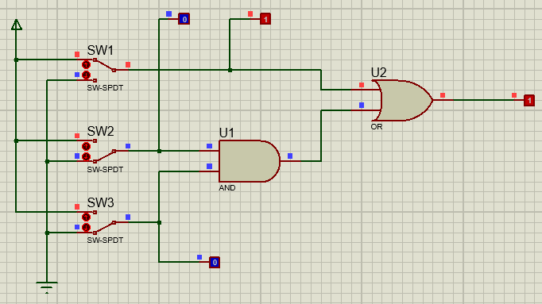

Percobaan 3.

1. Kombinasi gerbang logika

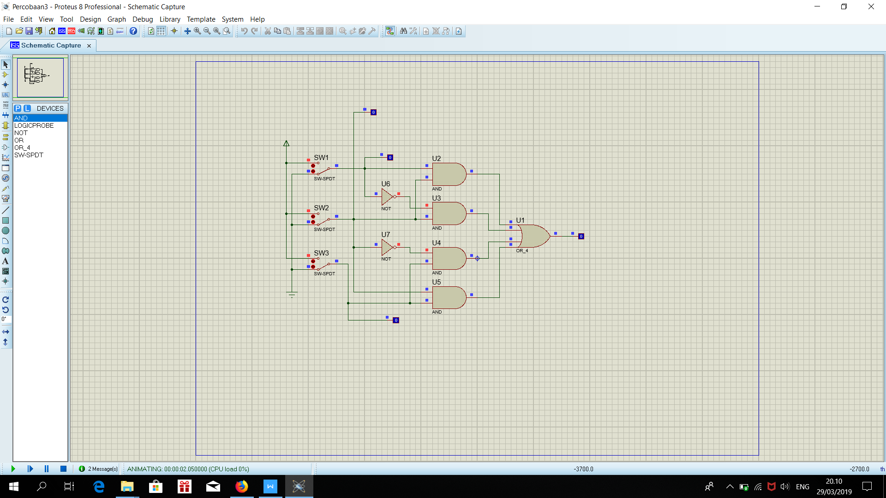

1. Fungsi Boolean F = AB + A’B + B’C + BC
2. Titik-titik dalam tabel

|  |  |  |  |
| --- | --- | --- | --- |
| **A** | **B** | **C** | **F** |
| 0 | 0 | 0 | 0 |
| 1 | 0 | 0 | 0 |
| 0 | 1 | 0 | 1 |
| 1 | 1 | 0 | 1 |
| 0 | 0 | 1 | 1 |
| 1 | 0 | 1 | 1 |
| 0 | 1 | 1 | 1 |
| 1 | 1 | 1 | 1 |

1. Titik-titik dalam Karnaugh map

|  |  |  |  |  |  |
| --- | --- | --- | --- | --- | --- |
|  | | AB | | | |
| 00 | 01 | 11 | 10 |
| C | 0 |  | 1 | 1 |  |
| 1 | 1 | 1 | 1 | 1 |

1. Bentuk sederhana fungsi Boolean berdasarkan Karnaugh map F = B + C
2. Kombinasi gerbang logika berdasarkan fungsi Boolean baru

