**MODUL 5**

NAMA : EDI SUPRIYANTO KELAS : A

NIM : L200180002

**Percobaan 1.**

1. Kombinasi gerbang logika

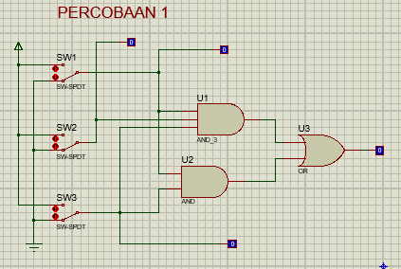

1. Fungsi Boolean **F = ABC + AC**
2. Titik-titik dalam tabel

|  |  |  |  |
| --- | --- | --- | --- |
| **A** | **B** | **C** | **F** |
| 0 | 0 | 0 | 0 |
| 1 | 0 | 0 | 0 |
| 0 | 1 | 0 | 0 |
| 1 | 1 | 0 | 0 |
| 0 | 0 | 1 | 0 |
| 1 | 0 | 1 | 1 |
| 0 | 1 | 1 | 0 |
| 1 | 1 | 1 | 1 |

1. Titik-titik dalam Karnaugh map

|  |  |  |  |  |  |
| --- | --- | --- | --- | --- | --- |
|  | | AB | | | |
| 00 | 01 | 11 | 10 |
| C | 0 |  |  |  |  |
| 1 |  |  | 1 | 1 |

1. Bentuk sederhana fungsi Boolean berdasarkan Karnaugh map **F = AC**
2. Kombinasi gerbang logika berdasarkan fungsi Boolean baru

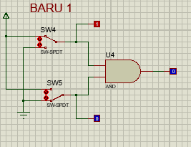

**Percobaan 2**

1. Kombinasi gerbang logika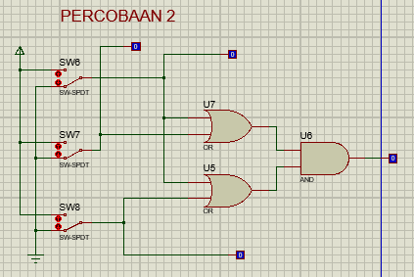
2. Fungsi Boolean **F =(A + B). (A + C)**
3. Titik-titik dalam tabel

|  |  |  |  |
| --- | --- | --- | --- |
| **A** | **B** | **C** | **F** |
| 0 | 0 | 0 | 0 |
| 1 | 0 | 0 | 1 |
| 0 | 1 | 0 | 0 |
| 1 | 1 | 0 | 1 |
| 0 | 0 | 1 | 0 |
| 1 | 0 | 1 | 1 |
| 0 | 1 | 1 | 1 |
| 1 | 1 | 1 | 1 |

1. Titik-titik dalam Karnaugh map

|  |  |  |  |  |  |
| --- | --- | --- | --- | --- | --- |
|  | | AB | | | |
| 00 | 01 | 11 | 10 |
| C | 0 |  |  | 1 | 1 |
| 1 |  | 1 | 1 | 1 |

1. Bentuk sederhana fungsi Boolean berdasarkan Karnaugh map **F = A + BC**
2. Kombinasi gerbang logika berdasarkan fungsi Boolean baru

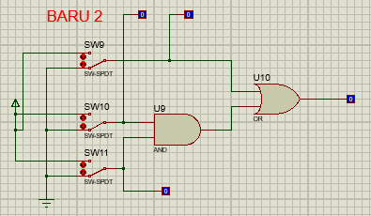

**Percobaan 3.**

1. Kombinasi gerbang logika

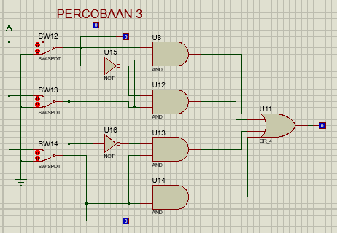

1. Fungsi Boolean **F = AB + A’B + B’C + BC**
2. Titik-titik dalam tabel

|  |  |  |  |
| --- | --- | --- | --- |
| **A** | **B** | **C** | **F** |
| 0 | 0 | 0 | 0 |
| 1 | 0 | 0 | 0 |
| 0 | 1 | 0 | 1 |
| 1 | 1 | 0 | 1 |
| 0 | 0 | 1 | 1 |
| 1 | 0 | 1 | 1 |
| 0 | 1 | 1 | 1 |
| 1 | 1 | 1 | 1 |

1. Titik-titik dalam Karnaugh map

|  |  |  |  |  |  |
| --- | --- | --- | --- | --- | --- |
|  | | AB | | | |
| 00 | 01 | 11 | 10 |
| C | 0 |  | 1 | 1 |  |
| 1 | 1 | 1 | 1 | 1 |

1. Bentuk sederhana fungsi Boolean berdasarkan Karnaugh map **F = B + C**
2. Kombinasi gerbang logika berdasarkan fungsi Boolean baru

