MODUL 3

Nama : Edi Supriyanto

NIM : L200180002

Percobaan 1. **Gerbang AND**

**SW 1 : 0 dan SW 2: 0**

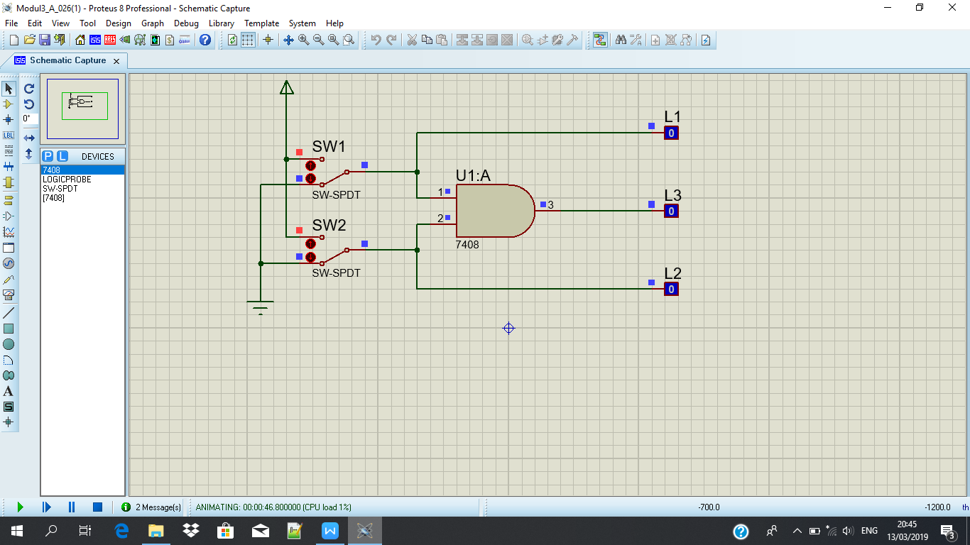

**SW 1 : 1 DAN SW 2: 0**

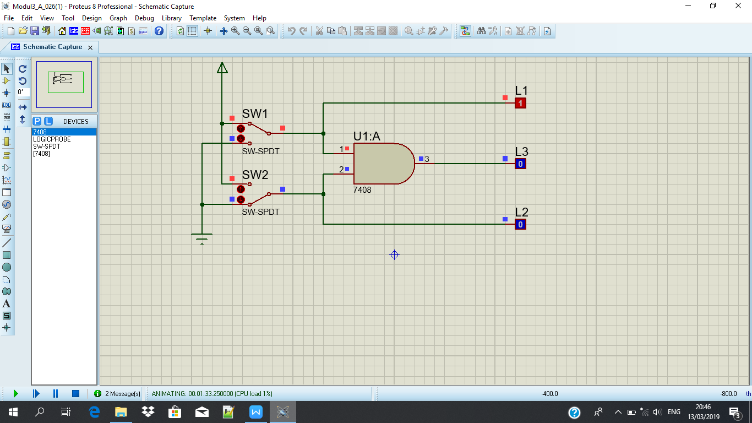

**SW 1 : 0 DAN SW 2 : 1**

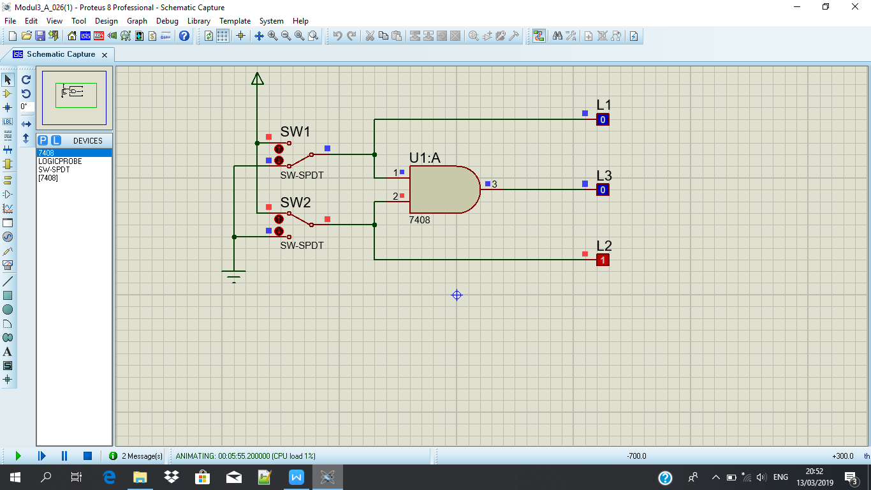

**SW 1: 1 DAN SW2: 1**

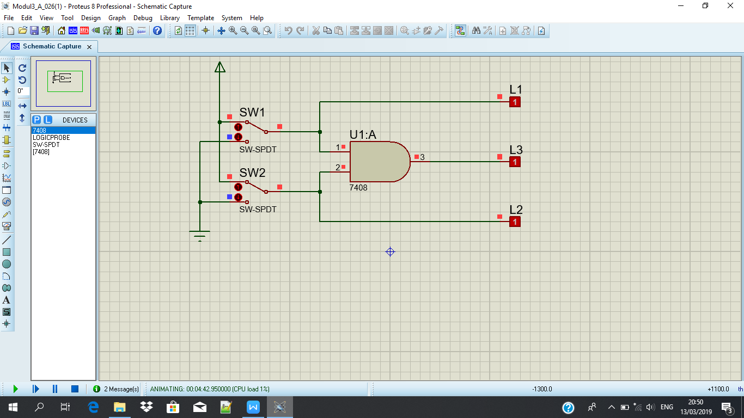

**Tabel kebenaran**

|  |  |  |  |  |
| --- | --- | --- | --- | --- |
| **SW 1** | **SW 2** | **L1** | **L2** | **L3** |
| **0** | **0** | **0** | **0** | **0** |
| **1** | **0** | **1** | **0** | **0** |
| **0** | **1** | **0** | **1** | **0** |
| **1** | **1** | **1** | **1** | **1** |

**Diagram Waktu**

**L1 :**

|  |  |  |  |
| --- | --- | --- | --- |
|  |  |  |  |
|  |  |  |  |
|  | |  |  |

**L2 :**

|  |  |  |  |
| --- | --- | --- | --- |
|  |  |  |  |
|  |  |  |  |
|  |  |  |  |

**L3 :**

|  |  |  |  |
| --- | --- | --- | --- |
|  |  |  |  |
|  |  |  |  |
|  |  |  |  |

Percobaan 2. **Gerbang OR**

**SW 1 : 0 DAN SW 2 : 0**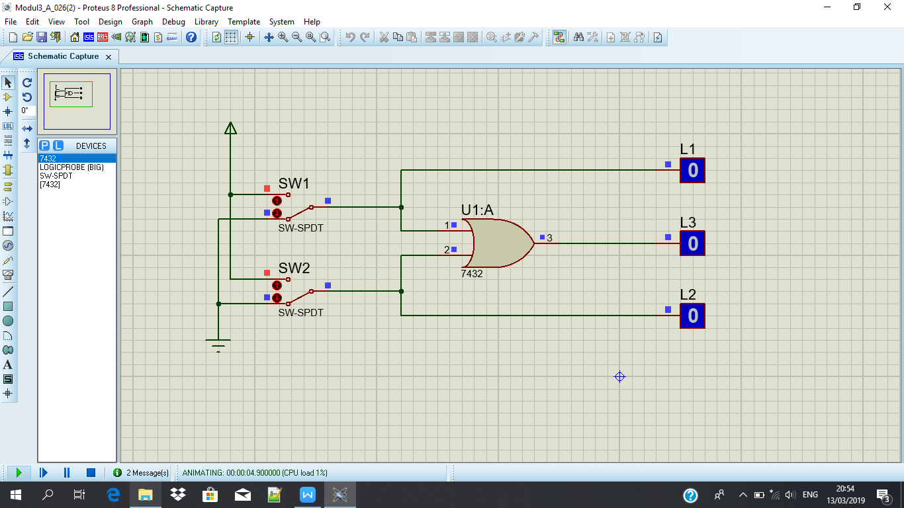

**SW1 : 1 DAN SW2 : 0**

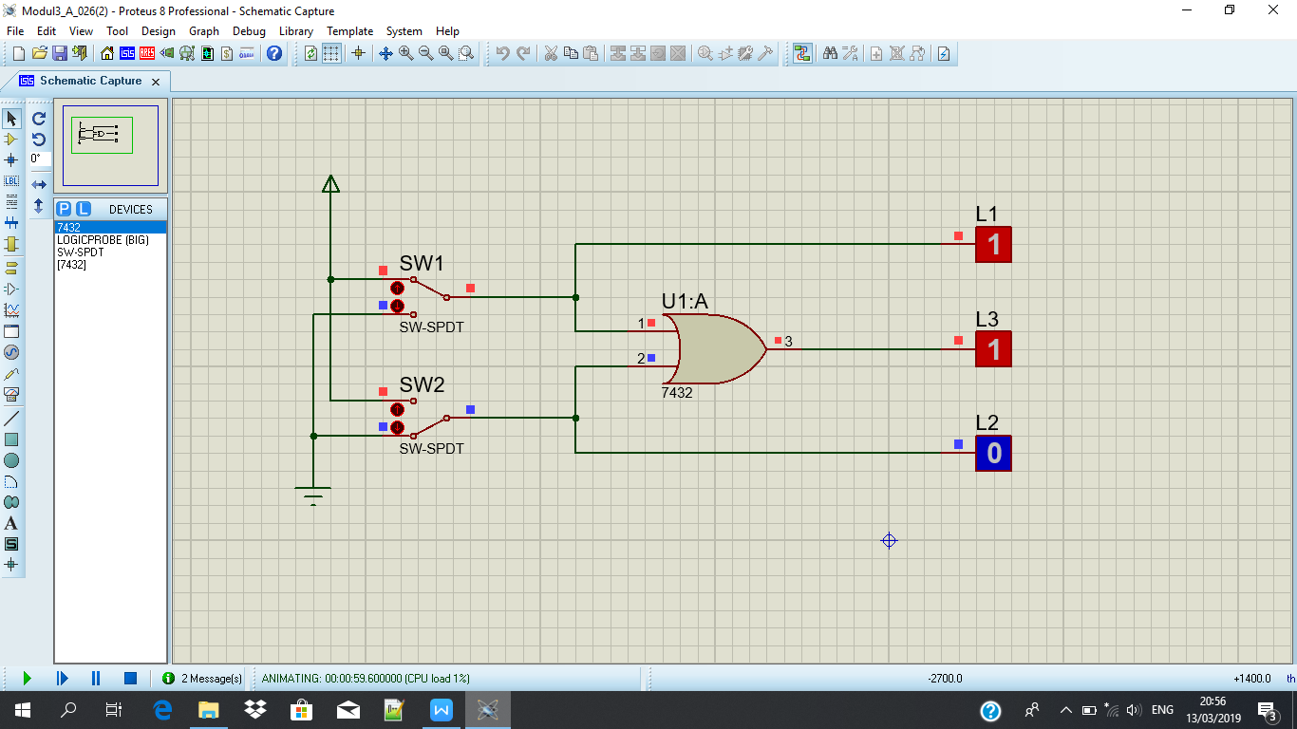

**SW 1: 0 DAN SW2: 1**

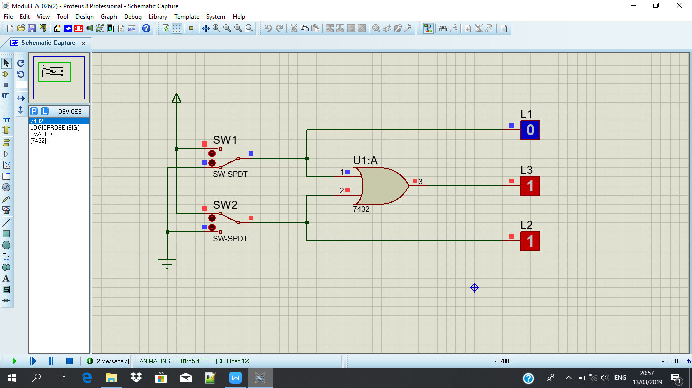

**SW1 : 1 DAN SW2: 1**

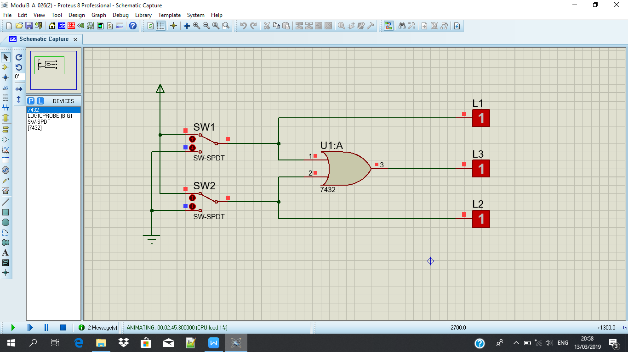

**Tabel kebenaran :**

|  |  |  |  |  |
| --- | --- | --- | --- | --- |
| **SW 1** | **SW 2** | **L1** | **L2** | **L3** |
| **0** | **0** | **0** | **0** | **0** |
| **1** | **0** | **1** | **0** | **1** |
| **0** | **1** | **0** | **1** | **1** |
| **1** | **1** | **1** | **1** | **1** |

**Diagram Waktu**

**L1 :**

|  |  |  |  |
| --- | --- | --- | --- |
|  |  |  |  |
|  |  |  |  |
|  |  |  |  |

**L2 :**

|  |  |  |  |
| --- | --- | --- | --- |
|  |  |  |  |
|  |  |  |  |
|  |  |  |  |

**L3 :**

|  |  |  |  |
| --- | --- | --- | --- |
|  |  |  |  |
|  |  |  |  |
|  |  |  |  |

* Percobaan 3 - 7**. Gerbang NOT**
* **Pecobaan 3 saat SW 1 : 0 dan percobaan 4 – 7 SW 1 : 0 dan SW 2 : 0**

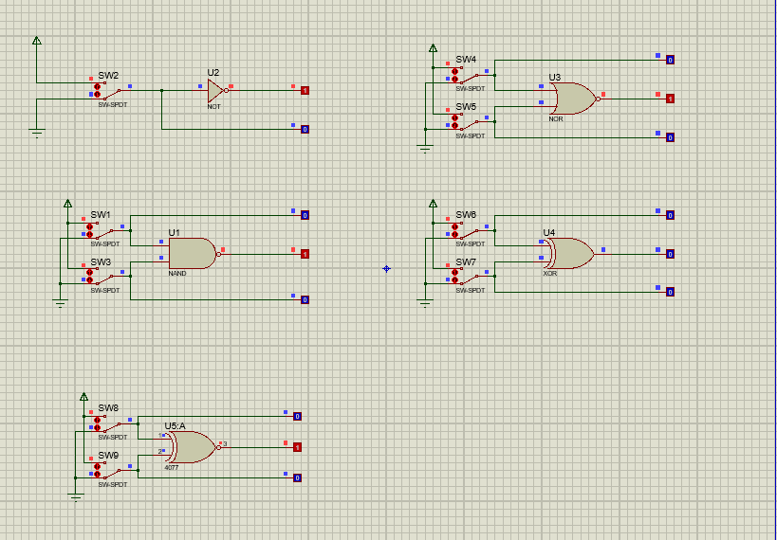

**Percobaan 4-7 SW 1 : 1 DAN SW 2: 0**

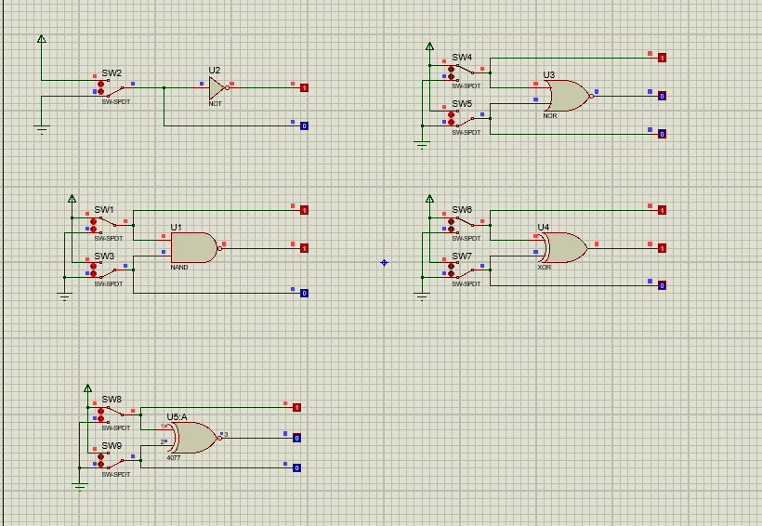

**Percobaan 4-7 saat SW 1 : 0 dan SW 2 : 1**

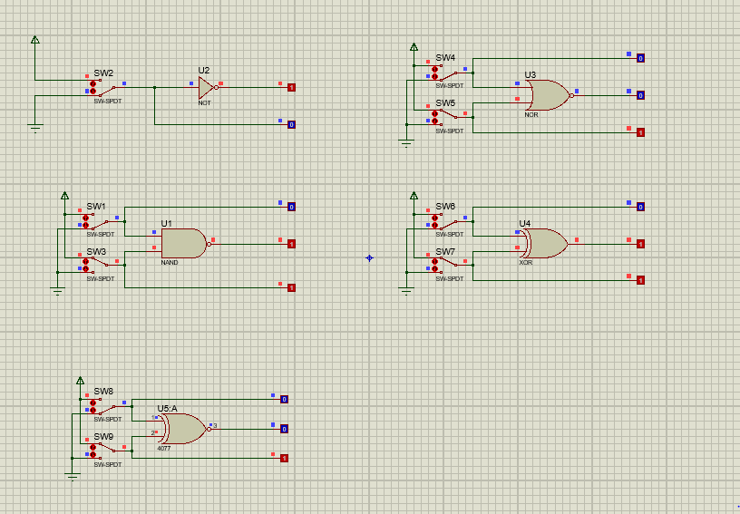

**Percobaan 4-7 saat SW 1 : 1 dan SW 2 : 1**

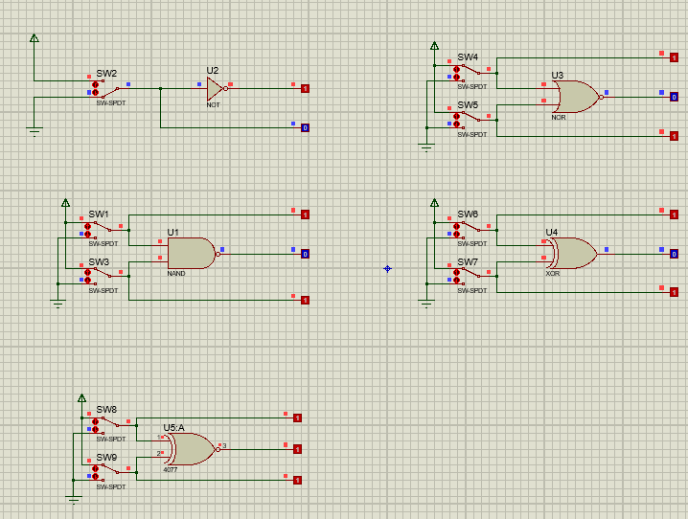

**Tabel Kebenaran percobaan 3**

|  |  |  |
| --- | --- | --- |
| **SW 1** | **L2** | **L1** |
| **0** | **0** | **1** |
| **1** | **1** | **0** |

**Diagram Waktu**

**L2 :**

|  |  |
| --- | --- |
|  |  |
|  |  |
|  |  |

**L1 :**

|  |  |
| --- | --- |
|  |  |
|  |  |
|  |  |

**Tabel Kebenaran percobaan 4**

|  |  |  |  |  |
| --- | --- | --- | --- | --- |
| **SW 1** | **SW 2** | **L1** | **L2** | **L3** |
| **0** | **0** | **0** | **0** | **1** |
| **1** | **0** | **1** | **0** | **1** |
| **0** | **1** | **0** | **1** | **1** |
| **1** | **1** | **1** | **1** | **0** |

**Diagram Waktu**

**L1 :**

|  |  |  |  |
| --- | --- | --- | --- |
|  |  |  |  |
|  |  |  |  |
|  |  |  |  |

**L2 :**

|  |  |  |  |
| --- | --- | --- | --- |
|  |  |  |  |
|  |  |  |  |
|  |  |  |  |

**L3 :**

|  |  |  |  |
| --- | --- | --- | --- |
|  |  |  |  |
|  |  |  |  |
|  |  |  |  |

**Tabel Kebenaran percobaan 5**

|  |  |  |  |  |
| --- | --- | --- | --- | --- |
| **SW 1** | **SW 2** | **L1** | **L2** | **L3** |
| **0** | **0** | **0** | **0** | **1** |
| **1** | **0** | **1** | **0** | **0** |
| **0** | **1** | **0** | **1** | **0** |
| **1** | **1** | **1** | **1** | **0** |

**Diagram Waktu**

**L1 :**

|  |  |  |  |
| --- | --- | --- | --- |
|  |  |  |  |
|  |  |  |  |
|  |  |  |  |

**L2 :**

|  |  |  |  |
| --- | --- | --- | --- |
|  |  |  |  |
|  |  |  |  |
|  |  |  |  |

**L3 :**

|  |  |  |  |
| --- | --- | --- | --- |
|  |  |  |  |
|  |  |  |  |
|  |  |  |  |

**Tabel Kebenaran percobaan 6**

|  |  |  |  |  |
| --- | --- | --- | --- | --- |
| **SW 1** | **SW 2** | **L1** | **L2** | **L3** |
| **0** | **0** | **0** | **0** | **0** |
| **1** | **0** | **1** | **0** | **1** |
| **0** | **1** | **0** | **1** | **1** |
| **1** | **1** | **1** | **1** | **0** |

**Diagram Waktu**

**L1 :**

|  |  |  |  |
| --- | --- | --- | --- |
|  |  |  |  |
|  |  |  |  |
|  |  |  |  |

**L2 :**

|  |  |  |  |
| --- | --- | --- | --- |
|  |  |  |  |
|  |  |  |  |
|  |  |  |  |

**L3 :**

|  |  |  |  |
| --- | --- | --- | --- |
|  |  |  |  |
|  |  |  |  |
|  |  |  |  |

**Tabel Kebenaran percobaan 7**

|  |  |  |  |  |
| --- | --- | --- | --- | --- |
| **SW 1** | **SW 2** | **L1** | **L2** | **L3** |
| **0** | **0** | **0** | **0** | **1** |
| **1** | **0** | **1** | **0** | **0** |
| **0** | **1** | **0** | **1** | **0** |
| **1** | **1** | **1** | **1** | **1** |

**Diagram Waktu**

**L1 :**

|  |  |  |  |
| --- | --- | --- | --- |
|  |  |  |  |
|  |  |  |  |
|  |  |  |  |

**L2 :**

|  |  |  |  |
| --- | --- | --- | --- |
|  |  |  |  |
|  |  |  |  |
|  |  |  |  |

**L3 :**

|  |  |  |  |
| --- | --- | --- | --- |
|  |  |  |  |
|  |  |  |  |
|  |  |  |  |