Nama :Tito Andika Wahyu Purwa  
NIM :L200180007  
Kelas :A

**Tugas Modul ke-1**

1. ASCII merupakan kepanjangan dari (American Standard Code for Information Interchange), dan pengertian ASCII adalah suatu standar internasional dalam kode huruf dan simbol seperti Hex dan Unicode tetapi ASCII lebih bersifat universal, contohnya 124 adalah untuk karakter "|". Ia selalu digunakan oleh komputer dan alat komunikasi lain untuk menunjukkan teks.  
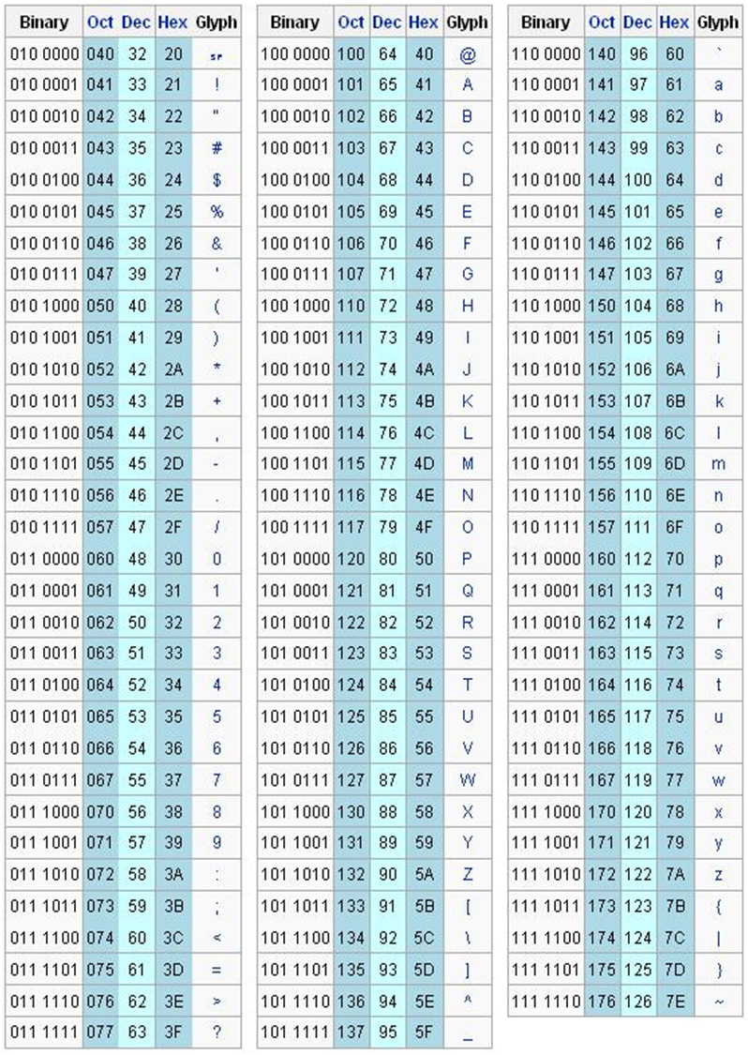

2.Daftar Assembly Directive

|  |  |
| --- | --- |
| **Assembly Directive** | **Keterangan** |
| EQU | Pendefinisian konstanta |
| DB | Pendefinisian data dengan ukuran satuan 1 byte |
| DW | Pendefinisian data dengan ukuran satuan 1 word |
| DBIT | Pendefinisian data dengan ukuran satuan 1 bit |
| DS | Pemesanan tempat penyimpanan data di RAM |
| ORG | Inisialisasi alamat mulai program |
| END | Penanda akhir program |
| CSEG | Penanda penempatan di code segment |
| XSEG | Penanda penempatan di external data segment |
| DSEG | Penanda penempatan di internal direct data segment |
| ISEG | Penanda penempatan di internal indirect data segment |
| BSEG | Penanda penempatan di bit data segment |
| CODE | Penanda mulai pendefinisian program |
| XDATA | Pendefinisian external data |
| DATA | Pendefinisian internal direct data |
| IDATA | Pendefinisian internal indirect data |
| BIT | Pendefinisian data bit |
| #INCLUDE | Mengikutsertakan file program lain |

Daftar Intruksi

|  |  |
| --- | --- |
| **Instruksi** | **Keterangan Singkatan** |
| ACALL | Absolute Call |
| ADD | Add |
| ADDC | Add with Carry |
| AJMP | Absolute Jump |
| ANL | AND Logic |
| CJNE | Compare and Jump if Not Equal |
| CLR | Clear |
| CPL | Complement |
| DA | Decimal Adjust |
| DEC | Decrement |
| DIV | Divide |
| DJNZ | Decrement and Jump if Not Zero |
| INC | Increment |
| JB | Jump if Bit Set |
| JBC | Jump if Bit Set and Clear Bit |
| JC | Jump if Carry Set |
| JMP | Jump to Address |
| JNB | Jump if Not Bit Set |
| JNC | Jump if Carry Not Set |
| JNZ | Jump if Accumulator Not Zero |
| JZ | Jump if Accumulator Zero |
| LCALL | Long Call |
| LJMP | Long Jump |
| MOV | Move from Memory |
| MOVC | Move from Code Memory |
| MOVX | Move from Extended Memory |
| MUL | Multiply |
| NOP | No Operation |
| ORL | OR Logic |
| POP | Pop Value From Stack |
| PUSH | Push Value Onto Stack |
| RET | Return From Subroutine |
| RETI | Return From Interrupt |
| RL | Rotate Left |
| RLC | Rotate Left through Carry |
| RR | Rotate Right |
| RRC | Rotate Right through Carry |
| SETB | Set Bit |
| SJMP | Short Jump |
| SUBB | Subtract With Borrow |
| SWAP | Swap Nibbles |
| XCH | Exchange Bytes |
| XCHD | Exchange Digits |
| XRL | Exclusive OR Logic |