NIM :L200180007 Nilai Praktek :  
Nama : Tito Andika Wahyu Purwa  
Nama Asisten :Riza   
Tanggal Praktikum : 13 Maret 2019 Tanda Tangan :  
  
KEGIATAN PRAKTIKUM  
 percobaan 1.Gerbang AND  
1.Membuat rangkaian gambar 3.2  
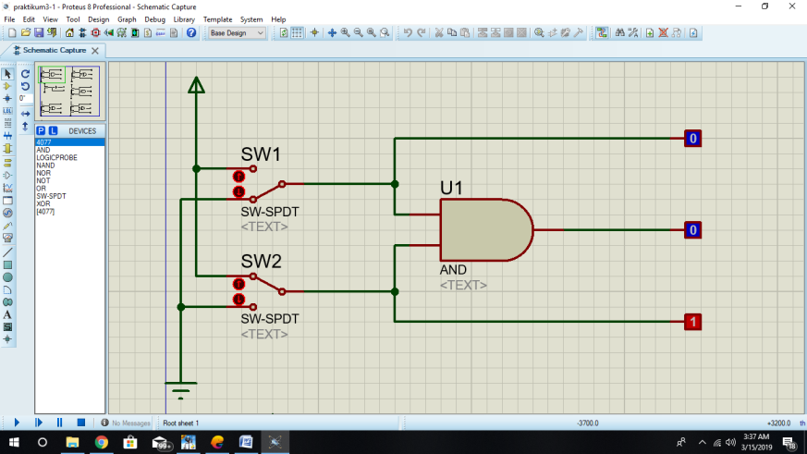  
2.Fungsi Boolean : L3=L1 L2 atau L3=L1.L2  
3.Tabel kebenaran

|  |  |  |  |  |
| --- | --- | --- | --- | --- |
| Sw1 | Sw2 | L1 | L2 | L3 |
| 0 | 0 | 0 | 0 | 0 |
| 1 | 0 | 1 | 0 | 0 |
| 0 | 1 | 0 | 1 | 0 |
| 1 | 1 | 1 | 1 | 1 |

4.Diagram waktu  
 L1 0 1 0 1  
 L2 0 0 1 1  
 L3 0 0 0 1

Percobaan 3.Gerbang OR  
1.Membuat rangkaian gambar 3.3  
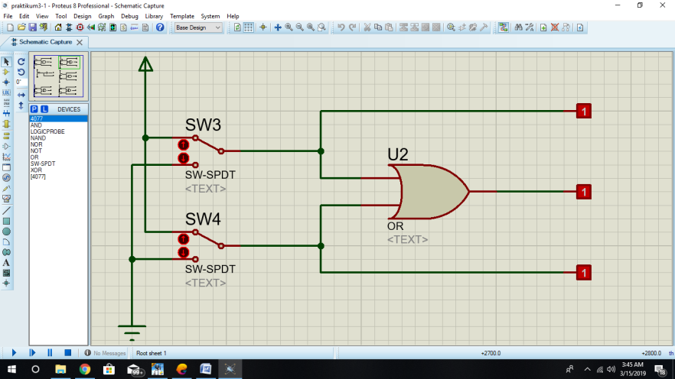  
2. Fungsi Boolean : L3=L1+L2  
3.Tabel kebenaran

|  |  |  |  |  |
| --- | --- | --- | --- | --- |
| Sw1 | Sw2 | L1 | L2 | L3 |
| 0 | 0 | 0 | 0 | 0 |
| 1 | 0 | 1 | 0 | 1 |
| 0 | 1 | 0 | 1 | 1 |
| 1 | 1 | 1 | 1 | 1 |

4.Diagram waktu  
 L1 0 1 0 1  
 L2 0 0 1 1  
 L3 0 1 1 1

Percobaan 3.Gerbang NOT  
1.Membuat rangkaian gambar 3.4  
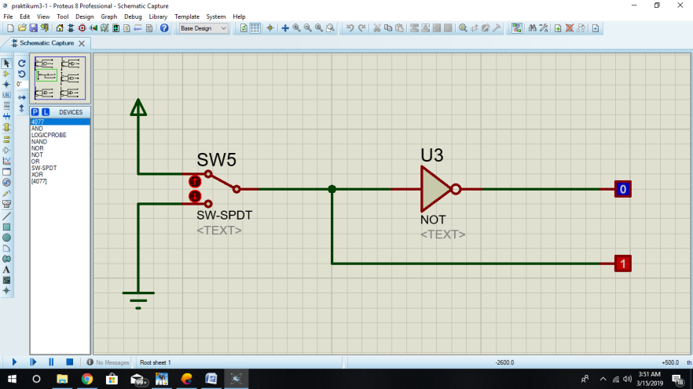  
2.Fungsi Boolean : L1=~L2 atau L1=L2  
3.Tabel kebenaran

|  |  |  |
| --- | --- | --- |
| Sw1 | L2 | L1 |
| 0 | 0 | 1 |
| 1 | 1 | 0 |

4.Diagram Waktu  
 L2 0 1  
 L1 1 0

Percobaan 4.Gerbang NAND  
1.Membuat rangkaian gambar 3.5  
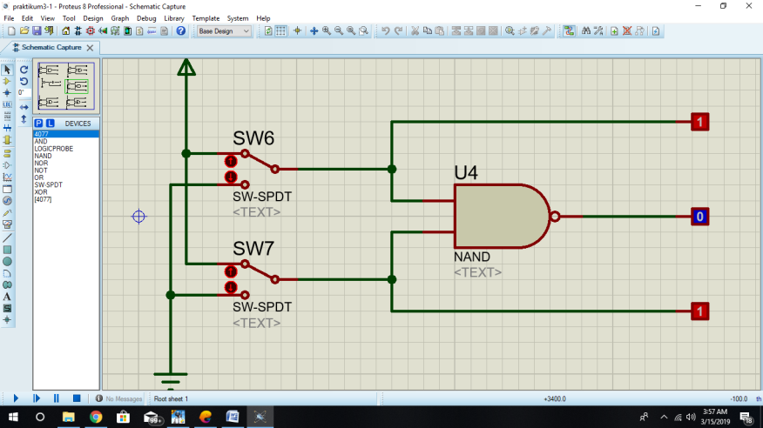  
2.Fungsi Boolean : L3 = L1 L2 atau L3= L1.L2  
3.Tabel Kebenaran

|  |  |  |  |  |
| --- | --- | --- | --- | --- |
| Sw1 | Sw2 | L1 | L2 | L3 |
| 0 | 0 | 0 | 0 | 1 |
| 1 | 0 | 1 | 0 | 1 |
| 0 | 1 | 0 | 1 | 1 |
| 1 | 1 | 1 | 1 | 0 |

4.Diagram waktu  
 L1 0 1 0 1  
 L2 0 0 1 1  
 L3 1 1 1 0

Percobaan 5.Gerbang NOR  
1.Membuat rangkaian gambar 3.6  
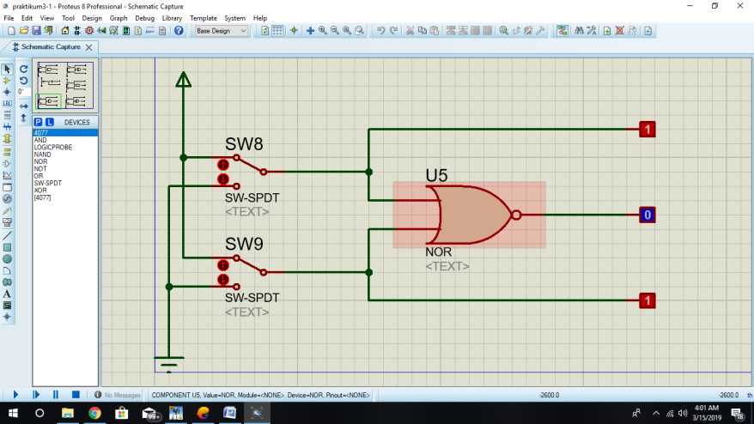  
2.Fungsi Boolean : L3 = L1+L2  
3.Tabel Kebenaran

|  |  |  |  |  |
| --- | --- | --- | --- | --- |
| Sw1 | Sw2 | L1 | L2 | L3 |
| 0 | 0 | 0 | 0 | 1 |
| 1 | 0 | 1 | 0 | 0 |
| 0 | 1 | 0 | 1 | 0 |
| 1 | 1 | 1 | 1 | 0 |

4.Diagram waktu  
 L1 0 1 0 1  
 L2 0 0 1 1  
 L3 1 0 0 0

Percobaan 6.Gerbang XOR  
1.Membuat rangkaian gambar 3.7  
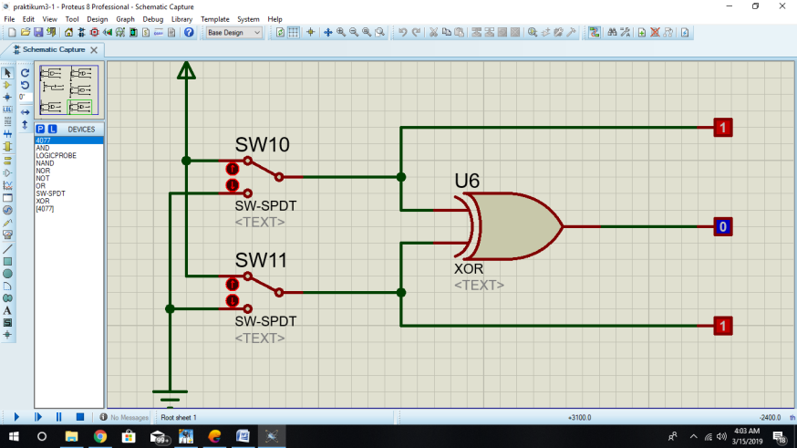  
2.Fungsi Boolean : L3 = L1+L2  
3.Tabel Kebenaran

|  |  |  |  |  |
| --- | --- | --- | --- | --- |
| Sw1 | Sw2 | L1 | L2 | L3 |
| 0 | 0 | 0 | 0 | 0 |
| 1 | 0 | 1 | 0 | 1 |
| 0 | 1 | 0 | 1 | 1 |
| 1 | 1 | 1 | 1 | 0 |

4.Diagram waktu  
 L1 0 1 0 1  
 L2 0 0 1 1  
 L3 0 1 1 0

Percobaan 7.Gerbang XNOR  
1.Membuat rangkaian gambar 3.8  
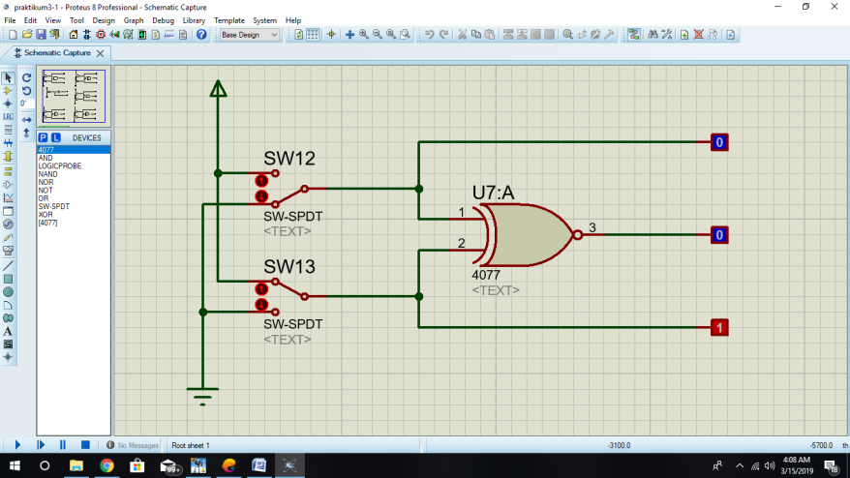  
2.Fungsi Boolean : L3 = L1+L2  
3.Tabel Kebenaran

|  |  |  |  |  |
| --- | --- | --- | --- | --- |
| Sw1 | Sw2 | L1 | L2 | L3 |
| 0 | 0 | 0 | 0 | 1 |
| 1 | 0 | 1 | 0 | 0 |
| 0 | 1 | 0 | 1 | 0 |
| 1 | 1 | 1 | 1 | 1 |

4.Diagram waktu  
 L1 0 1 0 1  
 L2 0 0 1 1  
 L3 1 0 0 1