LAPORAN PRAKTIKUM SISTEM DIGITAL

NAMA : RIFQI ALWAN PRAMASANDY

NIM : L200180008

KELAS : A

**Percobaan 1. Gerbang AND**

**SW 1 : 0 dan SW 2: 0**

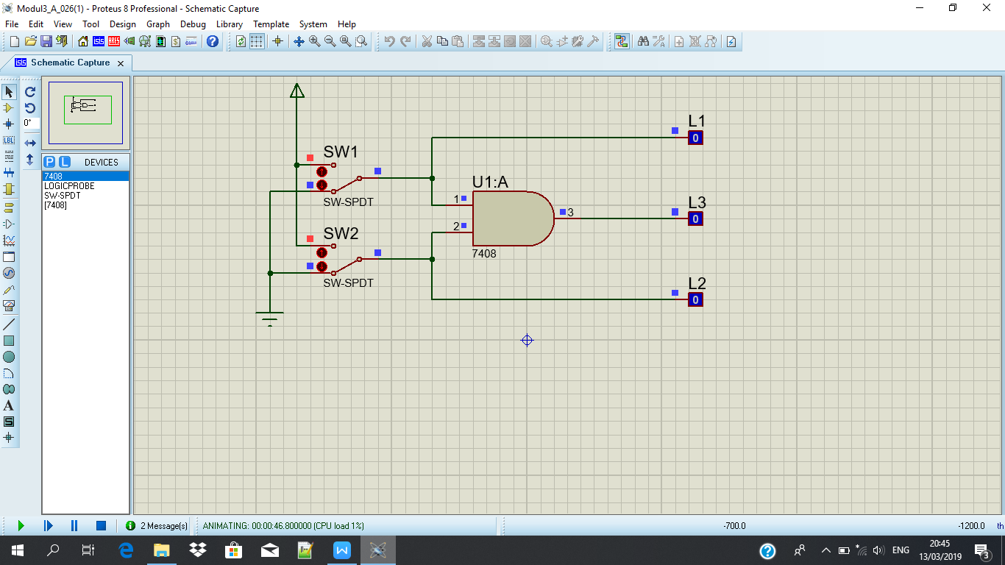

**SW 1 : 1 DAN SW 2: 0**

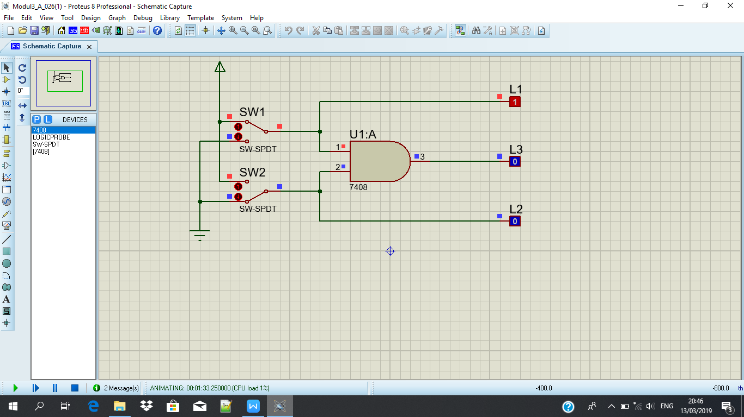

**SW 1 : 0 DAN SW 2 : 1**

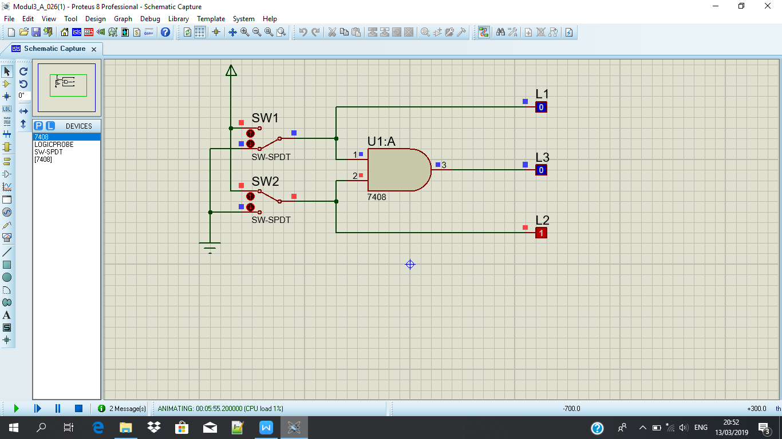

**SW 1: 1 DAN SW2: 1**

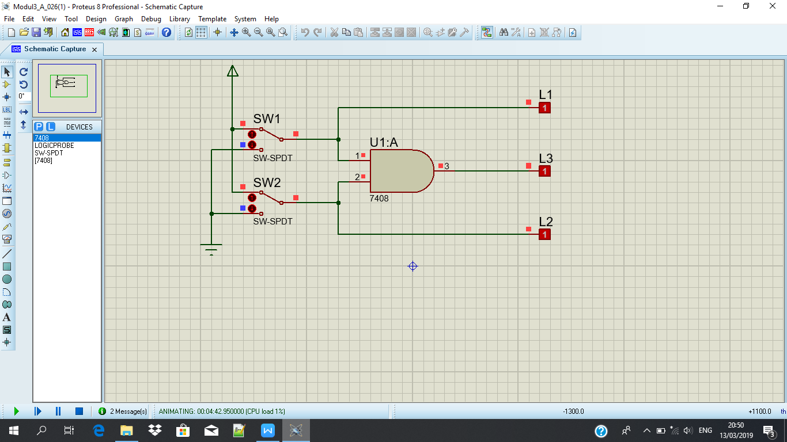

**Tabel kebenaran**

|  |  |  |  |  |
| --- | --- | --- | --- | --- |
| **SW 1** | **SW 2** | **L1** | **L2** | **L3** |
| **0** | **0** | **0** | **0** | **0** |
| **1** | **0** | **1** | **0** | **0** |
| **0** | **1** | **0** | **1** | **0** |
| **1** | **1** | **1** | **1** | **1** |

**Diagram Waktu**

**L1 :**

|  |  |  |  |
| --- | --- | --- | --- |
|  |  |  |  |
|  |  |  |  |
|  | |  |  |

**L2 :**

|  |  |  |  |
| --- | --- | --- | --- |
|  |  |  |  |
|  |  |  |  |
|  |  |  |  |

**L3 :**

|  |  |  |  |
| --- | --- | --- | --- |
|  |  |  |  |
|  |  |  |  |
|  |  |  |  |

**Percobaan 2. Gerbang OR**

**SW 1 : 0 DAN SW 2 : 0**

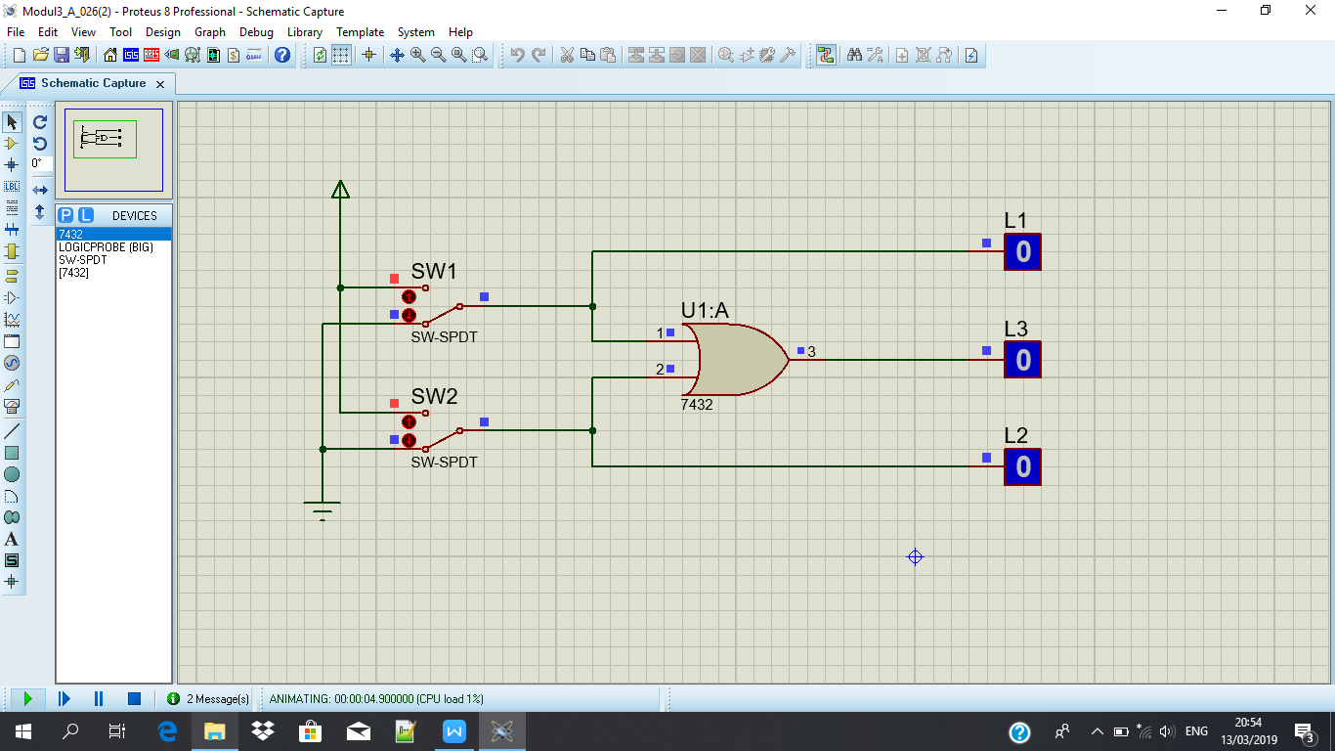

**SW1 : 1 DAN SW2 : 0**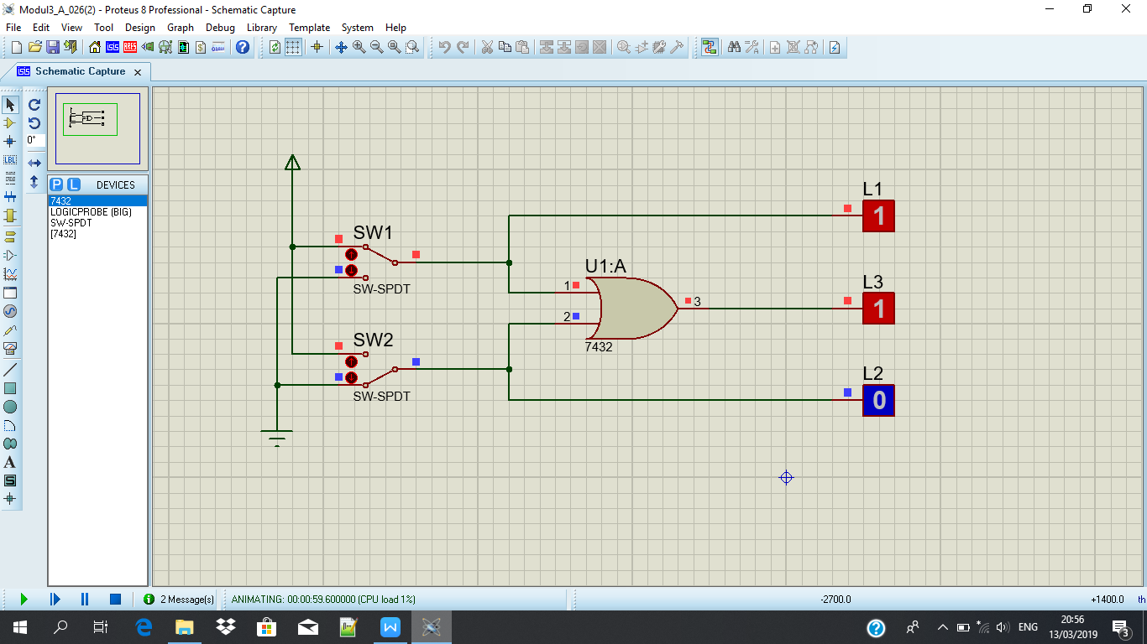

**SW 1: 0 DAN SW2: 1**

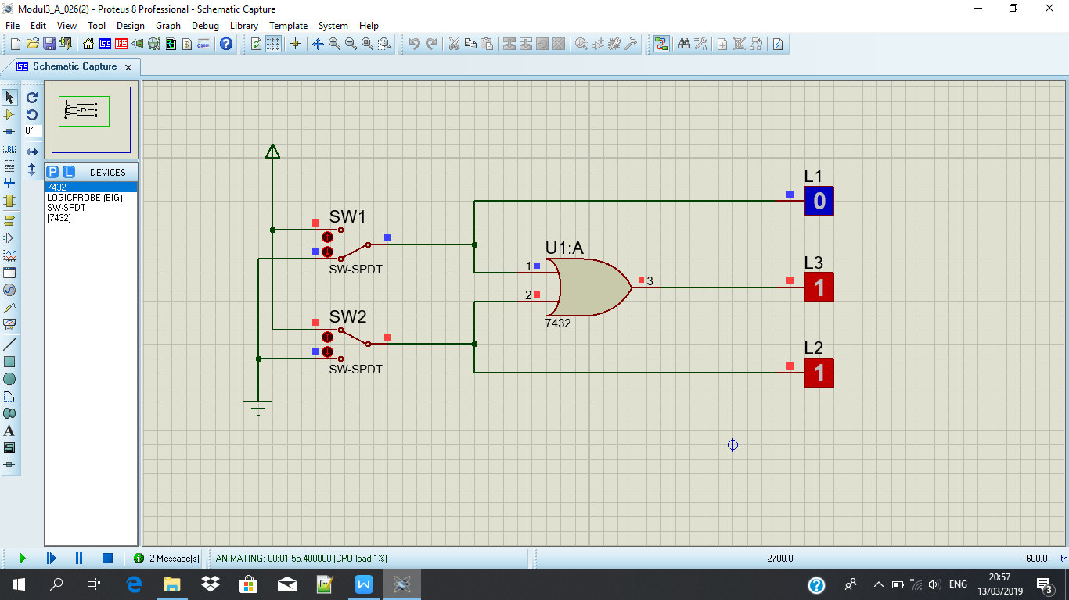

**SW1 : 1 DAN SW2: 1**

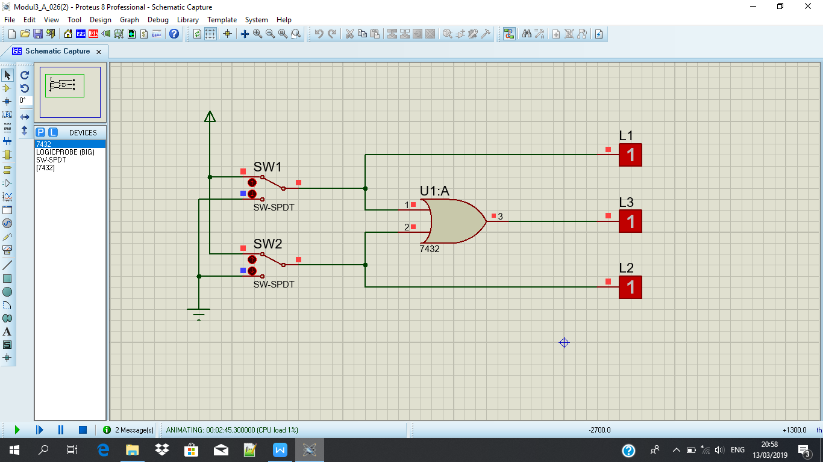

**Tabel kebenaran :**

|  |  |  |  |  |
| --- | --- | --- | --- | --- |
| **SW 1** | **SW 2** | **L1** | **L2** | **L3** |
| **0** | **0** | **0** | **0** | **0** |
| **1** | **0** | **1** | **0** | **1** |
| **0** | **1** | **0** | **1** | **1** |
| **1** | **1** | **1** | **1** | **1** |

**Diagram Waktu**

**L1 :**

|  |  |  |  |
| --- | --- | --- | --- |
|  |  |  |  |
|  |  |  |  |
|  |  |  |  |

**L2 :**

|  |  |  |  |
| --- | --- | --- | --- |
|  |  |  |  |
|  |  |  |  |
|  |  |  |  |

**L3 :**

|  |  |  |  |
| --- | --- | --- | --- |
|  |  |  |  |
|  |  |  |  |
|  |  |  |  |

**Percobaan 3. Gerbang NOT**

**SW 1 : 0 DAN SW 2 : 0**

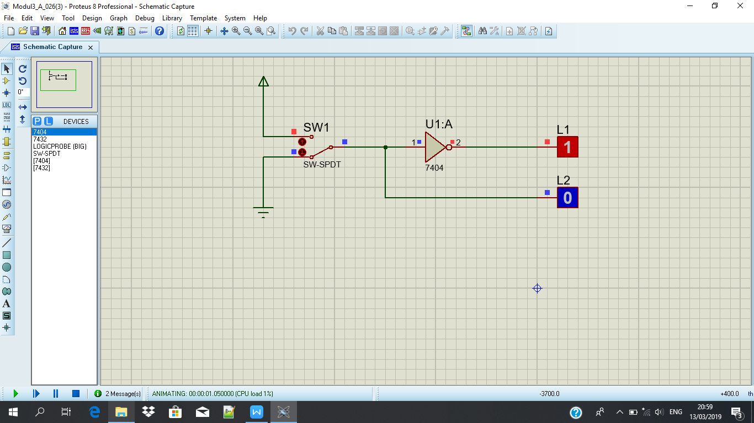

**SW 1 : 1 DAN SW 2: 0**

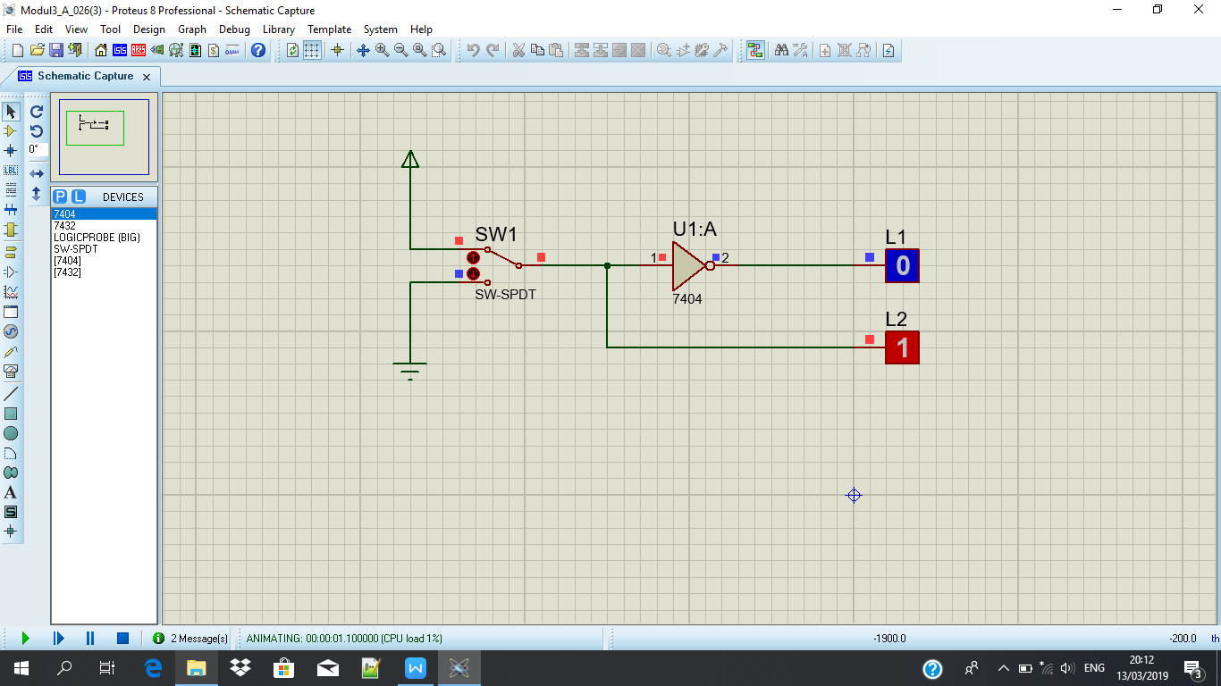

**Tabel Kebenaran**

|  |  |  |
| --- | --- | --- |
| **SW 1** | **L2** | **L1** |
| **0** | **0** | **1** |
| **1** | **1** | **0** |

**Diagram Waktu**

**L2 :**

|  |  |
| --- | --- |
|  |  |
|  |  |
|  |  |

**L1 :**

|  |  |
| --- | --- |
|  |  |
|  |  |
|  |  |

**Percobaan 4. Gerbang NAND**

**SW 1: 0 DAN SW 2: 0**

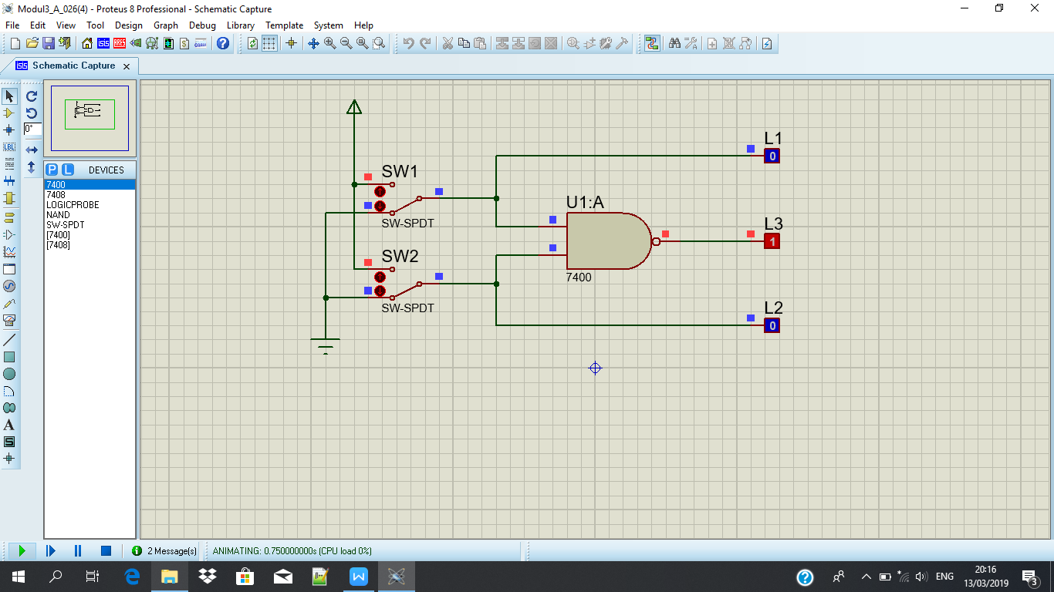

**SW 1: 1 DAN SW 2:0**

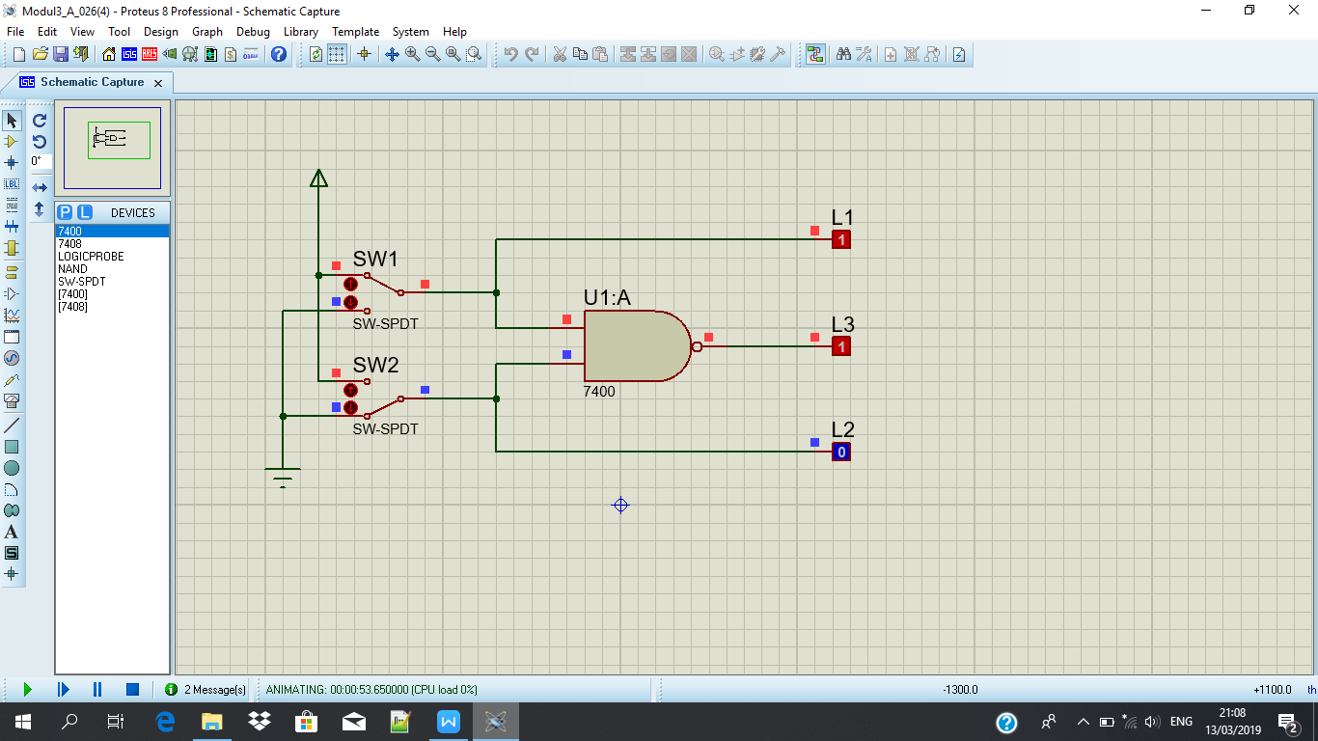

**SW 1: 0 DAN SW 2: 1**

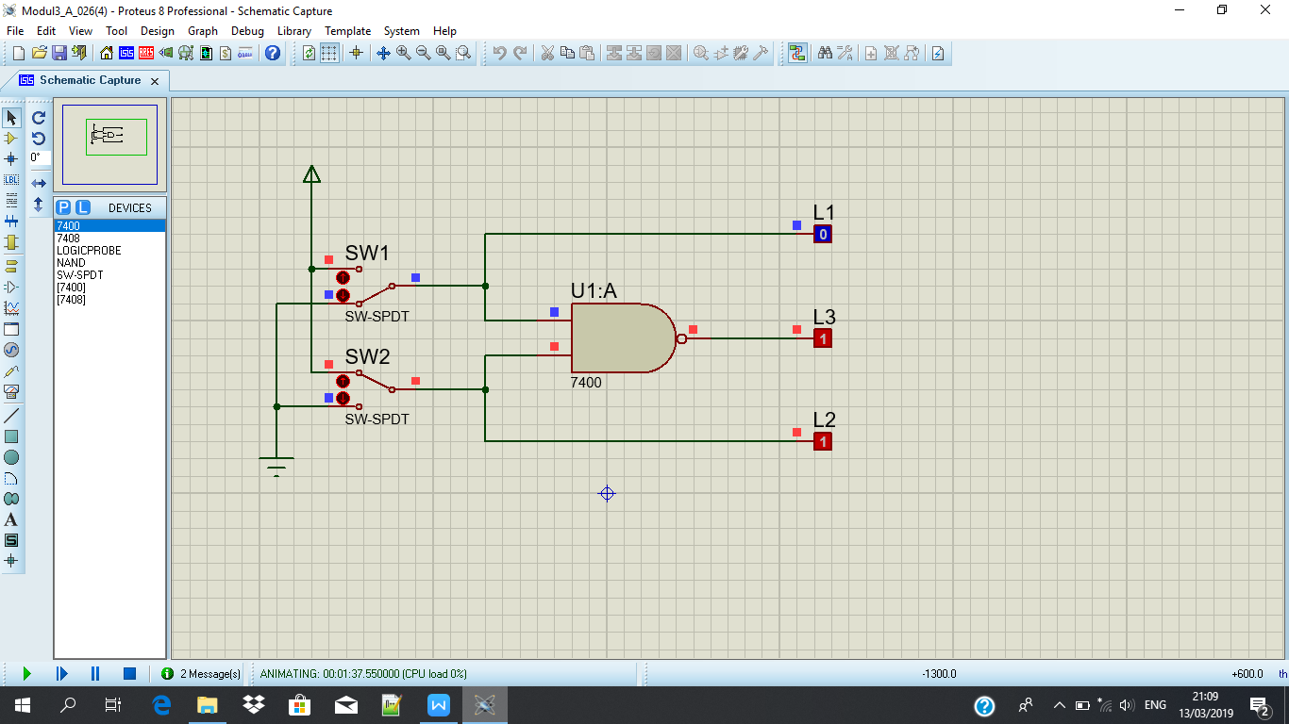

**SW 1: 1 DAN SW 2: 1**

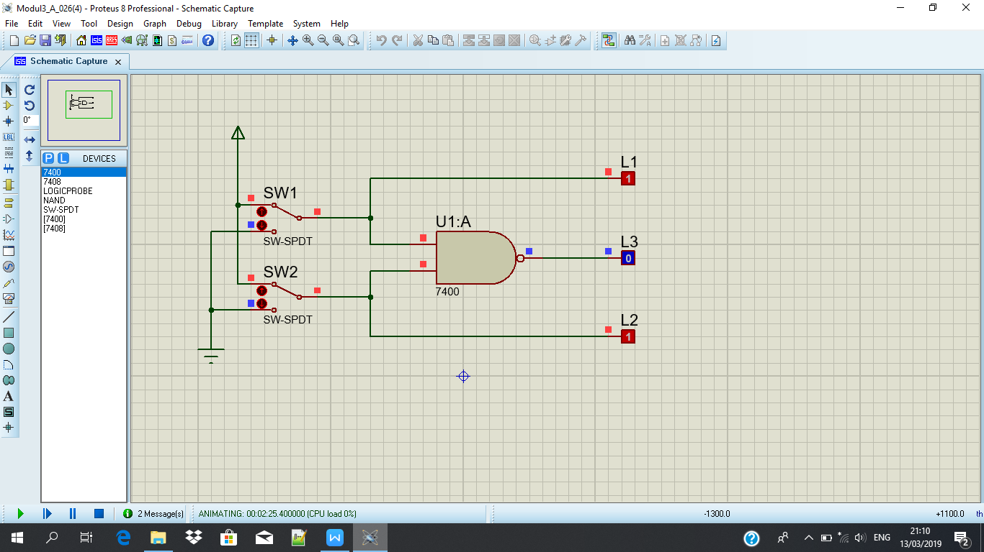

**Tabel Kebenaran**

|  |  |  |  |  |
| --- | --- | --- | --- | --- |
| **SW 1** | **SW 2** | **L1** | **L2** | **L3** |
| **0** | **0** | **0** | **0** | **1** |
| **1** | **0** | **1** | **0** | **1** |
| **0** | **1** | **0** | **1** | **1** |
| **1** | **1** | **1** | **1** | **0** |

**Diagram Waktu**

**L1 :**

|  |  |  |  |
| --- | --- | --- | --- |
|  |  |  |  |
|  |  |  |  |
|  |  |  |  |

**L2 :**

|  |  |  |  |
| --- | --- | --- | --- |
|  |  |  |  |
|  |  |  |  |
|  |  |  |  |

**L3 :**

|  |  |  |  |
| --- | --- | --- | --- |
|  |  |  |  |
|  |  |  |  |
|  |  |  |  |

**Percobaan 5. Gerbang NOR**

**SW 1: 0 DAN SW 2: 0**

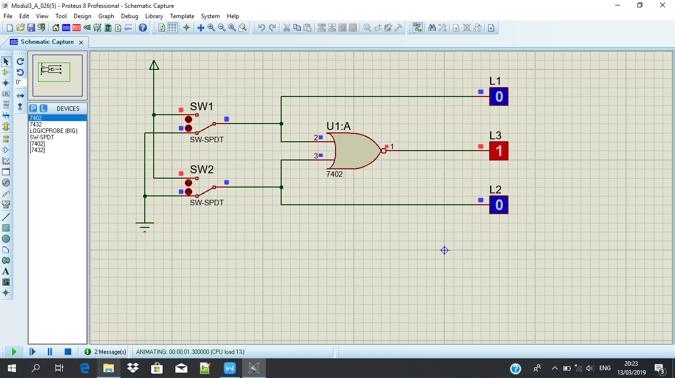

**SW 1: 1 DAN SW2 : 0**

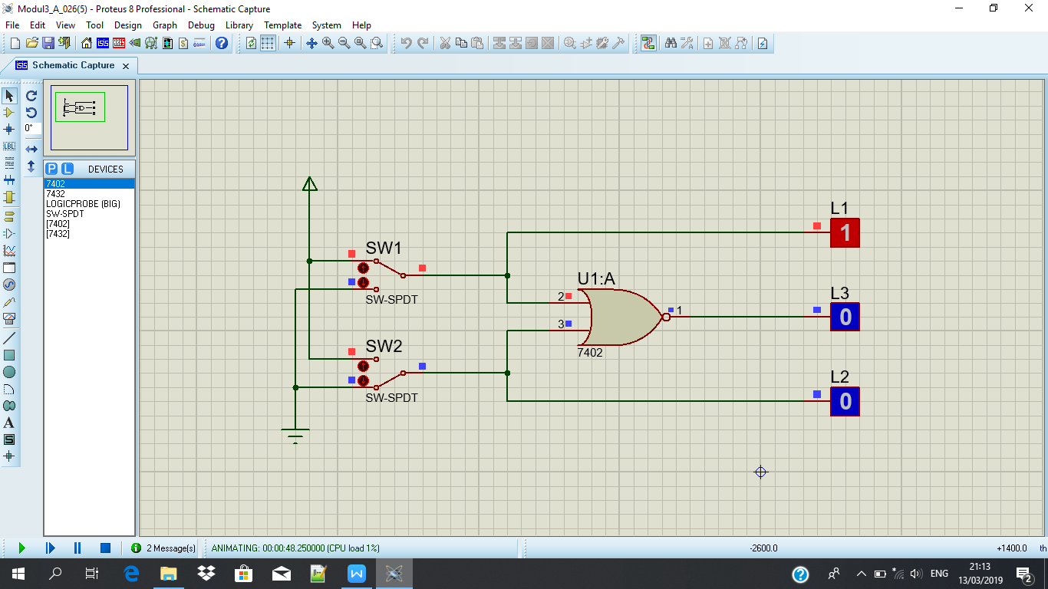

**SW 1: 0 DAN SW 2: 1**

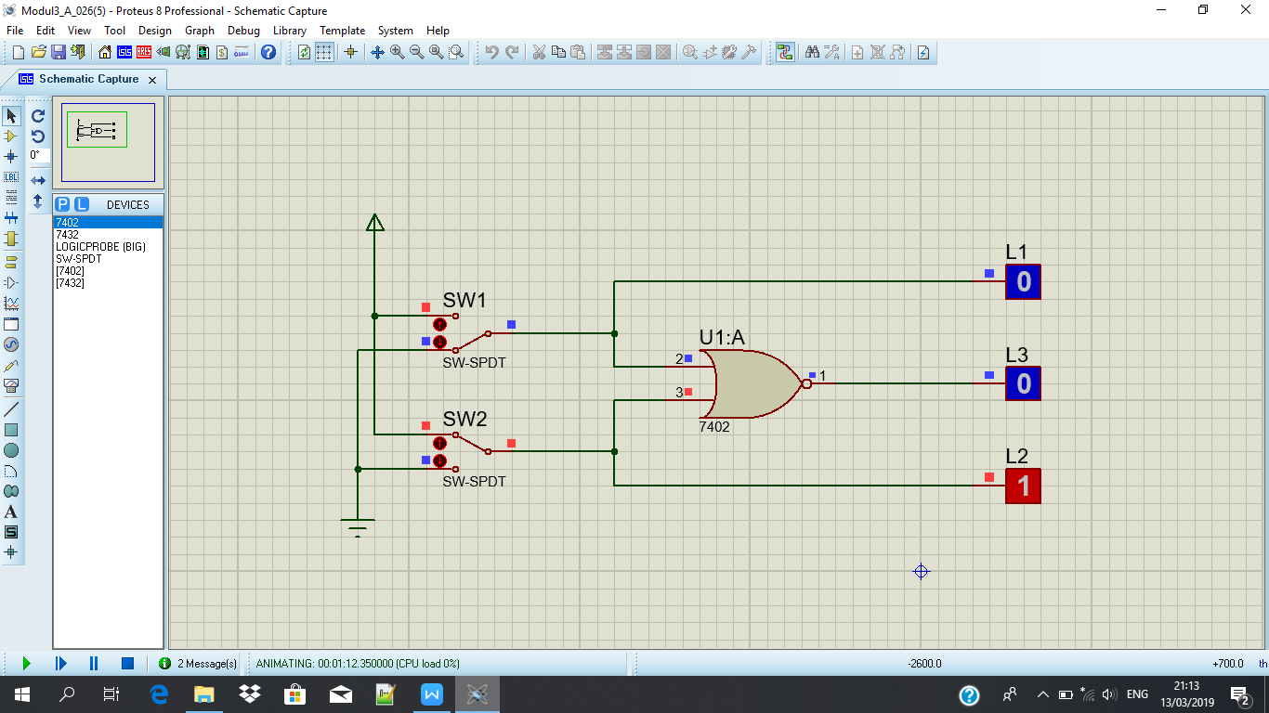

**SW 1: 1 DAN SW 2: 1**

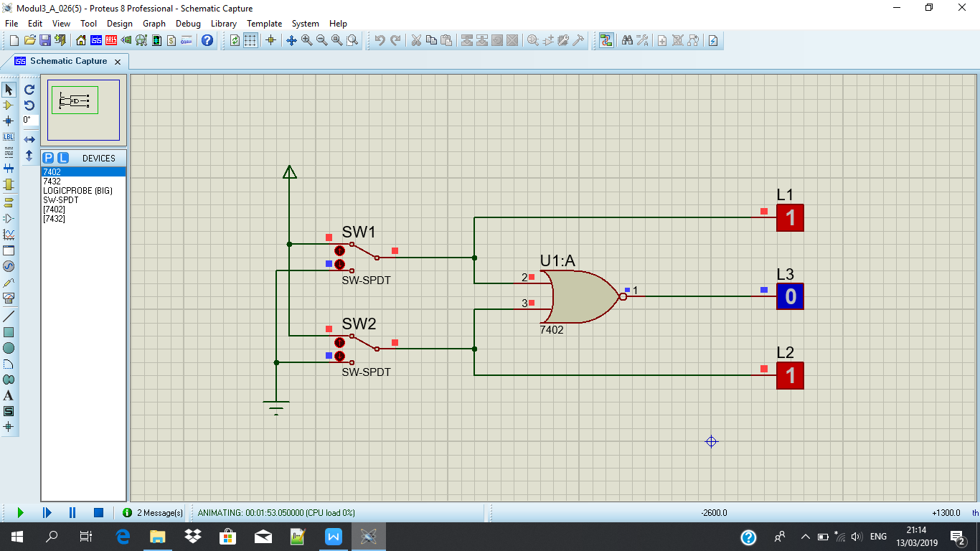

**Tabel Kebenaran**

|  |  |  |  |  |
| --- | --- | --- | --- | --- |
| **SW 1** | **SW 2** | **L1** | **L2** | **L3** |
| **0** | **0** | **0** | **0** | **1** |
| **1** | **0** | **1** | **0** | **0** |
| **0** | **1** | **0** | **1** | **0** |
| **1** | **1** | **1** | **1** | **0** |

**Diagram Waktu**

**L1 :**

|  |  |  |  |
| --- | --- | --- | --- |
|  |  |  |  |
|  |  |  |  |
|  |  |  |  |

**L2 :**

|  |  |  |  |
| --- | --- | --- | --- |
|  |  |  |  |
|  |  |  |  |
|  |  |  |  |

**L3 :**

|  |  |  |  |
| --- | --- | --- | --- |
|  |  |  |  |
|  |  |  |  |
|  |  |  |  |

**Percobaan 6. Gerbang XOR**

**SW 1: 0 DAN SW 2: 0**

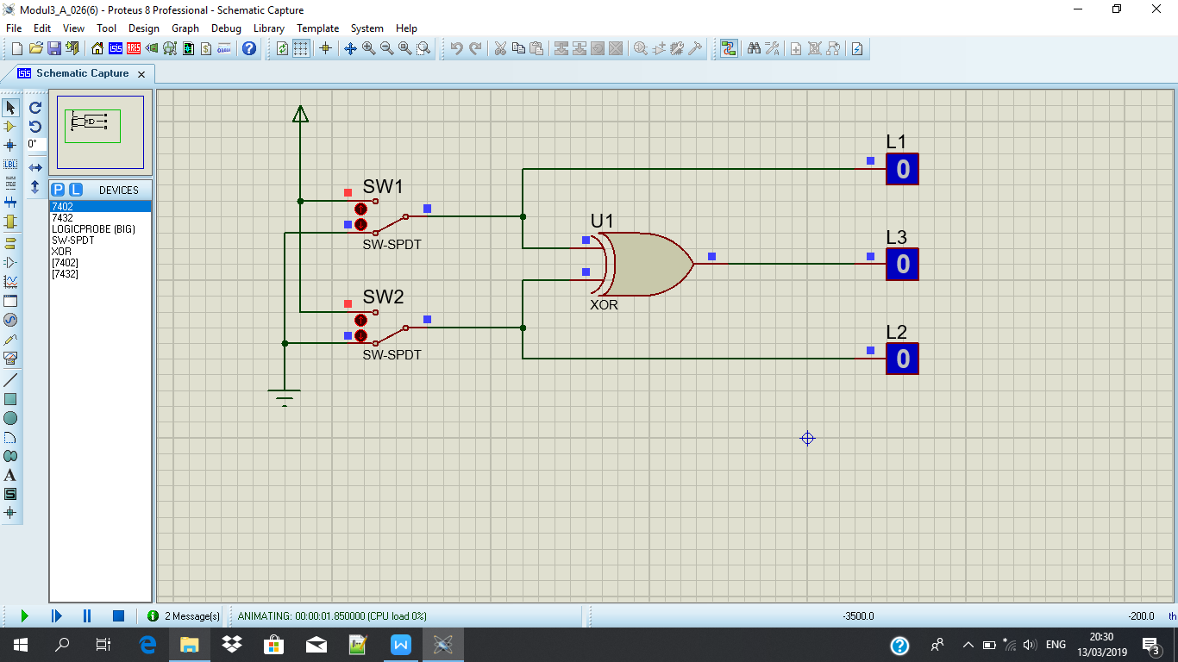

**SW 1 : 1 DAN SW 2: 0**

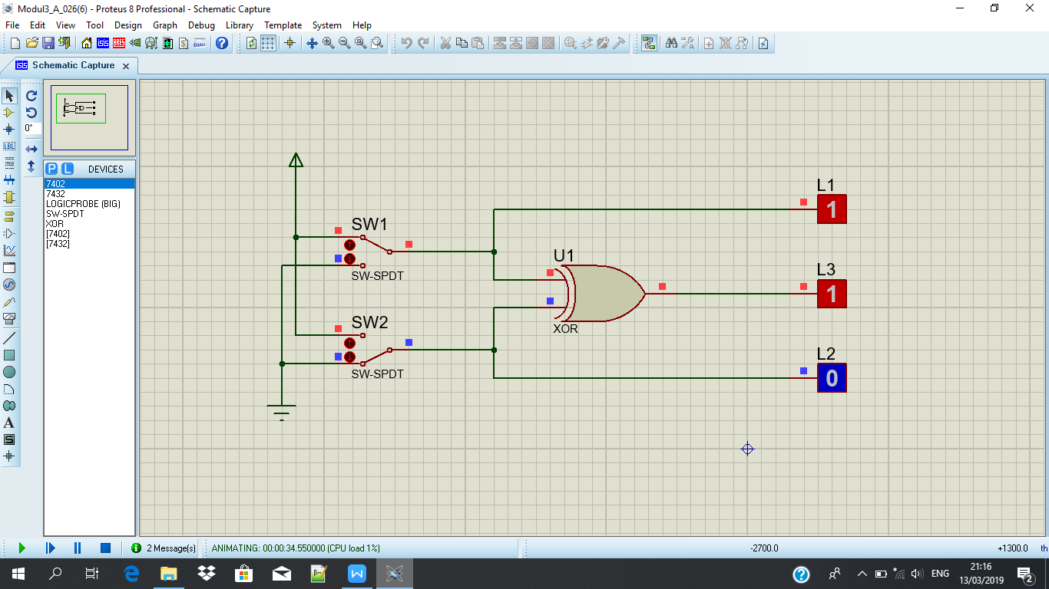

**SW 1: 0 DAN SW 2: 1**

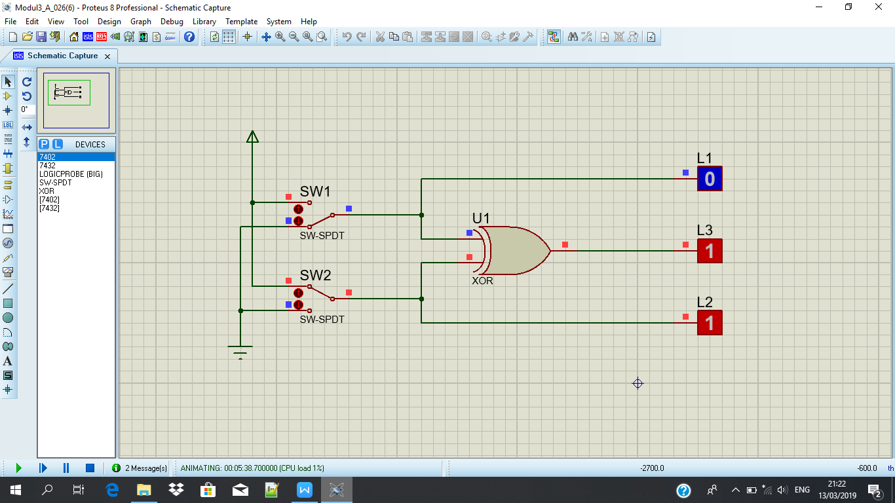

**SW 1 : 1 DAN SW 2: 1**

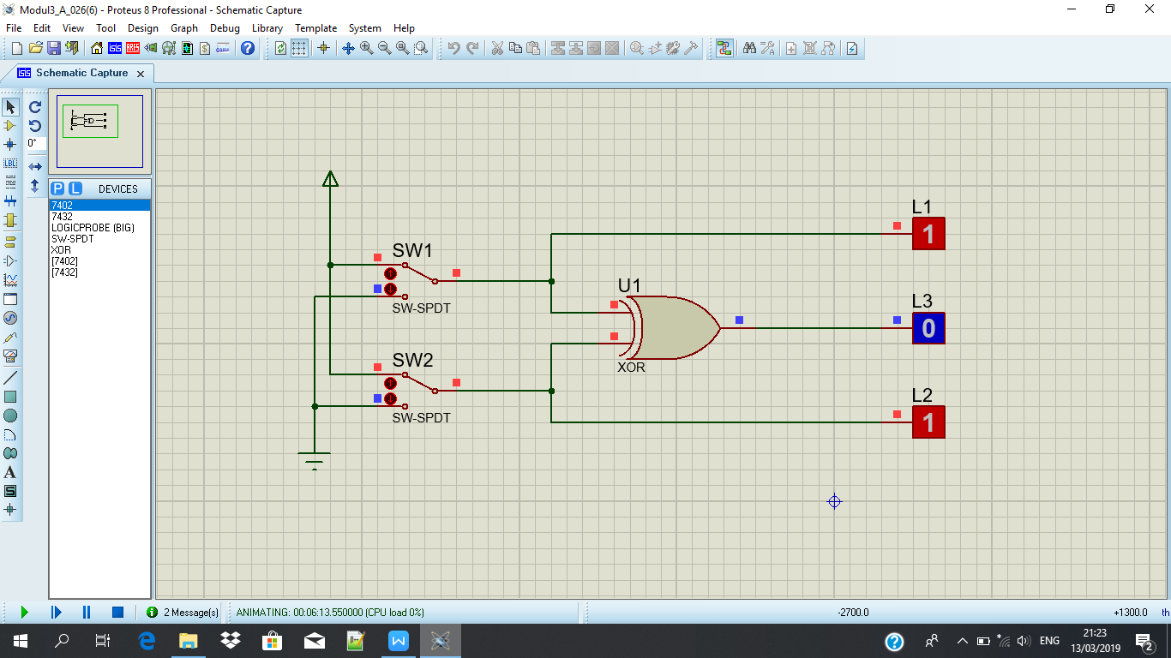

**Tabel Kebenaran**

|  |  |  |  |  |
| --- | --- | --- | --- | --- |
| **SW 1** | **SW 2** | **L1** | **L2** | **L3** |
| **0** | **0** | **0** | **0** | **0** |
| **1** | **0** | **1** | **0** | **1** |
| **0** | **1** | **0** | **1** | **1** |
| **1** | **1** | **1** | **1** | **0** |

**Diagram Waktu**

**L1 :**

|  |  |  |  |
| --- | --- | --- | --- |
|  |  |  |  |
|  |  |  |  |
|  |  |  |  |

**L2 :**

|  |  |  |  |
| --- | --- | --- | --- |
|  |  |  |  |
|  |  |  |  |
|  |  |  |  |

**L3 :**

|  |  |  |  |
| --- | --- | --- | --- |
|  |  |  |  |
|  |  |  |  |
|  |  |  |  |

**Percobaan 7. Gerbang XNOR**

**SW 1 : 0 DAN SW 2: 0**

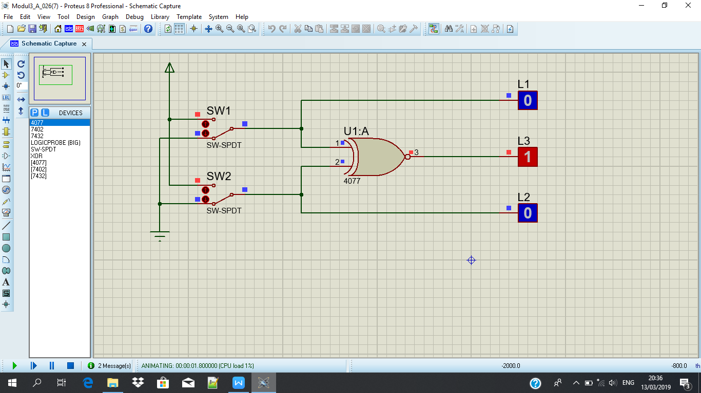

**SW 1 : 1 DAN SW 2: 0**

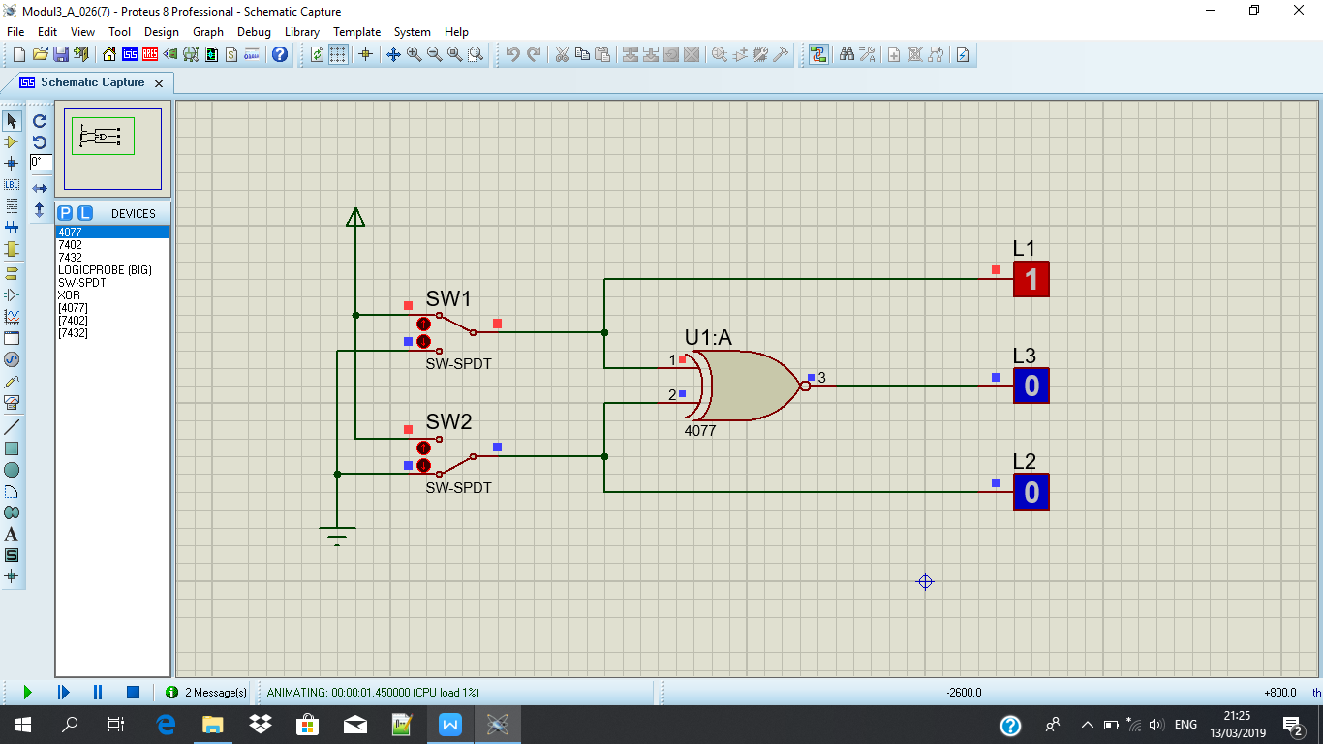

**SW 1 : 0 DAN SW 2: 1**

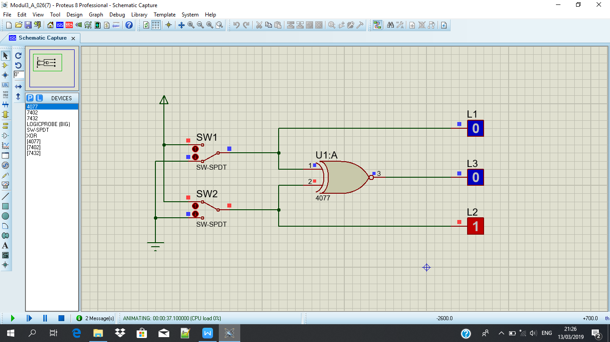

**SW 1 : 1 DAN SW 2: 1**

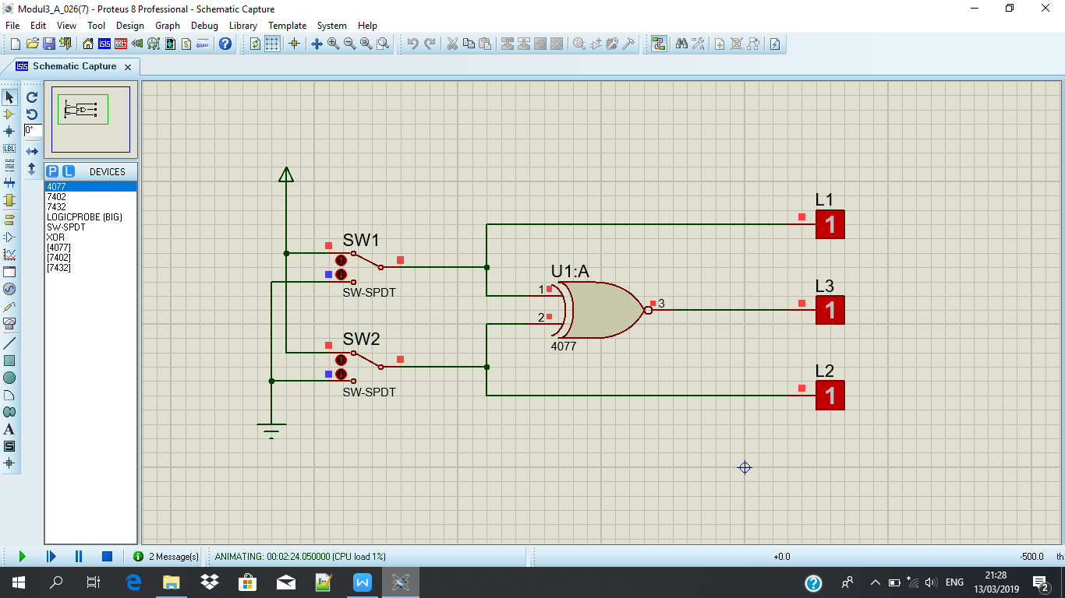

**Tabel Kebenaran**

|  |  |  |  |  |
| --- | --- | --- | --- | --- |
| **SW 1** | **SW 2** | **L1** | **L2** | **L3** |
| **0** | **0** | **0** | **0** | **1** |
| **1** | **0** | **1** | **0** | **0** |
| **0** | **1** | **0** | **1** | **0** |
| **1** | **1** | **1** | **1** | **1** |

**Diagram Waktu**

**L1 :**

|  |  |  |  |
| --- | --- | --- | --- |
|  |  |  |  |
|  |  |  |  |
|  |  |  |  |

**L2 :**

|  |  |  |  |
| --- | --- | --- | --- |
|  |  |  |  |
|  |  |  |  |
|  |  |  |  |

**L3 :**

|  |  |  |  |
| --- | --- | --- | --- |
|  |  |  |  |
|  |  |  |  |
|  |  |  |  |