Nama : Muhammad Mahatma Rosyid Habibilah

Nim : L200180024

# Kegiatan Praktikum

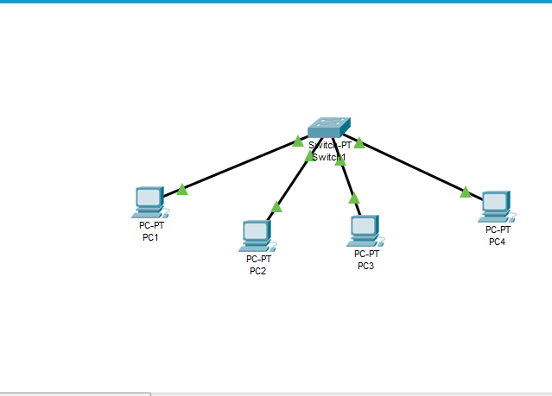Kegiatan 1. Desain dan Konfigurasi Subnetting

Melakukan pengaturan alamat IP pada masig-masing pc dengan mengikuti ketentuan berikut ini :

|  |  |  |
| --- | --- | --- |
| PC | IP address | Subnet Mask |
| 1 | 201.222.5.1 | 255.255.255.48 |
| 2 | 201.222.5.2 |
| 3 | 201.222.5.9 |
| 4 | 201.222.5.10 |



Top

DHCP

201.ZZZ. E.2

201.ZZZ. E.2

DHCP

FE80::201:C9FF:FEE1:B66A

802.1X

@ Use 802.1X Security











 







Top

DHCP

201.222.E.1

0.0.0 0

DHCP

FE80 :2E0:FFF:FE93:E2CE

B02.1X

@ U se 802.1X Security



Top

DMCP

201.ZZ2. E .1 0

Subnet II a sk

0. 0. 0. 0

0. 0. 0. 0

DMCP

Ffi BO ::260:2FFF: Ffi B6:A6D9

802.1X

@ U se 802.1X Security



Top

DMCP

201.ZZ2 E. 9

0. 0. 0. 0

0. 0. 0. 0

DMCP

FE 80::201:CUFF: FE29: 9B26

802.1X

@ U se 802.1X Security