Nama : Muhammad Mahatma Rosyid Habibilah

Nim : L200180024

# Tugas Modul

* 1. 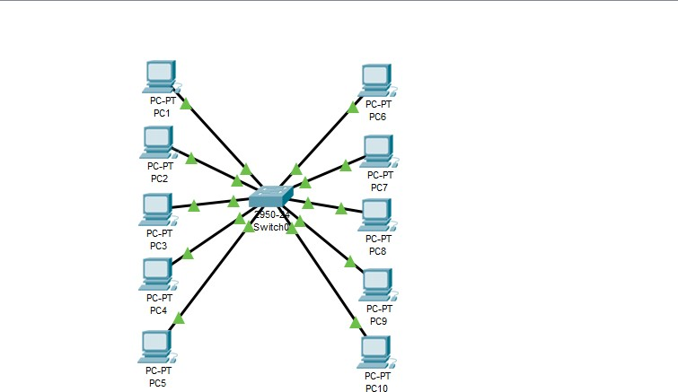Membuat desain jaringan
  2. Menentukan subnet mask dan subnet Adress 202.155.19.0/27

11111111 11111111 11111111 11100000

Subnet mask : 255.255.255.224

* + - Jumlah subnet : 23 = 8 subnet
    - Jumlah host : 25 – 2 = 30 host
    - Block subnet : 256 – 224 = 32
    - Tabel subnet

|  |  |  |  |  |  |  |  |  |
| --- | --- | --- | --- | --- | --- | --- | --- | --- |
| Netwo  rk | 202.155.19.0 | 202.155.19.32 | 202.155.19.64 | 202.155.19.96 | 202.155.19  .128 | 202.155.19  .160 | 202.155.  19.192 | 202.155.19  .224 |
| Host pertam  a | 202.155.19.1 | 202.155.19.33 | 202.155.19.65 | 202.155.19.97 | 202.155.19  .129 | 202.155.19  .161 | 202.155.  19.193 | 202.155.19  .225 |
| Host terakhi  r | 202.155.19.3  0 | 202.155.19.62 | 202.155.19.94 | 202.155.19.126 | 202.155.19  .158 | 202.155.19  .190 | 202.155.  19.222 | 202.155.19  .254 |
| Broadc  ast | 202.155.19.3  1 | 202.155.19.63 | 202.155.19.95 | 202.155.19.127 | 202.155.19  .159 | 202.155.19  .191 | 202.155.  19.223 | 202.155.19  .225 |