LATIHAN PRAKTIKUM MODUL 7

Nama : M. Mahatma Rosyid H. NIM : L200180024

Kelas : A

1. Praktikum1

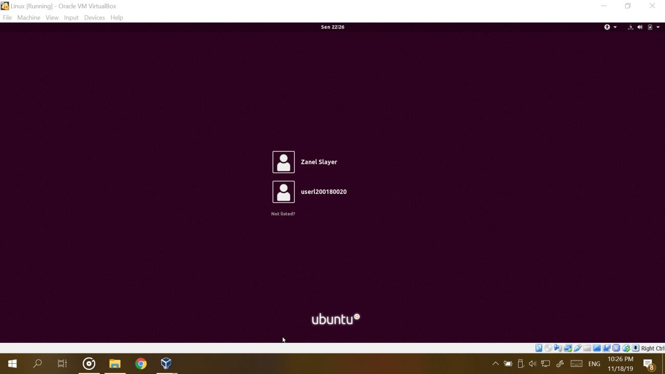

1. Praktikum2

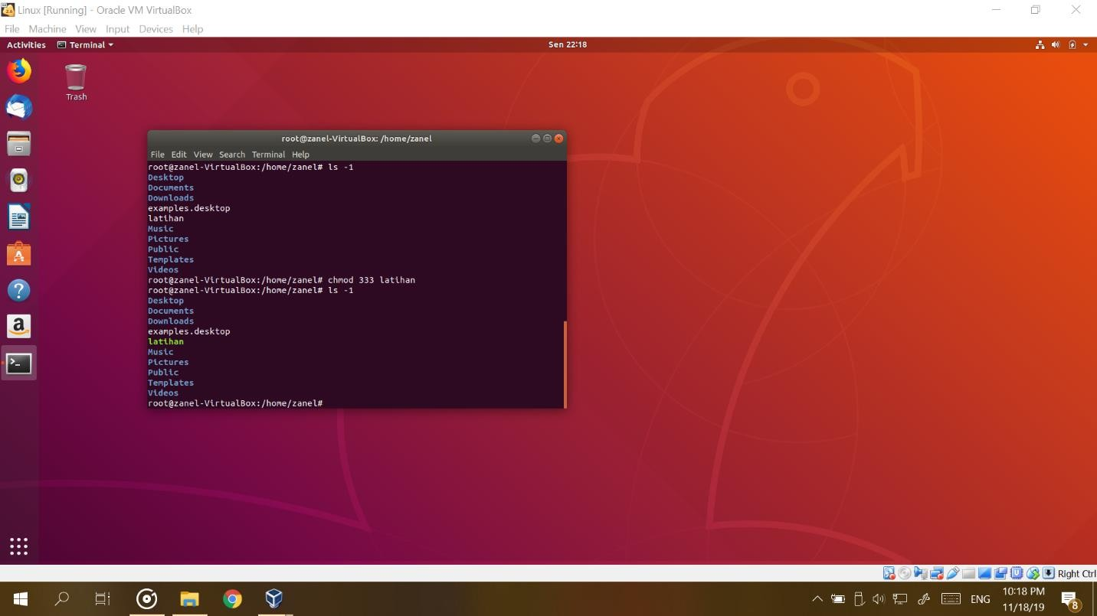

1. Praktikum3

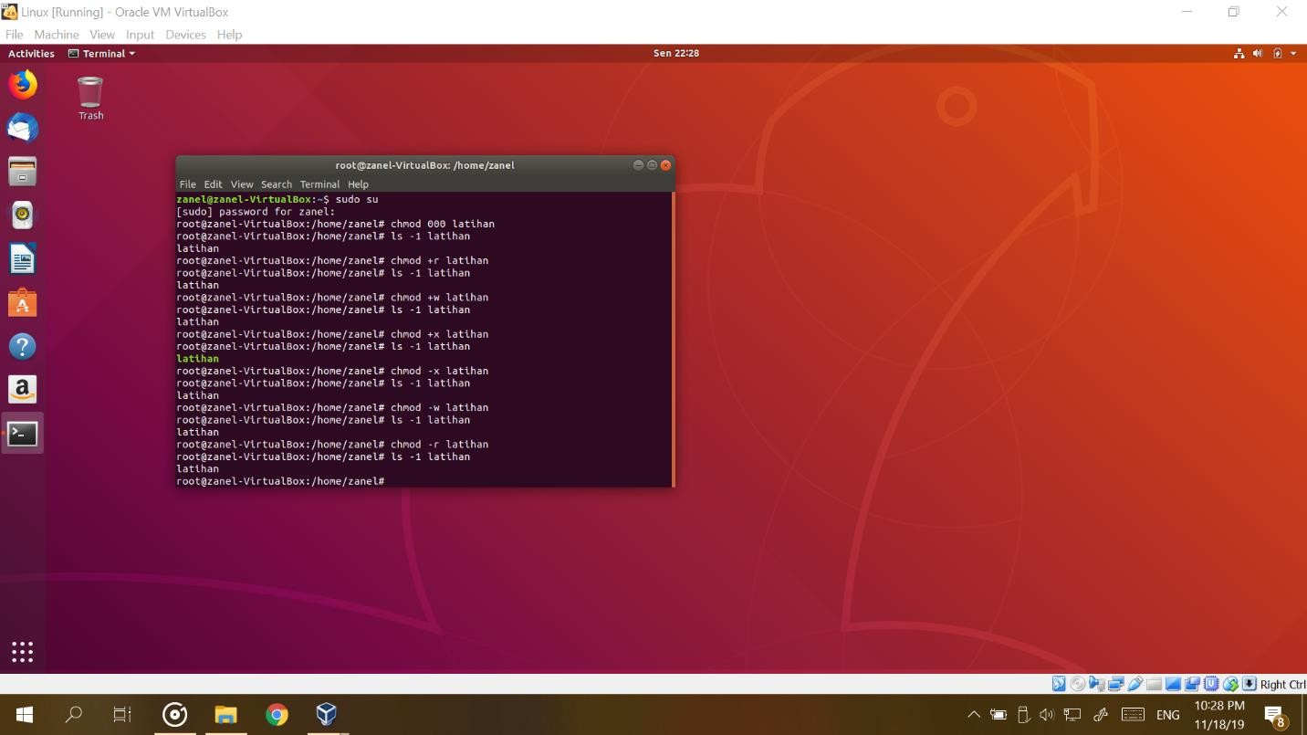

Thank you for using [www.freepdfconvert.com](http://www.freepdfconvert.com/) service!

Only two pages are converted. Please Sign Up to convert all pages. <https://www.freepdfconvert.com/membership>