Nama : Aisyah Goevara

NIM : L200180034

Laporan Modul 1 Praktikum PBO

ScreenShoot PATH

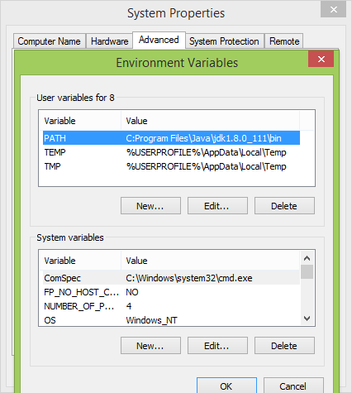

ScreenShoot

