NAMA : DWI ALVIAN VERRY A

NIM : L20180052

KELAS : B

FCFS

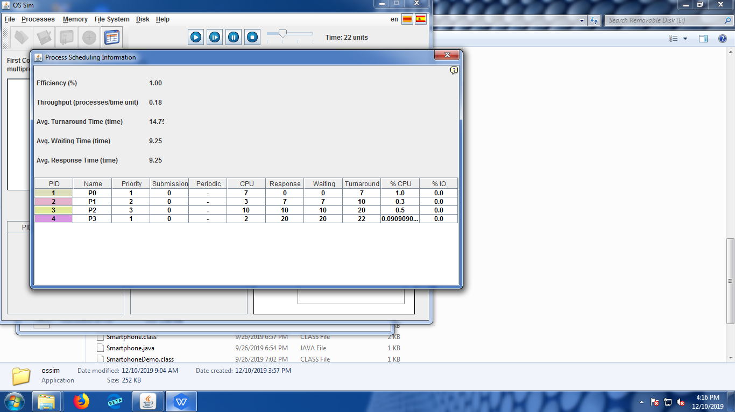

|  |  |
| --- | --- |
| Proses | Wait Time |
| P0 | 0 |
| P1 | 7 |
| P2 | 10 |
| P3 | 22 |
| Average Wait Time | 9.25 |
| Average Turnaround | 14.75 |
| Average Respon | 9.25 |

SJFS

1. Premtive

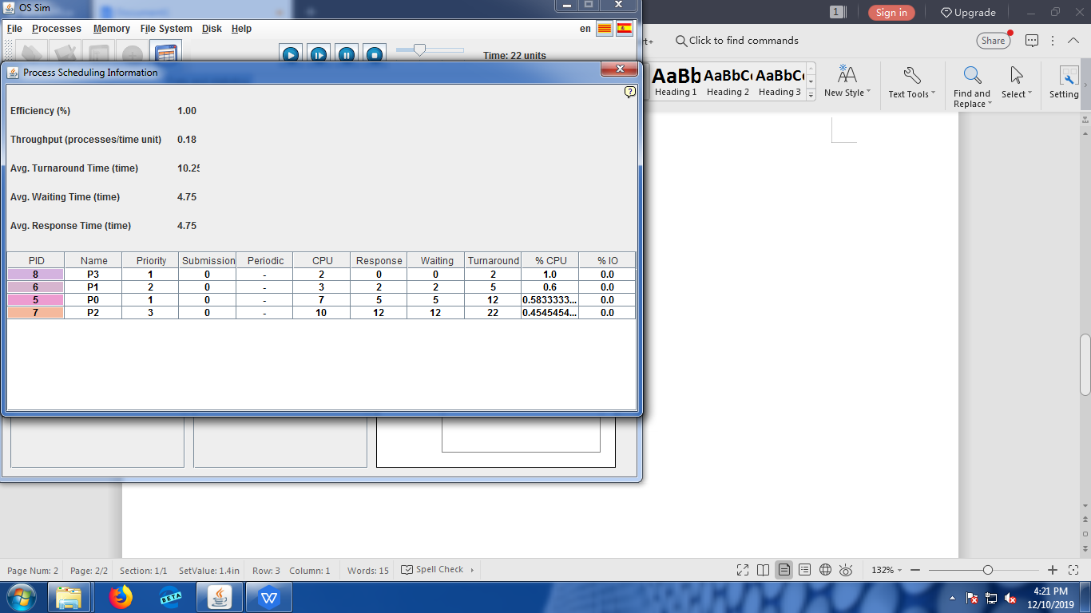

|  |  |
| --- | --- |
| Proses | Wait Time |
| P0 | 5 |
| P1 | 2 |
| P2 | 12 |
| P3 | 0 |
| Average Wait Time | 4.75 |
| Average Turnaround | 10.25 |
| Average Respon | 4.75 |

1. Non Premtive

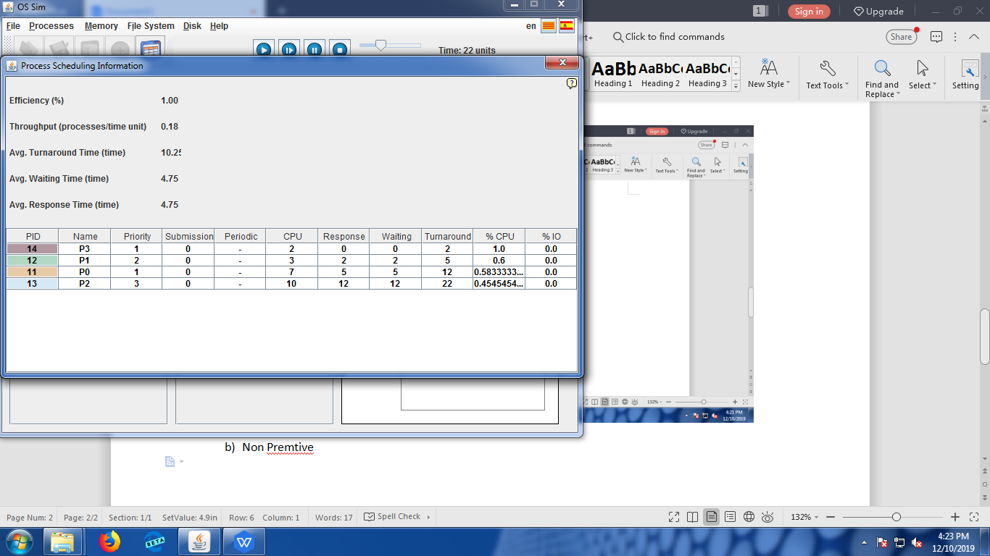

|  |  |
| --- | --- |
| Proses | Wait Time |
| P0 | 5 |
| P1 | 2 |
| P2 | 12 |
| P3 | 0 |
| Average Wait Time | 4.75 |
| Average Turnaround | 10.25 |
| Average Respon | 4.75 |

Priority Sceduling

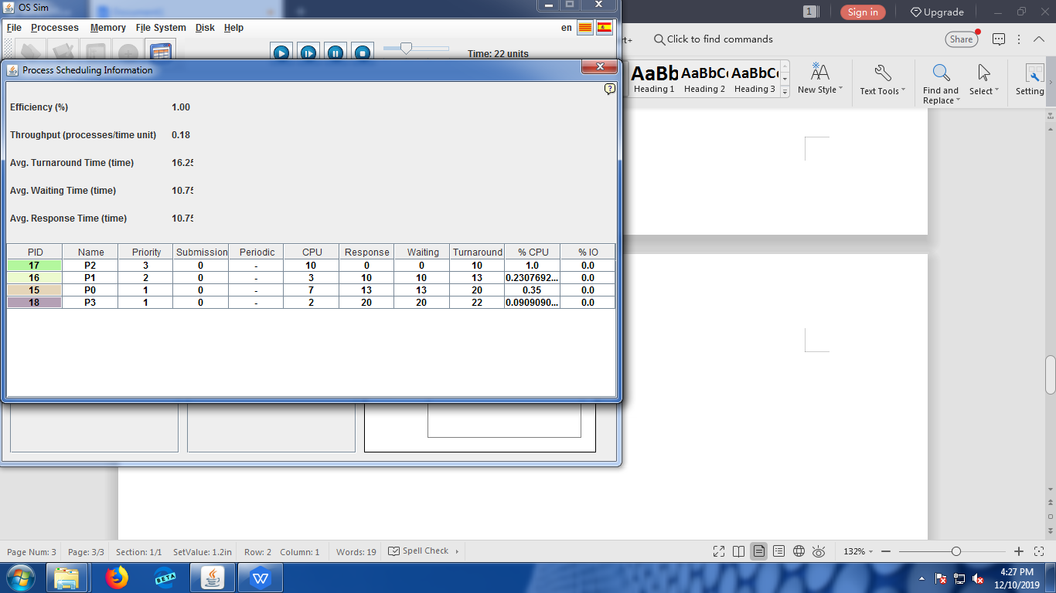

|  |  |
| --- | --- |
| Proses | Wait Time |
| P0 | 13 |
| P1 | 10 |
| P2 | 0 |
| P3 | 20 |
| Average Wait Time | 10.75 |
| Average Turnaround | 16.25 |
| Average Respon | 10.75 |

Round Robin (Quantum Time = 4)

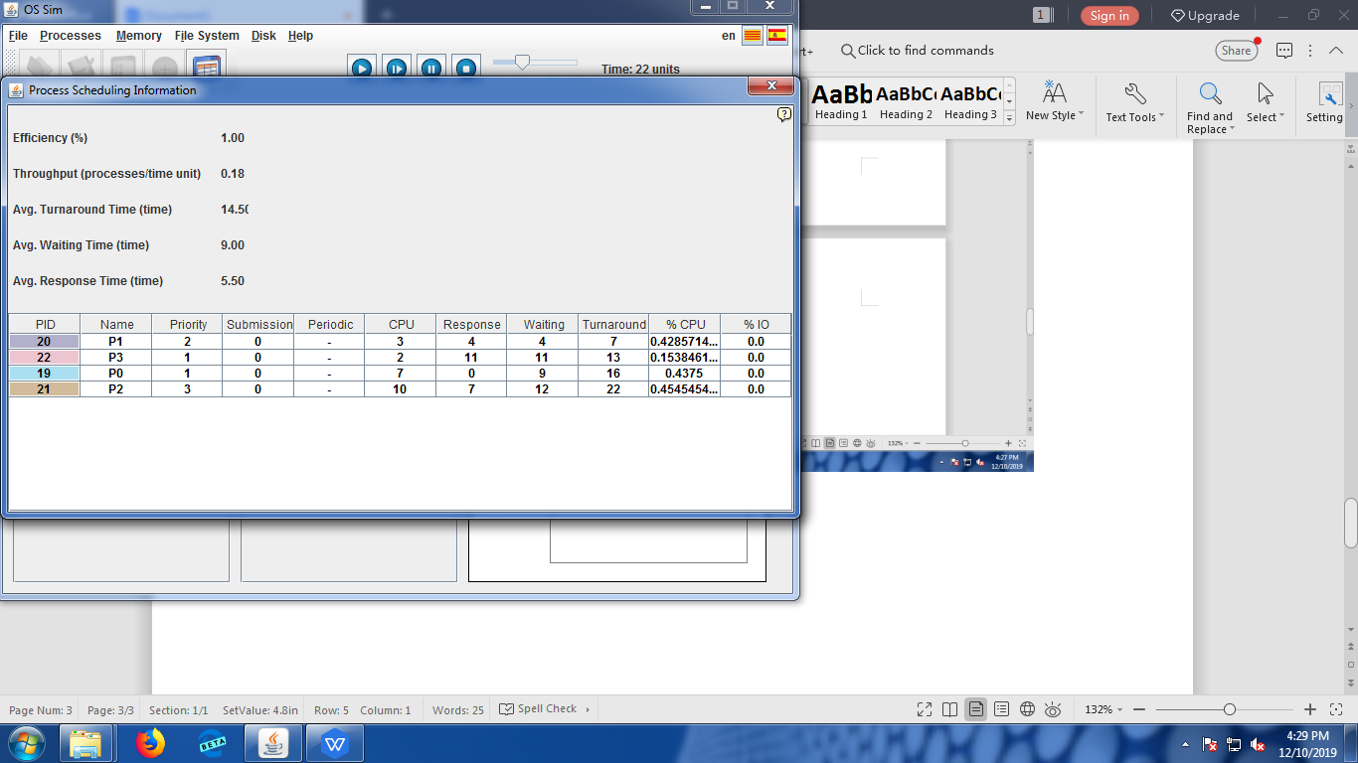

|  |  |
| --- | --- |
| Proses | Wait Time |
| P0 | 9 |
| P1 | 4 |
| P2 | 12 |
| P3 | 11 |
| Average Wait Time | 9.00 |
| Average Turnaround | 14.50 |
| Average Respon | 9.00 |