Aprinta Sewelastami

L200180088/C

**Percobaan 1**

1. Kombinasi Gerbang Logika

|  |  |  |  |  |  |
| --- | --- | --- | --- | --- | --- |
|  | | AB | | | |
| 00 | 01 | 11 | 10 |
| CD | 00 | 0 | 0 | 0 | 0 |
| 01 | 1 | 1 | 1 | 0 |
| 11 | 0 | 1 | 1 | 1 |
| 10 | 0 | 0 | 0 | 0 |

1. Fungsi Boolean : **F = BD + ACD + A’C’D**
2. Gambar gerbang logika

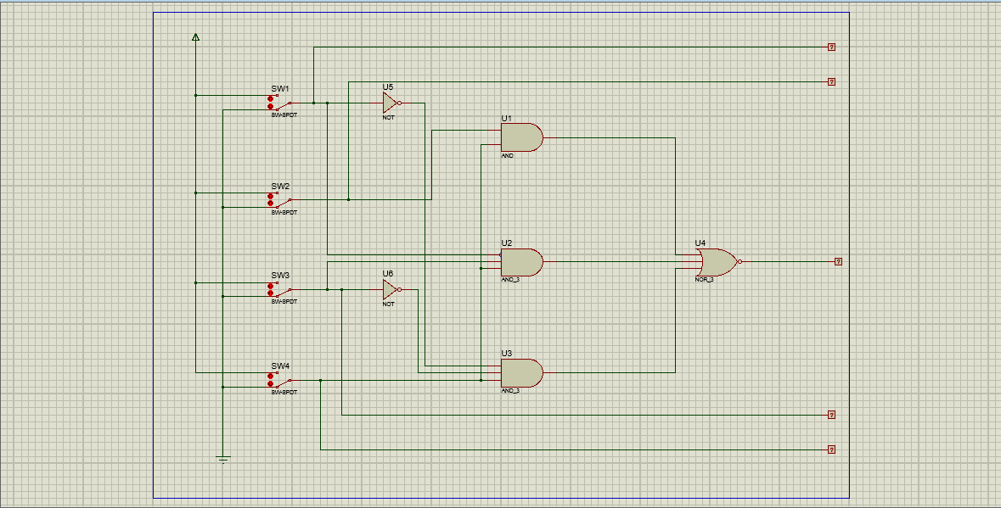

**Percobaan 2**

1. Kombinasi Gerbang Logika

|  |  |  |  |  |  |
| --- | --- | --- | --- | --- | --- |
|  | | AB | | | |
| 00 | 01 | 11 | 10 |
| CD | 00 | 1 | 0 | 0 | 1 |
| 01 | 0 | 1 | 1 | 0 |
| 11 | 0 | 1 | 1 | 0 |
| 10 | 1 | 0 | 0 | 1 |

1. Fungsi Boolean :
2. **F = B’D’ + BD** (AND-OR)
3. **F = (B’+D’).(B+D’)** (OR-AND)
4. Gambar Gerbang Logika

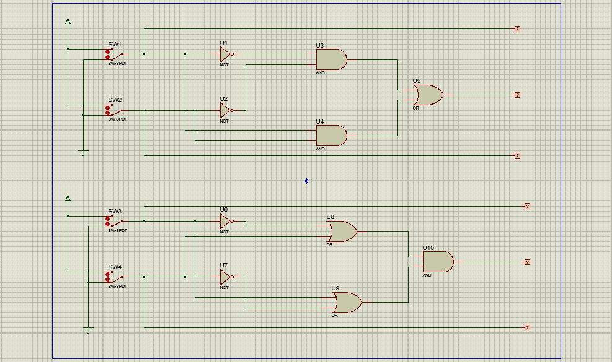

**Percobaan 3**

1. Fungsi Boolean : **F = XYZ + XYZ’ + XY’Z + X’YZ + X’YZ’ + XY’Z’ + X’Y’Z’**
2. Peta Karnaugh

|  |  |  |  |  |  |
| --- | --- | --- | --- | --- | --- |
|  | | XY | | | |
| 00 | 01 | 11 | 10 |
| Z | 0 | 1 | 1 | 1 | 1 |
| 1 | 0 | 1 | 1 | 1 |

1. Fungsi Boolean Sederhana : **F = X+Y+Z’**
2. Gerbang Logika

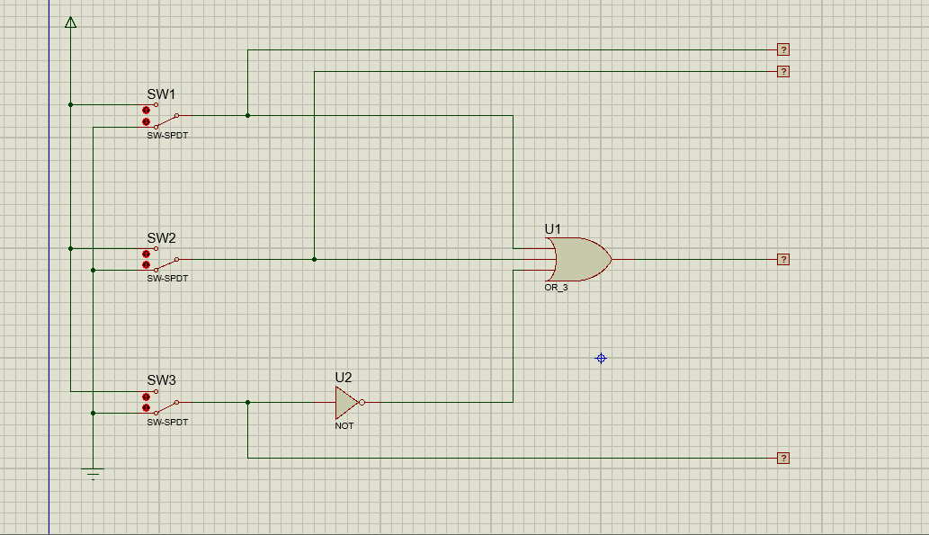

**Percobaan 4**

1. Fungsi Boolean : **F = AD’ + ABC + ABC’ + BCD + BC’D’ + AB’CD’**
2. Peta Karnaugh

|  |  |  |  |  |  |
| --- | --- | --- | --- | --- | --- |
|  | | AB | | | |
| 00 | 01 | 11 | 10 |
| CD | 00 | 0 | 1 | 1 | 1 |
| 01 | 0 | 0 | 1 | 0 |
| 11 | 0 | 1 | 1 | 0 |
| 10 | 0 | 0 | 1 | 1 |

1. Fungsi Boolean Sederhana : **F = AD’ + AB + BCD + BC’D’**
2. Gerbang Logika

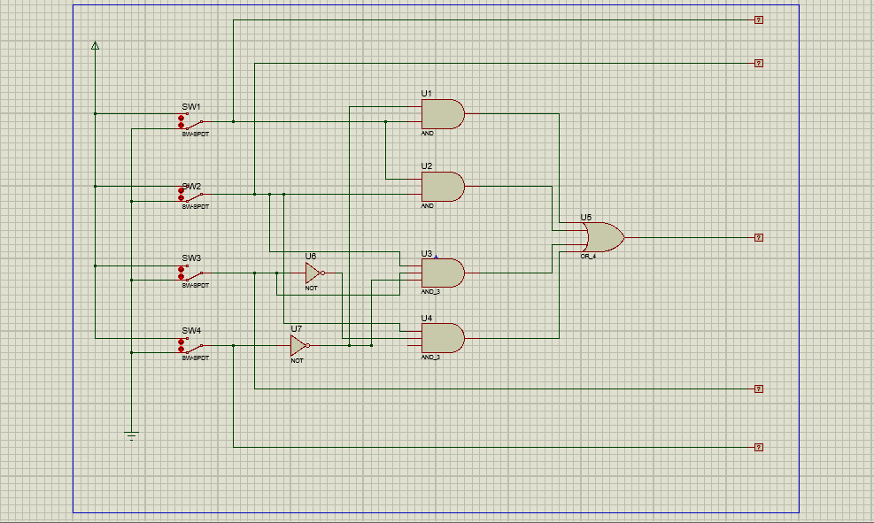

**Percobaan 5**

1. Tabel Fungsi Boolean :

|  |  |  |  |  |
| --- | --- | --- | --- | --- |
| A | B | C | D | F |
| 0 | 0 | 0 | 0 | **1** |
| 1 | 0 | 0 | 0 | 0 |
| 0 | 1 | 0 | 0 | 0 |
| 1 | 1 | 0 | 0 | **1** |
| 0 | 0 | 1 | 0 | **1** |
| 1 | 0 | 1 | 0 | **1** |
| 0 | 1 | 1 | 0 | 0 |
| 1 | 1 | 1 | 0 | 0 |
| 0 | 0 | 0 | 1 | **1** |
| 1 | 0 | 0 | 1 | **1** |
| 0 | 1 | 0 | 1 | 0 |
| 1 | 1 | 0 | 1 | **1** |
| 0 | 0 | 1 | 1 | **1** |
| 1 | 0 | 1 | 1 | **1** |
| 0 | 1 | 1 | 1 | **1** |
| 1 | 1 | 1 | 1 | 0 |

1. Peta Karnaugh

|  |  |  |  |  |  |
| --- | --- | --- | --- | --- | --- |
|  | | AB | | | |
| 00 | 01 | 11 | 10 |
| CD | 00 | 1 | 0 | 1 | 0 |
| 01 | 1 | 0 | 1 | 1 |
| 11 | 1 | 1 | 0 | 0 |
| 10 | 1 | 0 | 0 | 1 |

1. Fungsi Boolean Sederhana : **F = A’B’ + A’CD + AC’D + ABC’ + B’CD’**
2. Gerbang Logika

