**Nama : Farid Aziz Priyo F**

**Nim : L200180117**

**Kelas : E**

**Tugas**

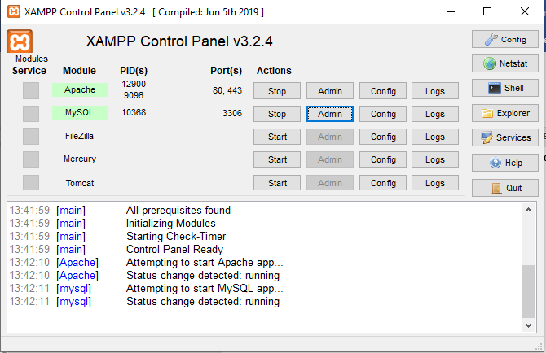

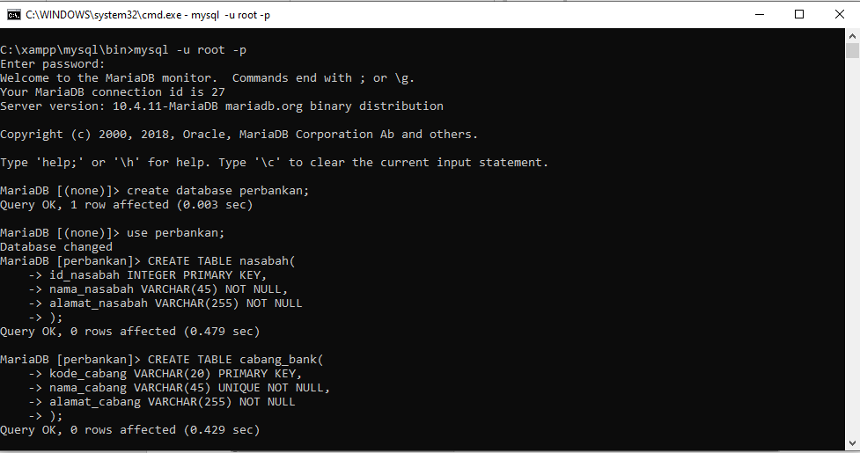

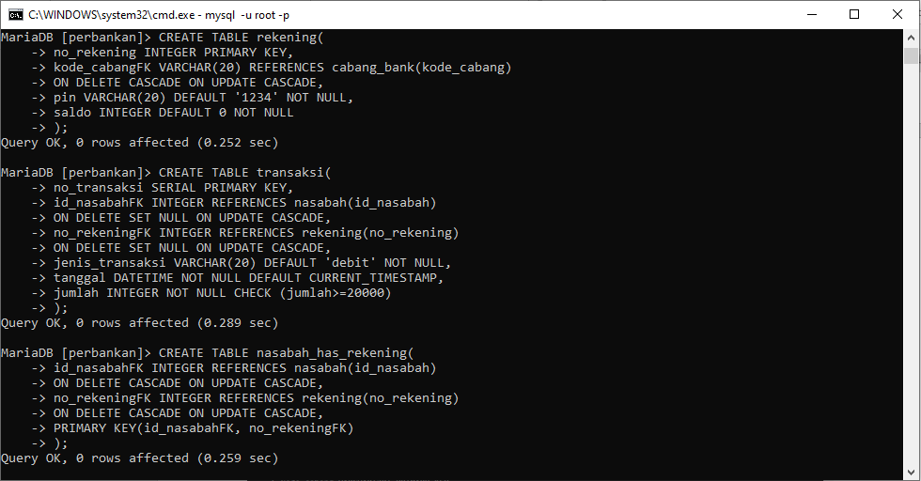

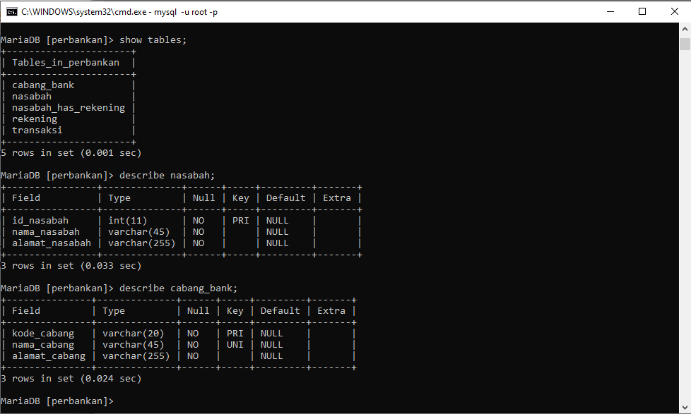

**TUGAS**

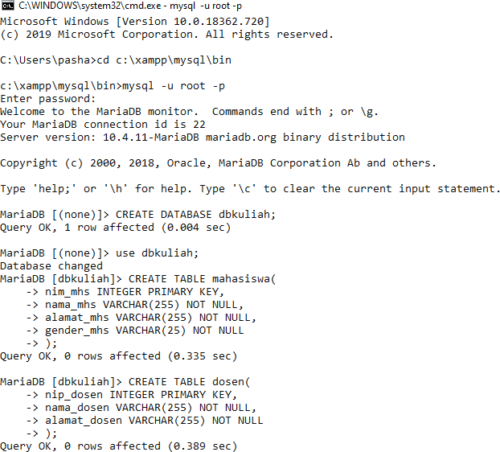

EtaniaDB [dbkuliah]> CREATE TABLE nuang kelas(

- › kode rk INT EG ER PR I f'tARY K EY,

-> kapasitas INTEGER NOT NULL Queny OK, 0 nods affected (0.334 sec)

EtaniaDB [dbkuliah]> describe nuang kelas;

Field Type Null Key Default Extna

## kode nk | int(11) | NO | PRI | NULL kapasitas | int(11) | NO | | NULL

2 nods in set (0.100 sec)

EtaniaDB [dbkuliah]> CREATE TABLE mata kuliah(

* › kode mk INT EG ER PR I f'tARY K EY,
* › kode rk INT EG ER RE F ERENC ES ruang kelas( kode rk )
* › ON DE L ET E S ET NU L L ON UPDAT E CASCADE ,
* › nama mk VARCHAR ( 2S ) NOT NU LL ,

-> jumlah sks INTEGER NOT NULL Queny OK, 0 nods affected (0.271 sec)

EtaniaDB [dbkuliah]> CREATE TABLE mahasisua has mata kuliah(

## › nip chs INT EG ER RE FERENC ES mahasi sea (nip chs)

* › ON DELET E CASCADE ON UPDAT E CASCADE,
* › kode mk INT EG ER RE FERENC ES rata kuliah(kode mk)
* › ON DELET E CASCADE ON UPDAT E CASCADE,
* › PRI DIARY K EY(nip chs, kode mk)

Queny OK, 0 nods affected (0.288 sec)

EtaniaDB [dbkuliah]> show tables;

Tables in dbkuliah dosen

mahasisua

mahasisua has mata kuliah mata kuliah

nuang kelas

S nods in set (0.001 sec)

EtaniaDB [dbkuliah]> describe dosen;

Field Type Null | Key | Default | Extna nip dosen | int(11) | NO | PRI | NULL

nama dosen vanchan(255) NO NULL alamat dosen | vanchan(255) | NO | | NULL

3 nods in set (0.026 sec)

EtaniaDB [dbkuliah]> describe mahasisua;

Field Type Null | Key | Default | Extna

nip chs | int ( 11) | NO | PRI | NULL nama chs | va rcha r ( 255 ) | NO | | NU LL alamat chs | va rcha r (255) | NO | | NULL gende r chs | va rcha r ( 2S ) | NO | | NU LL nip dosen | int(11) | YES | | NULL

S nods in set (0.024 sec)

EtaniaDB [dbkuliah]> describe mata kuliah;

Field Type Null | Key | Default | Extna

## kode mk | int(11) | NO | PRI | NULL kode rk | int(11) | YES | | NULL nama mk varchar(2S) NO NULL jumlah sks | int(11) | NO | | NULL

4 nods in set (0.094 sec)

EtaniaDB [dbkuliah]> describe nuang kelas;

Field | Type | Null | Key | Default | Extna

## kode nk | int(11) | NO | PRI | NULL kapasitas | int(11) | NO | | NULL

2 nods in set (0.024 sec)

EtaniaDB [dbkuliah]> describe mahasisua has mata kuliah; Field | Type | Null | Key | Default | Extna

|  |  |  |  |  |
| --- | --- | --- | --- | --- |
| nip chs | | int (11) | | NO | | | PRI | NULL |
| kode mk | | int (11) | | NO | | | PRI | NULL |

2 nods in set (0.026 sec) EtaniaDB [dbkuliah]>