Nama : Maulana Alhif Ikhsan

NIM : L200180120

Kelas : C

**Modul 11**

**Kegiatan** Desain Jaringan

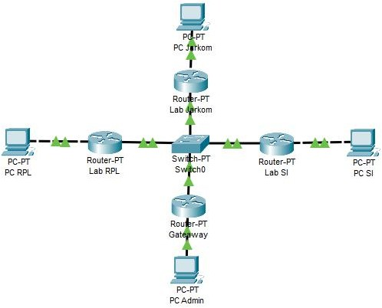

1. Konfigurasi router

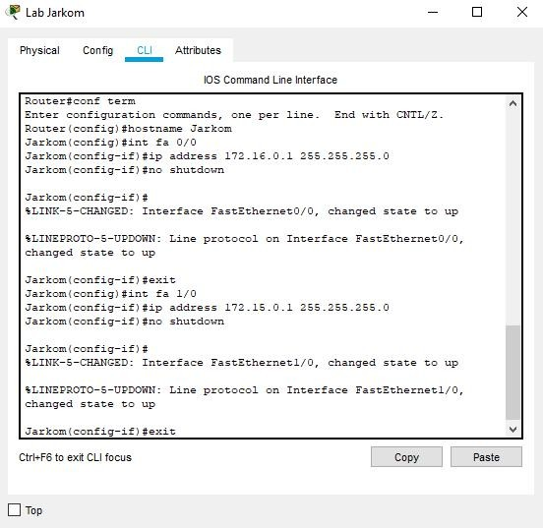

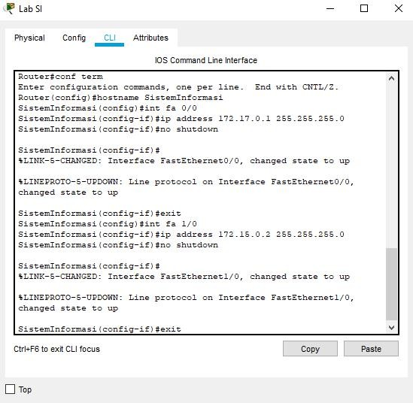

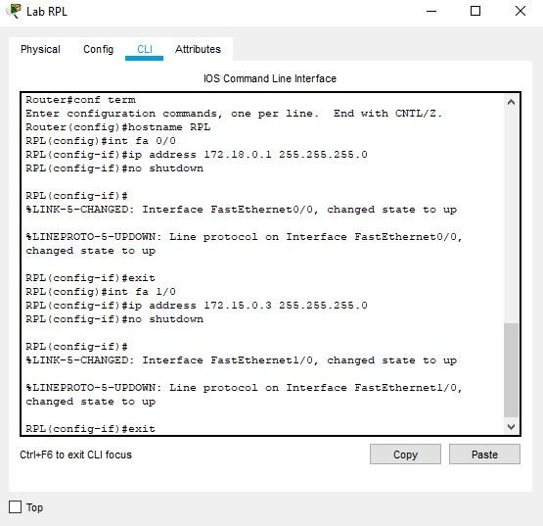

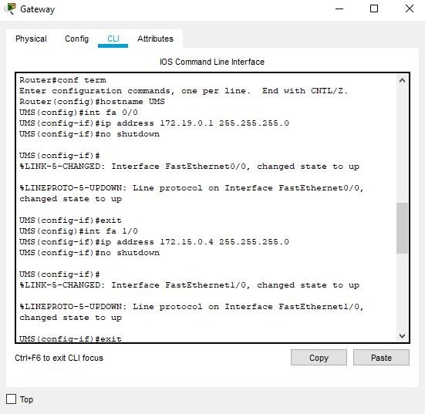

1. Konfigurasi routing table pada 4 router
   * Membuat Routing Table pada router1 / Jarkom

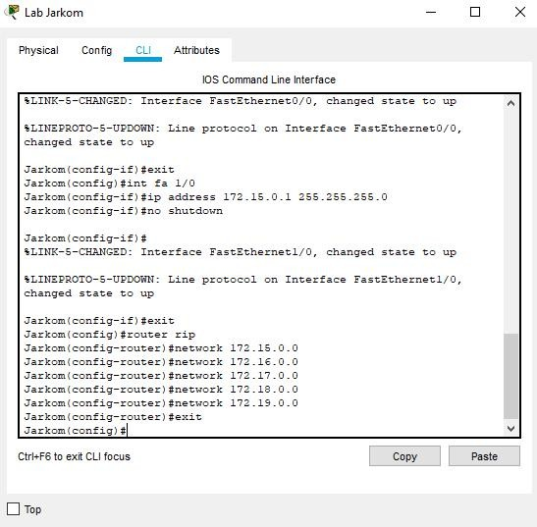

* + Membuat Routing Table pada router2 / SistemInformasi

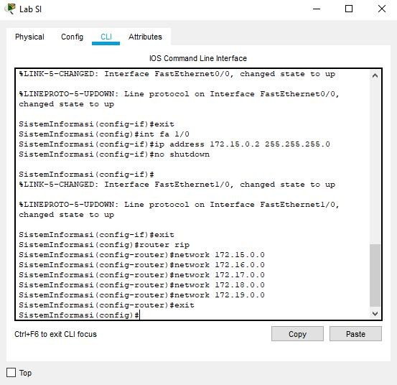

* + Membuat Routing Table pada router3 / RPL

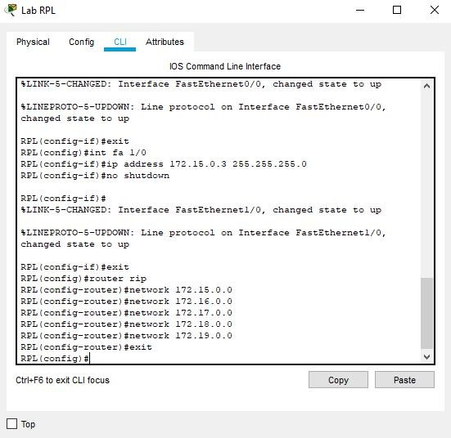

* + Membuat Routing Table pada router4 / gateaway UMS

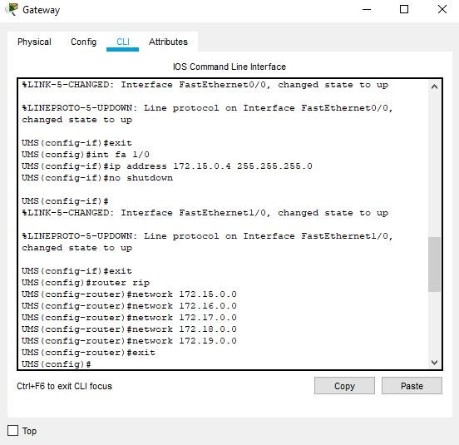

1. Konfigurasi IP pada masing-masing PC

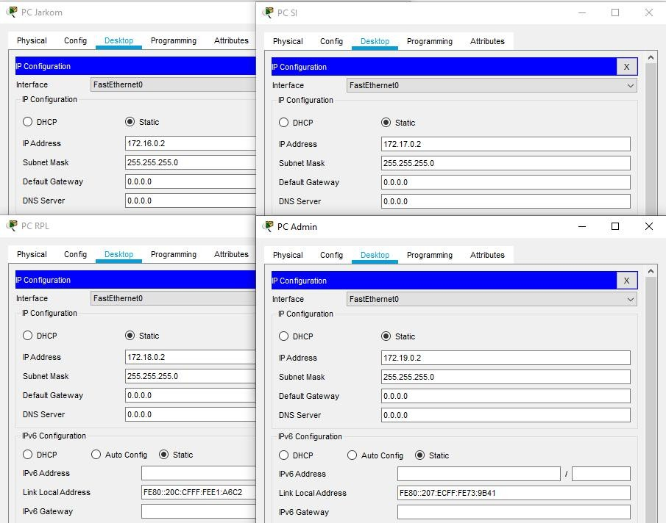

1. Lakukan pengujian ICMP request (ping)

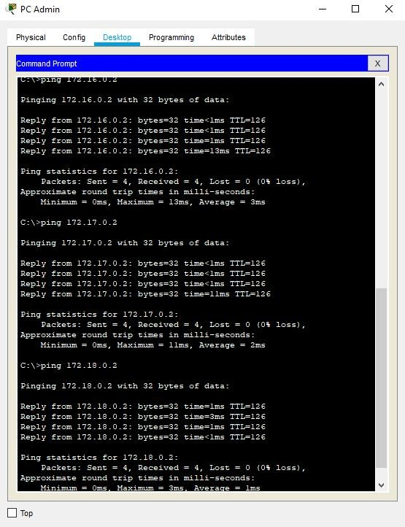

**Tugas**

1. Buatlah topologi jaringan serupa dengan gambar 10.1, namun metode routing yang digunakan adalah routing statis
   1. Buatlah tabel routing statis dari soal no 1

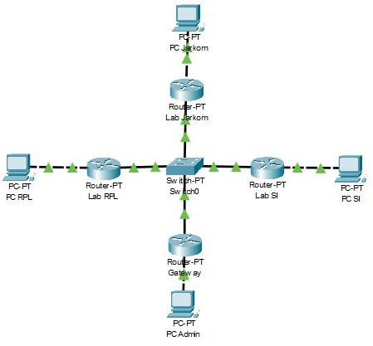

**Petunjuk tabel routing statis pada router cisco**

**#ip route <ip network ID tujuan><subnet mask network tujuan><ip next hop-interface tetangga terdekat>**

* + - Konfigurasi masing-masing router

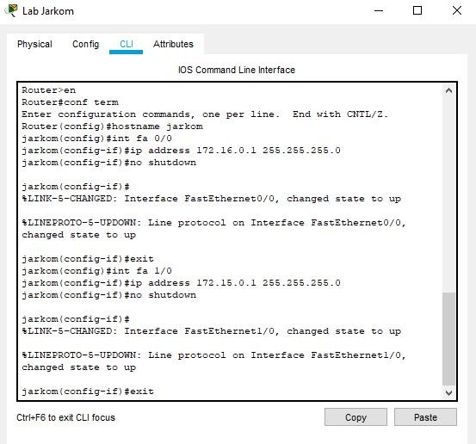

Lab SI 

Physical hon fig '? L i Attributes

IO S Comman d Line Interface



**Dcuter>en**

Acuter#ccn* term

**Inter ccn*iguraticn ccmmanfs, cne per** line. ind with CNIL/Z.

s1 \ oc rz*1g— i * ) 1t1p a JJx e ss 17 < . 1 z . 0 . 1 SS -. ñ ñ . SS . 0 s1 ', c c rz*1g— i ) It no shucdcw=t

tLINB-o-CHANGaJ: Interface Fast:thernet3./O, changed state to up

$LIN2PA0TD-o-U¥ WH:

changed state to up

**cn Interface** Fast=thernet'3/0,

si\conSig-if)#er.i1 si \con*ig) #int fa 1./0

si\con*ig-if)#ip affress 172.l9.O.2 ?B9.=99.?8o.O si(config-iS)#no shutdown

s1 ', c o o* 1 g- i fi) It

5L,IITK—ñ — CEMTG D : Inc e z ace 'a scT the zzte c1./ 0, eta rtqe d sc oc e 1z c up

5LINZPNOIJ-S-UE WN: Line protocol on Interface FastithernetL/0,

**si(ocn*ig-i*)#er.it**

Ctrl+F6 to exit DLI fa cus

@ Lab RPL

Physical Con fig '. LI Attributes

IO 5 Command Line Interface

,Copy : Pedte.’





Jou1er•en

louter#conf term

enter configuration ccmmanfs, cne per line. Inf with CFTL/Z.

Aoutericonfig)#hostname rpl rpl'ccnfig)#int za OA3

rpl(ccnSig-iS)#ip address 172.18.'3.1 26o.âo5.26o.'3 rpliconfig-if)#no shutdown

zpi ' oc rz*iE/-i ) 8

+I,INZ- 3 — CHMTDZ D : I etc e z fia c e 'a sc the z ne c 0./ '3, cbange 4 sc a t:e c c up

5LIHZFDOIO-5-UF OWN: Line protocol on Interface FastZthernet0/•3, changed state tc up

rpliccnfig-if)#er.it rpl!ccnfig)#int *a 1/0

rpl{config-if)#ip address 178.lo.'J.3 2oB.2ou.?9o.'J rpl(ccnIig-iI)#no shuticwn

tLIHZPAOIO-B-UP WN: **Line prctcccl cn Interface** Fast=thernetl/'3,

changed slace lo up

**rpl(ccnIig-iI)#er.it**

Ctrl+F6 to exit CLI fa cus Eopy.

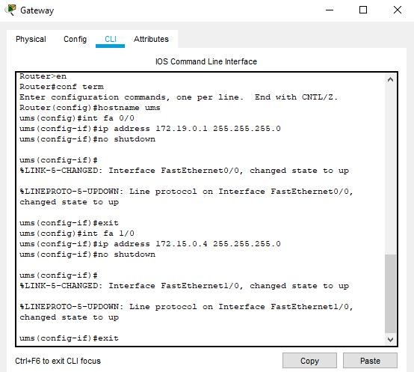

* + - Konfigurasi masing-masing PC

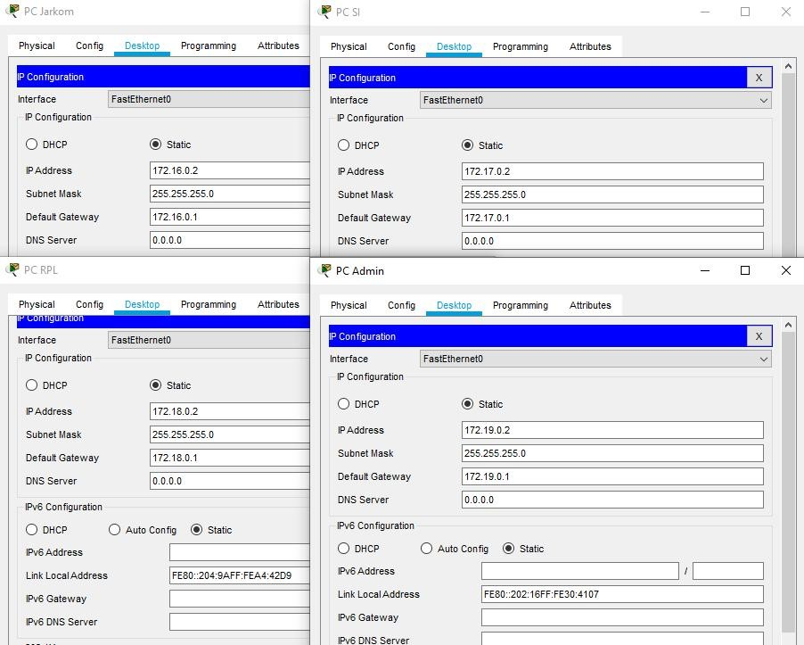

* + - Melakukan routing pada masing-masing router

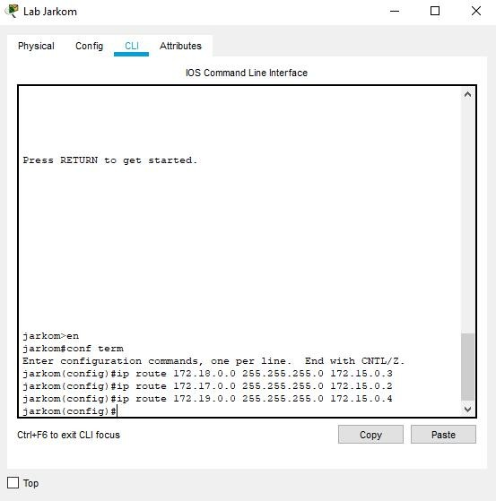

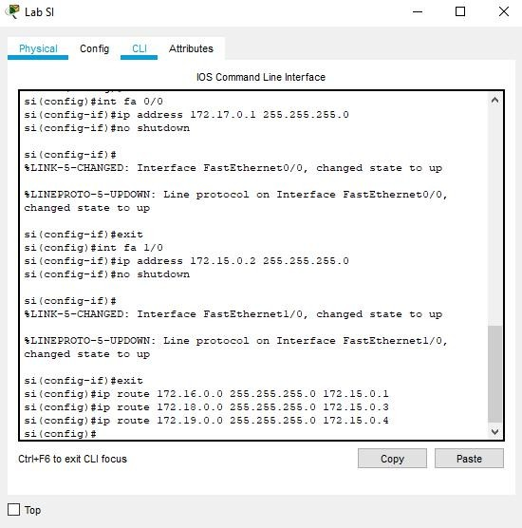

- @ Lab RPL 

Physical Con fig 'CLI Attributes

IO S Command Line Interface



**rpl›en**

rpl#conf term

Enter configuration comesnds. one per line. snd with CWTL/Z. rpllconfig)#ip route l 2.lf.0.0 255.2oS.255.0 172.15.0.1 rpllconfig)#ip route 172.17.0.0 255.255.255.'3 172.15.0.2

rplCconfig)#ip route l7?.l5.0.0 295.255.295.0 172.15.0.4

**rpllconfig)#**

Ctrl+F6 to exit CLI focus

Trip



Physical Con fig ñ LI Attributes

IOS Command Line Interface



umsCconfig-ifl$ip address 172.15.0.1 255.255.255.0

BLINR-S-CHANGaD: Interface EastEthernet0/0, changed state to up

BLINEPROTO-o-UPDOWN: Line protocol on Interface Fasththernet0/0,

umslconfig-ifl8exit umslconfigl#int fa 1/0

umsCconfig-ill$ip address 172.15.0.4 255.259.255.0

ums{config-iI)#no shutdown

**BLINR-S-CHANGED: Interface FastEthernetl/0. changed** state to up

Line protocol on Interface EastEthernetl/U,

umsCconfig-ill$exit

umslconfig)4ip route 172.lv.0.0 255.2S8.255.'J 172.lS.U.l ums{configl#ip route 17 .18.0.0 ?55.?SS.?55.0 172.15.0.3

umsCconfigl#ip route 172.17.1.0 2o5.?5o.255.0 172.15.1.2







Ctrl+F6 to ait CLI focus

Cnpy Paste







Paste



# Melakukan uji konektivitas

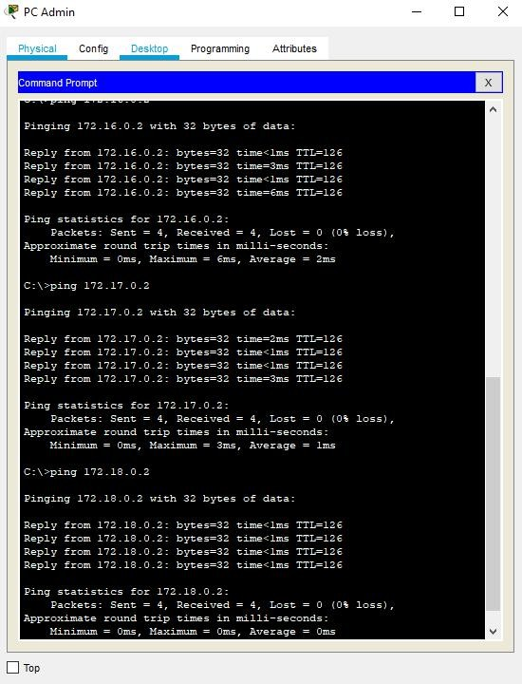

1. Buatlah topologi jaringan BUS untuk membangun sebuah laboratorium computer yang terdiri dari 3 router (Jarkom, RPL, SI) dan berpusat pada 1 router gateway, dengan metode routing:

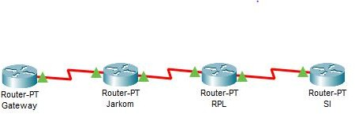

* 1. Statis

**Petunjuk untuk routing statis, gunakan default gateway 0.0.0.0/0 pada topologi dibawah router gateway ketika route data akan menuju gateway.**

1. Konfigurasi router (Gateway, Jarkom, RPL, SI).

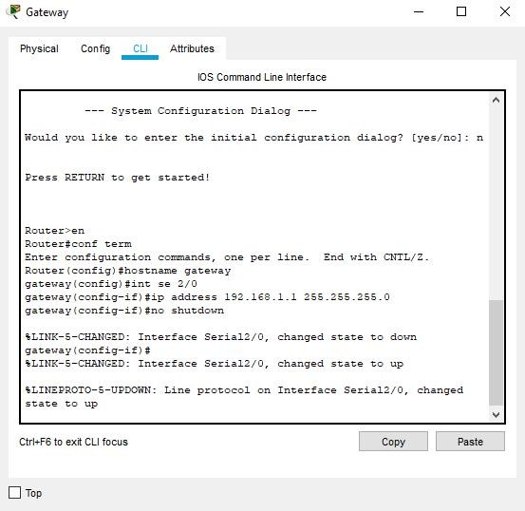

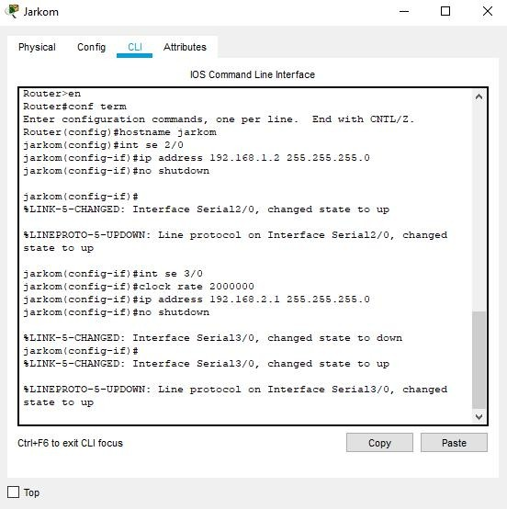

### @ RPL



Paste

Physical Config C LI Attributes

IOS Command Lin e Interface



Bouter>en

Rnter configuration commands, one per line. End xith CNIL/Z.

BouterCconfig)#hostnaume rpl rpllconfig)#int se 2/0

rpllconfig-ifl4clock rate 2000000

rpllconfig-ifl4ip address 152.lC8.O.l 255.255.255.0 rpllconfig-ifl#no shutdown

BLINK-S-CHANGBD: Interface Serial2/0, changed state to down rpllconfig-ifl4

rpllconfig-ifl#int se 3/0

rpllconfig-ifl#ip address 152.lC8.2.2 255.255.255.0

rpllconfig-ifl4no shutdown

rpllconfig-ifl #

BLINK-S-CHANGED: Interface Serial3/0, changed state to up BLINEPB0TO-S-UPD0WN:

8LINK-S-CHANGED: Interface Serial2/0. changed state to up

Ctrl+F6 to ait CLI focus

Top



. SI 

Physical Con fig CLI Attributes

IOS Command Line Interface





Bouter4conf term

Bnter configuration commands, one per line. End with CNTL/Z.

silconfigl#int se 2/0

silcOnfig-if}#ip address 152.lf8.0.2 255.255.255.0

BLINK-S-CHAWGBD: Interface Serial2/0. changed state to up

%LINBPR0ID-S-UPDOUW: Line protocol on Interface Serial2/0. changed

Ctrl+F6 to ait CLI focus

# Routing router ( Gateway, Jarkom, RPL, SI).

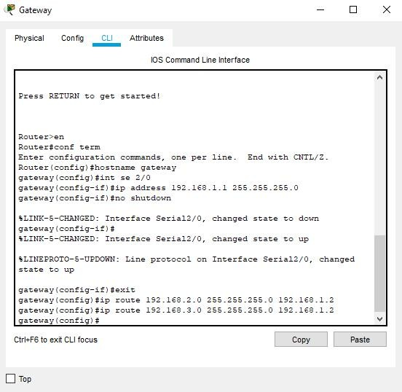

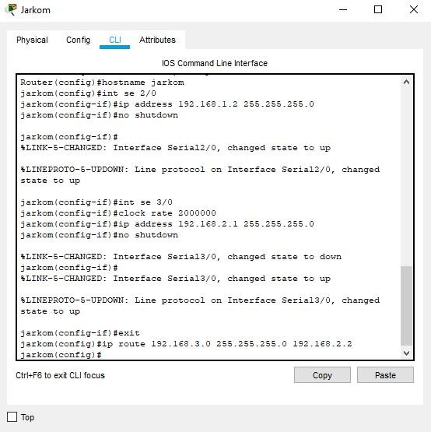

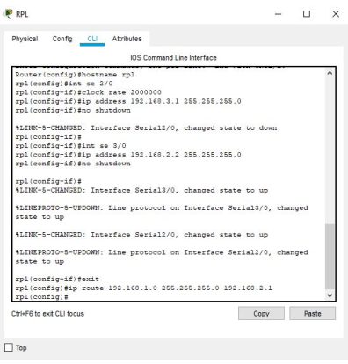

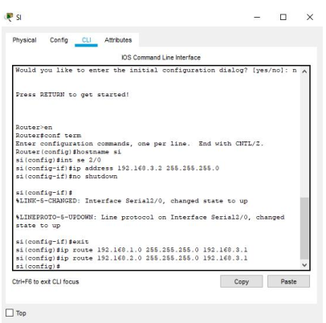

# Uji konektivitas

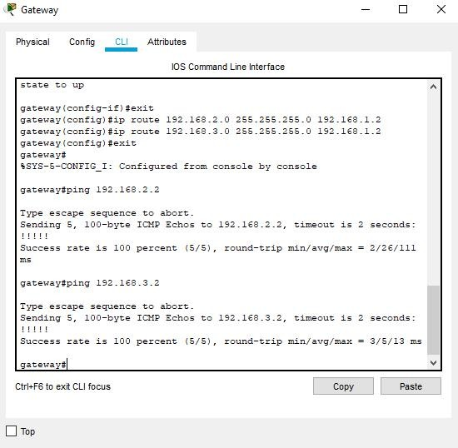

* 1. Dinamis

1. Routing router (Gateway, Jarkom, RPL, SI).

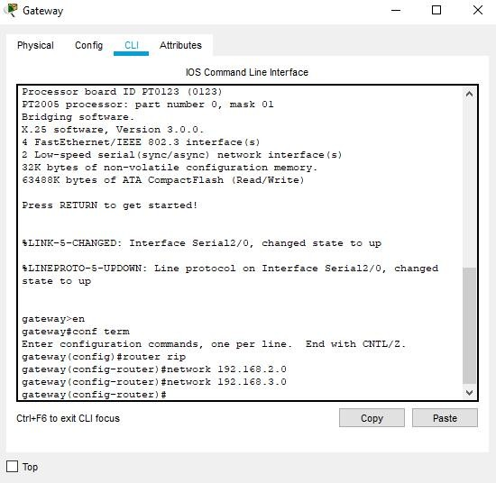

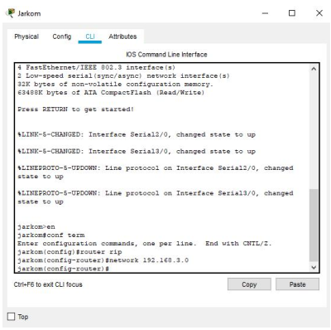

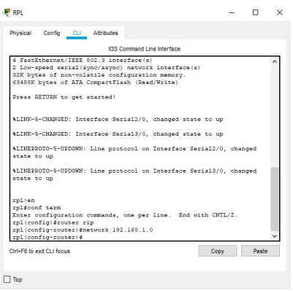

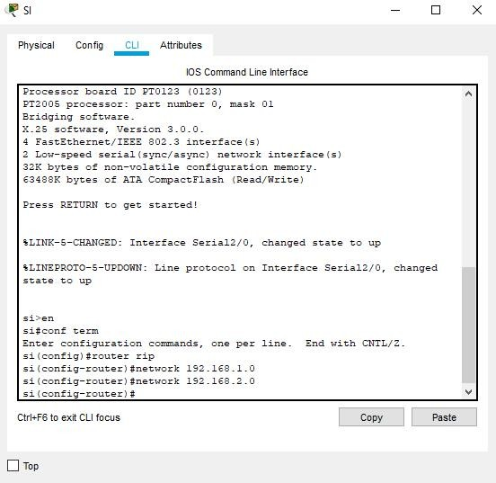

# Uji konektivitas.

