Nama : Karina Muslimah

Nim : L200180138

LAB D

**PRAKTIKUM 6**

**Kegiatan 4**

1. Fungsi Boolean : **F = AD’** + **ABC** + **ABC’** + **BCD** + **BC’D’** + **AB’CD’**
2. Berdasarkan fungsi Boolean, isi titik-titik dalam peta karnaugh berikut !

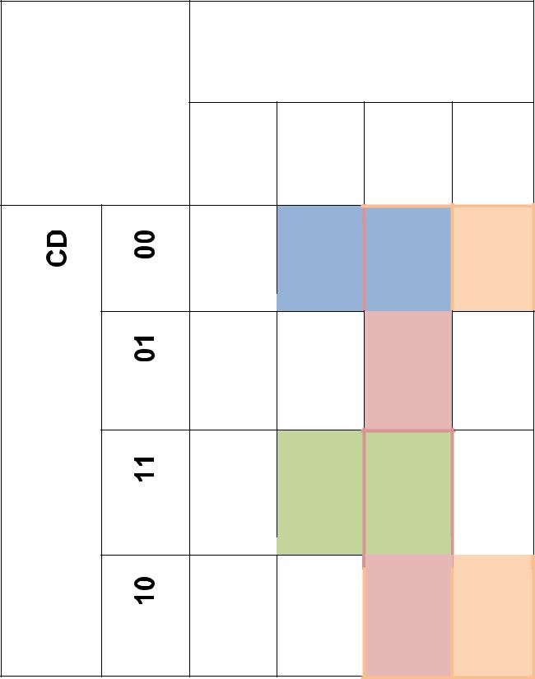

**AB**

**00** **01** **11** **10**

1 1 1

1

1 1

1 1

1. Sederhanakan fungsi Boolean : **F** = **AB** **+ BCD + BC’D’ + AD’**
2. Buat gerbang logika berdasarkan fungsi Boolean anda ! Gambar dalam kotak dibawah ini !

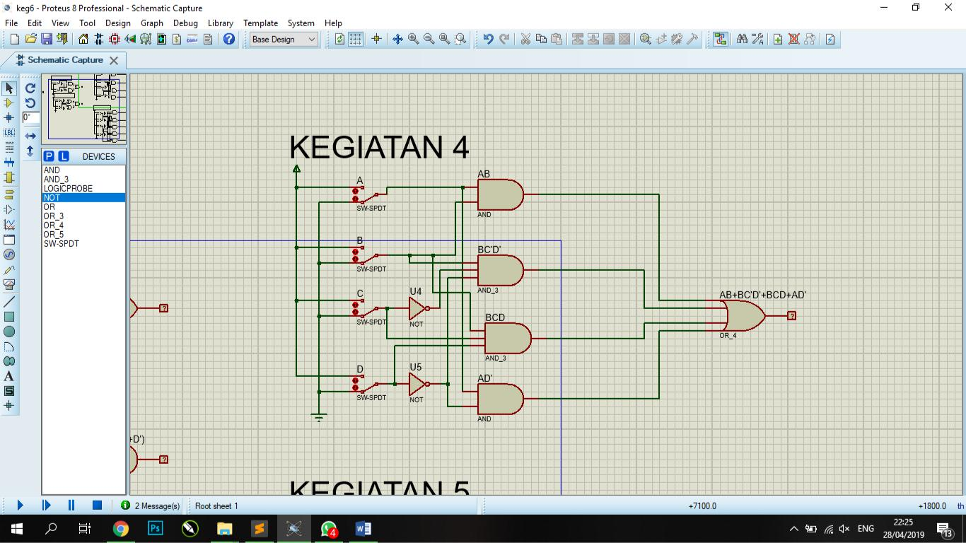

**Kegiatan 5**

1. Tabel fungsi Boolean

|  |  |  |  |  |
| --- | --- | --- | --- | --- |
| A | B | C | D | F |
|  |  |  |  |  |
| 0 | 0 | 0 | 0 | **1** |
|  |  |  |  |  |
| 1 | 0 | 0 | 0 | 0 |
| 3 |  |  |  |  |
|  |  |  |  |  |
| 0 | 1 | 0 | 0 | 0 |
|  |  |  |  |  |
| 1 | 1 | 0 | 0 | **1** |
|  |  |  |  |  |
| 0 | 0 | 1 | 0 | **1** |
|  |  |  |  |  |
| 1 | 0 | 1 | 0 | **1** |
|  |  |  |  |  |
| 0 | 1 | 1 | 0 | 0 |
|  |  |  |  |  |
| 1 | 1 | 1 | 0 | 0 |
|  |  |  |  |  |
| 0 | 0 | 0 | 1 | **1** |
|  |  |  |  |  |
| 1 | 0 | 0 | 1 | **1** |
|  |  |  |  |  |
| 0 | 1 | 0 | 1 | 0 |
|  |  |  |  |  |
| 1 | 1 | 0 | 1 | **1** |
|  |  |  |  |  |
| 0 | 0 | 1 | 1 | **1** |
|  |  |  |  |  |
| 1 | 0 | 1 | 1 | 0 |
|  |  |  |  |  |
| 0 | 1 | 1 | 1 | **1** |
|  |  |  |  |  |
| 1 | 1 | 1 | 1 | 0 |
|  |  |  |  |  |

1. Berdasarkan tabel, isi titik-titik dalam karnaugh map berikut !

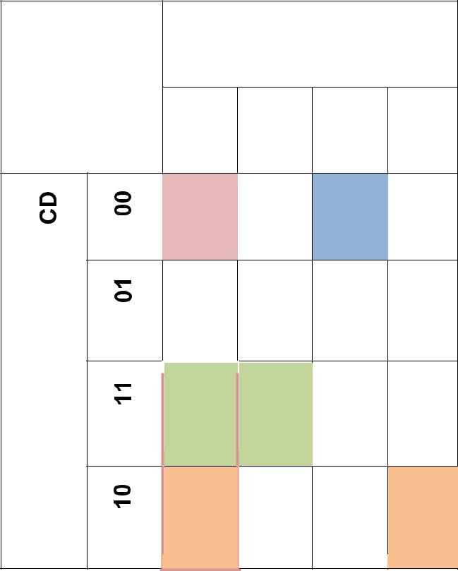

**AB**

|  |  |  |  |
| --- | --- | --- | --- |
| **00** | **01** | **11** | **10** |

1 1

|  |  |  |  |  |
| --- | --- | --- | --- | --- |
|  |  |  |  |  |
| 1 |  | 1 |  | 1 |
|  |  |  |  |  |
|  |  |  |  |  |
|  |  |  |  |  |

1 1

1 1

1. Fungsi Boolean Sederhana :

**F = A’B’ + ABC’ + AC’D + B’CD’ + A’CD**

1. Buat Gerbang Logika berdasarkan fungsi Boolean anda ! Gambar dalam kotak dibawah ini !

