**Mu’taz Al Farisi**

**L200180152**

**Modul 6**

**Peta Karnaugh**

**Kurang percobaan 4 dan 5**

**Percobaan 4**

|  |  |  |  |  |  |
| --- | --- | --- | --- | --- | --- |
|  | | **AB** | | | |
| **00** | **01** | **11** | **10** |
| **CD** | **00** | **0** | **1** | **1** | **1** |
| **01** | **0** | **0** | **1** | **0** |
| **11** | **0** | **1** | **1** | **0** |
| **10** | **0** | **0** | **1** | **1** |

**F = A’B’ + A’CD + AC’D + ABC’ + B’CD’**

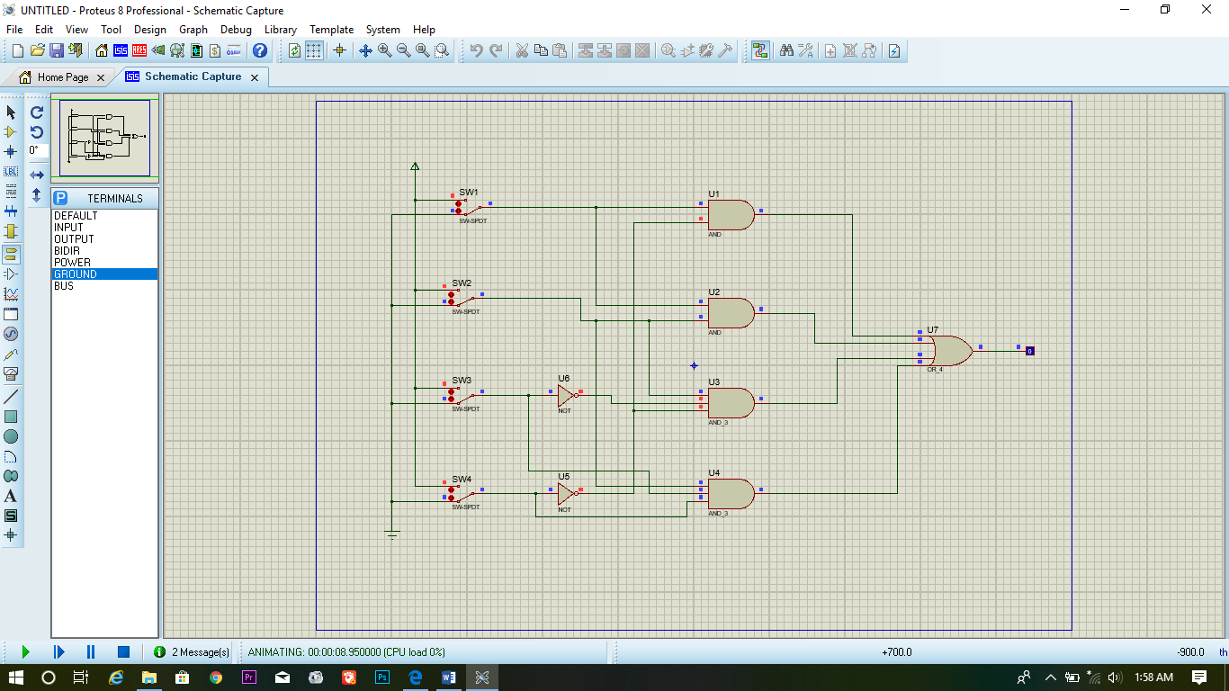

**Pecobaan 5**

|  |  |  |  |  |  |
| --- | --- | --- | --- | --- | --- |
|  | | **AB** | | | |
| **00** | **01** | **11** | **10** |
| **CD** | **00** | **1** | **0** | **1** | **0** |
| **01** | **1** | **0** | **1** | **1** |
| **11** | **1** | **1** | **0** | **0** |
| **10** | **1** | **0** | **0** | **1** |

**F = A’B’ + A’CD + AC’D + ABC’ + B’CD’**

