Nama : Raihan Mazarul Hidayat

NIM : L200180162

Kelas : F

**Percobaan 2**

Buatlah kombinasi gerbang logika berdasarkan peta karnaugh berikut !

|  |  |  |  |  |  |
| --- | --- | --- | --- | --- | --- |
|  | | **AB** | | | |
| 00 | 01 | 11 | 10 |
| **CD** | 00 | 1 | 0 | 0 | 1 |
| 01 | 0 | 1 | 1 | 0 |
| 11 | 0 | 1 | 1 | 0 |
| 10 | 1 | 0 | 0 | 1 |

Fungsi Boolean

**F = BD + B’D’ (AND-OR)**

**F = ( B + D’) + ( B’ + D ) (OR - AND)**

Gerbang logika ( AND - OR )

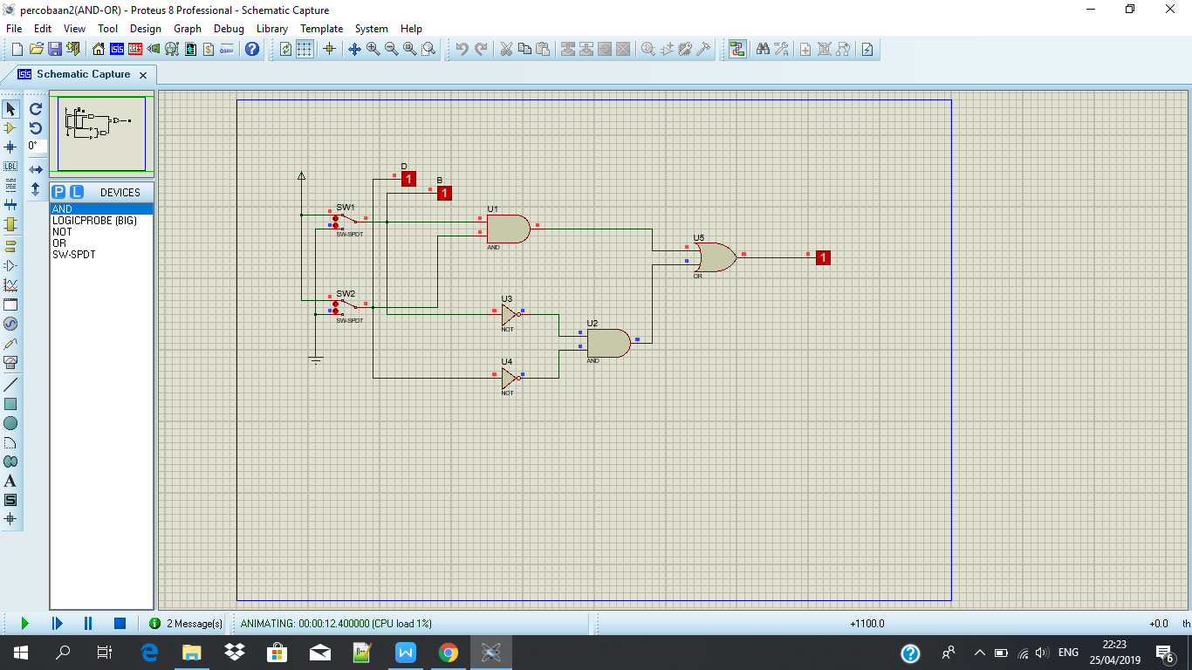

Gerbang logika ( OR - AND )

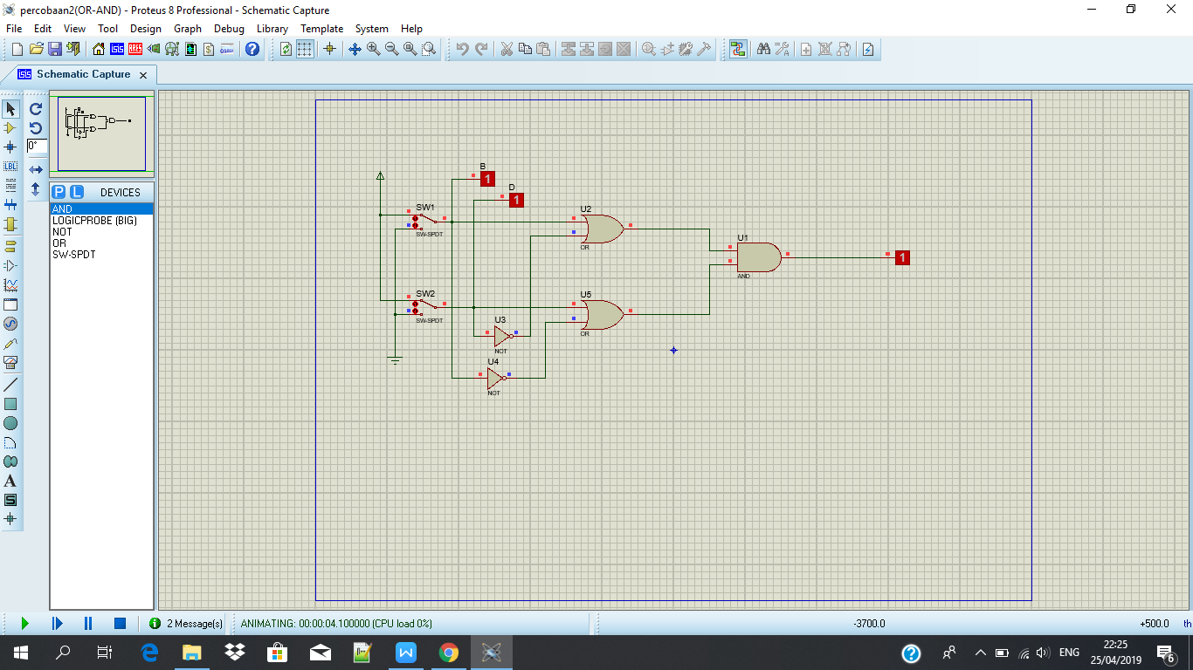

**Percobaan 3**

Fungsi Boolean : **F = XYZ + XYZ’ + XY’Z + X’YZ + X’YZ’ + XY’Z’ + X’Y’Z’**

Berdasarkan fungsi Boolean, isi titik-titik dalam peta karnaugh berikut !

|  |  |  |  |  |  |
| --- | --- | --- | --- | --- | --- |
|  | | **XY** | | | |
| 00 | 01 | 11 | 10 |
| **Z** | 0 | 1 | 1 | 1 | 1 |
| 1 |  | 1 | 1 | 1 |

Sederhanakan Fungsi boolean : **F = Z’ + X + Y**

Gerbang logika :

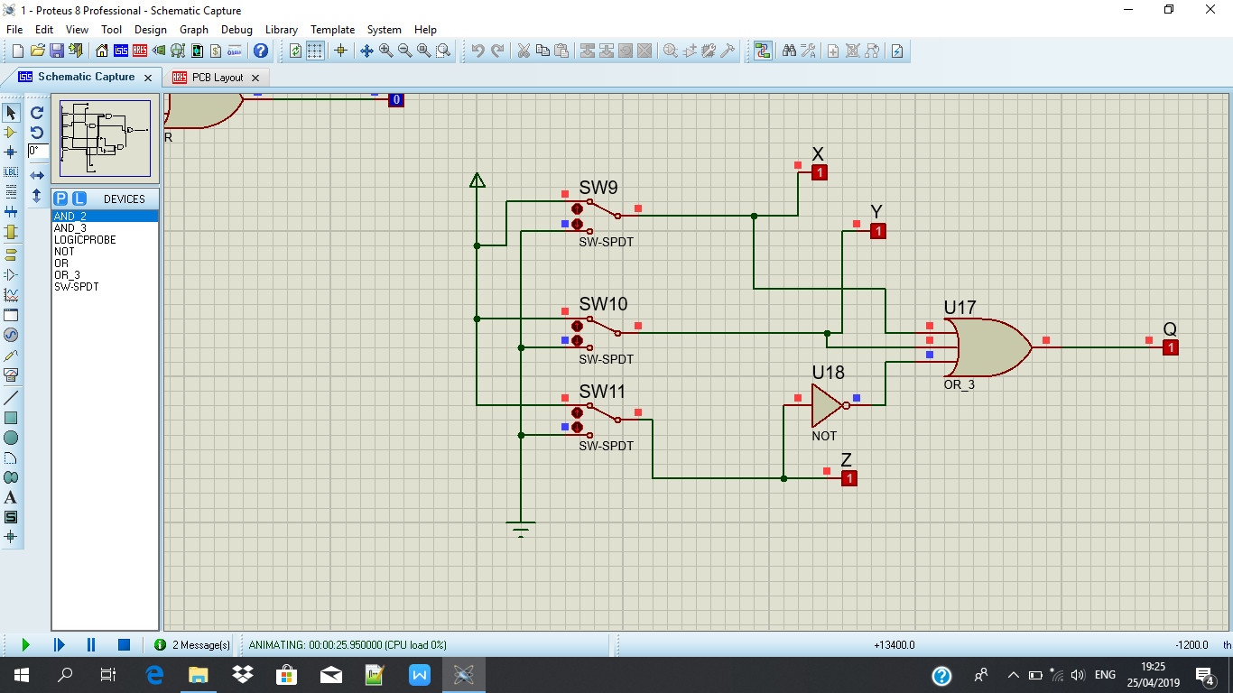

**Percobaan 4**

Fungsi Boolean : **F = AD’ + ABC + ABC’ + BCD + BC’D’ + AB’CD’**

Berdasarkan Fungsi Boolean, isi titik-titik dalam peta karnaugh berikut !

|  |  |  |  |  |  |
| --- | --- | --- | --- | --- | --- |
|  | | **AB** | | | |
| 00 | 01 | 11 | 10 |
| **CD** | 00 |  | 1 | 1 |  |
| 01 |  |  | 1 |  |
| 11 |  | 1 | 1 |  |
| 10 |  |  | 1 | 1 |

Sederhanakan fungsi Boolean :  **F = AB + BC’D’ + BCD + ACD’**

Gerbang Logika :

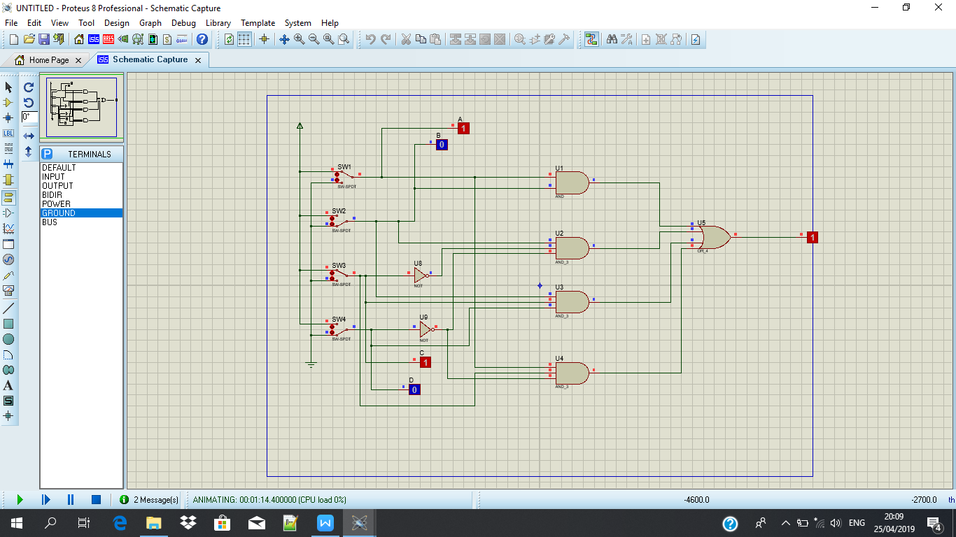

**Percobaan 5**

Tabel fungsi Boolean

|  |  |  |  |  |
| --- | --- | --- | --- | --- |
| **A** | **B** | **C** | **D** | **F** |
| 0 | 0 | 0 | 0 | 1 |
| 1 | 0 | 0 | 0 | 0 |
| 0 | 1 | 0 | 0 | 0 |
| 1 | 1 | 0 | 0 | 1 |
| 0 | 0 | 1 | 0 | 1 |
| 1 | 0 | 1 | 0 | 1 |
| 0 | 1 | 1 | 0 | 0 |
| 1 | 1 | 1 | 0 | 0 |
| 0 | 0 | 0 | 1 | 1 |
| 1 | 0 | 0 | 1 | 1 |
| 0 | 1 | 0 | 1 | 0 |
| 1 | 1 | 0 | 1 | 1 |
| 0 | 0 | 1 | 1 | 1 |
| 1 | 0 | 1 | 1 | 0 |
| 0 | 1 | 1 | 1 | 1 |
| 1 | 1 | 1 | 1 | 0 |

Berdasarkan tabel, Isi titik-titik dalam karnaugh map berikut !

|  |  |  |  |  |  |
| --- | --- | --- | --- | --- | --- |
|  | | **AB** | | | |
| 00 | 01 | 11 | 10 |
| **CD** | 00 | 1 |  | 1 |  |
| 01 | 1 |  | 1 | 1 |
| 11 | 1 | 1 |  |  |
| 10 | 1 |  |  | 1 |

Fungsi Boolean sederhana :

**F = A’B’ + A’CD + ABC’ + AC’D + B’CD’**

Gerbang Logika :

