Nama : Ulin Nuha Trisiana

NIM : L200180190

Kelas F

**Nomor 1**

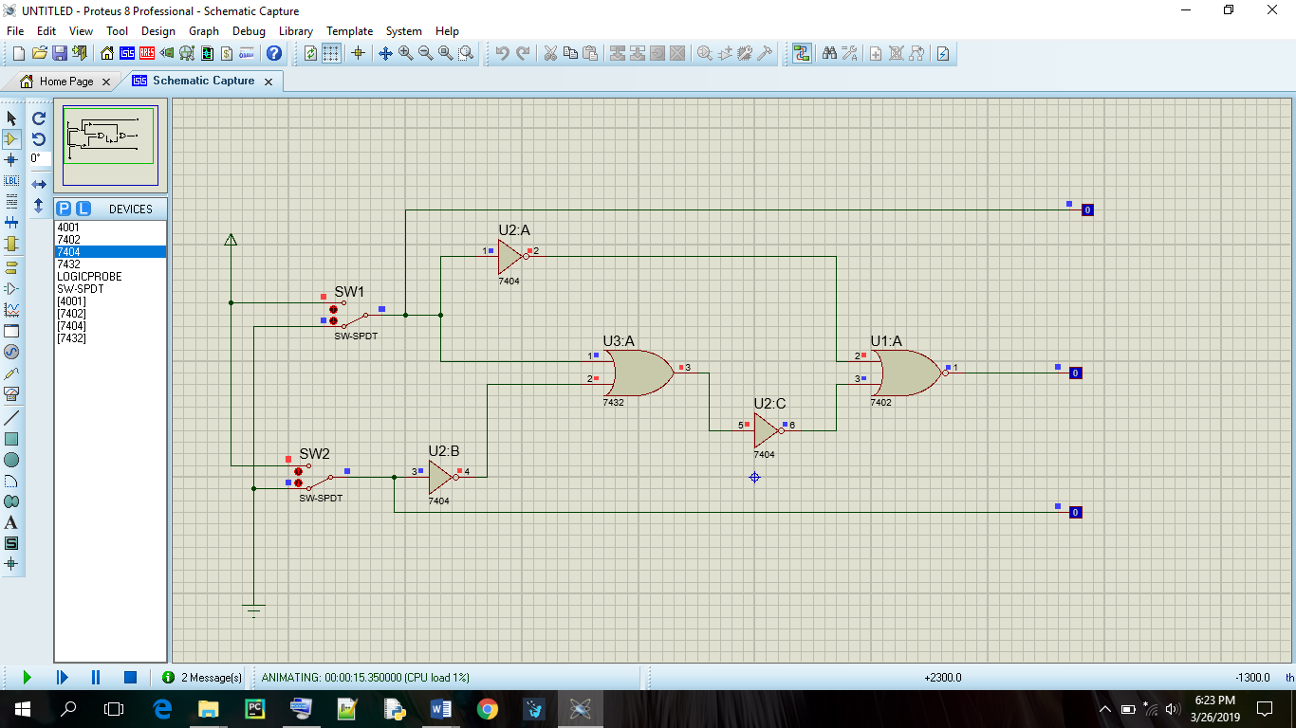

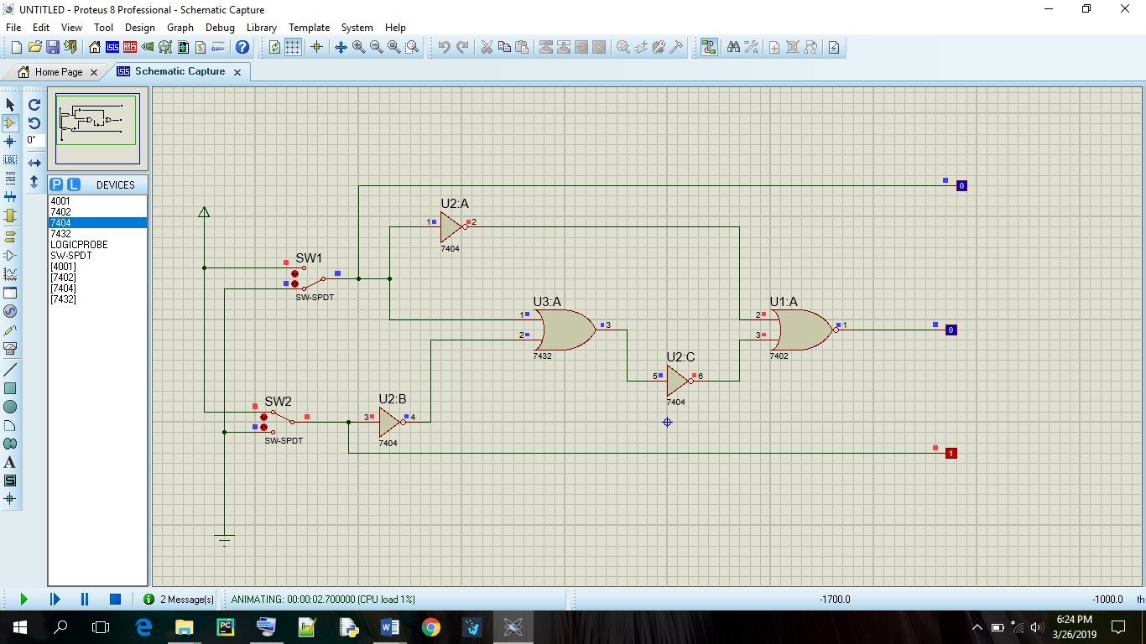

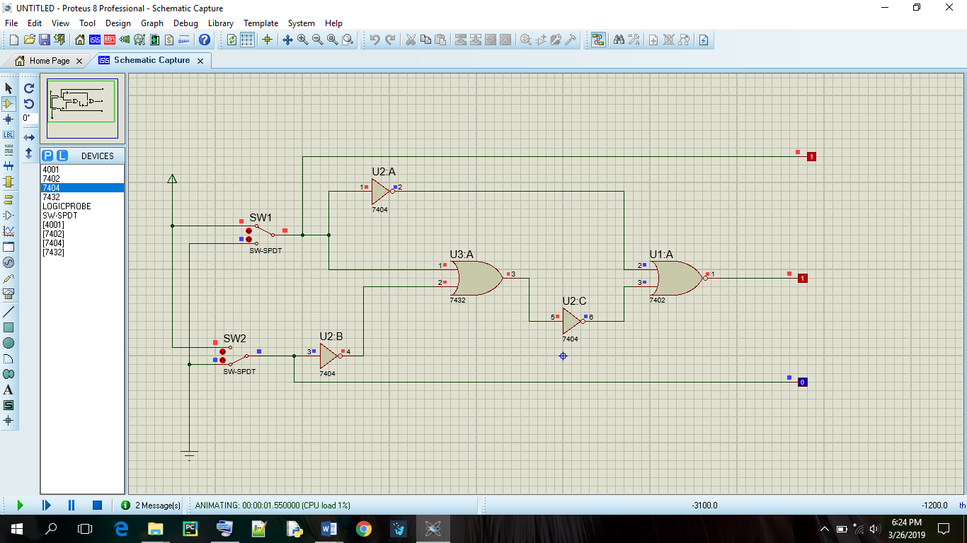

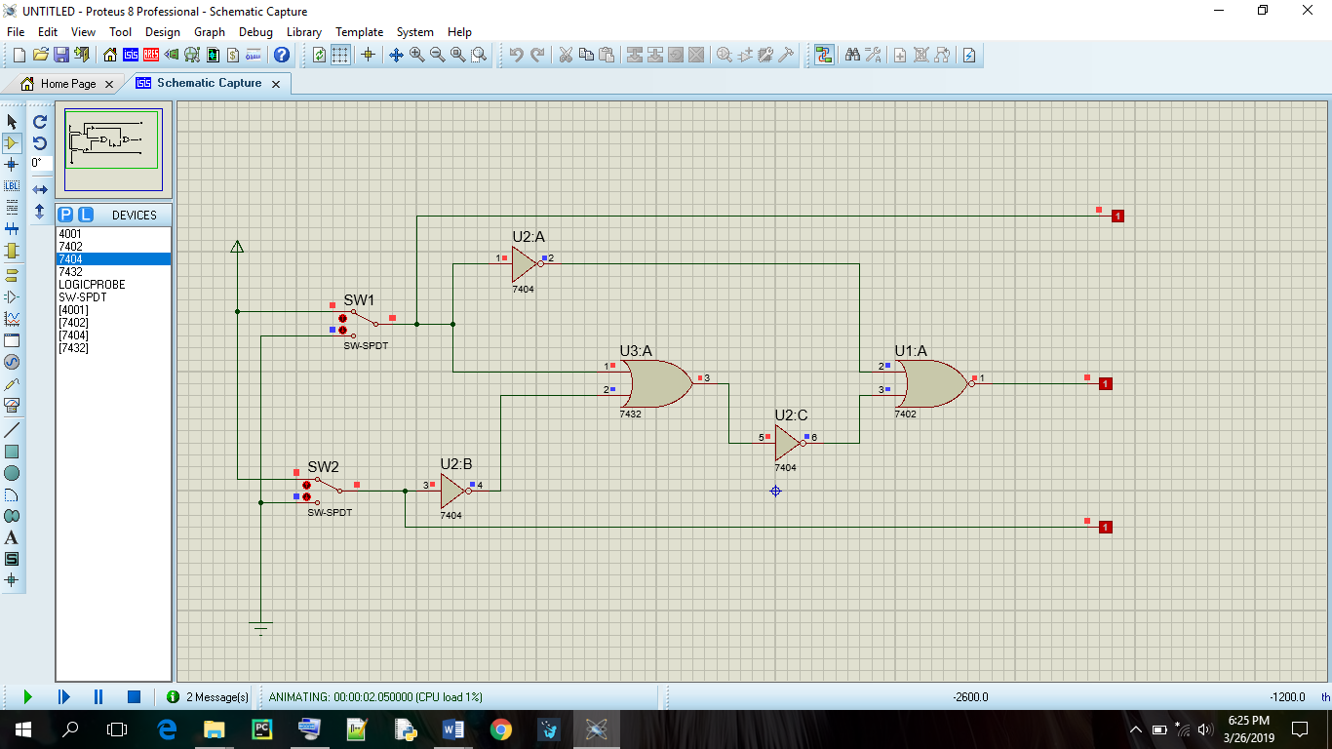

Tabel Kebenaran :

|  |  |  |  |  |
| --- | --- | --- | --- | --- |
| **SW 1** | **SW 2** | **L1** | **L2** | **L3** |
| 0 | 0 | 0 | 0 | 0 |
| 0 | 1 | 0 | 1 | 0 |
| 1 | 0 | 1 | 0 | 1 |
| 1 | 1 | 1 | 1 | 1 |

Diagram waktu

|  |  |  |  |  |
| --- | --- | --- | --- | --- |
| L1 |  |  |  |  |
|  |  |  |  |
|  |  |  |  |
| L2 |  |  |  |  |
|  |  |  |  |
|  |  |  |  |
| L3 |  |  |  |  |
|  |  |  |  |
|  |  |  |  |

**Nomor 2**

