Nama : Amartya Maulana

NIM : L200180196

Kelas : G

MODUL 10
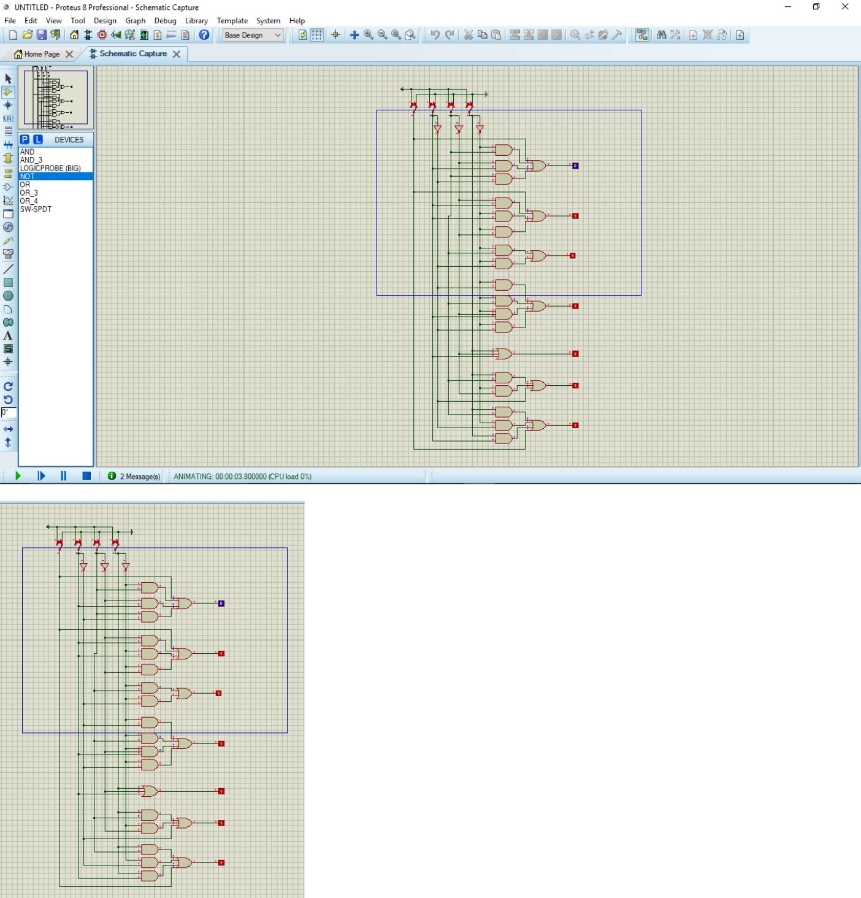
Decimal |  |  | Input |  |  |  |  | Output |  |  |  |  |  | Display
Digit |  |  |  |  |  |  |  |  |  |  |  |  |  | Output
Digit | LT | D | C | B | A | a | b | c |  | d | e | f | g | Output
0 | H | L | L | L | L | H | H | H |  | H | H | H | L | 0
1 | H | L | L | L | H | H | H | H |  | H | H | H | H | 8
2 | H | L | L | H | L | L | H | H |  | H | L | H | H | y
3 | H | L | L | H | H | H | H | H |  | H | L | H | H | 9
4 | H | L | H | L | L | H | H | L |  | H | H | L | H | 2
5 | H | L | H | L | H | H | H | L |  | H | H | H | H | e
6 | H | L | H | H | L | L | L | H |  | H | H | H | H | b
7 | H | L | H | H | H | H | L | H |  | H | H | H | H | 6
8 | H | H | L | L | L | L | H | H |  | L | L | L | L | 1
9 | H | H | L | L | H | H | H | H |  | L | L | H | H | q
LT | L | X | X | X | X | H | H | H |  | H | H | H | H | 8

Berbeda dengan table IC 4511

