Nama : Rizki Hanif A.M

NIM : L200180210

Kelas : G

Tugas Modul 4

Nomor 1
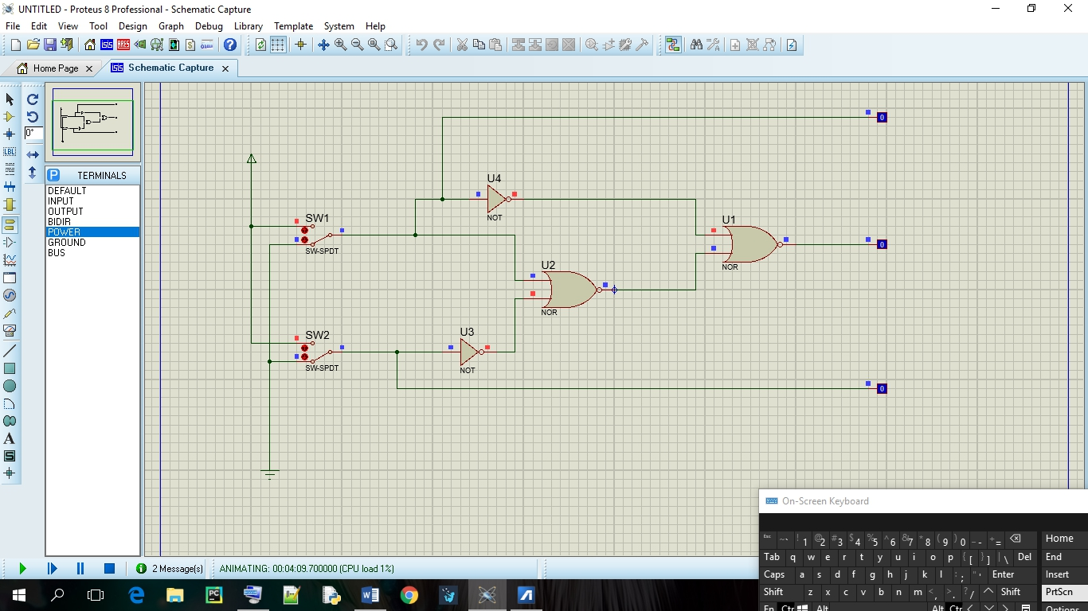
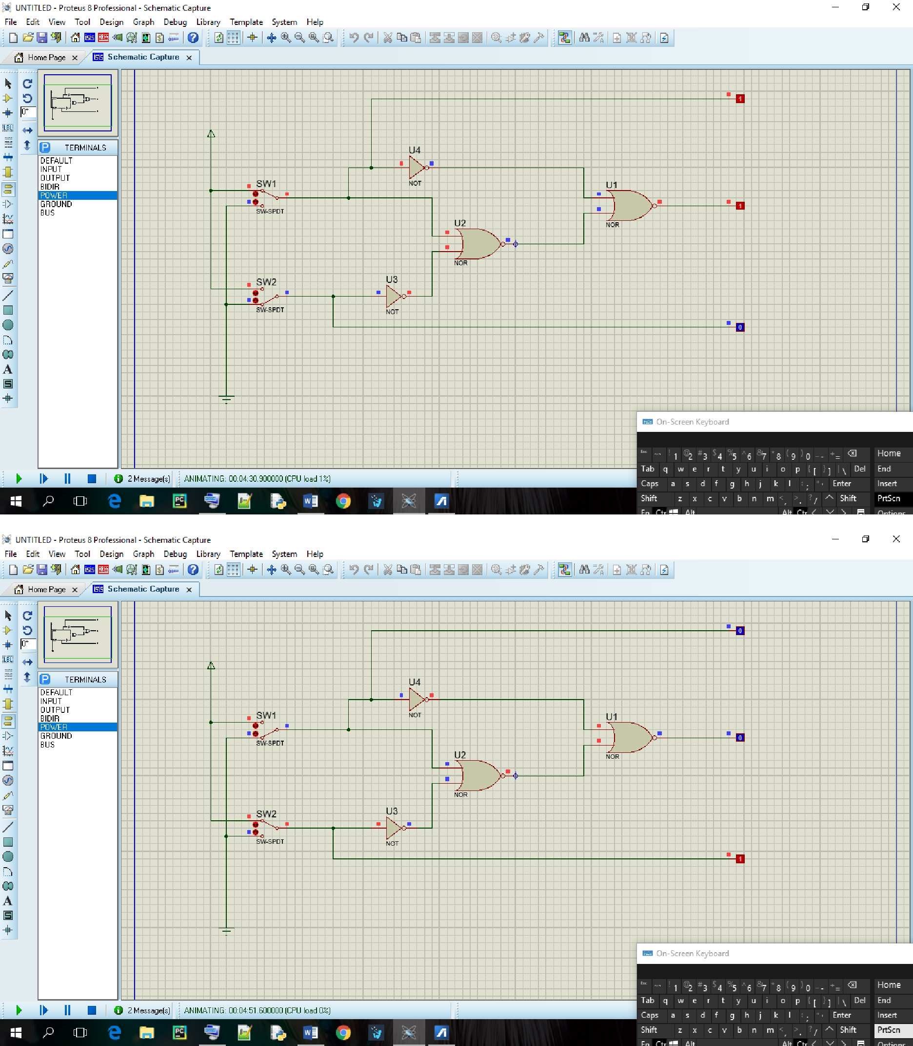
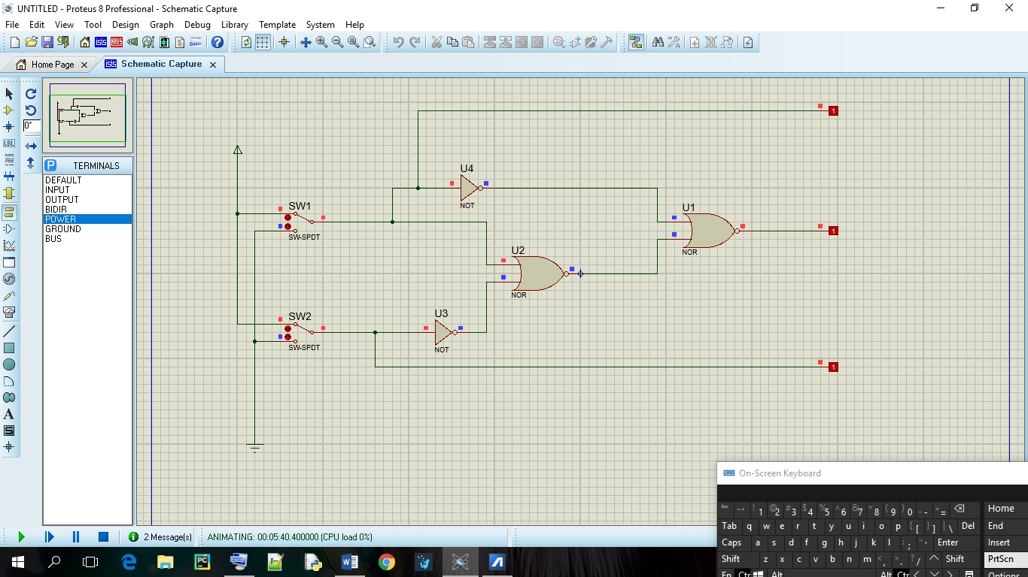

Tabel Kebenaran

SW1 | SW2 | L1 | L2 | L3
0 | 0 | 0 | 0 | 0
1 | 0 | 1 | 0 | 1
0 | 1 | 0 | 1 | 1
1 | 1 | 1 | 1 | 1

Diagram Waktu

L1

L2

L3

Fungsi Boolean
L3=L1+(L1+L2)

Nomor 2
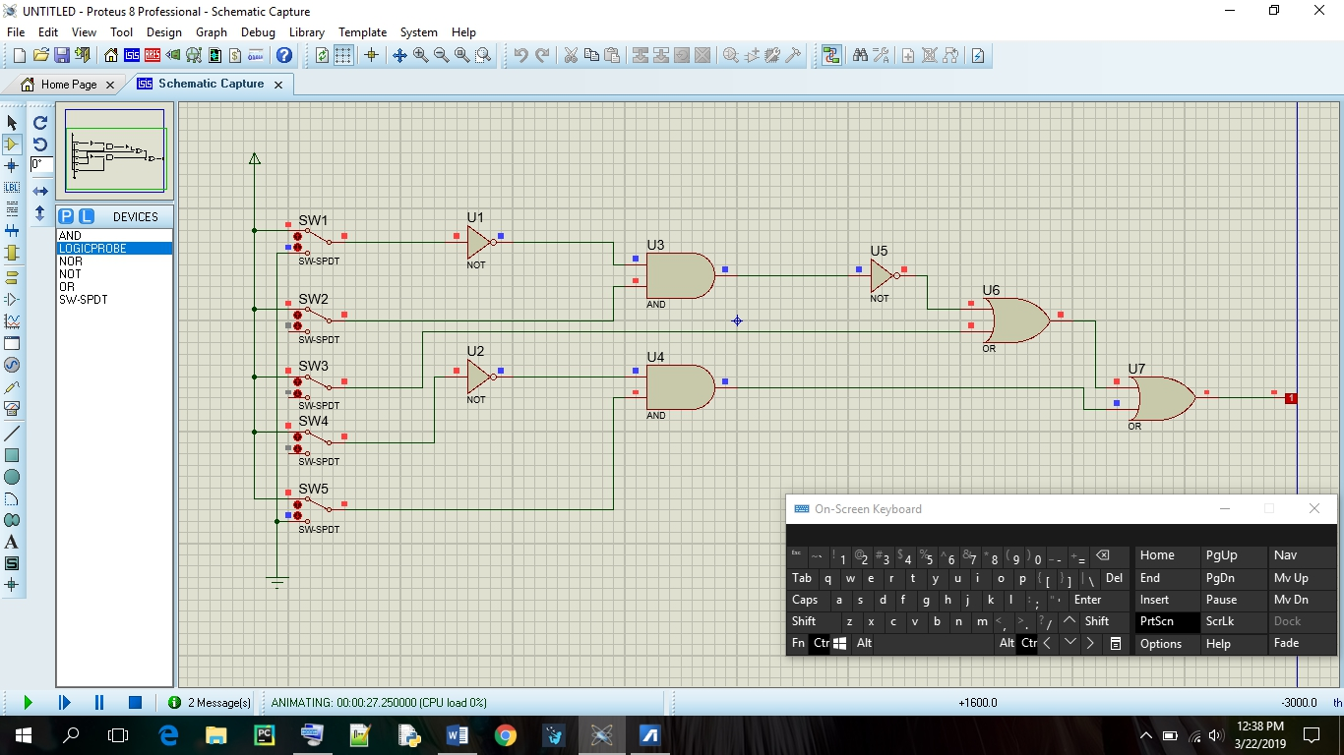

CFungsi Boolean

F = (A . B + C) + (D . E)

