Nama : Damping Rizki W.A

NIM : L200180213

Kelas E

|  |  |  |  |  |
| --- | --- | --- | --- | --- |
| Proses | Arrival time | Burst time | Service time | Priority |
| p0 | 0 | 7 | 0 | 4 |
| p1 | 1 | 3 | 7 | 2 |
| p2 | 2 | 10 | 10 | 1 |
| p3 | 3 | 2 | 20 | 3 |

FCFS

|  |  |
| --- | --- |
| Proses | Wait time |
| p0 | 7 |
| p1 | 3 |
| p2 | 10 |
| p3 | 2 |
| Avg.Turns time | 14.25 |
| Avg.Waiting time | 9.25 |
| Avg.Respon time | 9.25 |

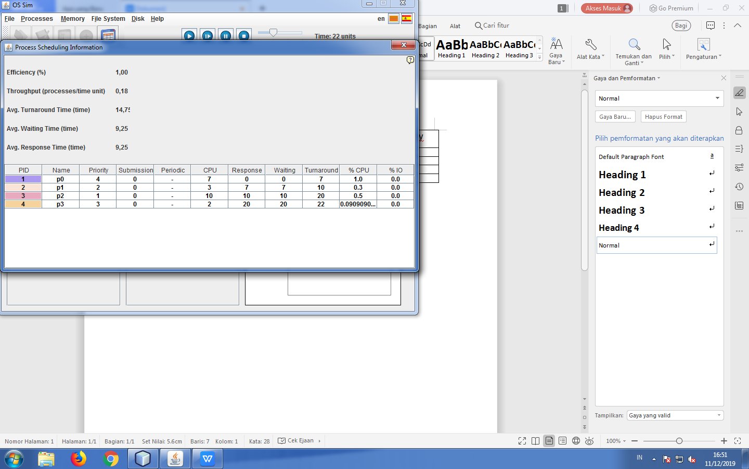

1. SJFS

Preemtive :

|  |  |
| --- | --- |
| Proses | Wait time |
| p0 | 7 |
| p1 | 3 |
| p2 | 10 |
| p3 | 2 |
| Avg.Turns time | 10.25 |
| Avg.Waiting time | 4.75 |
| Avg.Respon time | 4.75 |

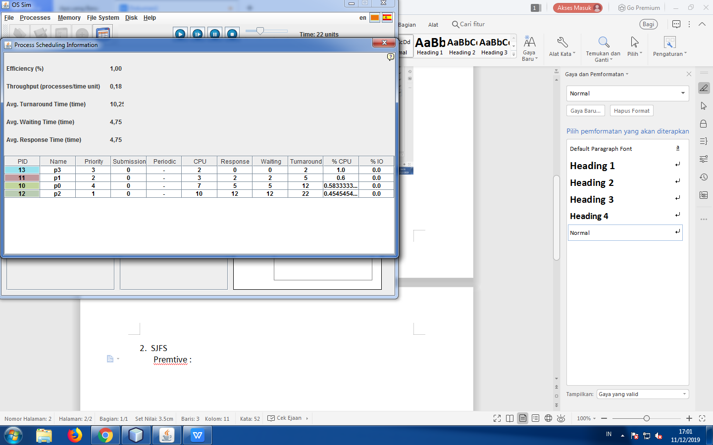

Non Preemtive:

|  |  |
| --- | --- |
| Proses | Wait time |
| p0 | 7 |
| p1 | 3 |
| p2 | 10 |
| p3 | 2 |
| Avg.Turns time | 10.25 |
| Avg.Waiting time | 4.75 |
| Avg.Respon time | 4.75 |

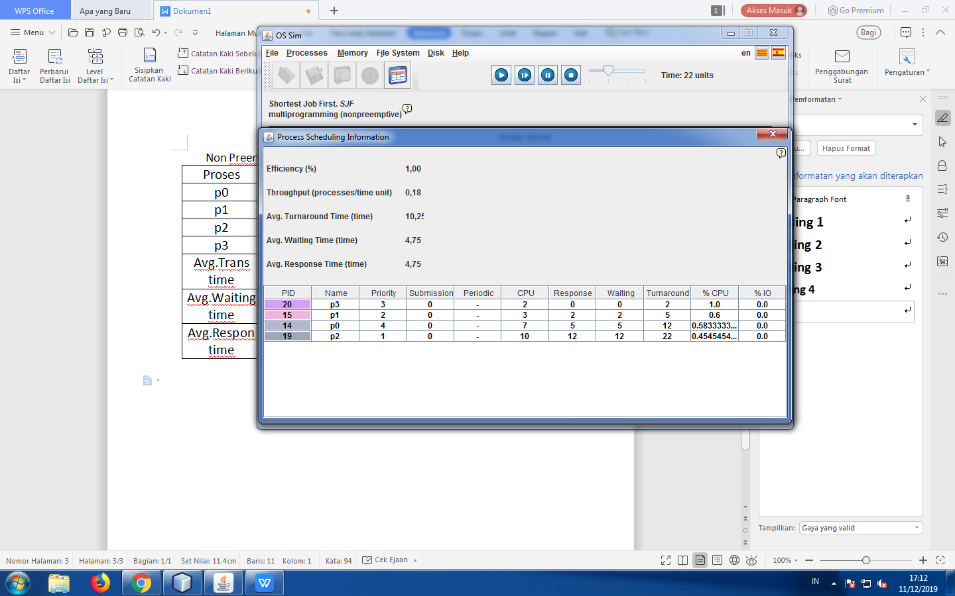

1. Priority scheduling

Non preemtive:

|  |  |
| --- | --- |
| Proses | Wait time |
| p0 | 7 |
| p1 | 3 |
| p2 | 10 |
| p3 | 2 |
| Avg.Turns time | 10.75 |
| Avg.Waiting time | 7.0 |
| Avg.Respon time | 7.0 |

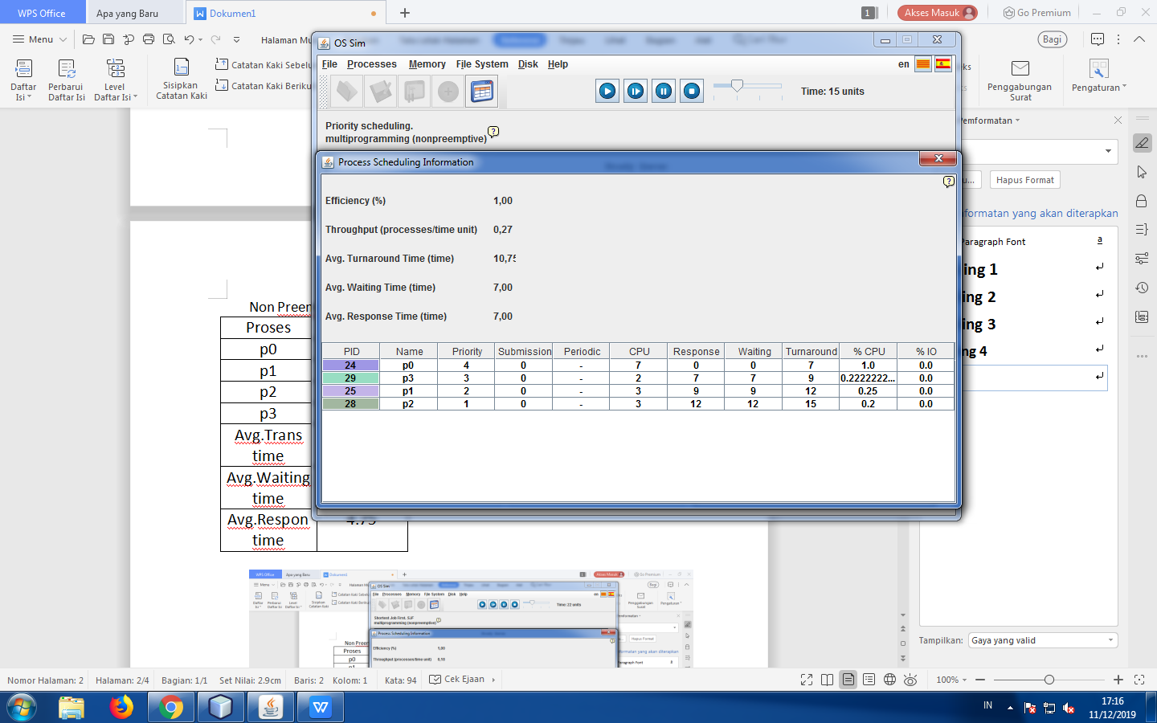

Preemtive :

|  |  |
| --- | --- |
| Proses | Wait time |
| p0 | 7 |
| p1 | 3 |
| p2 | 10 |
| p3 | 2 |
| Avg.Turns time | 12.50 |
| Avg.Waiting time | 7.0 |
| Avg.Respon time | 7.0 |

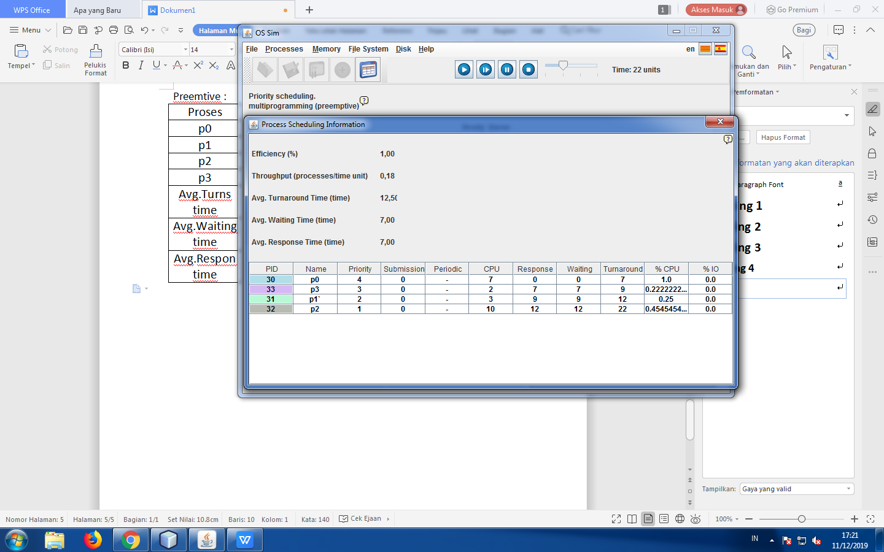

1. Round robin(Quantum time = 4)

|  |  |
| --- | --- |
| Proses | Wait time |
| p0 | 7 |
| p1 | 3 |
| p2 | 10 |
| p3 | 2 |
| Avg.Turns time | 14.50 |
| Avg.Waiting time | 9.0 |
| Avg.Respon time | 5.50 |

