Nama : Damping rizki W.A

NIM : L200180213

Kelas G

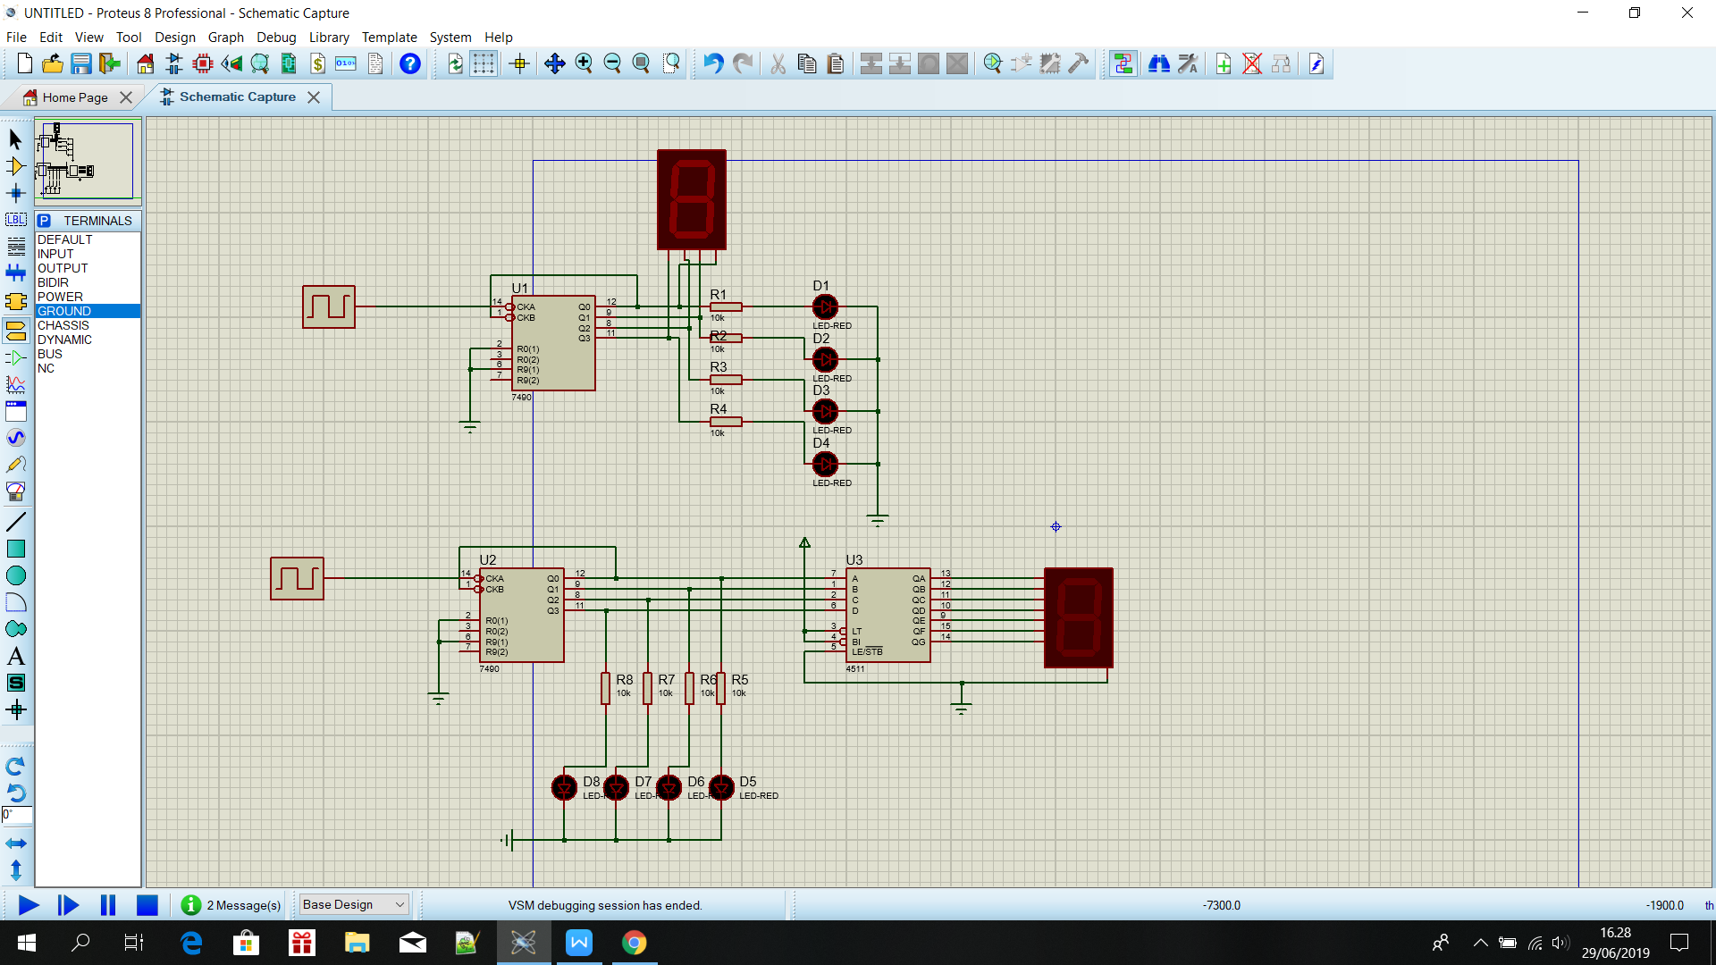

Percobaan 1

|  |  |  |  |  |  |
| --- | --- | --- | --- | --- | --- |
| INPUT Clock | OUTPUT LED | | | | OUPUT 7Segment |
| D1 | D2 | D3 | D4 |
| 1 | 1 | 0 | 0 | 0 | 1 |
| 2 | 0 | 1 | 0 | 0 | 2 |
| 3 | 1 | 1 | 0 | 0 | 3 |
| 4 | 0 | 0 | 1 | 0 | 4 |
| 5 | 1 | 0 | 1 | 0 | 5 |
| 6 | 0 | 1 | 1 | 0 | 6 |
| 7 | 1 | 1 | 1 | 0 | 7 |
| 8 | 0 | 0 | 0 | 1 | 8 |
| 9 | 1 | 0 | 0 | 1 | 9 |
| 10 | 0 | 0 | 0 | 0 | 0 |
| 11 | 1 | 0 | 0 | 0 | 1 |
| 12 | 0 | 1 | 0 | 0 | 2 |
| 13 | 1 | 1 | 0 | 0 | 3 |

Percobaan 2

|  |  |  |  |  |  |
| --- | --- | --- | --- | --- | --- |
| INPUT Clock | OUTPUT LED | | | | OUPUT 7Segment |
| D1 | D2 | D3 | D4 |
| 1 | 1 | 0 | 0 | 0 | 1 |
| 2 | 0 | 1 | 0 | 0 | 2 |
| 3 | 1 | 1 | 0 | 0 | 3 |
| 4 | 0 | 0 | 1 | 0 | 4 |
| 5 | 1 | 0 | 1 | 0 | 5 |
| 6 | 0 | 1 | 1 | 0 | 6 |
| 7 | 1 | 1 | 1 | 0 | 7 |
| 8 | 0 | 0 | 0 | 1 | 8 |
| 9 | 1 | 0 | 0 | 1 | 9 |
| 10 | 0 | 0 | 0 | 0 | 0 |
| 11 | 1 | 0 | 0 | 0 | 1 |

Perbandingannya saat 7-segment common cathode menunjukan angka 9 terlihat seperti huruf Q kecil ( q ).

Jadi dapat disimpulkan jelas berbeda 7-seg-BCD dengan BCD to 7-segment decoder.

Percobaan 3 dan TUGAS

Output yang dihasilkan berbeda dengan tabel poin 1. Perbedaan ada pada display output pada decimal digit ke 6. Jika pada fungsi tabel poin 1 angka 6 terlihat seperti huruf B kecil ( b ),sedangkan pada BCD-to-7segment tidak atau terlihat angka 6 pada umumnnya.