Nama : Damping rizki W.A

NIM : L200180213

Kelas G

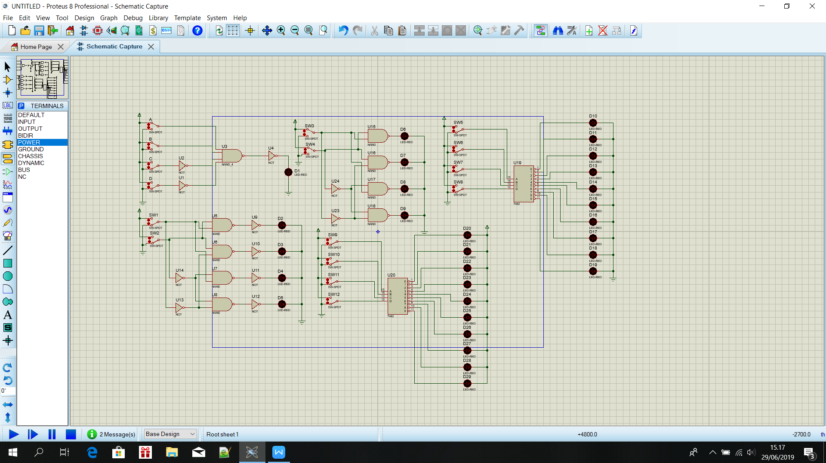

Percobaan 1

|  |  |  |  |  |
| --- | --- | --- | --- | --- |
| A | B | C | D | F |
| 0 | 0 | 0 | 0 | 0 |
| 1 | 0 | 0 | 0 | 0 |
| 0 | 1 | 0 | 0 | 0 |
| 1 | 1 | 0 | 0 | 1 |
| 0 | 0 | 1 | 0 | 0 |
| 1 | 0 | 1 | 0 | 0 |
| 0 | 1 | 1 | 0 | 0 |
| 1 | 1 | 1 | 0 | 0 |
| 0 | 0 | 0 | 1 | 0 |
| 1 | 0 | 0 | 1 | 0 |
| 0 |  | 0 | 1 | 0 |
| 1 | 1 | 0 | 1 | 0 |
| 0 | 0 | 1 | 1 | 0 |
| 1 | 0 | 1 | 1 | 0 |
| 0 | 1 | 1 | 1 | 0 |
| 1 | 1 | 1 | 1 | 0 |

Decoder akan bekerja jika A=1, B=1, C=0, D=0

Untuk membuat F=1 jika kondisi A=0, B=1, C=1, D=1 maka sama seperti rangkain tetapi NOT pada C dan D dihilangkan lalu not tersebut dipasangkan pada A.

Percobaan 2

|  |  |  |  |  |  |
| --- | --- | --- | --- | --- | --- |
| INPUT | | OUTPUT LED | | | |
| SW1 | SW2 | D1 | D2 | D3 | D4 |
| 0 | 0 | 0 | 0 | 0 | 1 |
| 0 | 1 | 0 | 1 | 0 | 0 |
| 1 | 0 | 0 | 0 | 1 | 0 |
| 1 | 1 | 1 | 0 | 0 | 0 |

D1= SW1.SW2

D2= SW1’.SW2

D3= SW1.SW2’

D4= SW1’.SW2’

Percobaan 3

|  |  |  |  |  |  |
| --- | --- | --- | --- | --- | --- |
| INPUT | | OUTPUT LED | | | |
| SW1 | SW2 | D1 | D2 | D3 | D4 |
| 0 | 0 | 1 | 1 | 1 | 0 |
| 0 | 1 | 1 | 0 | 1 | 1 |
| 1 | 0 | 1 | 1 | 0 | 1 |
| 1 | 1 | 0 | 1 | 1 | 1 |

D1= SW1.SW2

D2= SW1’.SW2

D3= SW1.SW2’

D4= SW1’.SW2’

Perbandingannya adalah bekerja berkebalikan, Jika pada percobaan 2 LED yang hidup adalah LED yang mati pada percobaan 3 begitu juga sebaliknya.

Percobaan 4

Common anode LED

|  |  |  |  |  |  |  |  |  |  |  |  |  |  |  |
| --- | --- | --- | --- | --- | --- | --- | --- | --- | --- | --- | --- | --- | --- | --- |
| INPUT | | | | OUTPUT | | | | | | | | | | |
| SW4 | SW3 | SW2 | SW1 | 0 | 1 | 2 | 3 | 4 | 5 | 6 | 7 | 8 | 9 |
| 0 | 0 | 0 | 0 | 1 | 0 | 0 | 0 | 0 | 0 | 0 | 0 | 0 | 0 |
| 0 | 0 | 0 | 1 | 0 | 1 | 0 | 0 | 0 | 0 | 0 | 0 | 0 | 0 |
| 0 | 0 | 1 | 0 | 0 | 0 | 1 | 0 | 0 | 0 | 0 | 0 | 0 | 0 |
| 0 | 0 | 1 | 1 | 0 | 0 | 0 | 1 | 0 | 0 | 0 | 0 | 0 | 0 |
| 0 | 1 | 0 | 0 | 0 | 0 | 0 | 0 | 1 | 0 | 0 | 0 | 0 | 0 |
| 0 | 1 | 0 | 1 | 0 | 0 | 0 | 0 | 0 | 1 | 0 | 0 | 0 | 0 |
| 0 | 1 | 1 | 0 | 0 | 0 | 0 | 0 | 0 | 0 | 1 | 0 | 0 | 0 |
| 0 | 1 | 1 | 1 | 0 | 0 | 0 | 0 | 0 | 0 | 0 | 1 | 0 | 0 |
| 1 | 0 | 0 | 0 | 0 | 0 | 0 | 0 | 0 | 0 | 0 | 0 | 1 | 0 |
| 1 | 0 | 0 | 1 | 0 | 0 | 0 | 0 | 0 | 0 | 0 | 0 | 0 | 1 |
| 1 | 0 | 1 | 0 | 0 | 0 | 0 | 0 | 0 | 0 | 0 | 0 | 0 | 0 |
| 1 | 0 | 1 | 1 | 0 | 0 | 0 | 0 | 0 | 0 | 0 | 0 | 0 | 0 |
| 1 | 1 | 0 | 0 | 0 | 0 | 0 | 0 | 0 | 0 | 0 | 0 | 0 | 0 |
| 1 | 1 | 0 | 1 | 0 | 0 | 0 | 0 | 0 | 0 | 0 | 0 | 0 | 0 |
| 1 | 1 | 1 | 0 | 0 | 0 | 0 | 0 | 0 | 0 | 0 | 0 | 0 | 0 |
| 1 | 1 | 1 | 1 | 0 | 0 | 0 | 0 | 0 | 0 | 0 | 0 | 0 | 0 |

Common cathode LED

|  |  |  |  |  |  |  |  |  |  |  |  |  |  |  |
| --- | --- | --- | --- | --- | --- | --- | --- | --- | --- | --- | --- | --- | --- | --- |
| INPUT | | | | OUTPUT | | | | | | | | | | |
| SW4 | SW3 | SW2 | SW1 | 0 | 1 | 2 | 3 | 4 | 5 | 6 | 7 | 8 | 9 |
| 0 | 0 | 0 | 0 | 0 | 1 | 1 | 1 | 1 | 1 | 1 | 1 | 1 | 1 |
| 0 | 0 | 0 | 1 | 1 | 0 | 1 | 1 | 1 | 1 | 1 | 1 | 1 | 1 |
| 0 | 0 | 1 | 0 | 1 | 1 | 0 | 1 | 1 | 1 | 1 | 1 | 1 | 1 |
| 0 | 0 | 1 | 1 | 1 | 1 | 1 | 0 | 1 | 1 | 1 | 1 | 1 | 1 |
| 0 | 1 | 0 | 0 | 1 | 1 | 1 | 1 | 0 | 1 | 1 | 1 | 1 | 1 |
| 0 | 1 | 0 | 1 | 1 | 1 | 1 | 1 | 1 | 0 | 1 | 1 | 1 | 1 |
| 0 | 1 | 1 | 0 | 1 | 1 | 1 | 1 | 1 | 1 | 0 | 1 | 1 | 1 |
| 0 | 1 | 1 | 1 | 1 | 1 | 1 | 1 | 1 | 1 | 1 | 0 | 1 | 1 |
| 1 | 0 | 0 | 0 | 1 | 1 | 1 | 1 | 1 | 1 | 1 | 1 | 0 | 1 |
| 1 | 0 | 0 | 1 | 1 | 1 | 1 | 1 | 1 | 1 | 1 | 1 | 1 | 0 |
| 1 | 0 | 1 | 0 | 1 | 1 | 1 | 1 | 1 | 1 | 1 | 1 | 1 | 1 |
| 1 | 0 | 1 | 1 | 1 | 1 | 1 | 1 | 1 | 1 | 1 | 1 | 1 | 1 |
| 1 | 1 | 0 | 0 | 1 | 1 | 1 | 1 | 1 | 1 | 1 | 1 | 1 | 1 |
| 1 | 1 | 0 | 1 | 1 | 1 | 1 | 1 | 1 | 1 | 1 | 1 | 1 | 1 |
| 1 | 1 | 1 | 0 | 1 | 1 | 1 | 1 | 1 | 1 | 1 | 1 | 1 | 1 |
| 1 | 1 | 1 | 1 | 1 | 1 | 1 | 1 | 1 | 1 | 1 | 1 | 1 | 1 |

TUGAS

