Nama : Damping rizki W.A

NIM : L200180213

Kelas G

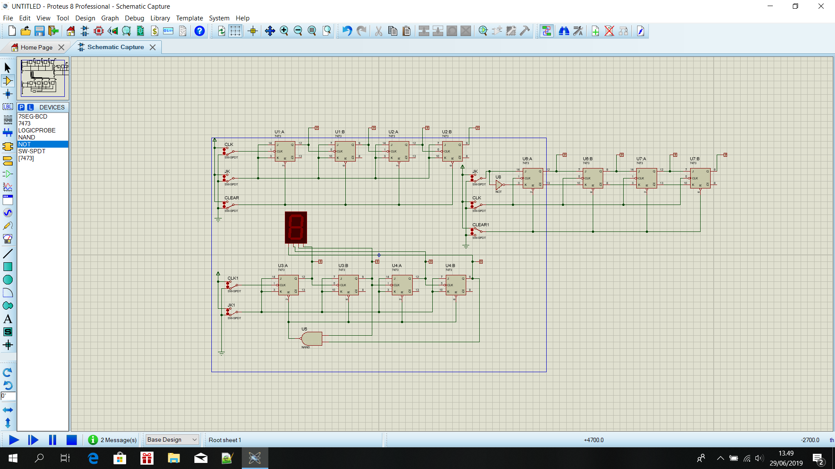

Percobaan 1

|  |  |  |  |  |  |  |  |
| --- | --- | --- | --- | --- | --- | --- | --- |
|  | INPUT | | | OUTPUT | | | |
| CLEAR | JK | CLK | A | B | C | D |
| 1 | 1 | 1 | 0 | 0 | 0 | 0 | 0 |
| 2 | 1 | 1 | 1 | 0 | 0 | 0 | 0 |
| 3 | 1 | 1 | 0 | 0 | 0 | 0 | 1 |
| 4 | 1 | 1 | 1 | 0 | 0 | 0 | 1 |
| 5 | 1 | 1 | 0 | 0 | 0 | 1 | 0 |
| 6 | 1 | 1 | 1 | 0 | 0 | 1 | 0 |
| 7 | 1 | 1 | 0 | 0 | 0 | 1 | 1 |
| 8 | 1 | 1 | 1 | 0 | 0 | 1 | 1 |
| 9 | 1 | 1 | 0 | 0 | 1 | 0 | 0 |

|  |  |  |  |  |  |  |  |
| --- | --- | --- | --- | --- | --- | --- | --- |
| 10 | 1 | 1 | 1 | 0 | 1 | 0 | 0 |
| 11 | 1 | 1 | 0 | 0 | 1 | 0 | 1 |
| 12 | 1 | 1 | 1 | 0 | 1 | 0 | 1 |
| 13 | 1 | 1 | 0 | 0 | 1 | 1 | 0 |
| 14 | 1 | 1 | 1 | 0 | 1 | 1 | 0 |
| 15 | 1 | 0 | 0 | 0 | 1 | 1 | 1 |
| 16 | 1 | 0 | 1 | 0 | 1 | 1 | 1 |
| 17 | 1 | 1 | 0 | 1 | 0 | 0 | 0 |
| 18 | 1 | 1 | 1 | 1 | 0 | 0 | 0 |
| 19 | 0 | 1 | 0 | 0 | 0 | 0 | 1 |
| 20 | 0 | 1 | 1 | 0 | 0 | 0 | 1 |

Fungsi CLK : sebagai indikator pengirim pulsa agar data dapat dikirim

Fungsi JK : sebagai arus data masuk

Fungsi CLEAR : sebagai pereset data

Kesimpulan : Disaat switch clear pada biner 1 dan juga JK disertai dengan 1 pulsa clock ( 0 - 1 - 0 ) maka terjadi proses pengirima data. Sedangkan jika switch clear di nonaktifkan maka terjadi peresetan data di dalam proses jika diberi pulsa clock.

Percobaan 2

|  |  |  |  |  |  |  |
| --- | --- | --- | --- | --- | --- | --- |
|  | INPUT | | OUTPUT | | | |
| JK | CLK | A | B | C | D |
| 1 | 1 | 0 | 0 | 0 | 0 | 0 |
| 2 | 1 | 1 | 0 | 0 | 0 | 0 |
| 3 | 1 | 0 | 0 | 0 | 0 | 1 |
| 4 | 1 | 1 | 0 | 0 | 0 | 1 |
| 5 | 1 | 0 | 0 | 0 | 1 | 0 |
| 6 | 1 | 1 | 0 | 0 | 1 | 0 |
| 7 | 1 | 0 | 0 | 0 | 1 | 1 |
| 8 | 1 | 1 | 0 | 0 | 1 | 1 |
| 9 | 1 | 0 | 0 | 1 | 0 | 0 |
| 10 | 1 | 1 | 0 | 1 | 0 | 0 |
| 11 | 1 | 0 | 0 | 1 | 0 | 1 |
| 12 | 1 | 1 | 0 | 1 | 0 | 1 |
| 13 | 1 | 0 | 0 | 1 | 1 | 0 |
| 14 | 1 | 1 | 0 | 1 | 1 | 0 |
| 15 | 1 | 0 | 0 | 1 | 1 | 1 |
| 16 | 1 | 1 | 0 | 1 | 1 | 1 |
| 17 | 1 | 0 | 1 | 0 | 0 | 0 |
| 18 | 1 | 1 | 1 | 0 | 0 | 0 |
| 19 | 1 | 0 | 1 | 0 | 0 | 1 |
| 20 | 1 | 1 | 1 | 0 | 0 | 1 |
| 21 | 0 | 0 | 1 | 0 | 0 | 1 |
| 22 | 0 | 1 | 0 | 0 | 0 | 0 |
| 23 | 1 | 0 | 0 | 0 | 0 | 0 |
| 24 | 1 | 1 | 0 | 0 | 0 | 1 |

Kesimpulan : rangkaian ini hanya dapat menghitung hingga 10bit

Jika dipaksakan akan terjadi error pada 7 segment.

Percobaan 3

|  |  |  |  |  |  |  |  |
| --- | --- | --- | --- | --- | --- | --- | --- |
|  | INPUT | | | OUTPUT | | | |
| CLEAR | JK | CLK | A | B | C | D |
| 1 | 0 | x | - | 0 | 0 | 0 | 0 |
| 2 | 1 | 1 | - | 0 | 0 | 0 | 0 |
| 3 | 1 | 1 | 1 | 0 | 0 | 0 | 1 |
| 4 | 1 | 1 | 2 | 0 | 0 | 1 | 1 |
| 5 | 1 | 1 | 3 | 0 | 1 | 1 | 1 |
| 6 | 1 | 0 | 4 | 1 | 1 | 1 | 0 |
| 7 | 1 | 0 | 5 | 1 | 1 | 0 | 0 |
| 8 | 1 | 0 | 6 | 1 | 0 | 0 | 0 |
| 9 | 1 | 0 | 7 | 0 | 0 | 0 | 0 |
| 10 | 1 | 0 | 8 | 0 | 0 | 0 | 0 |
| 11 | 1 | 1 | 9 | 1 | 0 | 0 | 0 |
| 12 | 1 | 0 | 10 | 0 | 1 | 0 | 0 |
| 13 | 1 | 0 | 11 | 0 | 0 | 1 | 0 |
| 14 | 1 | 0 | 12 | 0 | 0 | 0 | 1 |
| 15 | 1 | 0 | 13 | 0 | 0 | 0 | 0 |

Kesimpulan : di dalam rangkaian ini tidak akan terjadi proses peresetan data oleh input J dan K.