Nama : Muhammad Khalif Rizaldi Wibowo
Kelas : E
NIM : L200180217
Mata Kuliah : Praktikum Jaringan Komputer

Modul 6
1.
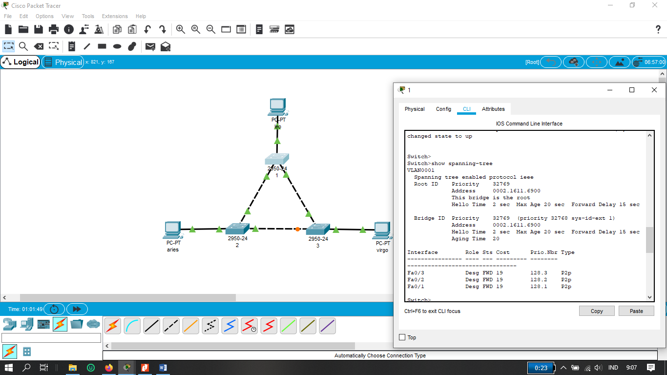
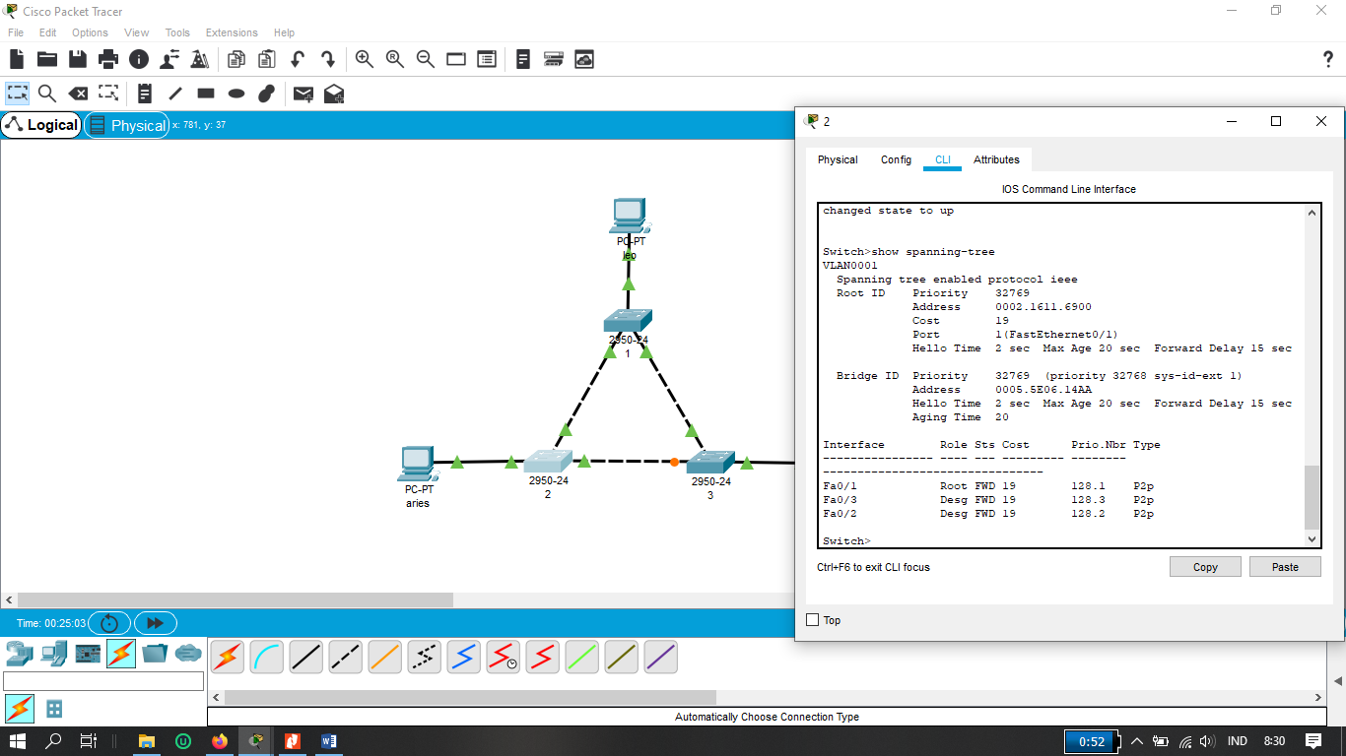

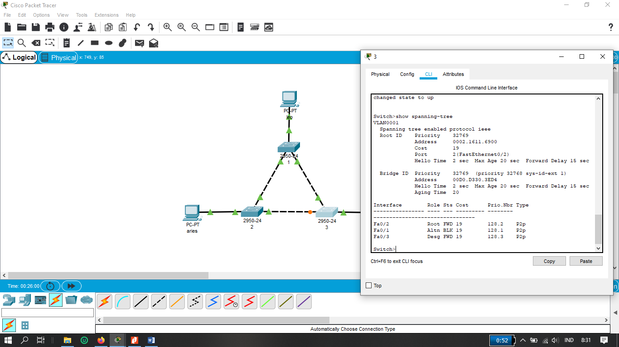

Switch 1
No | Variabel | Nilai
1 | Root ID | -
2 | Priority | 32769
3 | MAC Address | 0002.1611.6900
4 | Bridge ID | -
5 | Cost (0/1; 0/2; 0/3) | 19;19;19
6 | Hello Time | 2 Sec
7 | MaxAge | 20 Sec
8 | Forward Delay | 15 Sec

Switch 2
No | Variabel | Nilai
1 | Root ID | -
2 | Priority | 32769
3 | MAC Address | 0002.1611.6900
4 | Bridge ID | -
5 | Cost (0/1; 0/2; 0/3) | 19;19;19
6 | Hello Time | 2 Sec
7 | MaxAge | 20 Sec
8 | Forward Delay | 15 Sec

Switch 3
No | Variabel | Nilai
1 | Root ID | -
2 | Priority | 32769
3 | MAC Address | 0002.1611.6900
4 | Bridge ID | -
5 | Cost (0/1;0/2;0/3) | 19;19;19
6 | Hello Time | 2 Sec
7 | MaxAge | 20 Sec
8 | Forward Delay | 15 Sec

Switch 1
Fa0/1 = Designed
Fa0/2 = Designed
Fa0/3 = Designed

Switch 2
Fa0/1 = Root
Fa0/2 = Designed
Fa0/3 = Designed

Switch 3
Fa0/1 = Alternatif
Fa0/2 = Root
Fa0/3 = Designated

Switch 1
Fa0/1 = Forward
Fa0/2 = Forward
Fa0/3 = Forward

Switch 2
Fa0/1 = Forward
Fa0/2 = Forward
Fa0/3 = Forward

Switch 3
Fa0/1 = Block
Fa0/2 = Forward
Fa0/3 = Forward

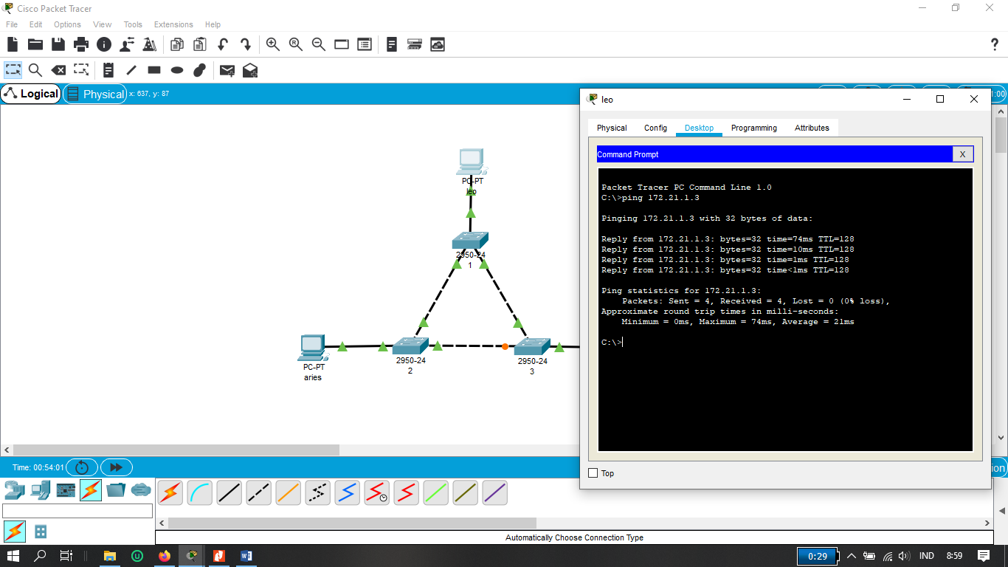

2.
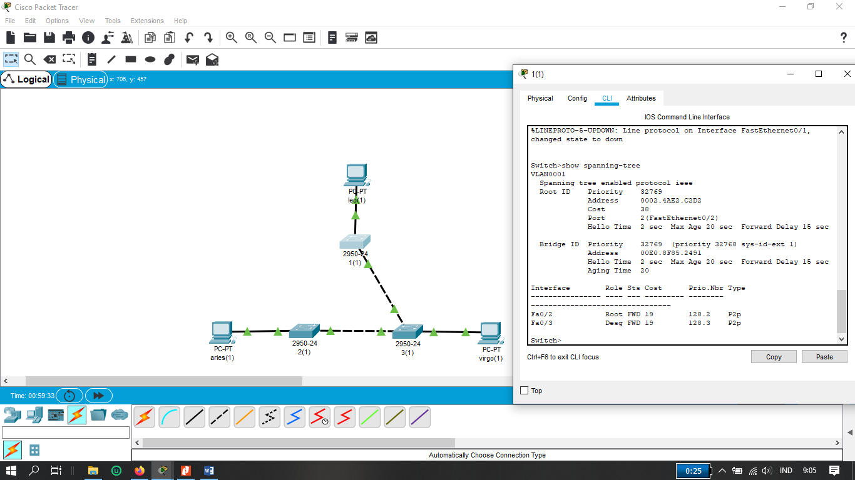
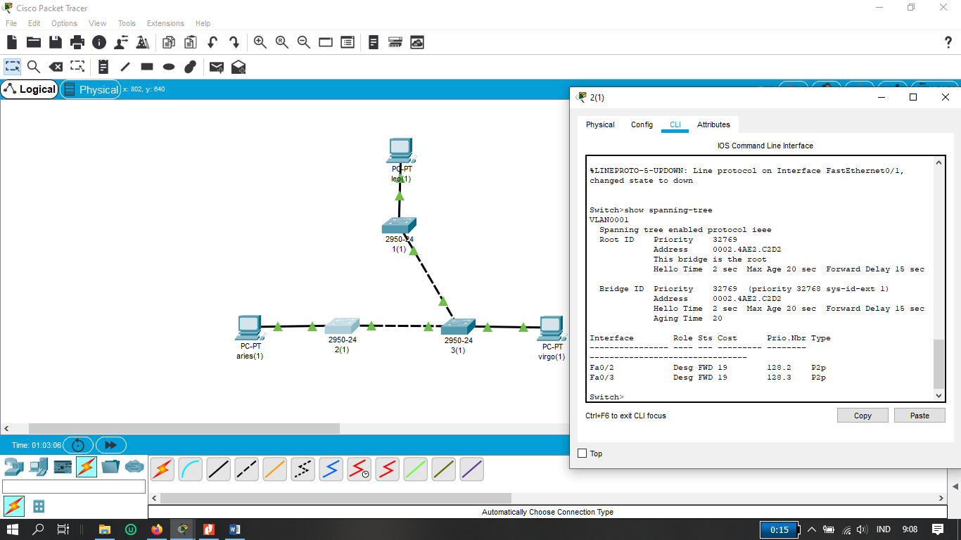
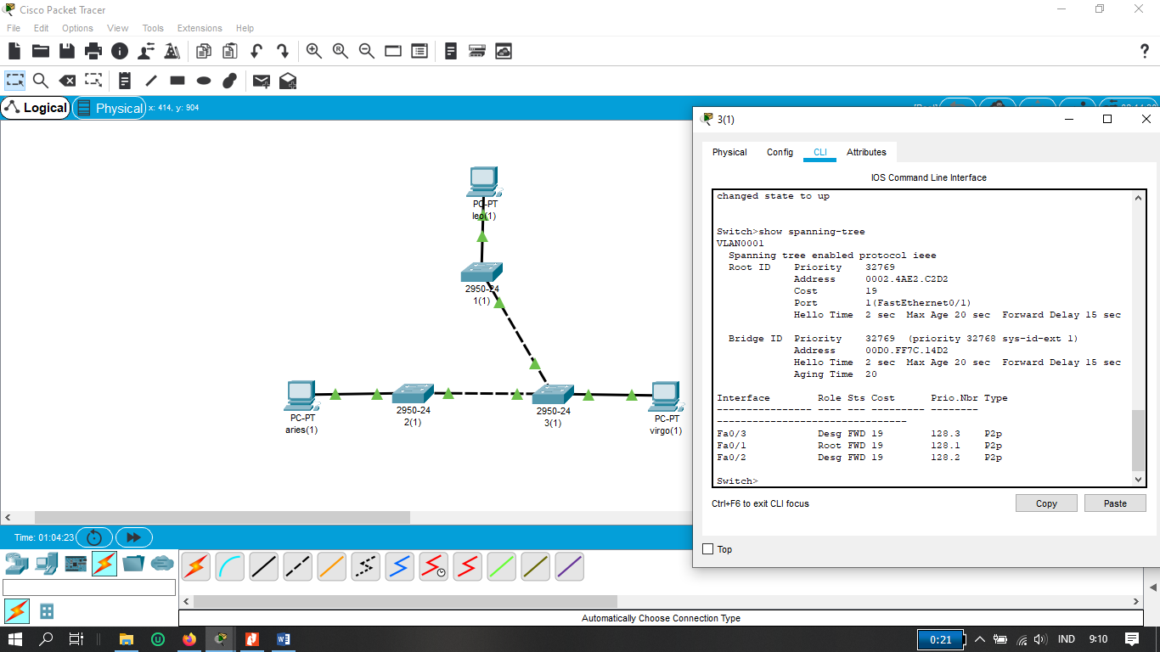
Switch 1
No | Variabel | Nilai
1 | Root ID | -
2 | Priority | 32769
3 | MAC Address | 0002.4AEK2.C2D2
4 | Bridge ID | -
5 | Cost (0/2;0/3) | 19; 19
6 | Hello Time | 2 Sec
7 | MaxAge | 20 Sec
8 | Forward Delay | 15 Sec

Switch 2
No | Variabel | Nilai
1 | Root ID | -
2 | Priority | 32769
3 | MAC Address | 0002.4AE2.C2D2
4 | Bridge ID | -
5 | Cost (0/2;0/3) | 19;19
6 | Hello Time | 2 Sec
7 | MaxAge | 20 Sec
8 | Forward Delay | 15 Sec

Switch 3
No | Variabel | Nilai
1 | Root ID | -
2 | Priority | 32769
3 | MAC Address | 0002.4AE2.C2D2
4 | Bridge ID | -
5 | Cost (0/1;0/2;0/3) | 19;19;19
6 | Hello Time | 2 Sec
7 | MaxAge | 20 Sec
8 | Forward Delay | 15 Sec
Switch 1
Fa0/1 = Root
Fa0/2 = Designated

Switch 2
Fa0/2 = Root
Fa0/3 = Designated
Switch 3
Fa0/1 = Designated
Fa0/2 = Designated
Fa0/3 = Designated

Switch 1
Fa0/2 = Forward
Fa0/3 = Forward

Switch 2
Fa0/2 = Forward
Fa0/3 = Forward

Switch 3
Fa0/1 = Forward
Fa0/2 = Forward
Fa0/3 = Forward

