**Nama : Akbar M**

**NIM : L200180218**

**MODUL 11**

1. **FCFS**

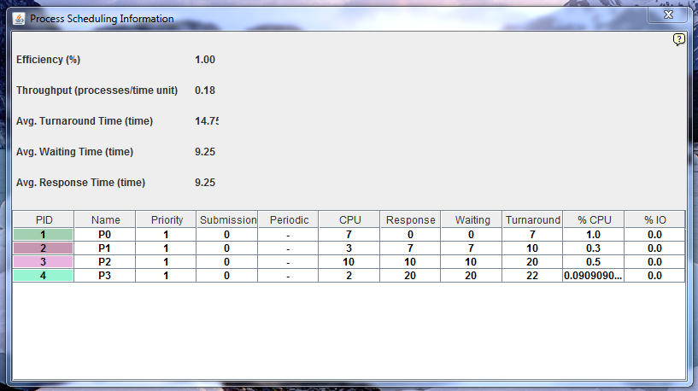

|  |  |
| --- | --- |
| Process | Waiting Time |
| P0 | 0 |
| P1 | 7 |
| P2 | 10 |
| P3 | 20 |
| Average Waiting Time | 9.25 |
| Average Turnaround | 14.75 |
| Average Respon | 9.25 |

1. **SJFS**
   1. Premptive

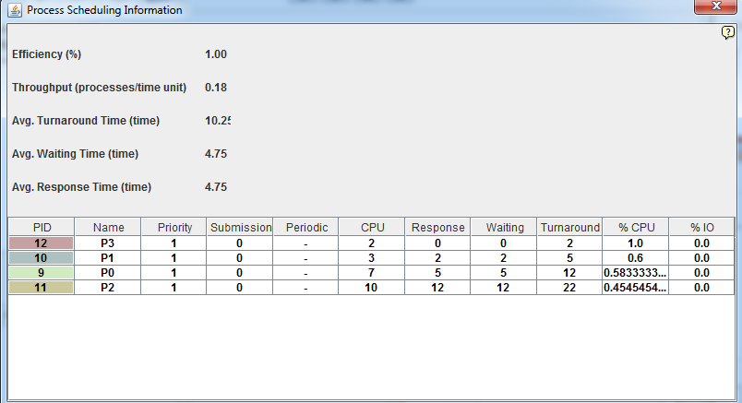

|  |  |
| --- | --- |
| Process | Waiting Time |
| P0 | 0 |
| P1 | 2 |
| P2 | 5 |
| P3 | 12 |
| Average Waiting Time | 4.75 |
| Average Turnaround | 10.25 |
| Average Respon | 4.75 |

* 1. Non-Premtive

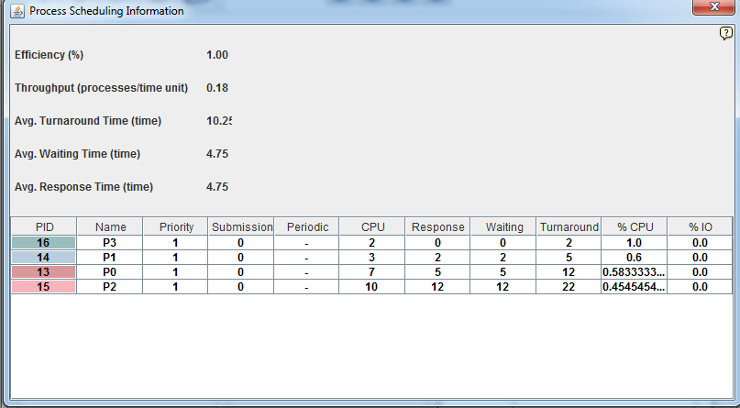

|  |  |
| --- | --- |
| Process | Waiting Time |
| P0 | 0 |
| P1 | 2 |
| P2 | 5 |
| P3 | 12 |
| Average Waiting Time | 4.75 |
| Average Turnaround | 10.25 |
| Average Respon | 4.75 |

1. **Priority Scheduling**

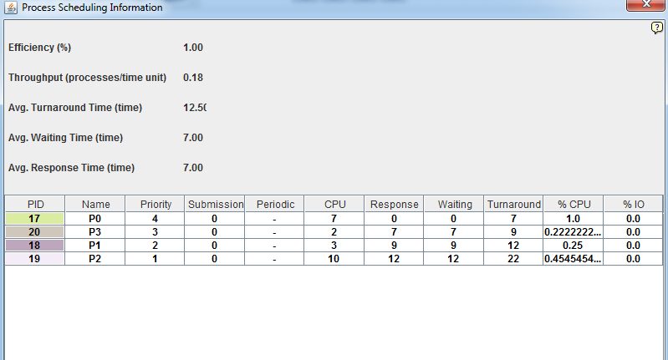

|  |  |
| --- | --- |
| Process | Waiting Time |
| P0 | 0 |
| P1 | 7 |
| P2 | 9 |
| P3 | 12 |
| Average Waiting Time | 7.00 |
| Average Turnaround | 12.50 |
| Average Respon | 7.00 |

1. **Round-Robin**

**Quantum 4**

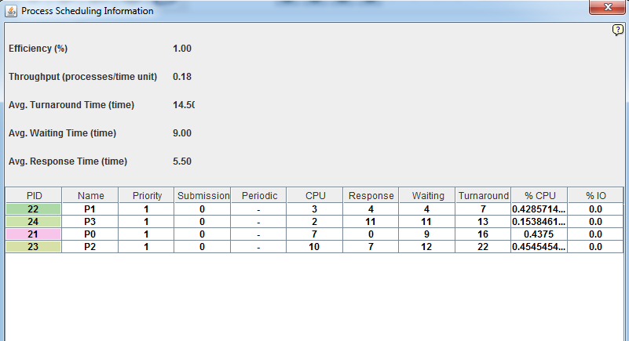

|  |  |
| --- | --- |
| Process | Waiting Time |
| P0 | 4 |
| P1 | 11 |
| P2 | 9 |
| P3 | 12 |
| Average Waiting Time | 9 |
| Average Turnaround | 14.5 |
| Average Respon | 5.5 |