**DIGITAL SYSTEM LABORATORY WORK**

**MOUL 10 : IMPLEMENTASI DECORDER**



**BY:**

**FARAH HUSNA PARAMADINA**

**L200183094**

**INFORMATION TECHNOLOGY**

**FACULTY OF COMNICATION AND INFORMATICS**

**UNIVERSITY OF MUHAMMADIYAH SURAKARTA**

Name : Farah Husna Pramadina

NIM : L200183094

Assistent Name : Salsa Sasmita Mukti

Date of Day : May 31, 2019

**ATTEMPT 1**

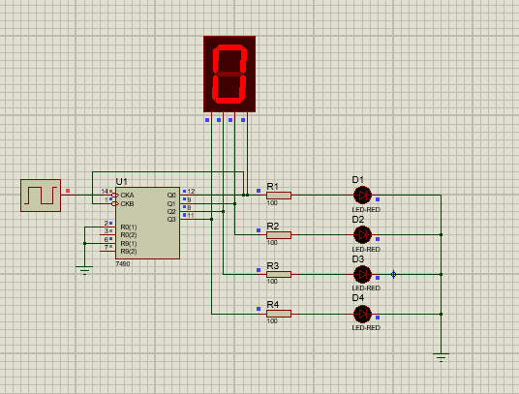

|  |  |  |  |  |  |
| --- | --- | --- | --- | --- | --- |
| **INPUT CLOCK** | **OUTPUT LED** | | | | **OUTPUT SEVEN SEGMENT** |
| **D1** | **D2** | **D3** | **D4** |
|  | 0 | 0 | 0 | 0 | 0 |
|  | 1 | 0 | 0 | 0 | 1 |
|  | 0 | 1 | 0 | 0 | 2 |
|  | 1 | 1 | 0 | 0 | 3 |
|  | 0 | 0 | 1 | 0 | 4 |
|  | 1 | 0 | 1 | 0 | 5 |
|  | 0 | 1 | 1 | 0 | 6 |
|  | 1 | 1 | 1 | 0 | 7 |
|  | 0 | 0 | 0 | 1 | 8 |
|  | 1 | 0 | 0 | 1 | 9 |
|  | 0 | 0 | 0 | 0 | 0 |
|  | 1 | 0 | 0 | 0 | 1 |
|  | 0 | 1 | 0 | 0 | 2 |

**ASSIGMENT**

Reference about IC 7490 of the data sheet

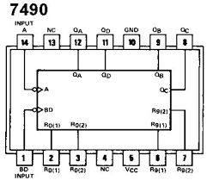

**ATTEMPT 2**

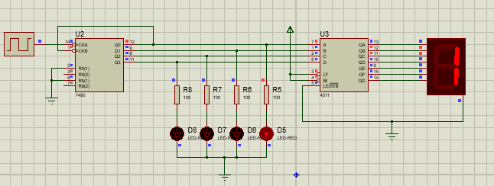

|  |  |  |  |  |  |
| --- | --- | --- | --- | --- | --- |
| **INPUT CLOCK** | **OUTPUT LED** | | | | **OUTPUT SEVEN SEGMENT** |
| **D1** | **D2** | **D3** | **D4** |
|  | 0 | 0 | 0 | 0 | 0 |
|  | 1 | 0 | 0 | 0 | 1 |
|  | 0 | 1 | 0 | 0 | 2 |
|  | 1 | 1 | 0 | 0 | 3 |
|  | 0 | 0 | 1 | 0 | 4 |
|  | 1 | 0 | 1 | 0 | 5 |
|  | 0 | 1 | 1 | 0 | 6 |
|  | 1 | 1 | 1 | 0 | 7 |
|  | 0 | 0 | 0 | 1 | 8 |
|  | 1 | 0 | 0 | 1 | 9 |

Whether that 7seg-BCD same with BCD-to-7segment decorder? ( yes / ~~not~~ )

From attempt 1 and attempt 2 is available sameness the output because the circuit in the attempt 1 is more simple then attempt which use BCD-to-7segment

**ATTEMPT 3**

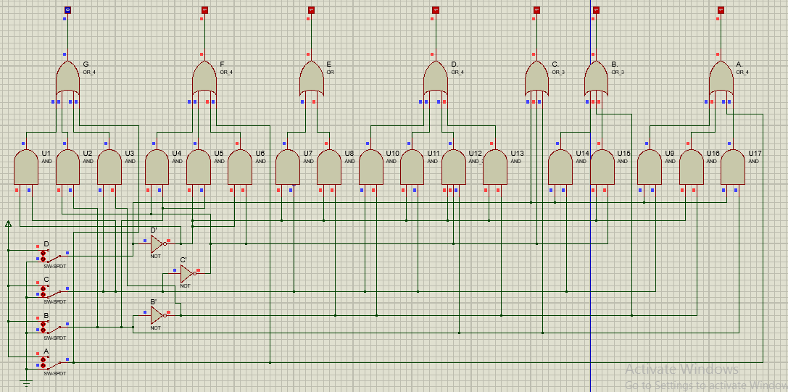

|  |  |  |  |  |  |  |  |  |  |  |  |  |  |
| --- | --- | --- | --- | --- | --- | --- | --- | --- | --- | --- | --- | --- | --- |
| **DECIMAL DIGIT** | **INPUT** | | | | | **OUTPUT** | | | | | | | **DISPLAY *OUTPUT*** |
| **LT** | **D** | **C** | **B** | **A** | **A** | **B** | **C** | **D** | **E** | **F** | **G** |
|  | H | L | L | L | L | H | H | H | H | H | H | L | 0 |
|  | H | L | L | L | H | L | H | H | L | L | L | L | 1 |
|  | H | L | L | H | L | H | H | L | H | H | L | H | 2 |
|  | H | L | L | H | H | H | H | H | H | L | L | H | 3 |
|  | H | L | H | L | L | L | H | H | L | L | H | H | 4 |
|  | H | L | H | L | H | H | L | H | H | L | H | H | 5 |
|  | H | L | H | H | L | L | L | H | H | H | H | H | 6 |
|  | H | L | H | H | H | H | H | H | L | L | L | L | 7 |
|  | H | H | L | L | L | H | H | H | H | H | H | H | 8 |
|  | H | H | L | L | H | H | H | H | L | L | H | H | 9 |
| LT | L | X | X | X | X | H | H | H | H | H | H | H | 8 |

|  |  |  |  |  |  |  |  |  |  |  |
| --- | --- | --- | --- | --- | --- | --- | --- | --- | --- | --- |
| **INPUT** | | | | **OUTPUT** | | | | | | |
| **A** | **B** | **C** | **D** | **A** | **B** | **C** | **D** | **E** | **F** | **G** |
| L | L | L | L | H | H | H | H | H | H | L |
| H | L | L | L | H | H | H | H | H | H | H |
| L | H | L | L | H | H | H | H | L | H | H |
| H | H | L | L | H | H | H | H | L | H | H |
| L | L | H | L | H | H | L | H | H | L | H |
| H | L | H | L | H | H | L | H | H | H | H |
| L | H | H | L | H | L | H | H | H | H | H |
| H | H | H | L | L | L | H | H | H | H | H |
| L | L | L | H | L | H | H | L | L | L | L |
| H | L | L | H | H | H | H | L | L | H | H |