**DIGITAL SYSTEMS**

PRACTICUM 2



By:

**LUCKYTA AFIA SUSANTO**

**NIM: L200183103**

INFORMATION TECHNOLOGY

FACULTY OF COMMUNICATION AND INFORMATICS

UNIVERSITY OF MUHAMMADIYAH SURAKARTA

**Task 1**

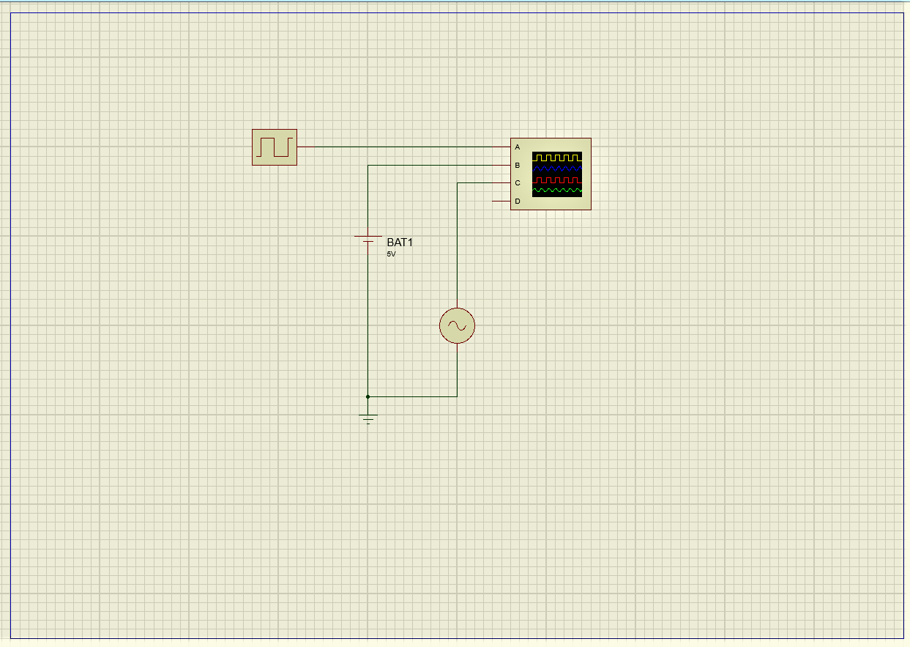

Picture 1.1. Screenshot of the first task

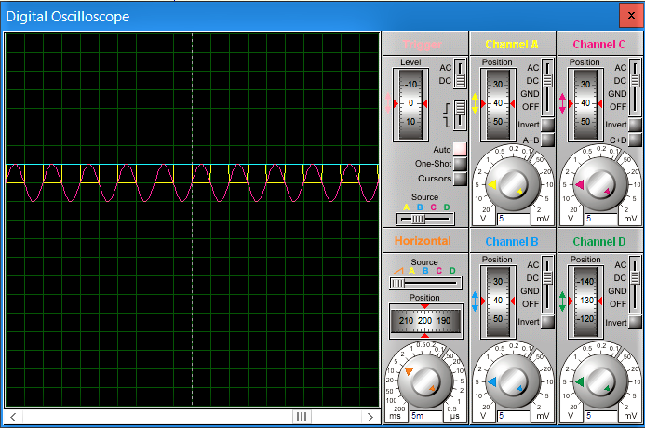

Picture 1.2.1 Screenshot on oscilloscope display

Explanation :

1. The shape of the A signal is corrugated box
2. The shape of the B signal is flat horizontal
3. The shape on signal C is wavy up and down
4. The shape of the D signal is flat horizontal

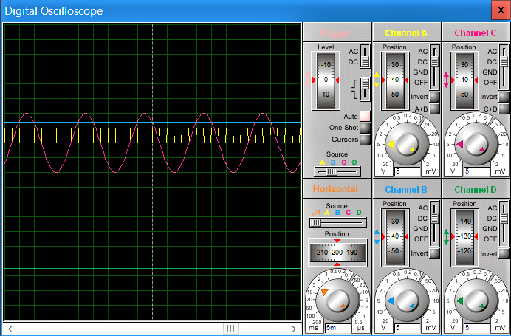

Picture 1.2.2. Screenshot on oscilloscope display

Explanation:

1. The shape of the A signal is corrugated box.
2. The shape of the B signal is flat horizontal.
3. The shape on signal C is wavy up and down.
4. The shape of the D signal is flat horizontal.

The answer of the question :

1. What is the difference between analog and digital signals?

Answer:

Digital signals have a fixed discrete value. Analog signals have a continuous range of values

1. What is the signal character of each component?

Answer:

* 1. Signal from Alternator: Digital. because the data signal have a fixed discrete value.
  2. Signal from Battery: Analog. because the data signal have a continuous range of values.
  3. Signal from Clock source: Analog. because the data signal have a continuous range of values.

1. Make a conclusions are based on observations on various types of signals

Answer:

Digital signals have a fixed discrete value. Analog signals have a continuous range of values.

**Task 2**

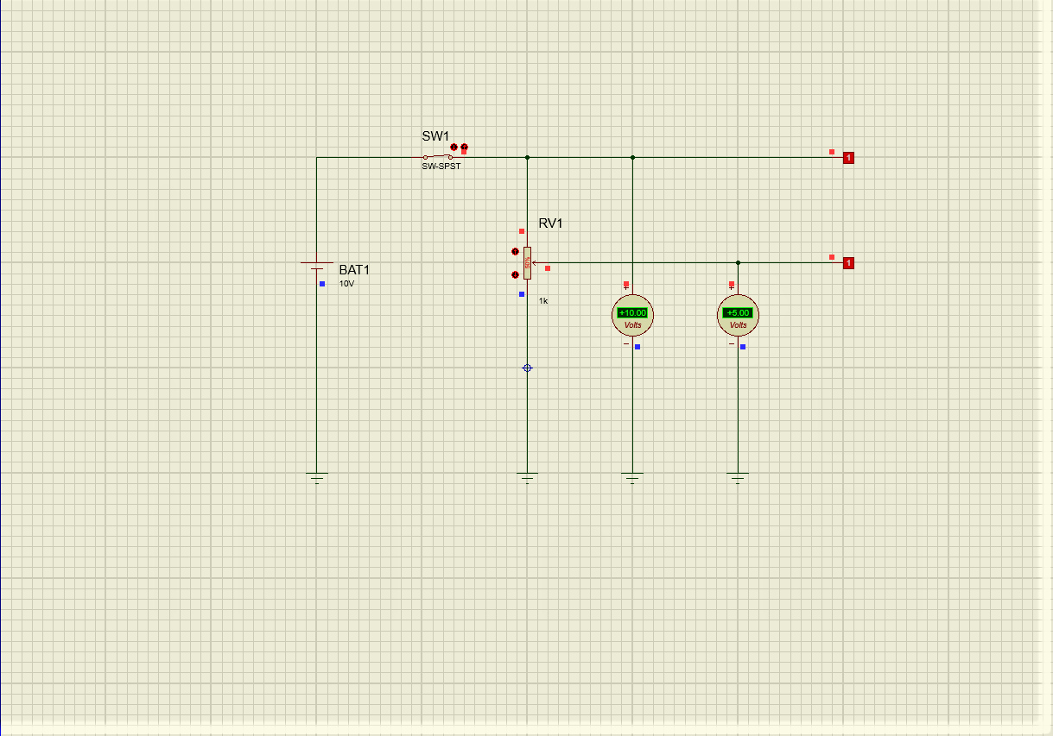

Picture 2.1. Screenshot of the task

1. Based on simulation
   1. Voltmeter DC 1: +10.00 Volts.
   2. Voltmeter DC 2: +5.00 Volts.
   3. Logicprobe 1 shows logic conditions: 1.
   4. Logicprobe 2 shows logic conditions: 1.
2. Based on simulation
   1. Logicprobe 2 shows logic 1 (high), if DC Voltmeter is 2: +3.10 Volts to +10.00 Volts.
   2. Logicprobe 2 shows logic 0 (Low), if DC Voltmeter 2: +0.00 Volts to +1.60 Volts.
3. Conclusion based on analysis

Logicprobe shows whether a voltage is included in the digital voltage range. Only two voltage conditions that are allowed on a digital voltage are 0 Volts and 5 Volts (with tolerance). Digital signals are not permitted through limit voltage (as in Logicprobe 1).