Nama : Kemas Muhamad Kevin

Nim : L200184033

Kelas:E

FCFS

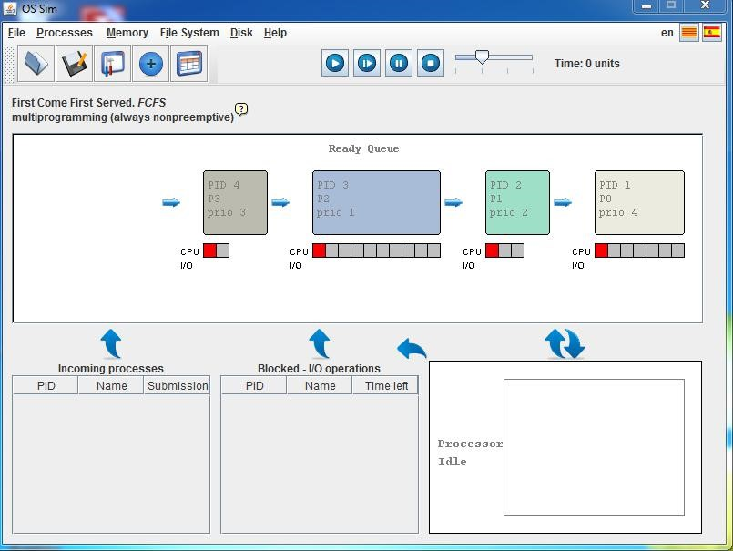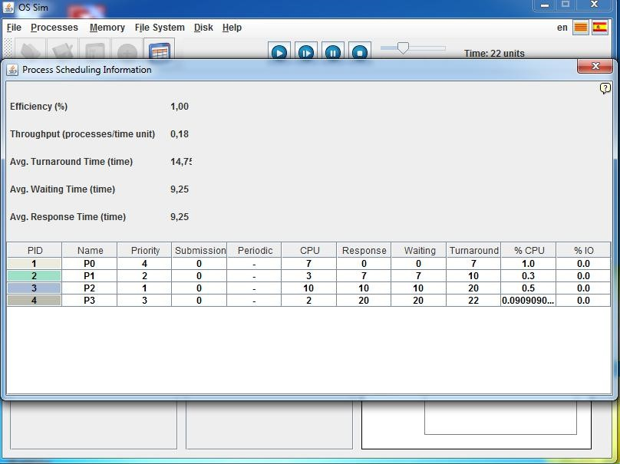

|  |  |
| --- | --- |
| Process | Waiting Time |
| P0 | 0 |
| P1 | 7 |
| P2 | 10 |
| P3 | 20 |
| AverageWaiting Time | 9.25 |
| Average Turnaround | 14.75 |
| Average Respon | 9.25 |

1. SJFS
   1. Preemptive

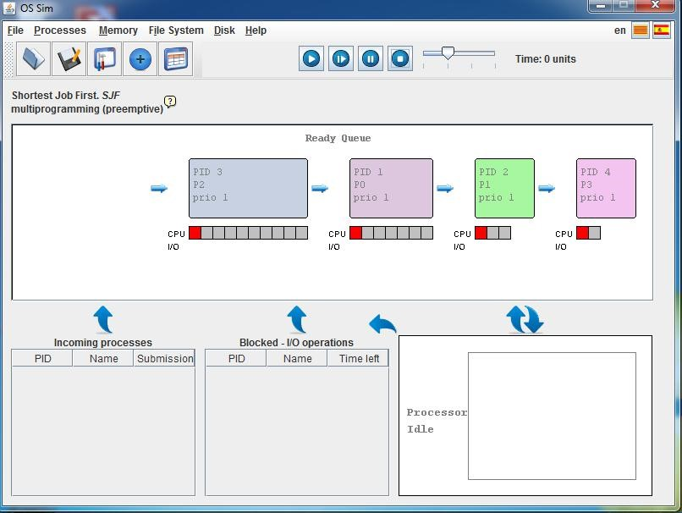

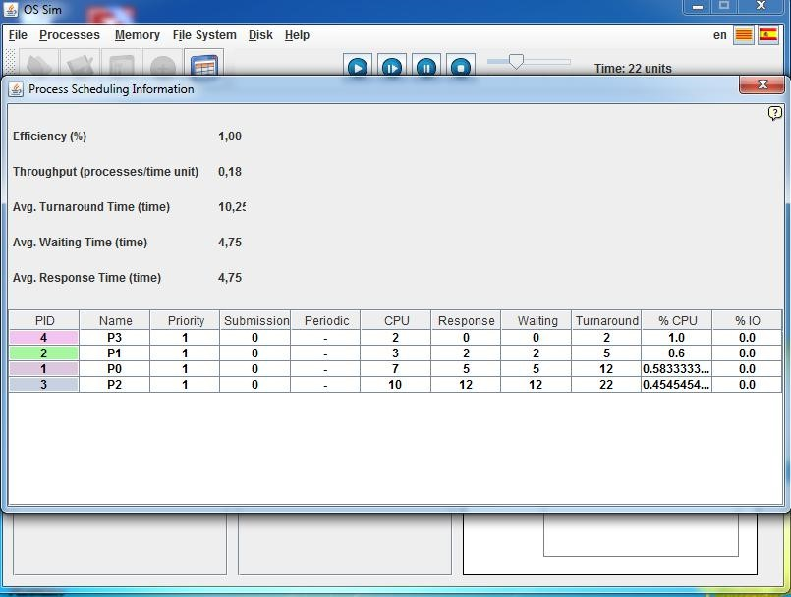

|  |  |
| --- | --- |
| Process | Waiting Time |
| P0 | 5 |
| P1 | 2 |
| P2 | 12 |
| P3 | 0 |
| Average Waiting Time | 4,75 |
| Average Turnaround | 10,25 |
| Average Respon | 4,75 |

b) Nonpreemptive

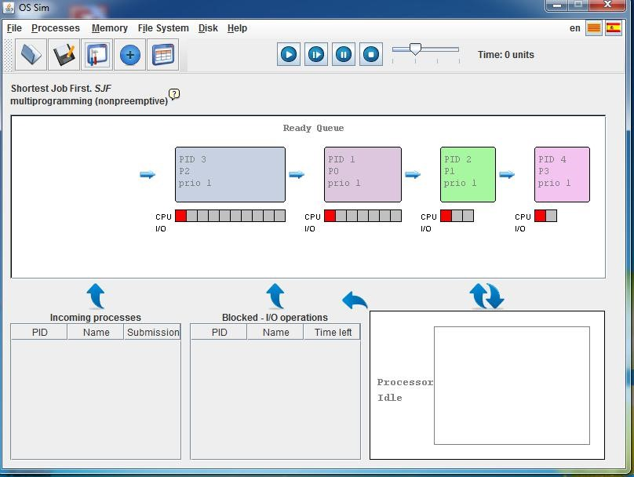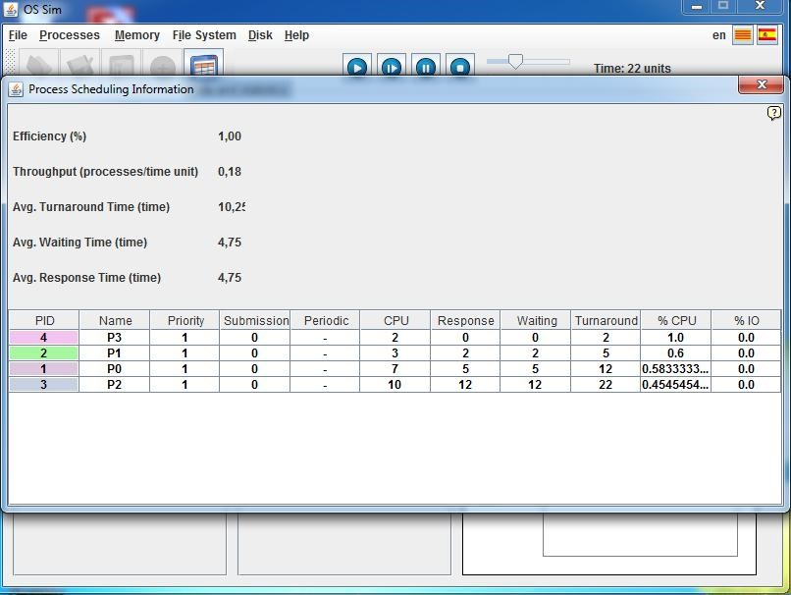

|  |  |
| --- | --- |
| Process | Waiting Time |
| P0 | 5 |
| P1 | 2 |
| P2 | 12 |
| P3 | 0 |
| Average Waiting Time | 4,75 |
| Average Turnaround | 10,25 |
| Average Respon | 4,75 |

1. Priority Sceduling

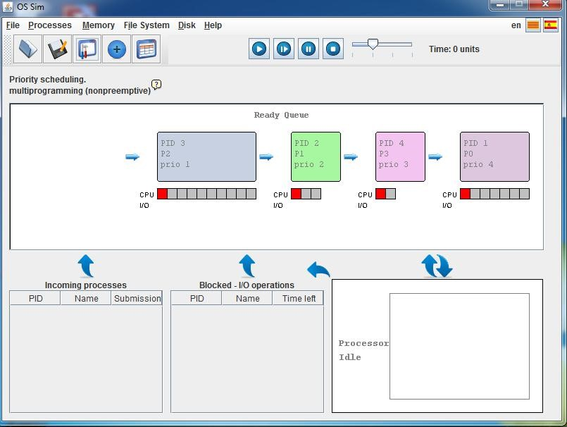

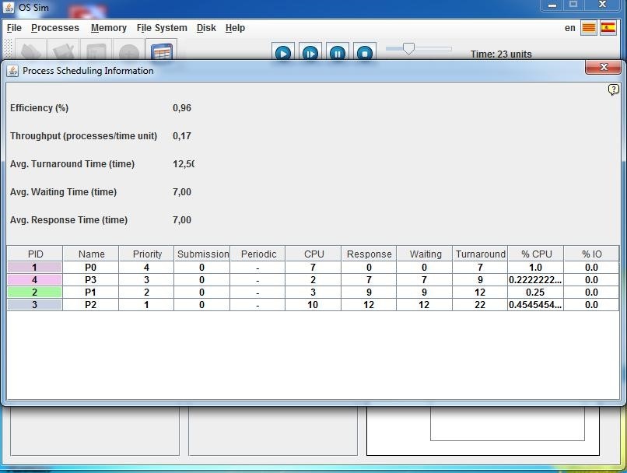

|  |  |
| --- | --- |
| Process | Waiting Time |
| P0 | 0 |
| P1 | 9 |
| P2 | 12 |
| P3 | 7 |
| Average Waiting Time | 7,00 |
| Average Turnaround | 12,50 |
| Average Respon | 7,00 |

1. RoundRobin (Quantum Time = 4)

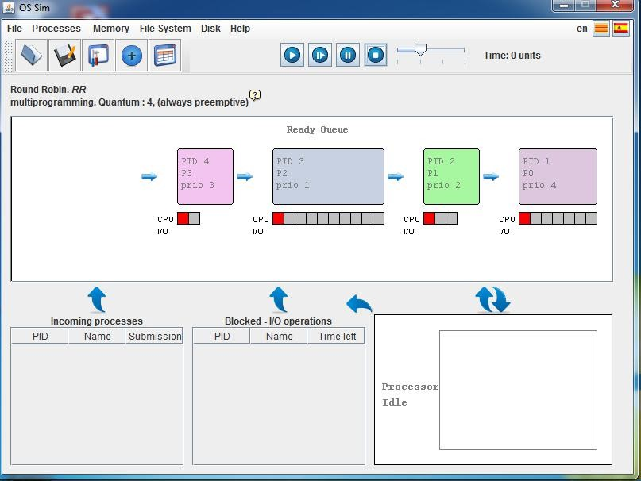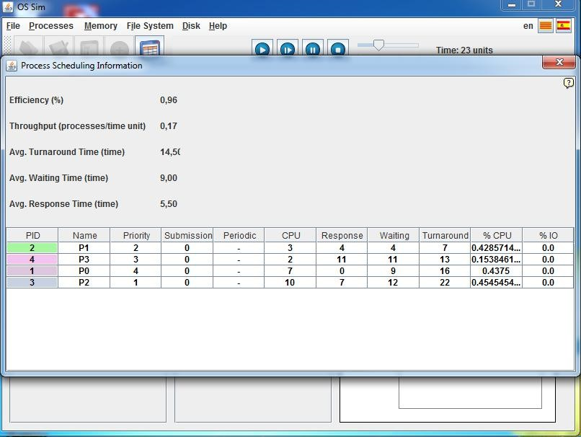

|  |  |
| --- | --- |
| Process | Waiting Time |
| P0 | 9 |
| P1 | 4 |
| P2 | 12 |
| P3 | 11 |
| Average Waiting Time | 9,00 |
| Average Turnaround | 14,50 |
| Average Respon | 5,50 |