**DATABASE SYSTEMS PRACTICUM**

**PRACTICUM 8**



**By:**

**GANNO TRIBUANA KURNIAJI**

**NIM: L200184092**

**INFORMATION TECHNOLOGY**

**FACULTY OF COMMUNICATION AND INFORMATICS**

**UNIVERSITY OF MUHAMMADIYAH SURAKARTA**

**2020**

1. **Activity**

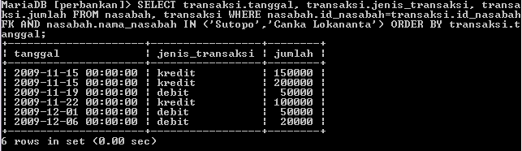

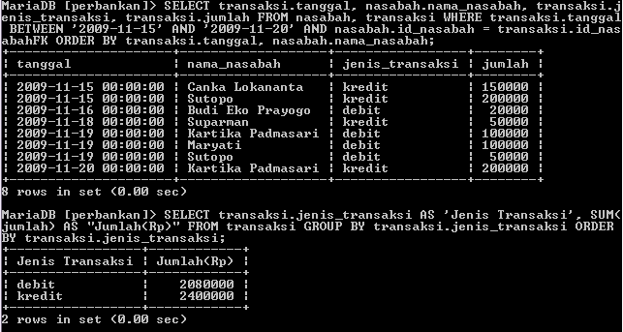

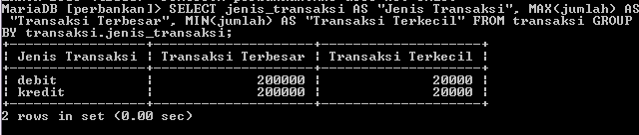

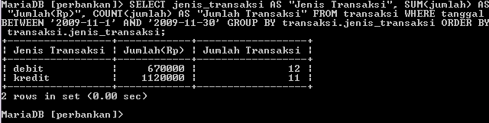

1. **Assignment**

