COMPUTER NETWORKS PRACTICUM 3



By:

MUHAMMAD IRFAN

NIM: L200184165

INFORMATION TECHNOLOGY

FACULTY OF COMMUNICATION AND INFORMATICS UNIVERSITY OF MUHAMMADIYAH SURAKARTA 2020

**1. Activity 1**

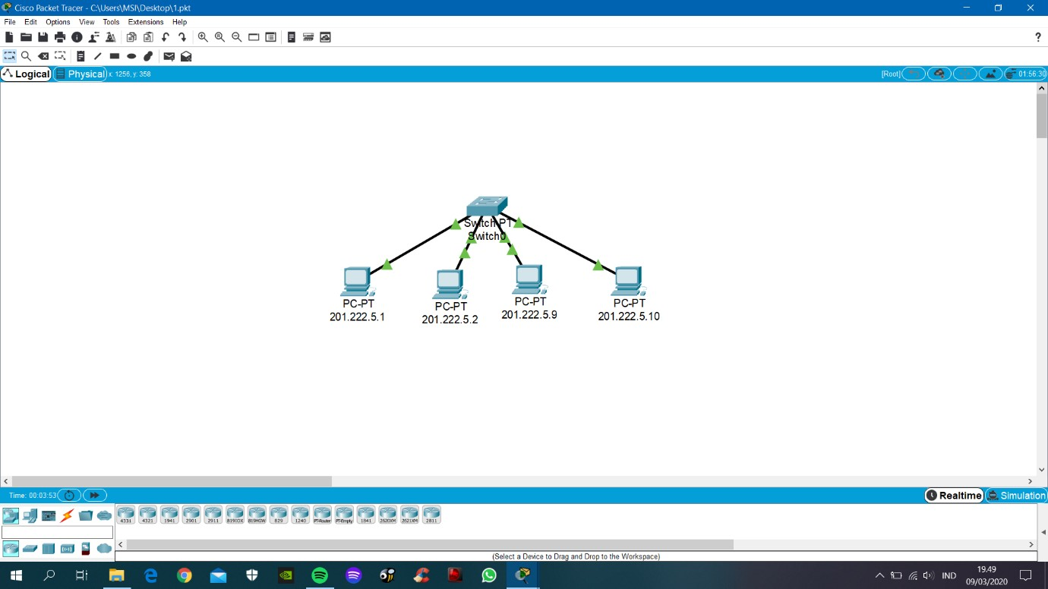

Picture 1.1. Set of the computer network

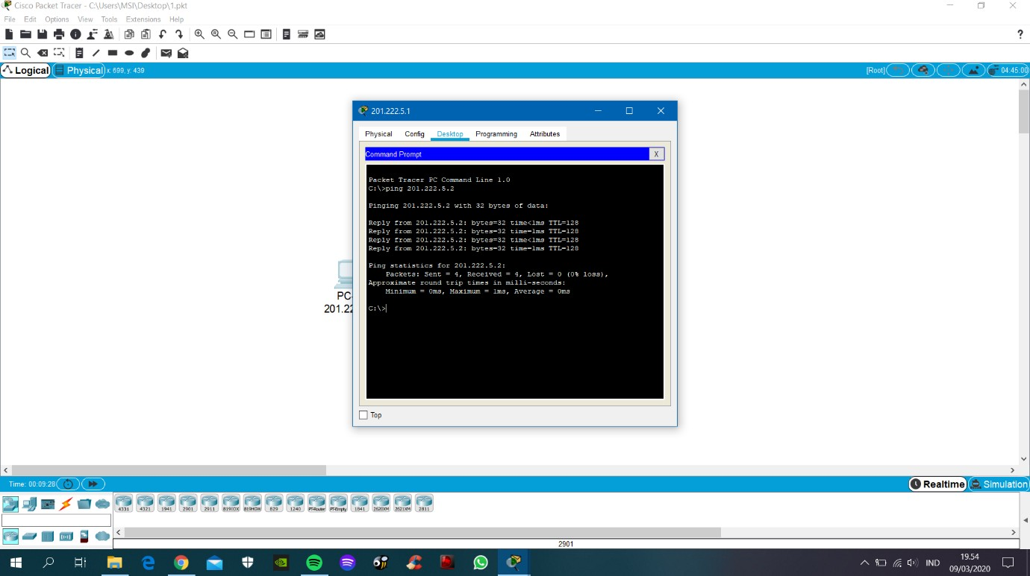

Picture 1.2. pinging result from PC1 to PC2

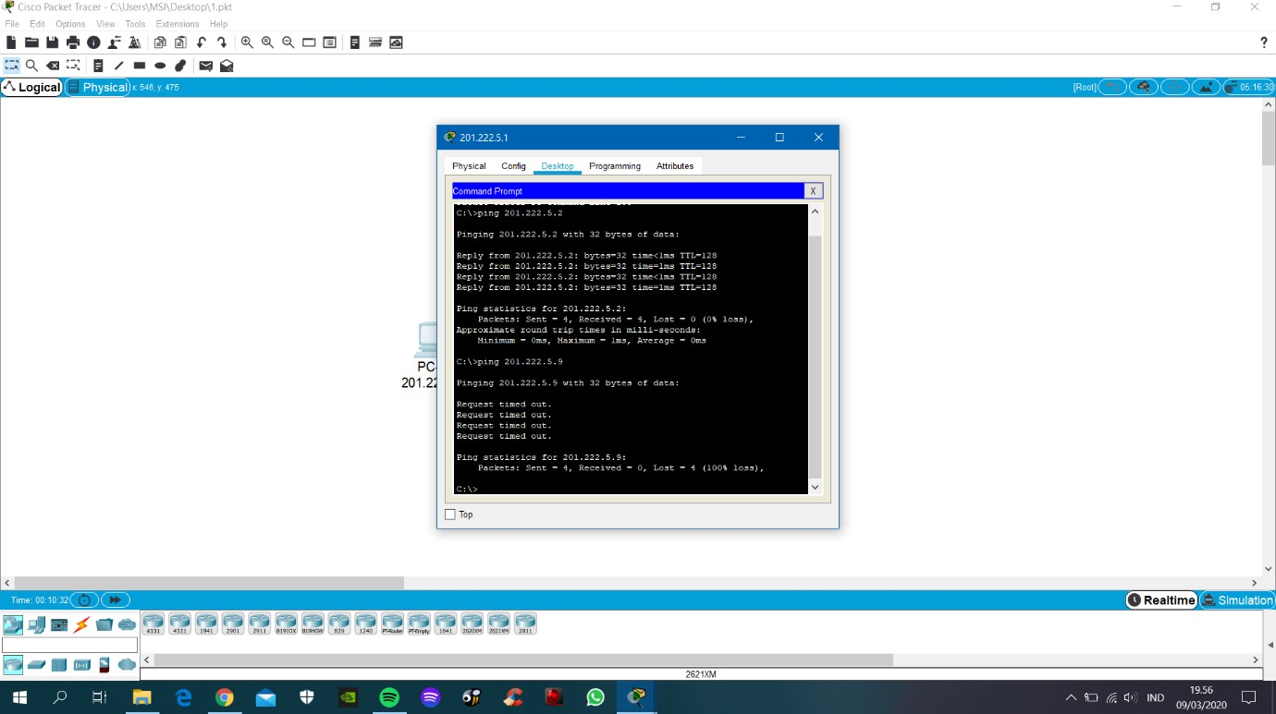

Picture 1.3. pinging result from PC1 to PC3

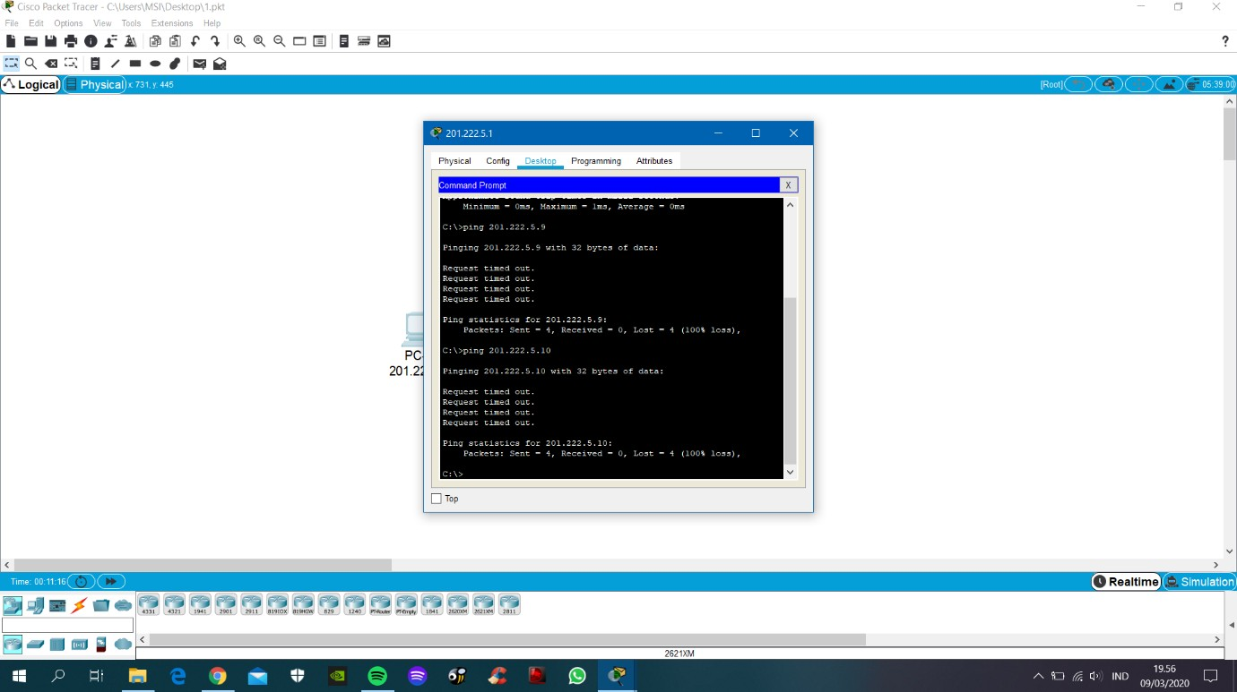

Picture 1.4. pinging result from PC1 to PC4