**LAPORAN PRAKTIKUM ALGORITMA DAN STRUKTUR DATA**

**MODUL 5  
**

**Nama** : Daffa Putra Alwansyah

**NIM** : L200190031  
**Kelas** : B

##===========Latihan==============

##Latihan 1

def swap(a,b,c):

tmp=a[b]

a[b]=a[c]

a[c]=tmp

K = [50,20,70,10]

swap(K,1,3)

Output:



##Latihan 2

def cariPosisiYangTerkecil(A, dariSini, sampaiSini):

posisiYangTerkecil = dariSini

for i in range(dariSini+1, sampaiSini):

if A[i] < A[posisiYangTerkecil]:

posisiYangTerkecil = i

return posisiYangTerkecil

A = [18, 13, 44, 25, 66, 107, 78, 89]

j = cariPosisiYangTerkecil(A, 2, len(A))

L = [10,51,2,18,4,31,13,5,23,64,29]

Output:



##Latihan 3

def bubbleSort(A):

n = len(A)

for i in range(n-1):

for j in range(n-i-1):

if A[j] > A[j+1]:

swap(A,j,j+1)

return A

Output:

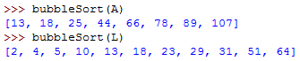

##Latihan 4

def selectionSort(A):

n = len(A)

for i in range(n - 1):

indexKecil = cariPosisiYangTerkecil(A,i,n)

if indexKecil != i:

swap(A,i,indexKecil)

return A

Output:

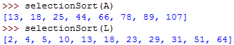

##Latihan 5

def insertionSort(A):

n = len(A)

for i in range(1, n):

nilai = A[i]

pos = i

while pos > 0 and nilai < A[pos-1]:

A[pos] = A[pos - 1]

pos = pos - 1

A[pos] = nilai

return A

Output:

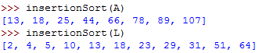

#==================Tugas Mahasiswa==========================

class MhsTIF(object):

def __init__(self,nama,nim,kotaTinggal,us):

self.nama = nama

self.nim = nim

self.kotaTinggal = kotaTinggal

self.uangSaku = us

c0 = MhsTIF('Ika', 'L20019001', 'Sukoharjo', 240000)

c1 = MhsTIF('Budi', 'L20019003', 'Sragen', 230000)

c2 = MhsTIF('Ahmad', 'L20019002', 'Surakarta', 250000)

c3 = MhsTIF('Chandra', 'L20019004', 'Surakarta', 235000)

c4 = MhsTIF('Eka', 'L20019006', 'Boyolali', 240000)

c5 = MhsTIF('Fandi', 'L20019005', 'Salatiga', 250000)

c6 = MhsTIF('Deni', 'L20019007', 'Klaten', 245000)

c7 = MhsTIF('Galuh', 'L20019009', 'Wonogiri', 245000)

c8 = MhsTIF('Janto', 'L20019008', 'Klaten', 245000)

c9 = MhsTIF('Hasan', 'L20019011', 'Karanganyar', 270000)

c10 = MhsTIF('Khalid', 'L20019010', 'Purwodadi', 265000)

Daftar=[c0,c1,c2,c3,c4,c5,c6,c7,c8,c9,c10]

#Nomor 1

def swap(i,j,k):

tmp=i[j]

i[j]=i[k]

i[k]=tmp

def urutNim(i):

n = len(i)

for x in range(n-1):

for y in range(n-x-1):

if i[y].nim > i[y+1].nim:

swap(i,y,y+1)

def cekNim(x):

for y in x:

print(y.nama, y.nim, y.kotaTinggal)

Output:

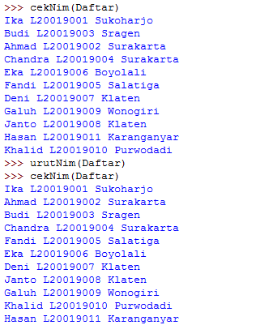

# Nomer 2

a = [10,9,8,7,6,5,4,3,2,1]

b = [20,19,18,17,16,15,14,13,12,11]

def urut(a,b):

c = a + b

for i in range(1,len(c)):

nilai = c[i]

pos = i

while pos > 0 and nilai<c[pos - 1]:

c[pos]=c[pos-1]

pos -=1

c[pos]=nilai

print©

Output:



## Nomer 3

def swap(A,p,q):

tmp = A[p]

A[p] = A[q]

A[q] = tmp

def cariPosisiYangTerkecil(A, dariSini, sampaiSini):

posisiTerkecil = dariSini

for i in range(dariSini+1, sampaiSini):

if A[1] < A[posisiTerkecil]:

posisiTerkecil = 1

return posisiTerkecil

def selectionSort(A):

n = len(A)

for i in range(n-1):

indexKecil = cariPosisiYangTerkecil(A, i, n)

if indexKecil != i:

swap(A, i, indexKecil)

def bubbleSort(A):

n = len(A)

for i in range(n-1):

for j in range(n-i-1):

if A[j] > A[j+1]:

swap(A,j,j+1)

def insertionSort(A):

n = len(A)

for i in range(1,n):

nilai = A[i]

posisi = i

while posisi > 0 and nilai < A[posisi-1]:

A[posisi] = A[posisi-1]

posisi = posisi-1

A[posisi] = nilai

from time import time as detak

from random import shuffle as kocok

k = [i for i in range(1,6001)]

kocok(k)

u_bub = k[:]

u_sel = k[:]

u_ins = k[:]

aw = detak();bubbleSort(u_bub);ak=detak();print("Bubble: %g detik"%(ak-aw));

aw = detak();selectionSort(u_sel);ak=detak();print("Selection: %g detik"%(ak-aw));

aw = detak();insertionSort(u_ins);ak=detak();print("Insertion: %g detik"%(ak-aw));

Output:

