**LAPORAN PRAKTIKUM ALGORITMA DAN STRUKTUR DATA**

**MODUL 6  
**

**Nama** : Daffa Putra Alwansyah

**NIM** : L200190031  
**Kelas** : B

**#===========================LATIHAN========================**

P = [2, 8, 15, 23, 37]

Q = [4, 6, 15, 20]

def gabungkanDuaListUrut(A, B):

la = len(A); lb = len(B)

C = list()

i = 0; j = 0

while i <la and j < lb:

if A[i] < B[j]:

C.append(A[i])

i += 1

else:

C.append(B[j])

j += 1

while i < la:

C.append(A[i])

i += 1

while j < lb:

C.append(B[j])

j +=1

return C

gabungkanDuaListUrut(P,Q)

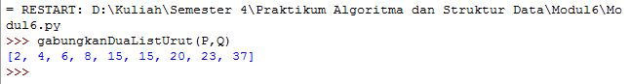

#============================================================

##def mergeSort(A):

## print("Membelah ", A)

## if len(A) > 1:

## mid = len(A) // 2

## separuhKiri = A[:mid]

## separuhKanan = A[mid:]

##

## mergeSort(separuhKiri)

## mergeSort(separuhKanan)

##

## i=0; j=0; k=0

## while i < len(separuhKiri) and j < len(separuhKanan):

## if separuhKiri[i] < separuhKanan[j]:

## A[k] = separuhKiri[i]

## i = i + 1

## else:

## A[k] = separuhKanan[j]

## j = j + 1

## k = k + 1

##

## while i < len(separuhKiri):

## A[k] = separuhKiri[i]

## i = i + 1

## k = k + 1

##

## while j < len(separuhKanan):

## A[k] = separuhKanan[j]

## j = j + 1

## k = k + 1

##

## print("Menggabungkan", A)

##

##alist = [54, 26, 93, 17, 77, 31, 44, 55, 20]

##mergeSort(alist)

##print(alist)

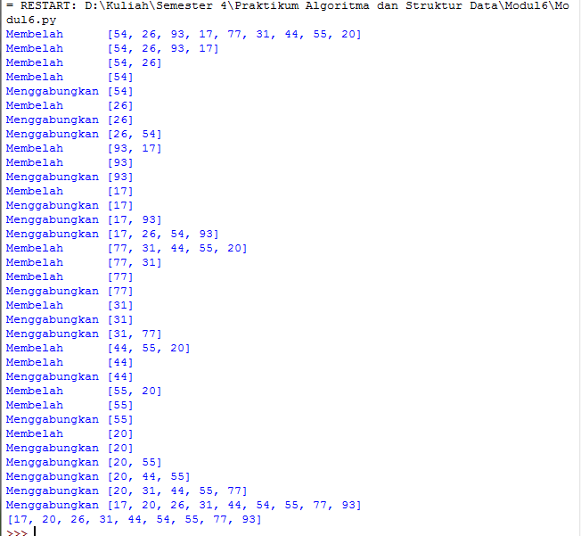

#============================================================

##alist = [54, 26, 93, 17, 77, 31, 44, 55, 20]

##def quickSort(A):

## quickSortBantu(A, 0, len(A) - 1)

##

##def quickSortBantu(A, awal, akhir):

## if awal < akhir:

## titikBelah = partisi(A, awal, akhir)

## quickSortBantu(A, titikBelah + 1, akhir)

##

##def partisi(A, awal, akhir):

## nilaiPivot = A[awal]

##

## penandaKiri = awal + 1

## penandaKanan = akhir

##

## selesai = False

## while not selesai:

##

## while penandaKiri <= penandaKanan and A[penandaKiri] <= nilaiPivot:

## penandaKiri = penandaKiri + 1

##

## while A[penandaKanan] >= nilaiPivot and penandaKanan >= penandaKiri:

## penandaKanan = penandaKanan - 1

##

## if penandaKanan < penandaKiri:

## selesai = True

## else:

## temp = A[penandaKiri]

## A[penandaKiri] = A[penandaKanan]

## A[penandaKanan] = temp

##

## temp = A[awal]

## A[awal] = A[penandaKanan]

## A[penandaKanan] = temp

##

## return penandaKanan

##

##quickSort(alist)

##print(alist)



**#========================SOAL MAHASISWA=================**

#Nomor 1

class MhsTIF(object):

def __init__(self,nama,nim,tinggal,us):

self.nama = nama

self.nim = nim

self.tinggal = tinggal

self.us = us

c0 = MhsTIF('Ika', 'L20019001', 'Sukoharjo', 240000)

c1 = MhsTIF('Budi', 'L20019003', 'Sragen', 230000)

c2 = MhsTIF('Ahmad', 'L20019002', 'Surakarta', 250000)

c3 = MhsTIF('Chandra', 'L20019004', 'Surakarta', 235000)

c4 = MhsTIF('Eka', 'L20019006', 'Boyolali', 240000)

c5 = MhsTIF('Fandi', 'L20019005', 'Salatiga', 250000)

c6 = MhsTIF('Deni', 'L20019007', 'Klaten', 245000)

c7 = MhsTIF('Galuh', 'L20019009', 'Wonogiri', 245000)

c8 = MhsTIF('Janto', 'L20019008', 'Klaten', 245000)

c9 = MhsTIF('Hasan', 'L20019011', 'Karanganyar', 270000)

c10 = MhsTIF('Khalid', 'L20019010', 'Purwodadi', 265000)

Daftar=[c0,c1,c2,c3,c4,c5,c6,c7,c8,c9]

###=====MergeSort=====

def mergeSort(A):

if len(A) > 1:

mid = len(A) // 2

separuhkiri = A[:mid]

separuhkanan = A[mid:]

mergeSort(separuhkiri)

mergeSort(separuhkanan)

i = 0;j=0;k=0

while i < len(separuhkiri) and j < len(separuhkanan):

if separuhkiri[i] < separuhkanan[j]:

A[k] = separuhkiri[i]

i = i + 1

else:

A[k] = separuhkanan[j]

j = j + 1

k=k+1

while i < len(separuhkiri):

A[k] = separuhkiri[i]

i = i + 1

k=k+1

while j < len(separuhkanan):

A[k] = separuhkanan[j]

j = j + 1

k=k+1

def convert(arr, obj):

hasil=[]

for x in range (len(arr)):

for i in range (len(arr)):

if arr[x] == obj[i].nim:

hasil.append(obj[i])

return hasil

A = []

for x in Daftar:

A.append(x.nim)

print("=====Merge Sort=====")

mergeSort(A)

for i in convert(A, Daftar):

print (i.nama,i.nim,i.tinggal,i.us)

print()

###=====QuickSort=====

def partisi(A, awal, akhir):

nilaipivot = A[awal]

penandakiri = awal + 1

penandakanan = akhir

selesai = False

while not selesai:

while penandakiri <= penandakanan and A[penandakiri] <= nilaipivot:

penandakiri = penandakiri + 1

while penandakanan >= penandakiri and A[penandakanan] >= nilaipivot:

penandakanan = penandakanan - 1

if penandakanan < penandakiri:

selesai = True

else:

temp = A[penandakiri]

A[penandakiri] = A[penandakanan]

A[penandakanan] = temp

temp = A[awal]

A[awal] = A[penandakanan]

A[penandakanan] = temp

return penandakanan

def quickSortBantu(A, awal, akhir):

if awal < akhir:

titikBelah = partisi(A, awal, akhir)

quickSortBantu(A, awal, titikBelah-1)

quickSortBantu(A, titikBelah+1, akhir)

def quickSort(A):

quickSortBantu (A, 0, len(A)-1)

def convert(arr, obj):

hasil=[]

for x in range (len(arr)):

for i in range (len(arr)):

if arr[x] == obj[i].nim:

hasil.append(obj[i])

return hasil

A = []

for x in Daftar:

A.append(x.nim)

print("=====Quick Sort=====")

quickSort(A)

for i in convert(A, Daftar):

print (i.nama,i.nim,i.tinggal,i.us)

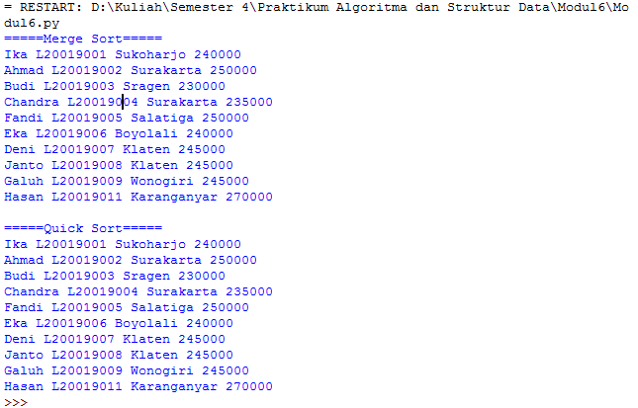

**Nomor 2**

Merge Sort  
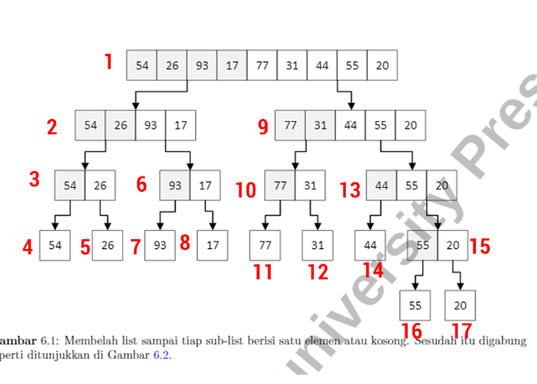  
  
  
Quick Sort  
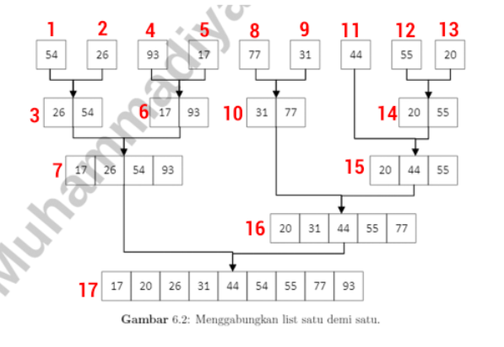

#============================================================

**#Nomor 3**

from time import time as detak

from random import shuffle as kocok

import time

def swap(A, p, q):

tmp = A[p]

A[p] = A[q]

A[q] = tmp

def cariPosisiYangTerkecil(A, dariSini, sampaiSini):

posisiYangTerkecil = dariSini

for i in range(dariSini+1, sampaiSini):

if A[i] < A[posisiYangTerkecil]:

posisiYangTerkecil = i

return posisiYangTerkecil

def bubbleSort(S):

n = len(S)

for i in range (n-1):

for j in range (n-i-1):

if S[j] > S[j+1]:

swap(S,j,j+1)

return S

def selectionSort(S):

n = len(S)

for i in range(n-1):

indexKecil = cariPosisiYangTerkecil(S, i, n)

if indexKecil != i:

swap(S, i, indexKecil)

return S

def insertionSort(S):

n = len(S)

for i in range(1, n):

nilai = S[i]

pos = i

while pos > 0 and nilai < S[pos -1]:

S[pos] = S[pos-1]

pos = pos - 1

S[pos] = nilai

return S

def mergeSort(A):

if len(A) > 1:

mid = len(A) // 2

separuhkiri = A[:mid]

separuhkanan = A[mid:]

mergeSort(separuhkiri)

mergeSort(separuhkanan)

i = 0;j=0;k=0

while i < len(separuhkiri) and j < len(separuhkanan):

if separuhkiri[i] < separuhkanan[j]:

A[k] = separuhkiri[i]

i = i + 1

else:

A[k] = separuhkanan[j]

j = j + 1

k=k+1

while i < len(separuhkiri):

A[k] = separuhkiri[i]

i = i + 1

k=k+1

while j < len(separuhkanan):

A[k] = separuhkanan[j]

j = j + 1

k=k+1

def partisi(A, awal, akhir):

nilaipivot = A[awal]

penandakiri = awal + 1

penandakanan = akhir

selesai = False

while not selesai:

while penandakiri <= penandakanan and A[penandakiri] <= nilaipivot:

penandakiri = penandakiri + 1

while penandakanan >= penandakiri and A[penandakanan] >= nilaipivot:

penandakanan = penandakanan - 1

if penandakanan < penandakiri:

selesai = True

else:

temp = A[penandakiri]

A[penandakiri] = A[penandakanan]

A[penandakanan] = temp

temp = A[awal]

A[awal] = A[penandakanan]

A[penandakanan] = temp

return penandakanan

def quickSortBantu(A, awal, akhir):

if awal < akhir:

titikBelah = partisi(A, awal, akhir)

quickSortBantu(A, awal, titikBelah-1)

quickSortBantu(A, titikBelah+1, akhir)

def quickSort(A):

quickSortBantu (A, 0, len(A)-1)

k = [[i] for i in range(1, 6001)]

kocok(k)

u_bub = k[:]

u_sel = k[:]

u_ins = k[:]

u_mrg = k[:]

u_qck = k[:]

aw=detak();bubbleSort(u_bub);ak=detak();print("bubble: %g detik" %(ak-aw));

aw=detak();selectionSort(u_sel);ak=detak();print("selection: %g detik" %(ak-aw));

aw=detak();insertionSort(u_ins);ak=detak();print("insertion: %g detik" %(ak-aw));

aw=detak();mergeSort(u_mrg);ak=detak();print("merge: %g detik" %(ak-aw));

aw=detak();quickSort(u_qck);ak=detak();print("quick: %g detik" %(ak-aw));

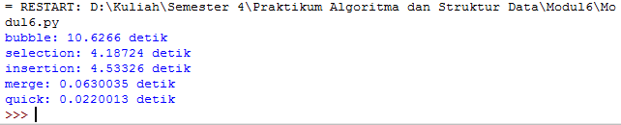

**Nomor 4**

Merge Sort

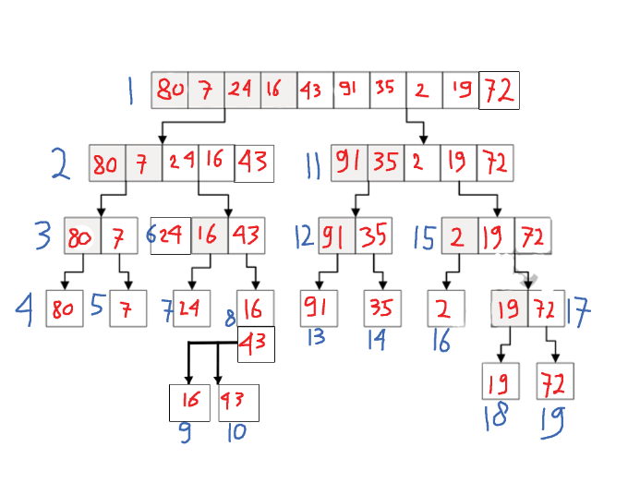

Quick Sort

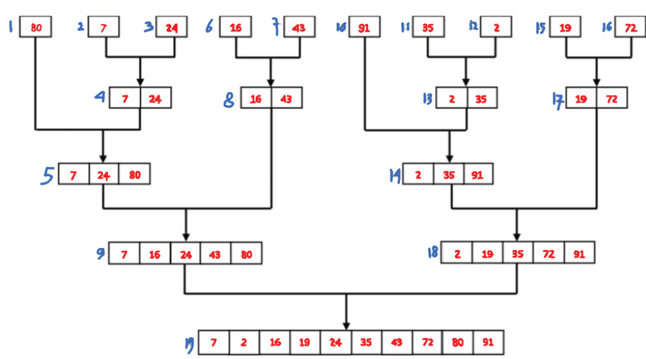

#============================================================

**#Nomor 5**

def mergeSort2(A, awal, akhir):

mid = (awal+akhir)//2

if awal < akhir:

mergeSort2(A, awal, mid)

mergeSort2(A, mid+1, akhir)

a, f, l = 0, awal, mid+1

tmp = [None] * (akhir - awal + 1)

while f <= mid and l <= akhir:

if A[f] < A[l]:

tmp[a] = A[f]

f += 1

else:

tmp[a] = A[l]

l += 1

a += 1

if f <= mid:

tmp[a:] = A[f:mid+1]

if l <= akhir:

tmp[a:] = A[l:akhir+1]

a = 0

while awal <= akhir:

A[awal] = tmp[a]

awal += 1

a += 1

def mergeSort(A):

mergeSort2(A, 0, len(A)-1)

def convert(arr, obj):

hasil=[]

for x in range (len(arr)):

for i in range (len(arr)):

if arr[x] == obj[i].nim:

hasil.append(obj[i])

return hasil

A = []

for x in Daftar:

A.append(x.nim)

print("MergeSort Urut NIM")

mergeSort(A)

for i in convert(A, Daftar):

print (i.nama,i.nim,i.tinggal,i.us)

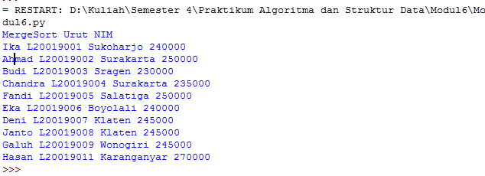

#============================================================

**#Nomor 6**

def partisi(A, awal, akhir):

hasil = 0

pivot, pidx = median_dari_tiga(A, awal, akhir)

A[awal], A[pidx] = A[pidx], A[awal]

i = awal + 1

for j in range(awal+1, akhir, 1):

hasil += 1

if (A[j] < pivot):

A[i], A[j] = A[j], A[i]

i += 1

A[awal], A[i-1] = A[i-1], A[awal]

return i - 1, hasil

def median_dari_tiga(A, awal, akhir):

tengah = (awal+akhir-1)//2

a = A[awal]

b = A[tengah]

c = A[akhir-1]

if a <= b <= c:

return b, tengah

if c <= b <= a:

return b, tengah

if a <= c <= b:

return c, akhir-1

if b <= c <= a:

return c, akhir-1

return a, awal

def quickSortBantu(A, awal, akhir):

hasil = 0

if awal < akhir:

titikBelah, hasil = partisi(A, awal, akhir)

hasil += quickSortBantu(A, awal, titikBelah)

hasil += quickSortBantu(A, titikBelah + 1, akhir)

return hasil

def quickSort(A):

quickSortBantu(A, 0, len(A))

def convert(arr, obj):

hasil=[]

for x in range (len(arr)):

for i in range (len(arr)):

if arr[x] == obj[i].nim:

hasil.append(obj[i])

return hasil

A = []

for x in Daftar:

A.append(x.nim)

print("QuickSort Urut NIM")

quickSort(A)

for i in convert(A, Daftar):

print (i.nama,i.nim,i.tinggal,i.us,)

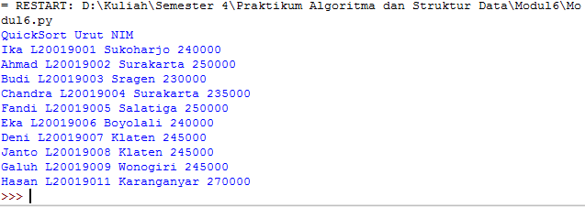

#===========================================================

**#Nomor 7**

from time import time as detak

from random import shuffle as kocok

import time

def mergeSort(A):

#print("Membelah ",A)

if len(A) > 1:

mid = len(A) // 2

separuhkiri = A[:mid]

separuhkanan = A[mid:]

mergeSort(separuhkiri)

mergeSort(separuhkanan)

i = 0;j=0;k=0

while i < len(separuhkiri) and j < len(separuhkanan):

if separuhkiri[i] < separuhkanan[j]:

A[k] = separuhkiri[i]

i = i + 1

else:

A[k] = separuhkanan[j]

j = j + 1

k=k+1

while i < len(separuhkiri):

A[k] = separuhkiri[i]

i = i + 1

k=k+1

while j < len(separuhkanan):

A[k] = separuhkanan[j]

j = j + 1

k=k+1

#print("Menggabungkan",A)

def partisi(A, awal, akhir):

nilaipivot = A[awal]

penandakiri = awal + 1

penandakanan = akhir

selesai = False

while not selesai:

while penandakiri <= penandakanan and A[penandakiri] <= nilaipivot:

penandakiri = penandakiri + 1

while penandakanan >= penandakiri and A[penandakanan] >= nilaipivot:

penandakanan = penandakanan - 1

if penandakanan < penandakiri:

selesai = True

else:

temp = A[penandakiri]

A[penandakiri] = A[penandakanan]

A[penandakanan] = temp

temp = A[awal]

A[awal] = A[penandakanan]

A[penandakanan] = temp

return penandakanan

def quickSortBantu(A, awal, akhir):

if awal < akhir:

titikBelah = partisi(A, awal, akhir)

quickSortBantu(A, awal, titikBelah-1)

quickSortBantu(A, titikBelah+1, akhir)

def quickSort(A):

quickSortBantu (A, 0, len(A)-1)

def mergeSort2(A, awal, akhir):

mid = (awal+akhir)//2

if awal < akhir:

mergeSort2(A, awal, mid)

mergeSort2(A, mid+1, akhir)

a, f, l = 0, awal, mid+1

tmp = [None] * (akhir - awal + 1)

while f <= mid and l <= akhir:

if A[f] < A[l]:

tmp[a] = A[f]

f += 1

else:

tmp[a] = A[l]

l += 1

a += 1

if f <= mid:

tmp[a:] = A[f:mid+1]

if l <= akhir:

tmp[a:] = A[l:akhir+1]

a = 0

while awal <= akhir:

A[awal] = tmp[a]

awal += 1

a += 1

def mergeSortNew(A):

mergeSort2(A, 0, len(A)-1)

def quickSortNew(arr):

kurang = []

pivotList = []

lebih = []

if len(arr) <= 1:

return arr

else:

pivot = arr[0]

for i in arr:

if i < pivot:

kurang.append(i)

elif i > pivot:

lebih.append(i)

else:

pivotList.append(i)

kurang = quickSortNew(kurang)

lebih = quickSortNew(lebih)

return kurang + pivotList + lebih

daftar = [10, 51, 2, 18, 4, 31, 13, 5, 23, 64, 29]

print (daftar)

mergeSort(daftar)

quickSort(daftar)

mergeSortNew(daftar)

quickSortNew(daftar)

k = [[i] for i in range(1, 6001)]

kocok(k)

u_mrg = k[:]

u_qck = k[:]

u_mrgNew = k[:]

u_qckNew = k[:]

aw=detak();mergeSort(u_mrg);ak=detak();print("Merge v.1: %g detik" %(ak-aw));

aw=detak();quickSort(u_qck);ak=detak();print("Quick v.1: %g detik" %(ak-aw));

aw=detak();mergeSortNew(u_mrgNew);ak=detak();print("Merge v.2: %g detik" %(ak-aw));

aw=detak();quickSortNew(u_qckNew);ak=detak();print("Quick v.2: %g detik" %(ak-aw));

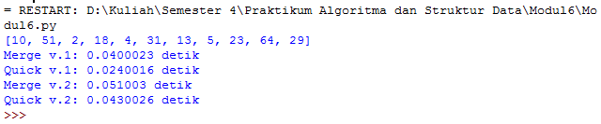

#===========================================================

**#Nomor 8**

class Node():

def __init__(self, data, tautan=None):

self.data = data

self.tautan = tautan

def cetak(head):

curr = head

while curr is not None:

try:

print (curr.data)

curr = curr.tautan

except:

pass

a = Node(80)

b = Node(7)

c = Node(24)

d = Node(16)

e = Node(43)

f = Node(91)

g = Node(35)

h = Node(2)

i = Node(19)

j = Node(72)

a.tautan = b

b.tautan = c

c.tautan = d

d.tautan = e

e.tautan = f

f.tautan = g

g.tautan = h

h.tautan = i

i.tautan = j

def mergeSortLinkedList(A):

linked = A

try:

daftar = []

curr = A

while curr:

daftar.append(curr.data)

curr = curr.tautan

A = daftar

except:

A = A

if len(A) > 1:

mid = len(A) // 2

separuhkiri = A[:mid]

separuhkanan = A[mid:]

mergeSortLinkedList(separuhkiri)

mergeSortLinkedList(separuhkanan)

i = 0;j=0;k=0

while i < len(separuhkiri) and j < len(separuhkanan):

if separuhkiri[i] < separuhkanan[j]:

A[k] = separuhkiri[i]

i = i + 1

else:

A[k] = separuhkanan[j]

j = j + 1

k=k+1

while i < len(separuhkiri):

A[k] = separuhkiri[i]

i = i + 1

k=k+1

while j < len(separuhkanan):

A[k] = separuhkanan[j]

j = j + 1

k=k+1

for x in A:

try:

linked.data = x

linked = linked.tautan

except:

pass

mergeSortLinkedList(a)

cetak(a)

