**LAPORAN PRAKTIKUM ALGORITMA DAN STRUKTUR DATA**

**MODUL 8  
”STACKS AND QUEUES”  
**

**Oleh:**

**NAMA : Daffa Putra Alwansyah**

**NIM : L200190031**

**KELAS : B**

**PRODI : Informatika**

**Fakultas Komunikasi dan Informatika**

**Universitas Muhammadiyah Surakarta**

**#=============Latihan===================**

**##=========Latihan 8.3=========**

class Stack:

def __init__(self):

self.items = []

def isEmpty(self):

return len(self) == 0

def __len__(self):

return len(self.items)

def peek(self):

assert not self.isEmpty()

return self.items[-1]

def pop(self):

assert not self.isEmpty()

return self.items.pop()

def push(self, data):

self.items.append(data)

class StackLL:

def __init__(self):

self.top = None

self.size = 0

def isEmpty(self):

return self.top is None

def __len__(self):

return self.size

def peek(self):

assert not self.isEmpty()

return self.top.item

def pop(self):

assert not self.isEmpty()

node = self.top

self.top = self.top.next

self.size -= 1

return node.item

def push(self):

self.top = _StackNode(data, self.top)

self.size += 1

class _StackNode:

def __init__(self, data, link):

self.item = data

self.next = link

PROMPT = "Masukkan bilangan positif (<0 untuk mengakhiri) : "

myStack = Stack()

value = int(input(PROMPT))

while value >= 0:

myStack.push(value)

value = int(input(PROMPT))

while not myStack.isEmpty():

value = myStack.pop()

print(value)

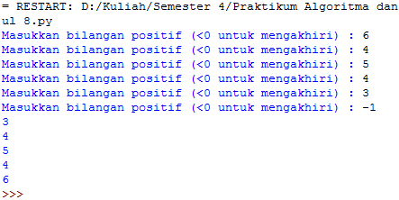  
  
**##=========Latihan 8.4=========**

def cetakBiner(d):

f = Stack()

if d==0: f.push(0);

while d !=0:

sisa = d%2

d = d//2

f.push(sisa)

st = ""

for i in range(len(f)):

st = st + str(f.pop())

return st

print(cetakBiner(11))

print(cetakBiner(53))  
  
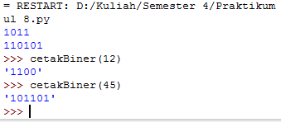

**##=========Latihan 8.6=========**

class Queue(object):

def __init__(self):

self.qlist = []

def isEmpty(self):

return len(self) == 0

def __len__(self):

return len(self.qlist)

def enqueue(self, data):

self.qlist.append(data)

def dequeue(self):

assert not self.isEmpty(), "Antrian sedang kosong"

return self.qlist.pop(0)

Q = Queue()

Q.enqueue(28)

Q.enqueue(19)

Q.enqueue(45)

Q.enqueue(13)

Q.enqueue(7)

print(Q.qlist)

Q.dequeue()

Q.dequeue()

Q.dequeue()

Q.dequeue()

Q.dequeue()

print(Q.qlist)

Q.enqueue(98)

Q.enqueue(54)

Q.dequeue()

print(Q.qlist)

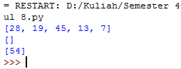

**##=========Latihan 8.7=========**

class PriorityQueue(object):

def __init__(self):

self.qlist = []

def __len__(self):

return len(self.qlist)

def isEmpty(self):

return len(self) == 0

def enqueue(self, data, priority):

entry = _PriorityQEntry(data, priority)

self.qlist.append(entry)

def dequeue(self):

pass

class _PriorityQEntry(object):

def __init__(self, data, priority):

self.item = data

self.priority = priority

def __str__(self):

return 'Item: {}\nPriority: {}'.format(self.item, self.priority)

S = PriorityQueue()

S.enqueue('Jeruk', 4)

S.enqueue('Tomat', 2)

S.enqueue('Mangga', 0)

S.enqueue('Duku', 5)

S.enqueue('Papaya', 2)

for i in S.qlist:

print(i)

S.dequeue()

S.dequeue()

S.dequeue()

for i in S.qlist:

print(i)

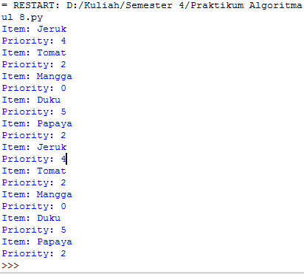

**##============Soal Mahasiswa============**

**##=========Nomor 1=========**

class Stack(object):

def __init__(self):

self.items = []

def isEmpty(self):

return len(self) == 0

def __len__(self):

return len(self.items)

def peek(self):

assert not self.isEmpty(), "Tidak bisa diintip. Stack kosong"

return self.items[-1]

def pop(self):

assert not self.isEmpty(), "Tidak bisa dipop dari Stack kosong"

return self.items.pop()

def push(self, data):

self.items.append(data)

def cetakHexa(d):

f = Stack()

if d == 0: f.push(0);

while d != 0:

sisa = d%16

d = d//16

if sisa == 10:

sisa = "A"

elif sisa == 11:

sisa = "B"

elif sisa == 12:

sisa = "C"

elif sisa == 13:

sisa = "D"

elif sisa == 14:

sisa = "E"

elif sisa == 15:

sisa = "F"

f.push(sisa)

st = ""

for i in range (len(f)):

st = st + str(f.pop())

return st

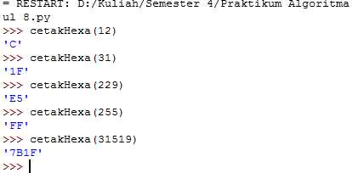

**##=========Nomor 2=========**

class Stack(object):

def __init__(self):

self.items = []

def isEmpty(self):

return len(self) == 0

def __len__(self):

return len(self.items)

def peek(self):

assert not self.isEmpty(), "Tidak bisa diintip. Stack kosong"

return self.items[-1]

def pop(self):

assert not self.isEmpty(), "Tidak bisa dipop dari Stack kosong"

return self.items.pop()

def push(self, data):

self.items.append(data)

nilai = Stack()

for i in range(16):

if i%3 == 0:

nilai.push(i)

print(nilai.items)

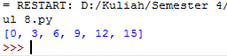

**##=========Nomor 3=========**

class Stack(object):

def __init__(self):

self.items = []

def isEmpty(self):

return len(self) == 0

def __len__(self):

return len(self.items)

def peek(self):

assert not self.isEmpty(), "Tidak bisa diintip. Stack kosong"

return self.items[-1]

def pop(self):

assert not self.isEmpty(), "Tidak bisa dipop dari Stack kosong"

return self.items.pop()

def push(self, data):

self.items.append(data)

nilai = Stack()

for i in range (16):

if i%3 == 0:

nilai.push(i)

elif i%4 == 0:

nilai.pop()

print(nilai.items)

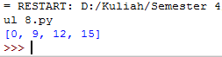

**##=========Nomor 4=========**

class Queue(object):

def __init__(self):

self.qlist = []

def isEmpty(self):

return len(self) == 0

def __len__(self):

return len(self.qlist)

def enqueue(self, data):

self.qlist.append(data)

def dequeue(self):

assert not self.isEmpty(), "Antrian sedang kosong"

return self.qlist.pop(0)

def getFrontMost(self):

return self.qlist[0]

def getRearMost(self):

return self.qlist[-1]

class PriorityQueue(object):

def __init__(self):

self.qlist = []

def isEmpty(self):

return len(self) == 0

def __len__(self):

return len(self.qlist)

def enqueue(self, data, priority):

entry = _PriorityQEntry(data, priority)

self.qlist.append(entry)

def getFrontMost(self):

x = 0

while self.qlist[x].priority != 0:

x+=1

return self.qlist[x].item

def getRearMost(self):

a = []

for i in self.qlist:

a.append(i.priority)

print (self.qlist[a.index(max(a))].item)

class _PriorityQEntry(object):

def __init__(self, data, priority):

self.item = data

self.priority = priority

A = Queue()

A.enqueue(28)

A.enqueue(19)

A.enqueue(45)

A.enqueue(13)

A.enqueue(7)

B = PriorityQueue()

B.enqueue("Jeruk", 4)

B.enqueue("Tomat", 2)

B.enqueue("Mangga", 0)

B.enqueue("Duku", 5)

B.enqueue("Pepaya", 2)

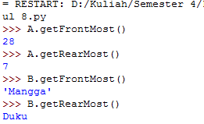

**##=========Nomor 5=========**

class PriorityQueue(object):

def __init__(self):

self.qlist = []

def isEmpty(self):

return len(self) == 0

def __len__(self):

return len(self.qlist)

def enqueue(self, data, priority):

entry = _PriorityQEntry(data, priority)

self.qlist.append(entry)

def dequeue(self):

assert not self.isEmpty(), "Antrian sedang kosong"

a = []

for i in self.qlist:

a.append(i.priority)

print (self.qlist.pop(a.index(min(a))).item)

class _PriorityQEntry(object):

def __init__(self, data, priority):

self.item = data

self.priority = priority

S = PriorityQueue()

S.enqueue("Jeruk", 4)

S.enqueue("Tomat", 2)

S.enqueue("Mangga", 0)

S.enqueue("Duku", 4)

S.enqueue("Pepaya", 2)  
  
