Indira Febriyanti
L200194197
Class X Informatics

Assigment Report.
MODUL 1
Before do the step :
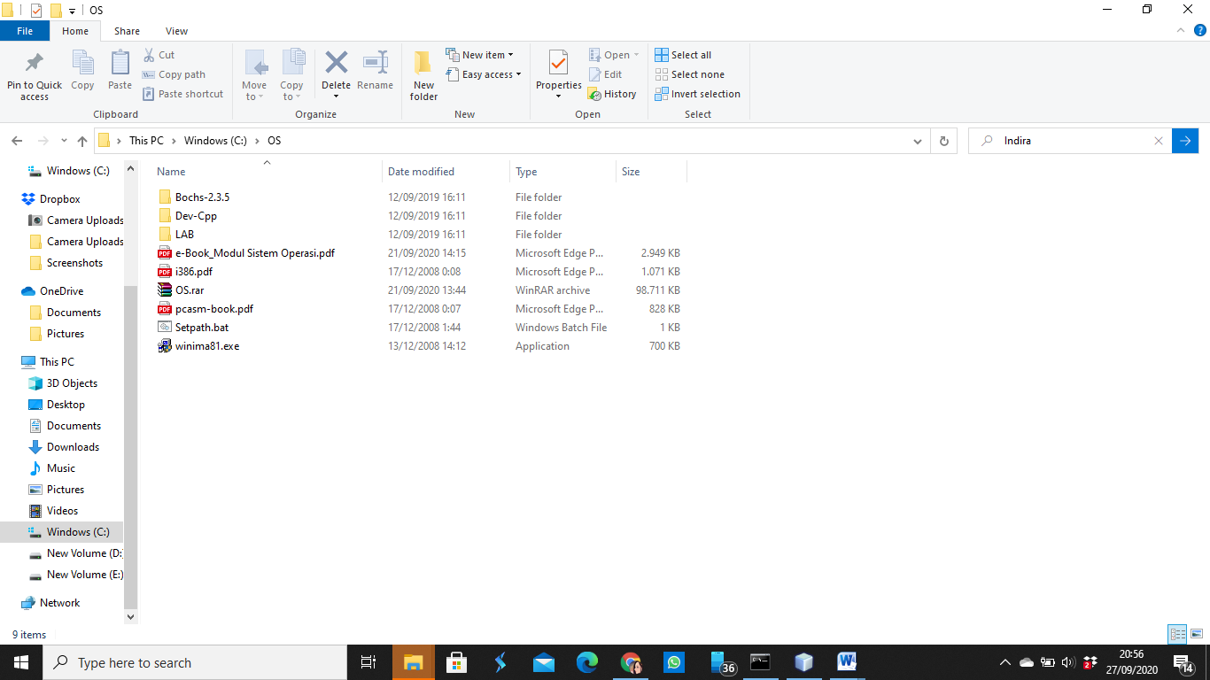
- Make one folder with name “OS” in Local Disk (C:).
- Put your rar of OS in Local Disk (C:) and do “extract here”.
- “Cut” your all file after the extract and “paste” in folder OS that you have made it.
Note :
These is to make easier for you to access the file in the cmd.

Step 1 : cd OS
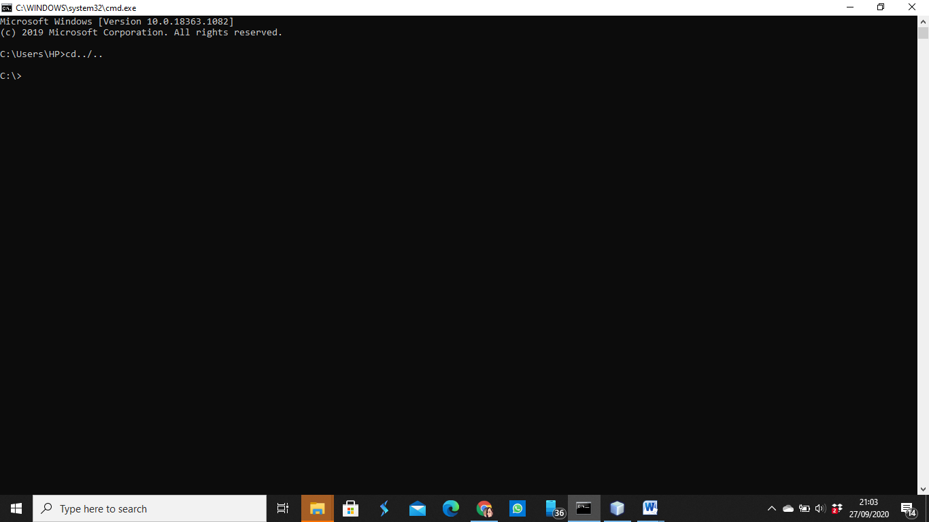
- Open cmd
- Then, Go to the first directory by command “cd../..” and <ENTER>. So you now in the first directory.
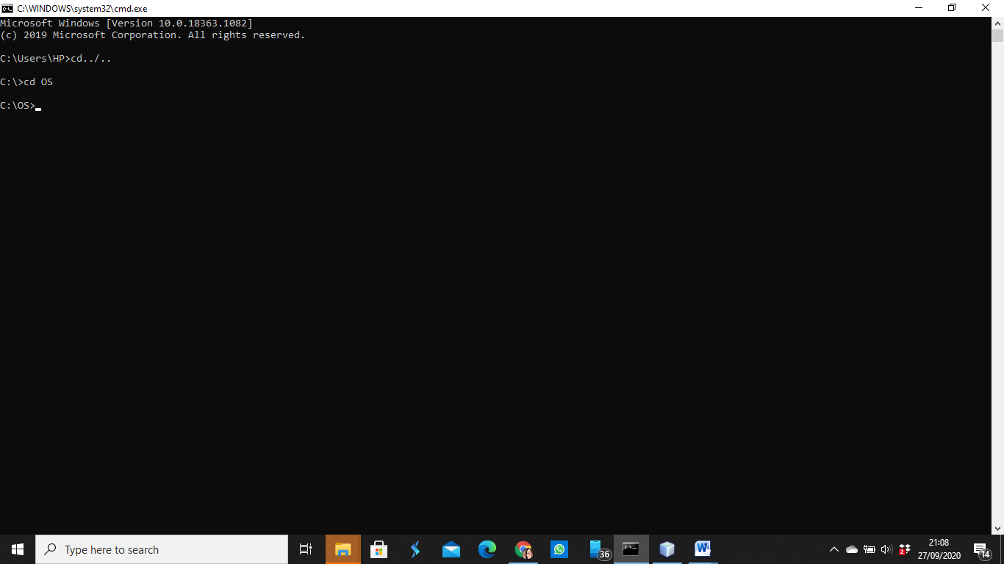
- Then, open OS directory by command “cd OS” and <ENTER>. So you now in the OS directory.

Step 2 : setpath
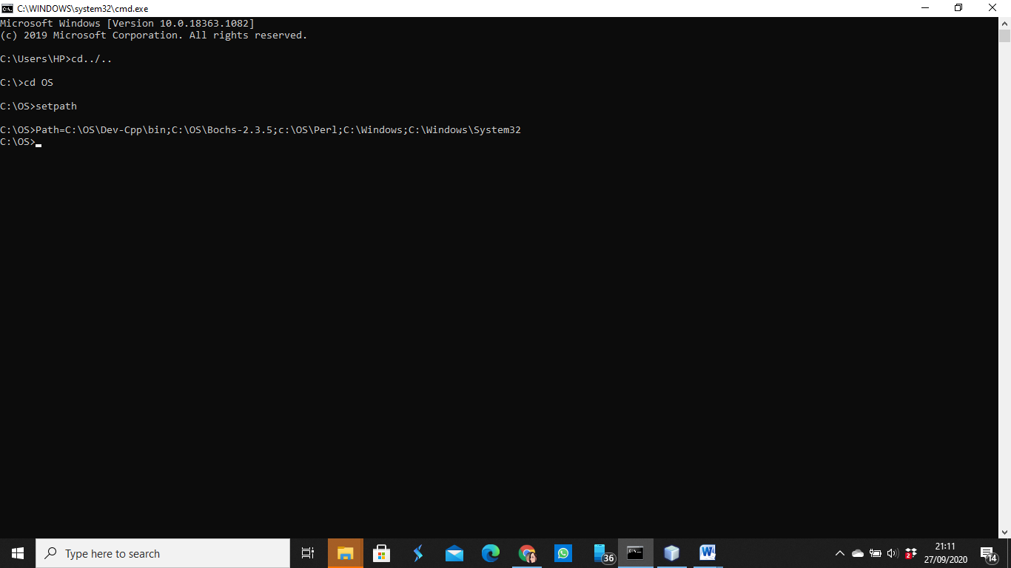
- Command setpath and <ENTER>.
Note :
the task of setting up the environment ('path') as long as you perform
practice, you must carry out this program before starting each of your practicum sessions.

Step 3 : cd LAB/LAB1
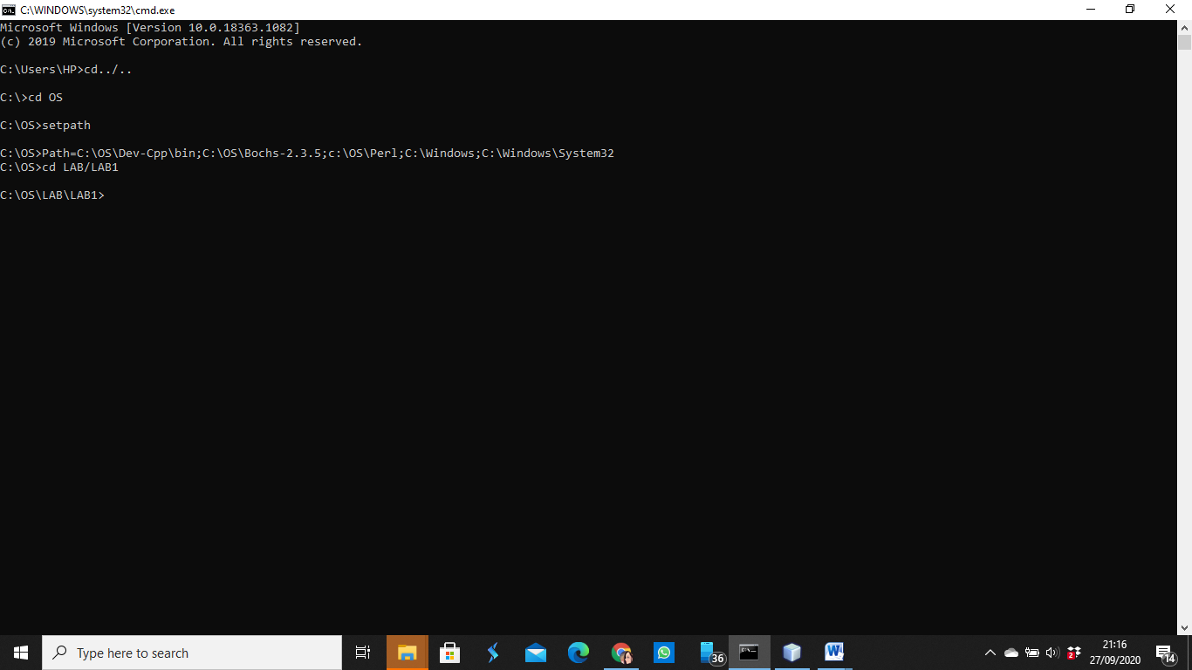
- Go to LAB1 directory by command “cd LAB/LAB1” and <ENTER>. So you now in the LAB1 directory.
Step 4 : make fp.disk
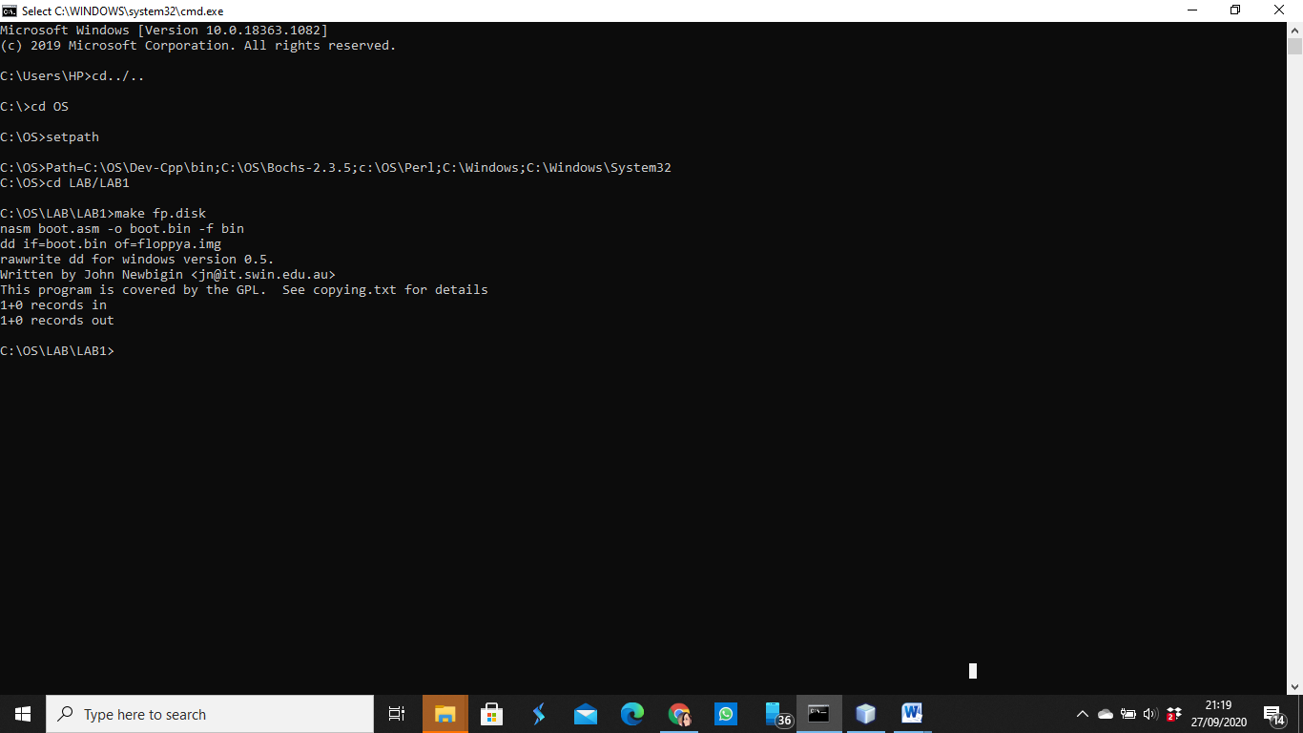
- Make fp.disk in the LAB1 directory by command “make fp.disk” and <ENTER>.
- So you now have fp.disk in the LAB1 directory
Note :
file 'image floppy' with the file name 'floppya.img' this file will used to store the results of the second compilation source code, then used as a 'boot disk' on PC-simulator 'Bochs'.
'Makefile' is a text file containing a set of command 'Command Prompt' is similar to bat file, but cannot be run directly. This file is used by the pplication program 'make.exe' to control the compilation process, lingking and others, program 'make.exe' will be more of a benefit when the source code program consisting of many files, the compilation process and the can be done utomatically, as the control is is the script contained in 'Makefile'. This way a lot used by users of the 'linux' operating system.
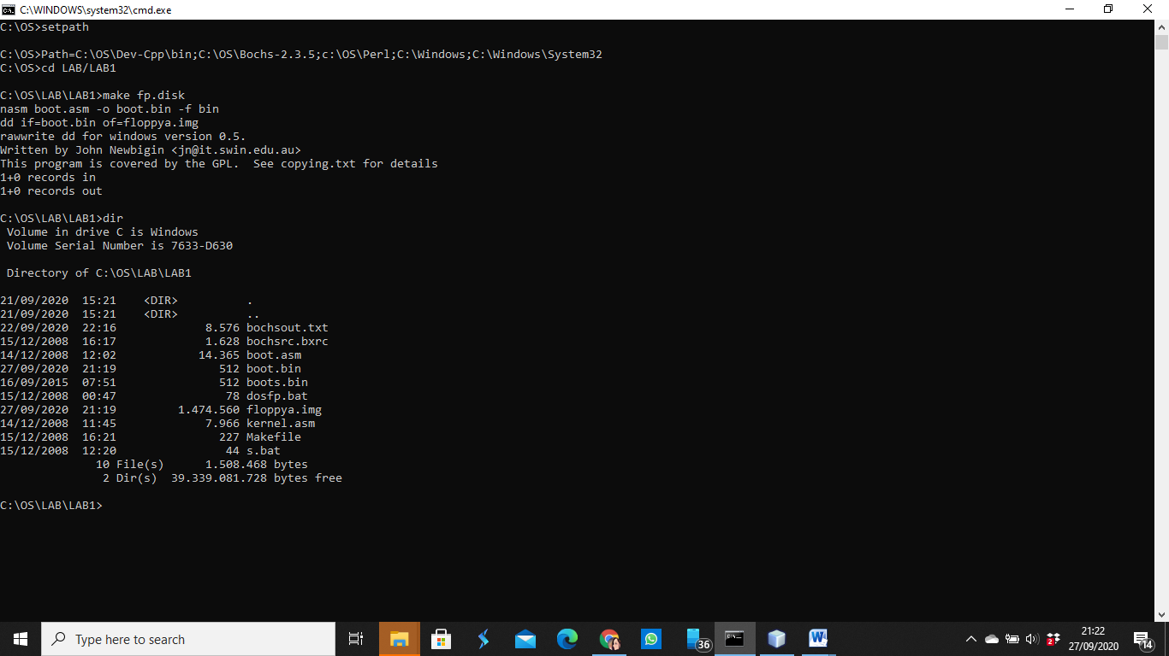
- Check out your LAB1 directory by command “dir” and <ENTER>.
- Then you can see all your file in the LAB1 directory.
Step 5 : Del floppya.img
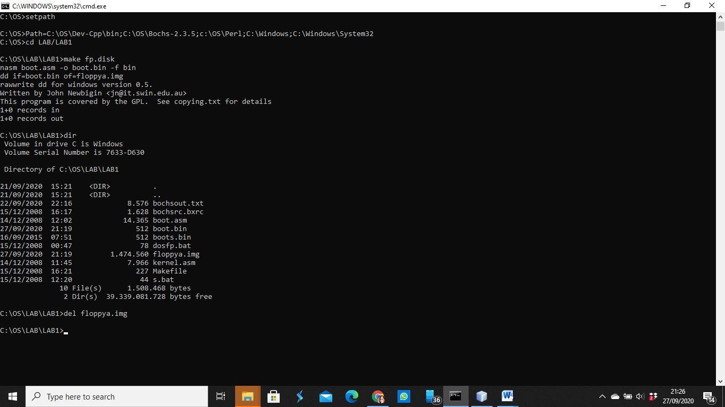
- Eliminate the floppya.img by write “del floppy.img” and <ENTER>.
Step 6 : Bximage -> fd, 1.44, floppya.img
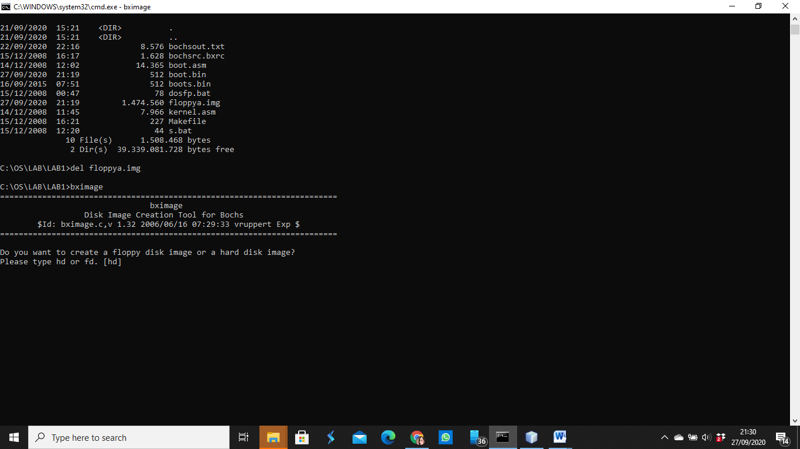
- Command “bximage” and <ENTER>
Note :
File this image can be created using the built-in assistive program
'Bochs' i.e. 'bximage' or using an application program 'Virtual PC' belongs to Windows (free as well) or with programs Magiciso. Now we try to create a floppy image file by using the application program 'bximage.exe'
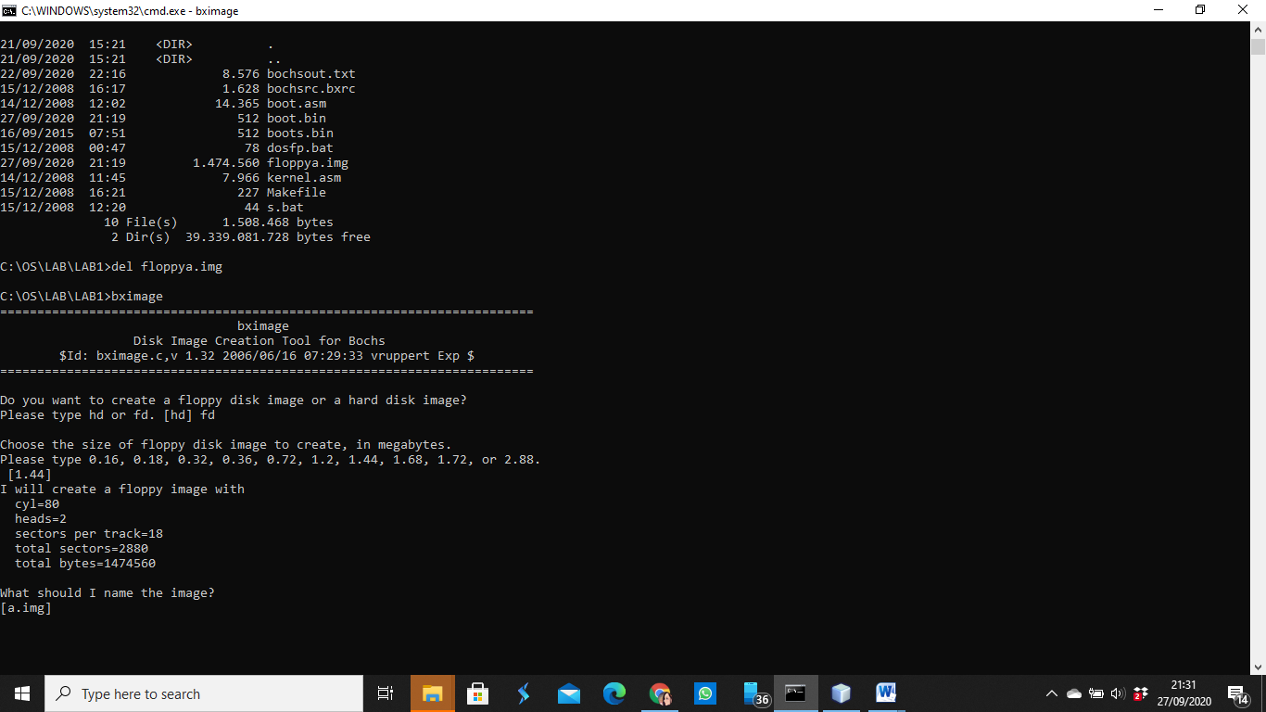
- Choose “fd” and <ENTER>
- Then <ENTER> twice.
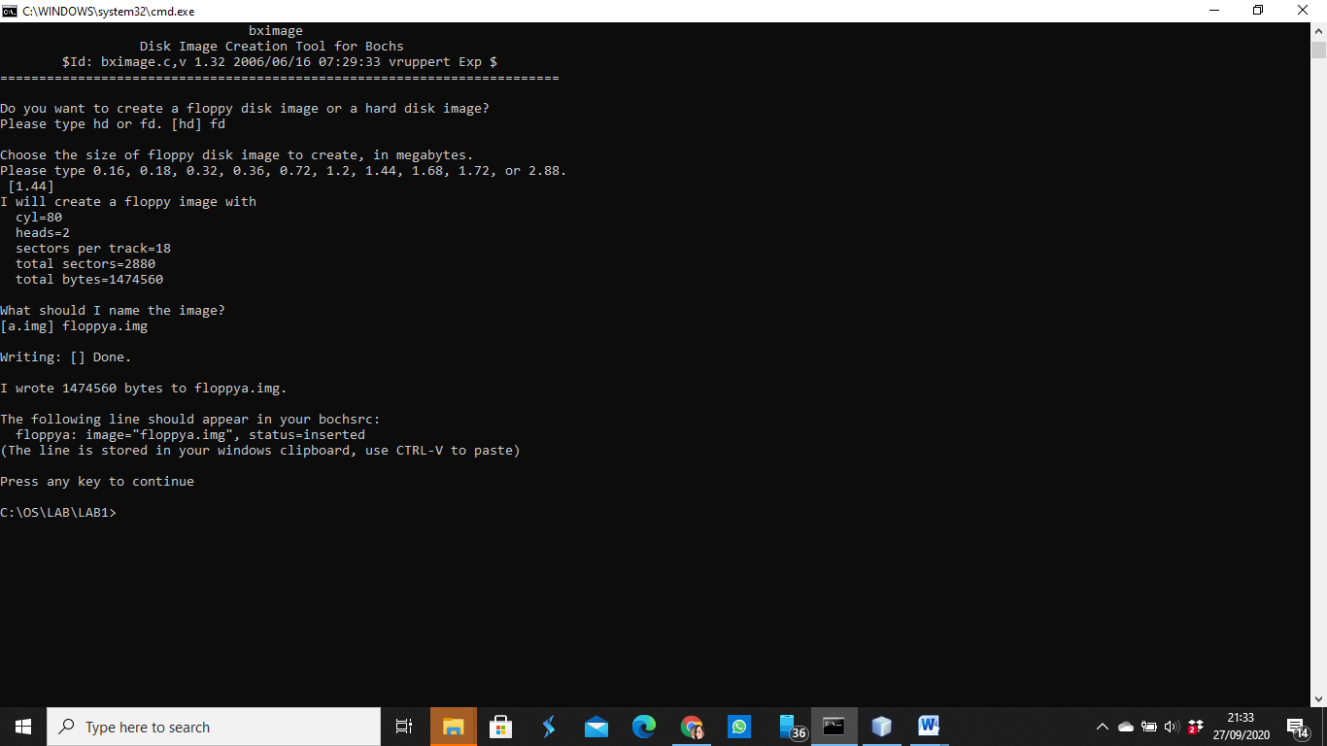
- Write “floppy.img” and <ENTER> twice.
Step 7 : Dosfp
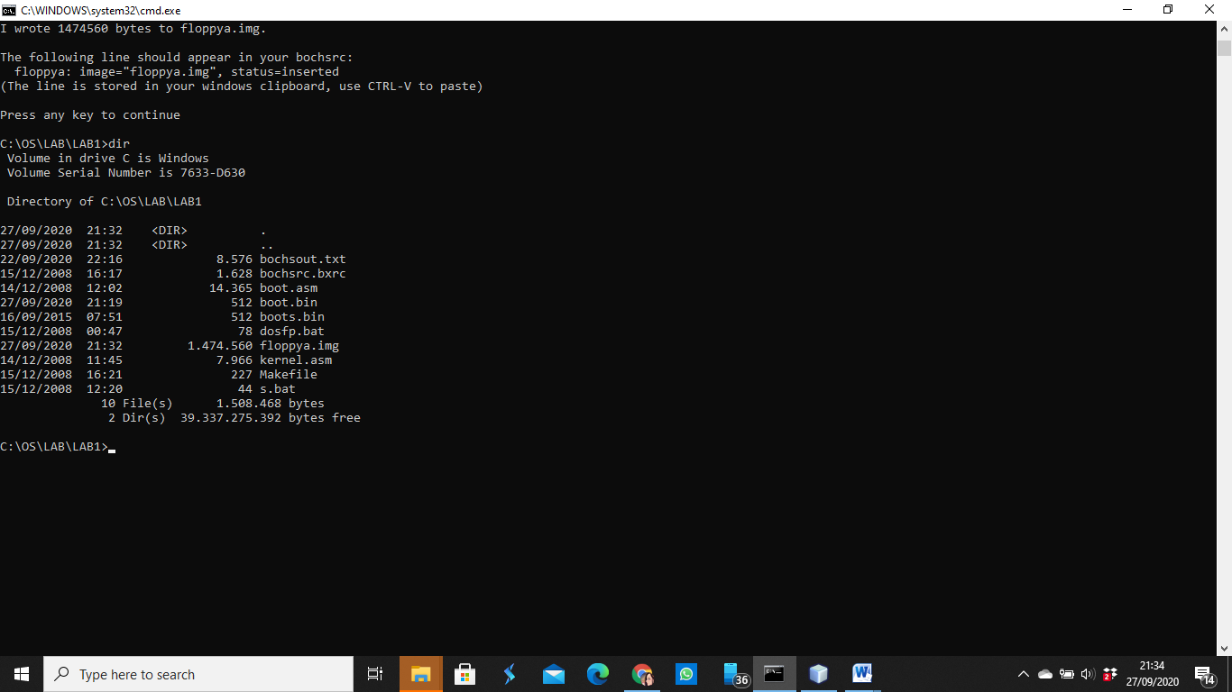
- Check out your LAB1 directory by command “dir” and <ENTER>
- Then you can see all your file in the LAB1 directory.
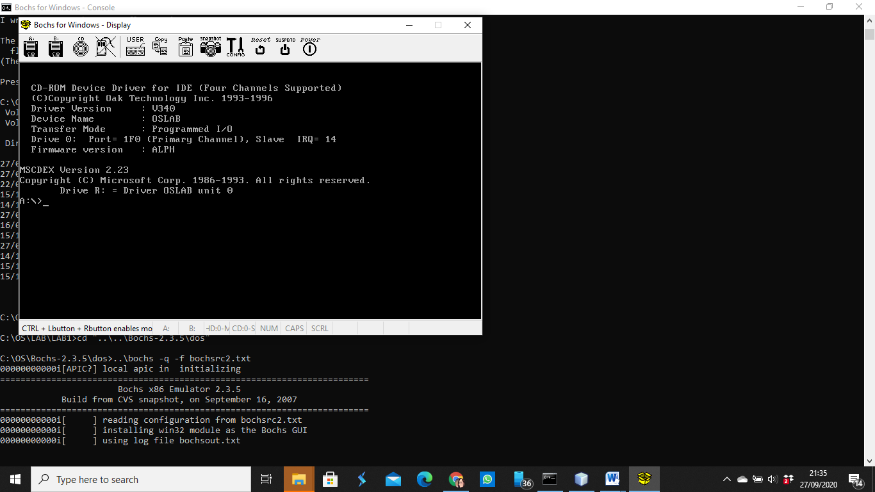
- Then, command “dosfp” and <ENTER>. It will be like the picture.
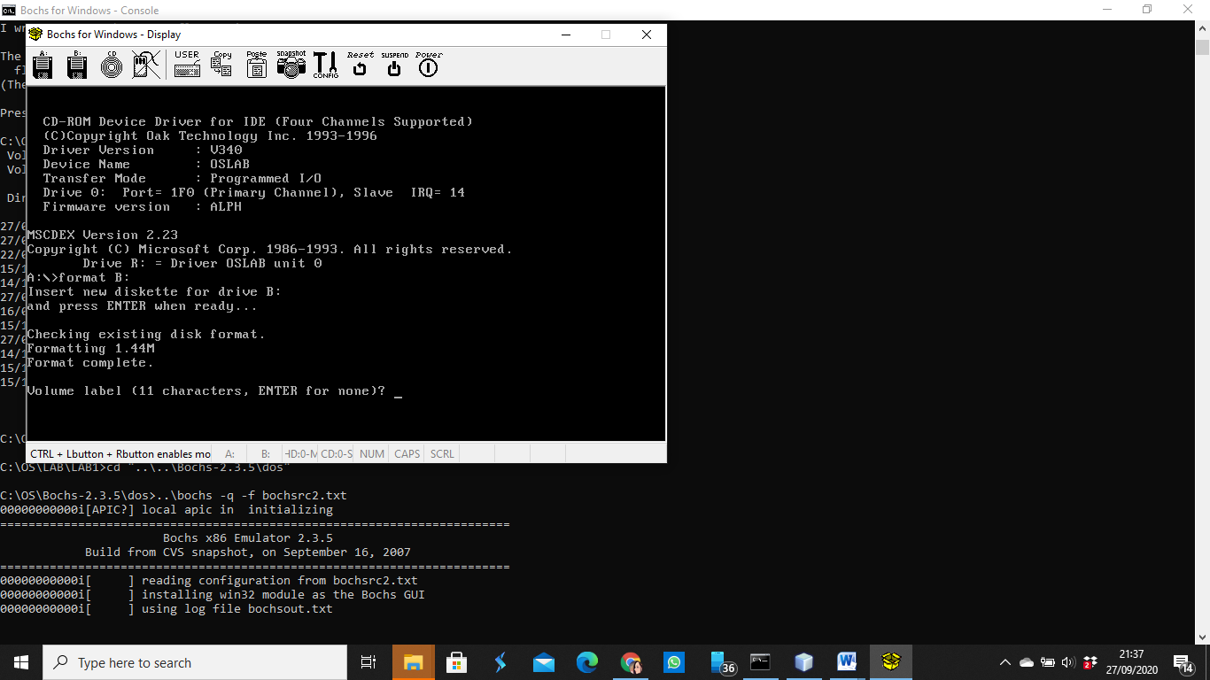
- Command “format B:” and <ENTER>.
- Then enter twice again.
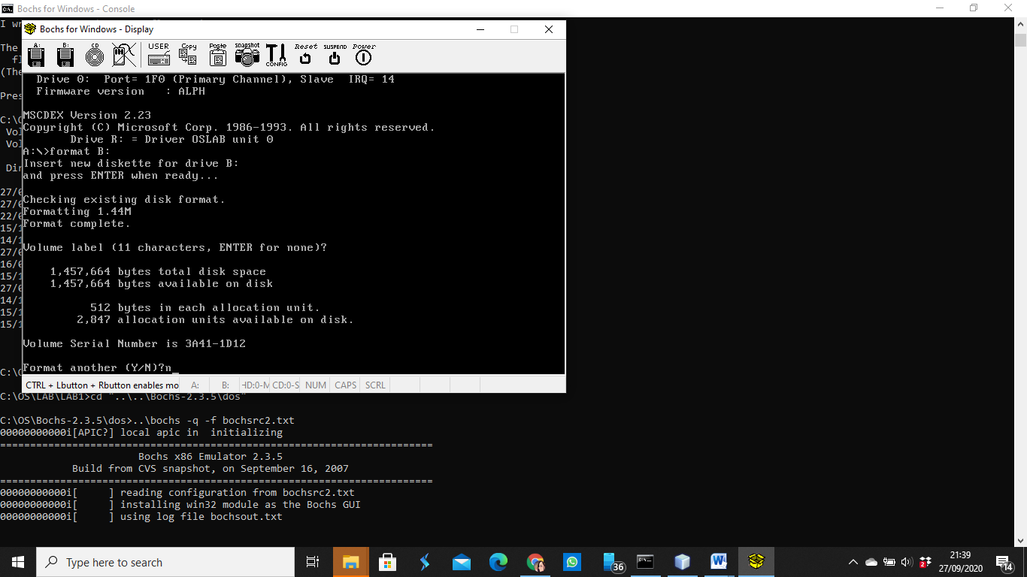
- Command “n” and <ENTER>.
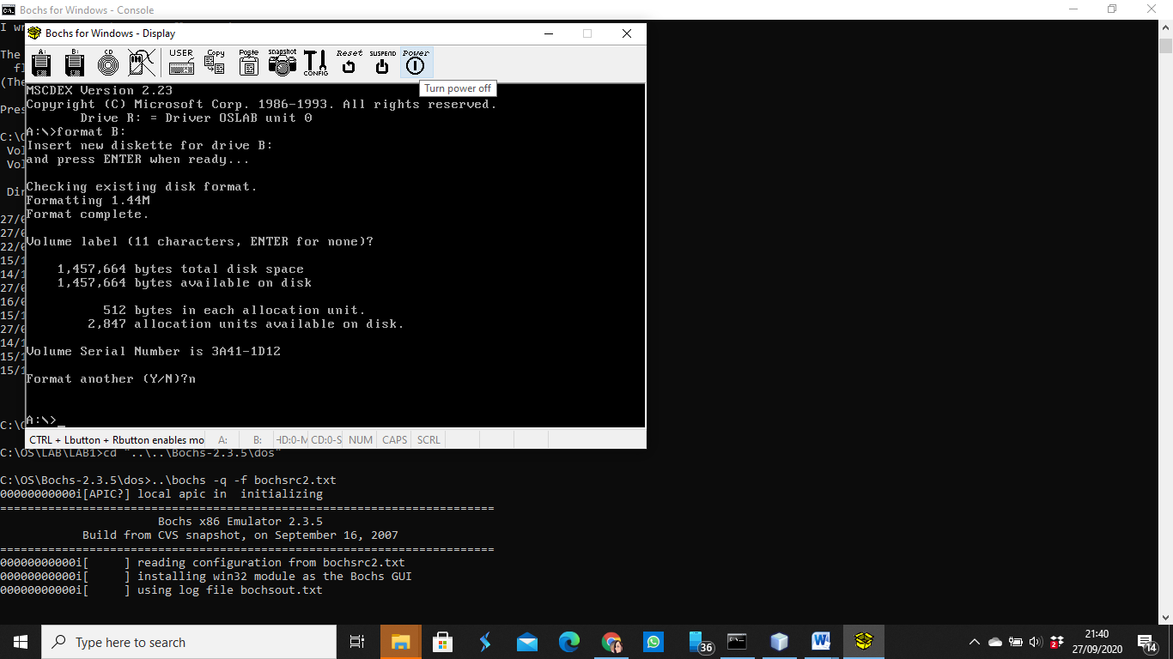
- Click power.
Step 8 : tdump boots.bin
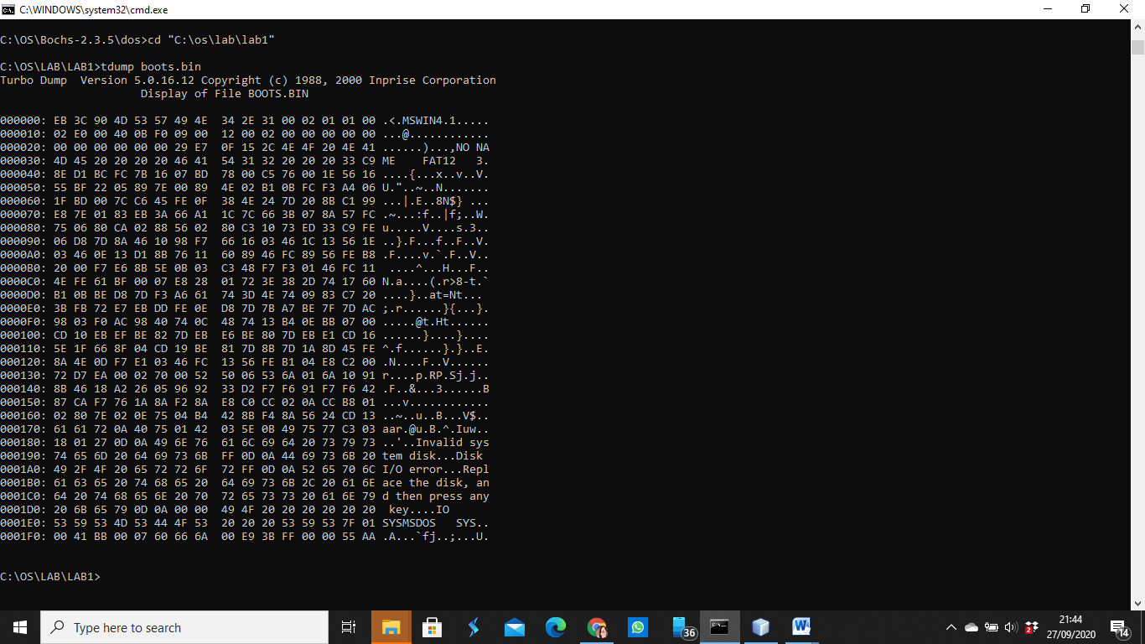
- Command “tdump boots.bin” and <ENTER>.
Step 9 : type s.bat
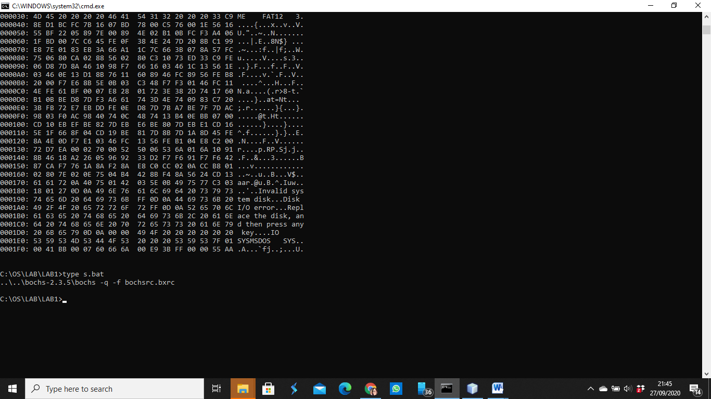
- Command “type s.bat” and <ENTER>

Step 10 : s
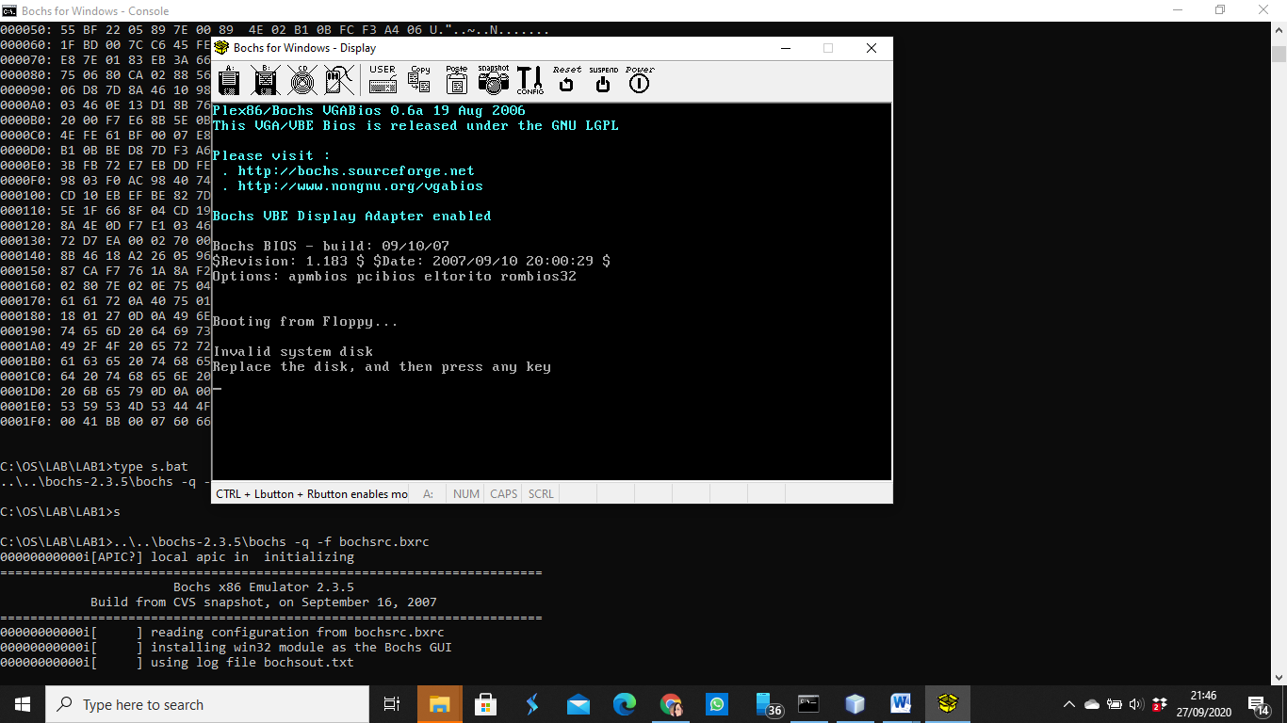
- Command “s” and <ENTER>.
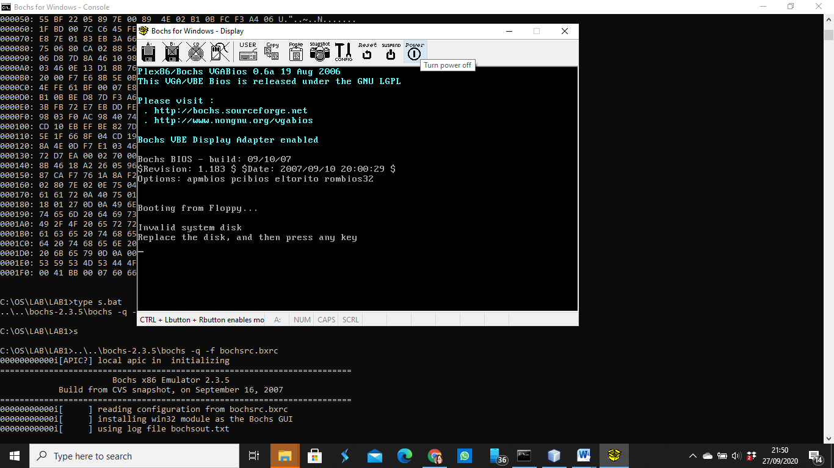
- Click power
Step 11 : dosfp -> format
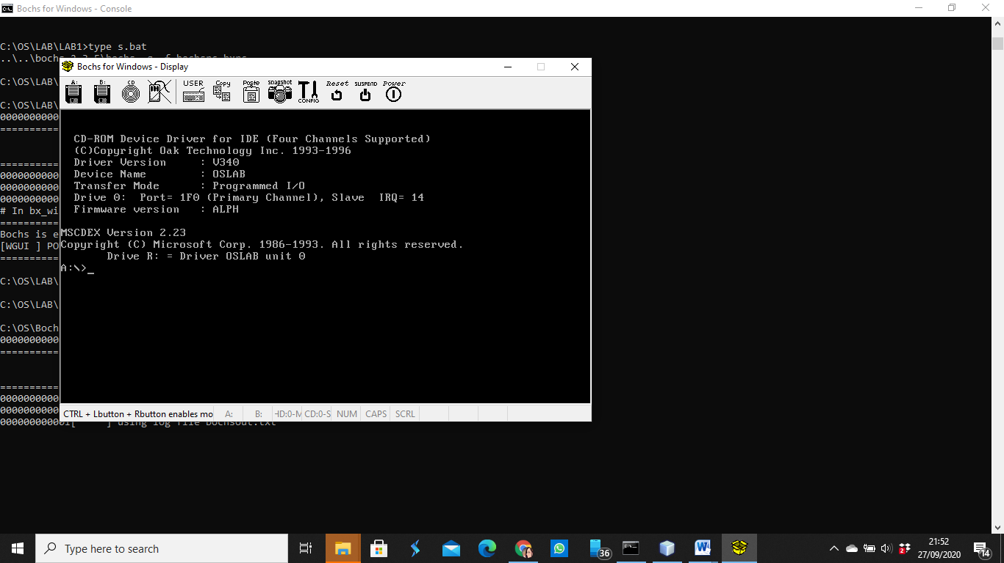
- Command “dosfp” and <ENTER>.
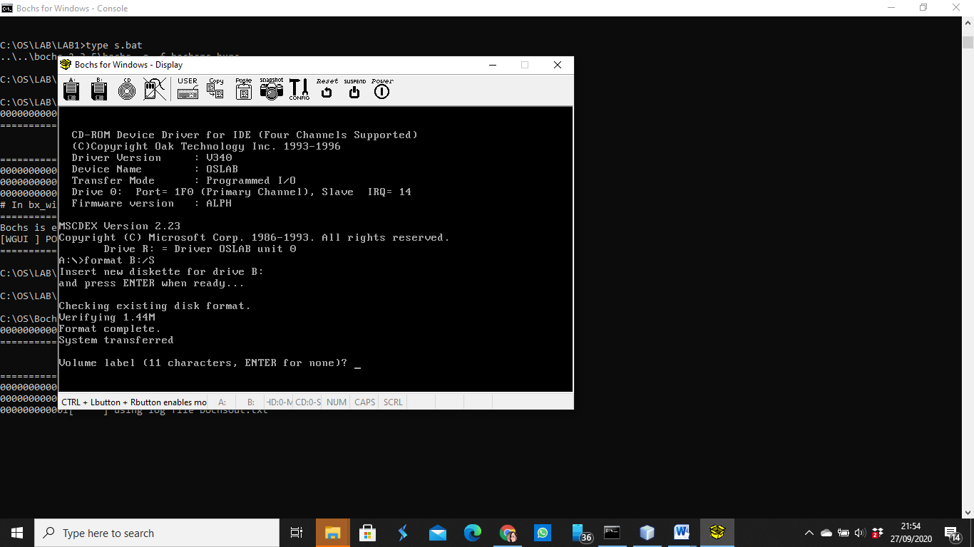
- Command “format B:/S” and <ENTER> twice.
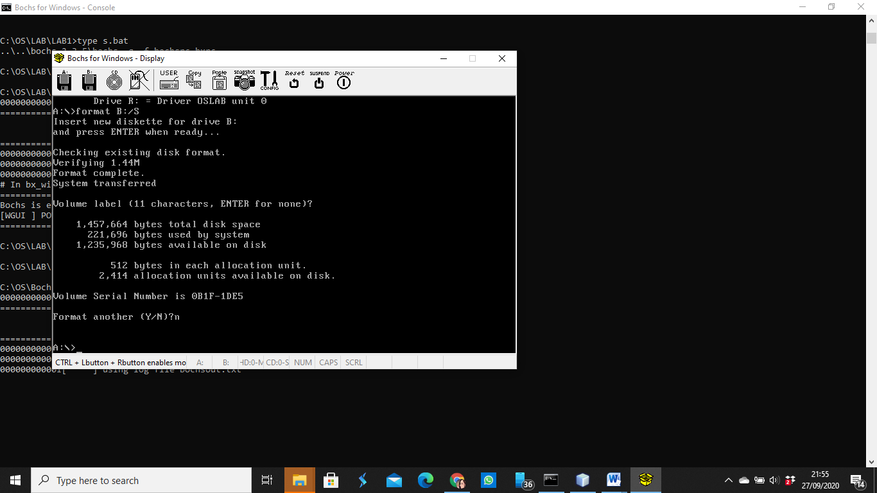
- Command “n” and <ENTER>.
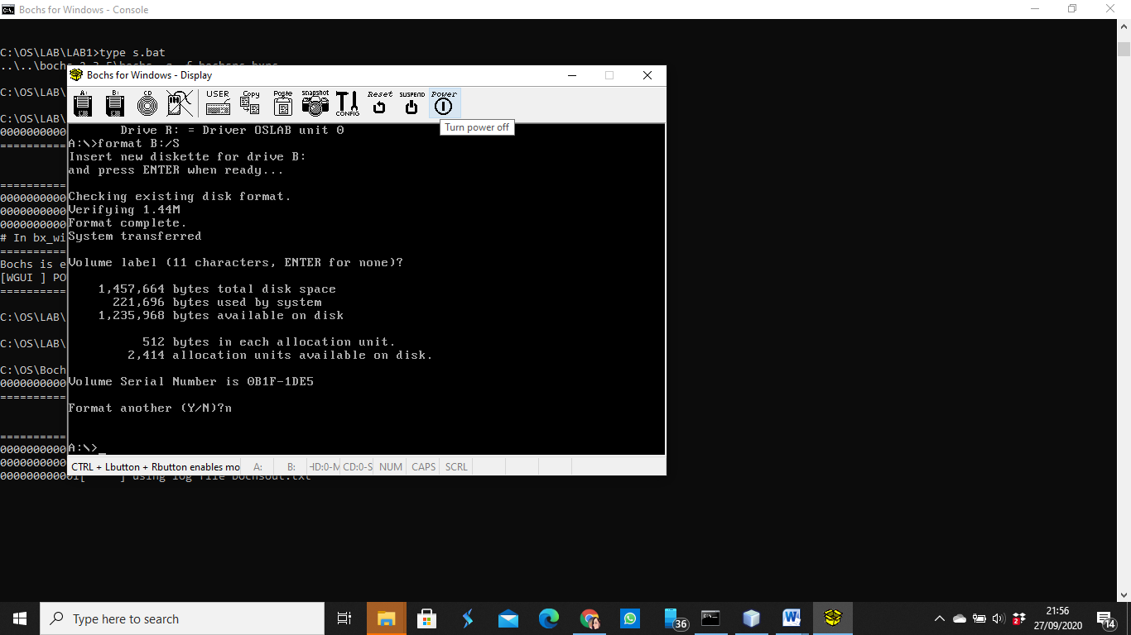
- Click power.
- Command “s” and <ENTER>.
- You done.

Assigntment from Module
ANSWER
- ASCII code is the numerical reprentation of a character such as ‘a’ or ‘@’ or an action of some sort.
Character | Unicode value  (hexadecimal) | ANSI ASCII value  (decimal) | Binary | Information
NUL | 0000 | 0 | 00000000 | Null (tidak tampak)
SOH | 0001 | 1 | 00000001 | Start of heading (tidak tampak)
STX | 0002 | 2 | 00000010 | Start of text (tidak tampak)
ETX | 0003 | 3 | 00000011 | End of text (tidak tampak)
EOT | 0004 | 4 | 00000100 | End of transmission (tidak tampak)
ENQ | 0005 | 5 | 00000101 | Enquiry (tidak tampak)
ACK | 0006 | 6 | 00000110 | Acknowledge (tidak tampak)
BEL | 0007 | 7 | 00000111 | Bell (tidak tampak)
BS | 0008 | 8 | 00001000 | Menghapus satu karakter di belakang kursor (Backspace)
HT | 0009 | 9 | 00001001 | Horizontal tabulation
LF | 000A | 10 | 00001010 | Pergantian baris (Line feed)
VT | 000B | 11 | 00001011 | Tabulasi vertikal
FF | 000C | 12 | 00001100 | Pergantian baris (Form feed)
CR | 000D | 13 | 00001101 | Pergantian baris (carriage return)
SO | 000E | 14 | 00001110 | Shift out (tidak tampak)
SI | 000F | 15 | 00001111 | Shift in (tidak tampak)
DLE | 0010 | 16 | 00010000 | Data link escape (tidak tampak)
DC1 | 0011 | 17 | 00010001 | Device control 1 (tidak tampak)
DC2 | 0012 | 18 | 00010010 | Device control 2 (tidak tampak)
DC3 | 0013 | 19 | 00010011 | Device control 3 (tidak tampak)
DC4 | 0014 | 20 | 00010100 | Device control 4 (tidak tampak)
NAK | 0015 | 21 | 00010101 | Negative acknowledge (tidak tampak)
SYN | 0016 | 22 | 00010110 | Synchronous idle (tidak tampak)
ETB | 0017 | 23 | 00010111 | End of transmission block (tidak tampak)
CAN | 0018 | 24 | 00011000 | Cancel (tidak tampak)
EM | 0019 | 25 | 00011001 | End of medium (tidak tampak)
SUB | 001A | 26 | 00011010 | Substitute (tidak tampak)
ESC | 001B | 27 | 00011011 | Escape (tidak tampak)
FS | 001C | 28 | 00011100 | File separator
GS | 001D | 29 | 00011101 | Group separator
RS | 001E | 30 | 00011110 | Record separator
US | 001F | 31 | 00011111 | Unit separator
SP | 0020 | 32 | 00100000 | Spasi
! | 0021 | 33 | 00100001 | Tanda seru (exclamation)
" | 0022 | 34 | 00100010 | Tanda kutip dua
# | 0023 | 35 | 00100011 | Tanda pagar (kres)
$ | 0024 | 36 | 00100100 | Tanda mata uang dolar
% | 0025 | 37 | 00100101 | Tanda persen
& | 0026 | 38 | 00100110 | Karakter ampersand (&)
‘ | 0027 | 39 | 00100111 | Karakter Apostrof
( | 0028 | 40 | 00101000 | Tanda kurung buka
) | 0029 | 41 | 00101001 | Tanda kurung tutup
* | 002A | 42 | 00101010 | Karakter asterisk (bintang)
+ | 002B | 43 | 00101011 | Tanda tambah (plus)
, | 002C | 44 | 00101100 | Karakter koma
- | 002D | 45 | 00101101 | Karakter hyphen (strip)
. | 002E | 46 | 00101110 | Tanda titik
/ | 002F | 47 | 00101111 | Garis miring (slash)
0 | 0030 | 48 | 00110000 | Angka nol
1 | 0031 | 49 | 00110001 | Angka satu
2 | 0032 | 50 | 00110010 | Angka dua
3 | 0033 | 51 | 00110011 | Angka tiga
4 | 0034 | 52 | 00110100 | Angka empat
5 | 0035 | 53 | 00110101 | Angka lima
6 | 0036 | 54 | 00110110 | Angka enam
7 | 0037 | 55 | 00110111 | Angka tujuh
8 | 0038 | 56 | 00111000 | Angka delapan
9 | 0039 | 57 | 00111001 | Angka sembilan
: | 003A | 58 | 00111010 | Tanda titik dua
; | 003B | 59 | 00111011 | Tanda titik koma
< | 003C | 60 | 00111100 | Tanda lebih kecil
= | 003D | 61 | 00111101 | Tanda sama dengan
> | 003E | 62 | 00111110 | Tanda lebih besar
? | 003F | 63 | 00111111 | Tanda tanya
@ | 0040 | 64 | 01000000 | A keong (@)
A | 0041 | 65 | 01000001 | Huruf latin A kapital
B | 0042 | 66 | 01000010 | Huruf latin B kapital
C | 0043 | 67 | 01000011 | Huruf latin C kapital
D | 0044 | 68 | 01000100 | Huruf latin D kapital
E | 0045 | 69 | 01000101 | Huruf latin E kapital
F | 0046 | 70 | 01000110 | Huruf latin F kapital
G | 0047 | 71 | 01000111 | Huruf latin G kapital
H | 0048 | 72 | 01001000 | Huruf latin H kapital
I | 0049 | 73 | 01001001 | Huruf latin I kapital
J | 004A | 74 | 01001010 | Huruf latin J kapital
K | 004B | 75 | 01001011 | Huruf latin K kapital
L | 004C | 76 | 01001100 | Huruf latin L kapital
M | 004D | 77 | 01001101 | Huruf latin M kapital
N | 004E | 78 | 01001110 | Huruf latin N kapital
O | 004F | 79 | 01001111 | Huruf latin O kapital
P | 0050 | 80 | 01010000 | Huruf latin P kapital
Q | 0051 | 81 | 01010001 | Huruf latin Q kapital
R | 0052 | 82 | 01010010 | Huruf latin R kapital
S | 0053 | 83 | 01010011 | Huruf latin S kapital
T | 0054 | 84 | 01010100 | Huruf latin T kapital
U | 0055 | 85 | 01010101 | Huruf latin U kapital
V | 0056 | 86 | 01010110 | Huruf latin V kapital
W | 0057 | 87 | 01010111 | Huruf latin W kapital
X | 0058 | 88 | 01011000 | Huruf latin X kapital
Y | 0059 | 89 | 01011001 | Huruf latin Y kapital
Z | 005A | 90 | 01011010 | Huruf latin Z kapital
[ | 005B | 91 | 01011011 | Kurung siku kiri
\ | 005C | 92 | 01011100 | Garis miring terbalik (backslash)
] | 005D | 93 | 01011101 | Kurung sikur kanan
^ | 005E | 94 | 01011110 | Tanda pangkat
_ | 005F | 95 | 01011111 | Garis bawah (underscore)
` | 0060 | 96 | 01100000 | Tanda petik satu
a | 0061 | 97 | 01100001 | Huruf latin a kecil
b | 0062 | 98 | 01100010 | Huruf latin b kecil
c | 0063 | 99 | 01100011 | Huruf latin c kecil
d | 0064 | 100 | 01100100 | Huruf latin d kecil
e | 0065 | 101 | 01100101 | Huruf latin e kecil
f | 0066 | 102 | 01100110 | Huruf latin f kecil
g | 0067 | 103 | 01100111 | Huruf latin g kecil
h | 0068 | 104 | 01101000 | Huruf latin h kecil
i | 0069 | 105 | 01101001 | Huruf latin i kecil
j | 006A | 106 | 01101010 | Huruf latin j kecil
k | 006B | 107 | 01101011 | Huruf latin k kecil
l | 006C | 108 | 01101100 | Huruf latin l kecil
m | 006D | 109 | 01101101 | Huruf latin m kecil
n | 006E | 110 | 01101110 | Huruf latin n kecil
o | 006F | 111 | 01101111 | Huruf latin o kecil
p | 0070 | 112 | 01110000 | Huruf latin p kecil
q | 0071 | 113 | 01110001 | Huruf latin q kecil
r | 0072 | 114 | 01110010 | Huruf latin r kecil
s | 0073 | 115 | 01110011 | Huruf latin s kecil
t | 0074 | 116 | 01110100 | Huruf latin t kecil
u | 0075 | 117 | 01110101 | Huruf latin u kecil
v | 0076 | 118 | 01110110 | Huruf latin v kecil
w | 0077 | 119 | 01110111 | Huruf latin w kecil
x | 0078 | 120 | 01111000 | Huruf latin x kecil
y | 0079 | 121 | 01111001 | Huruf latin y kecil
z | 007A | 122 | 01111010 | Huruf latin z kecil
{ | 007B | 123 | 01111011 | Kurung kurawal buka
¦ | 007C | 124 | 01111100 | Garis vertikal (pipa)
} | 007D | 125 | 01111101 | Kurung kurawal tutup
~ | 007E | 126 | 01111110 | Karakter gelombang (tilde)
DEL | 007F | 127 | 01111111 | Delete
 | 0080 | 128 | 10000000 | Dicadangkan
 | 0081 | 129 | 10000001 | Dicadangkan
 | 0082 | 130 | 10000010 | Dicadangkan
 | 0083 | 131 | 10000011 | Dicadangkan
IND | 0084 | 132 | 10000100 | Index
NEL | 0085 | 133 | 10000101 | Next line
SSA | 0086 | 134 | 10000110 | Start of selected area
ESA | 0087 | 135 | 10000111 | End of selected area
 | 0088 | 136 | 10001000 | Character tabulation set
 | 0089 | 137 | 10001001 | Character tabulation with justification
 | 008A | 138 | 10001010 | Line tabulation set
PLD | 008B | 139 | 10001011 | Partial line down
PLU | 008C | 140 | 10001100 | Partial line up
 | 008D | 141 | 10001101 | Reverse line feed
SS2 | 008E | 142 | 10001110 | Single shift two
SS3 | 008F | 143 | 10001111 | Single shift three
DCS | 0090 | 144 | 10010000 | Device control string
PU1 | 0091 | 145 | 10010001 | Private use one
PU2 | 0092 | 146 | 10010010 | Private use two
STS | 0093 | 147 | 10010011 | Set transmit state
CCH | 0094 | 148 | 10010100 | Cancel character
MW | 0095 | 149 | 10010101 | Message waiting
 | 0096 | 150 | 10010110 | Start of guarded area
 | 0097 | 151 | 10010111 | End of guarded area
 | 0098 | 152 | 10011000 | Start of string
 | 0099 | 153 | 10011001 | Dicadangkan
 | 009A | 154 | 10011010 | Single character introducer
CSI | 009B | 155 | 10011011 | Control sequence introducer
ST | 009C | 156 | 10011100 | String terminator
OSC | 009D | 157 | 10011101 | Operating system command
PM | 009E | 158 | 10011110 | Privacy message
APC | 009F | 158 | 10011111 | Application program command
 | 00A0 | 160 | 10100000 | Spasi yang bukan pemisah kata
¡ | 00A1 | 161 | 10100001 | Tanda seru terbalik
¢ | 00A2 | 162 | 10100010 | Tanda sen (Cent)
£ | 00A3 | 163 | 10100011 | Tanda Poundsterling
¤ | 00A4 | 164 | 10100100 | Tanda mata uang (Currency)
¥ | 00A5 | 165 | 10100101 | Tanda Yen
¦ | 00A6 | 166 | 10100110 | Garis tegak putus-putus (broken bar)
§ | 00A7 | 167 | 10100111 | Section sign
¨ | 00A8 | 168 | 10101000 | Diaeresis
© | 00A9 | 169 | 10101001 | Tanda hak cipta (Copyright)
ª | 00AA | 170 | 10101010 | Feminine ordinal indicator
« | 00AB | 171 | 10101011 | Left-pointing double angle quotation mark
¬ | 00AC | 172 | 10101100 | Not sign
 | 00AD | 173 | 10101101 | Tanda strip (hyphen)
® | 00AE | 174 | 10101110 | Tanda merk terdaftar
¯ | 00AF | 175 | 10101111 | Macron
° | 00B0 | 176 | 10110000 | Tanda derajat
± | 00B1 | 177 | 10110001 | Tanda kurang lebih (plus-minus)
² | 00B2 | 178 | 10110010 | Tanda kuadrat (pangkat dua)
³ | 00B3 | 179 | 10110011 | Tanda kubik (pangkat tiga)
´ | 00B4 | 180 | 10110100 | Acute accent
µ | 00B5 | 181 | 10110101 | Micro sign
¶ | 00B6 | 182 | 10110110 | Pilcrow sign
· | 00B7 | 183 | 10110111 | Middle dot

- 