Nama : fatikha azzahra ardhiyani

Class : x/L202173004

Modul : 6

Topology 1

1.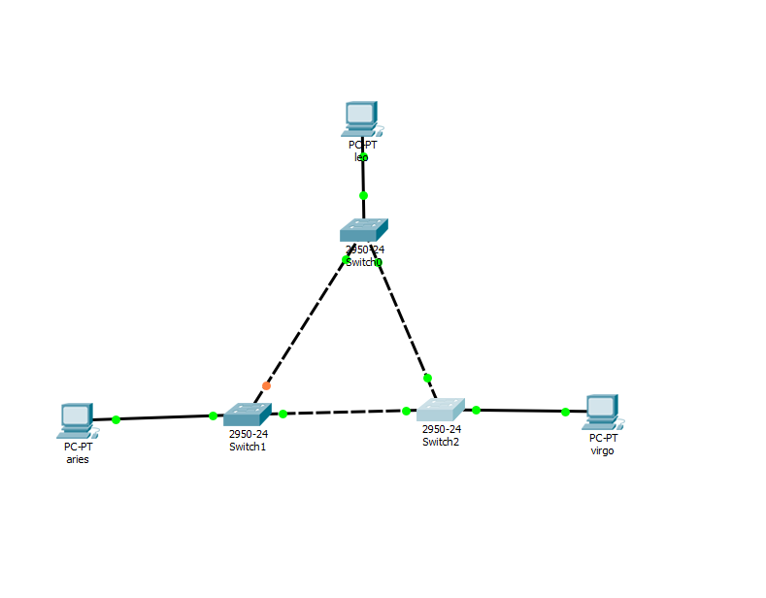

2. 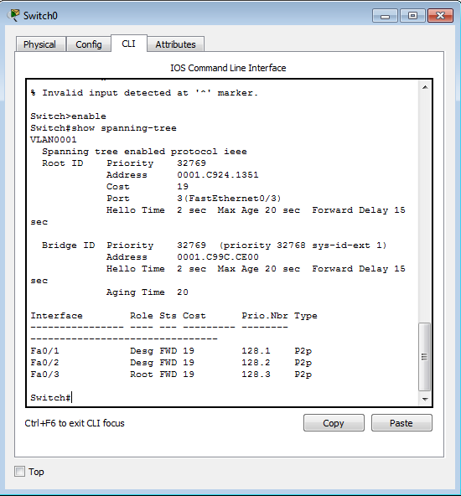

3.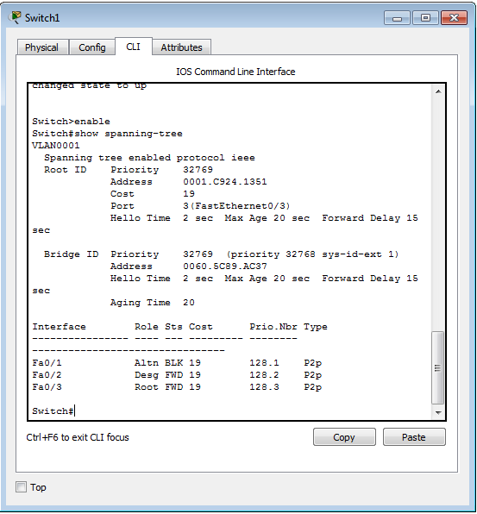

4.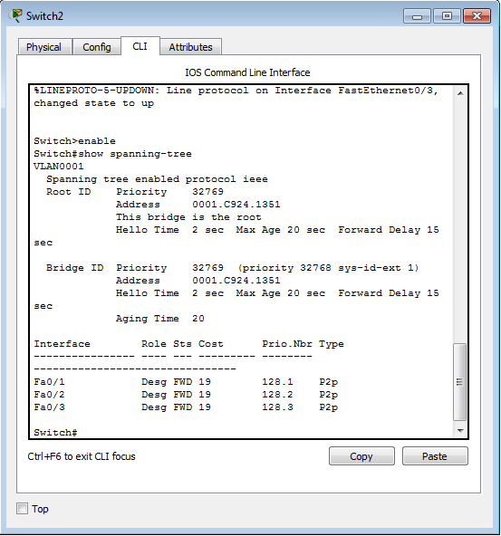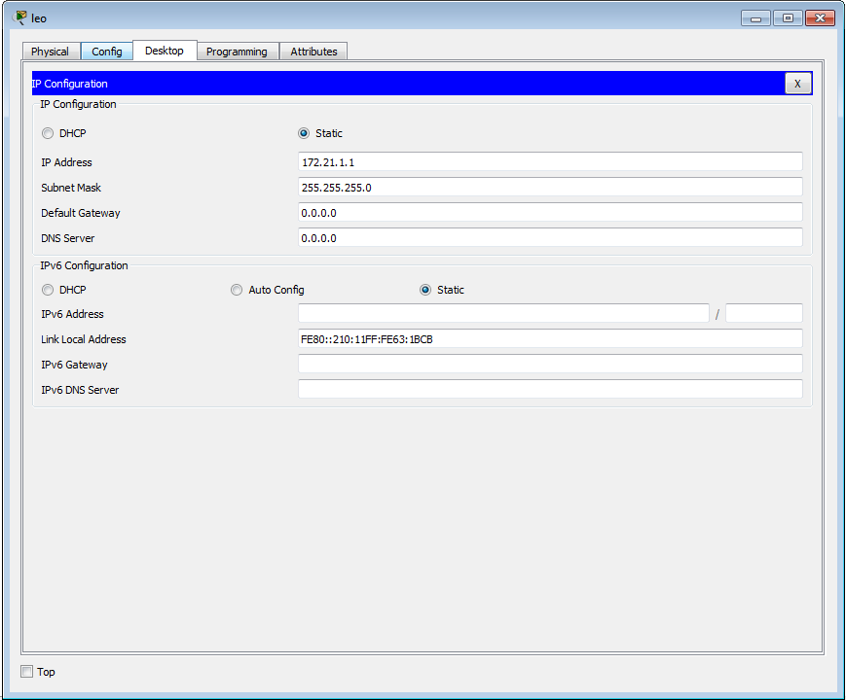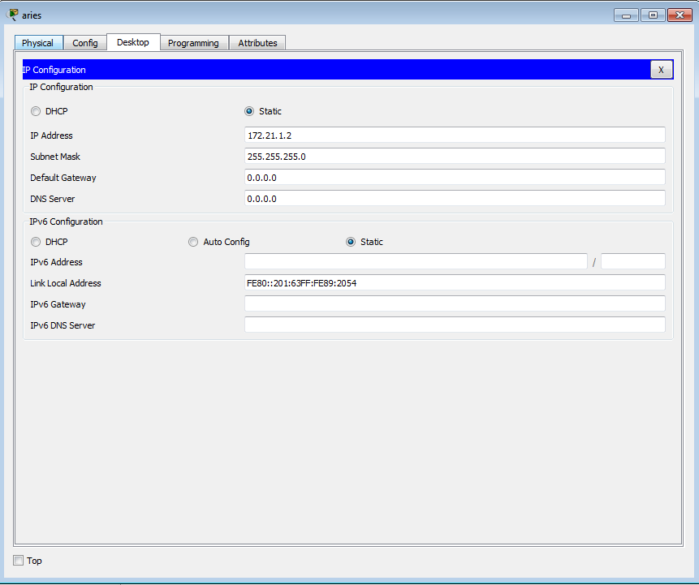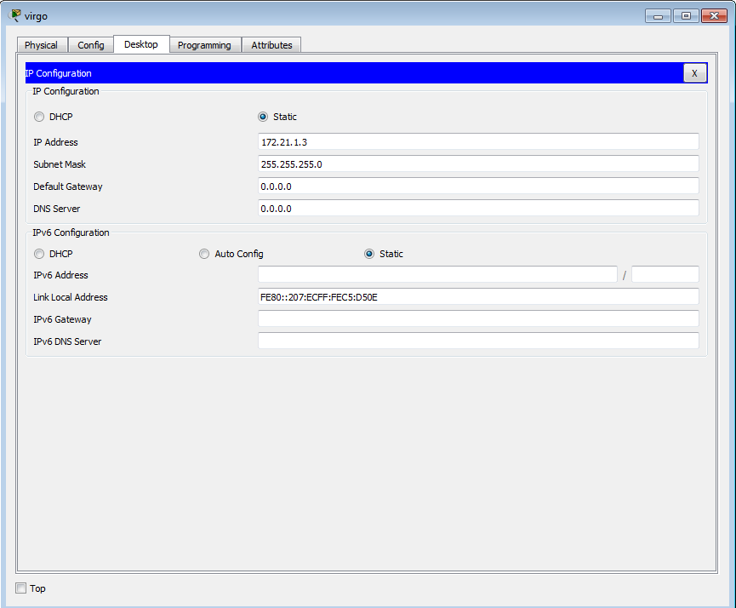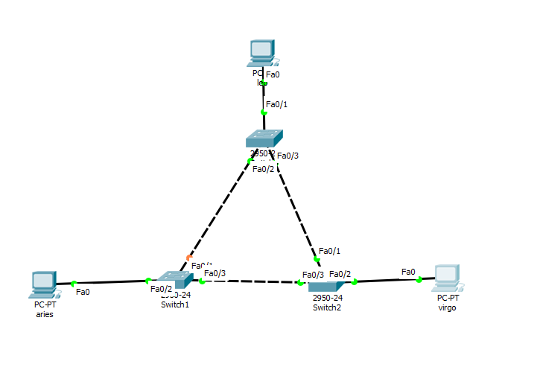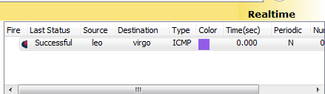

Topology 2

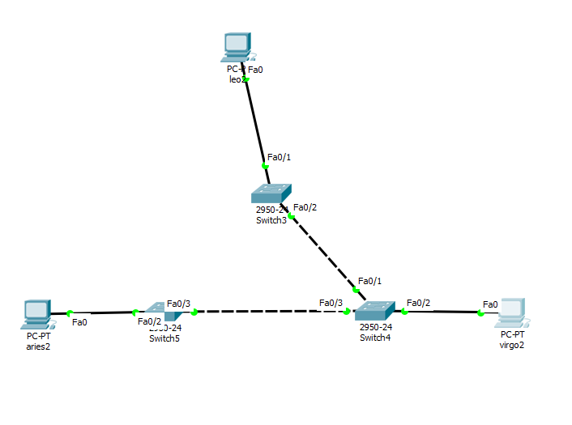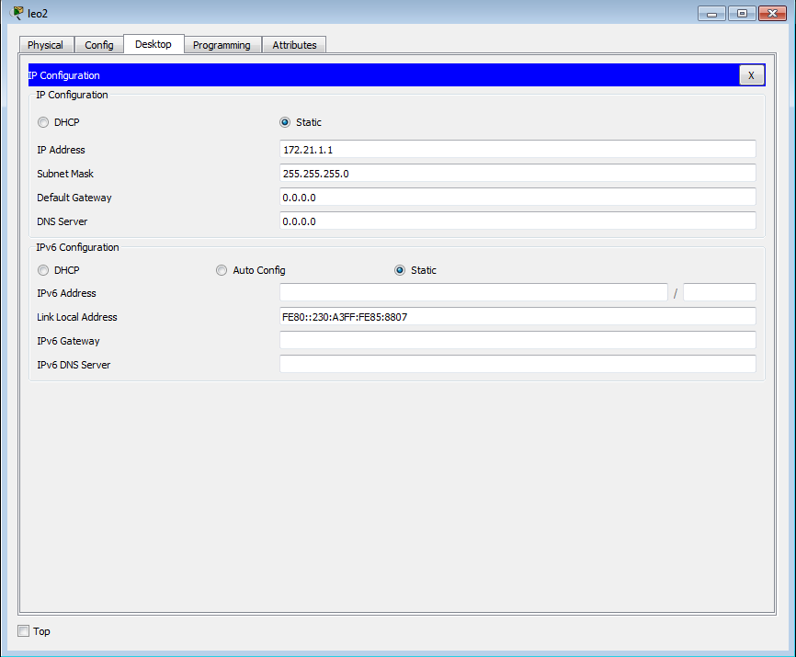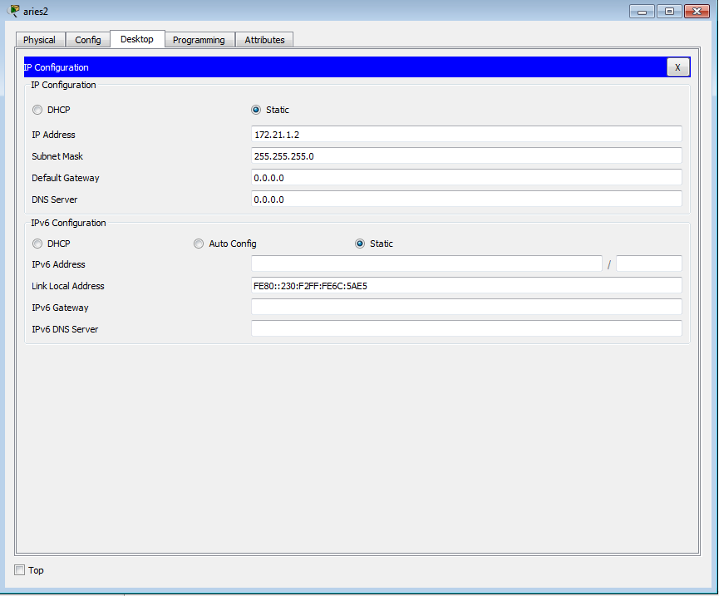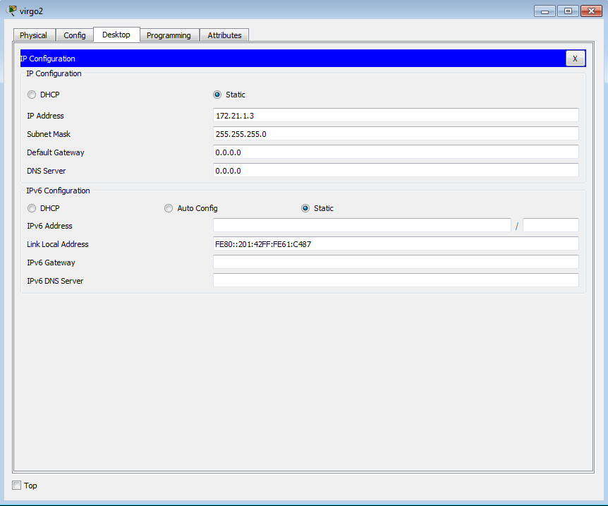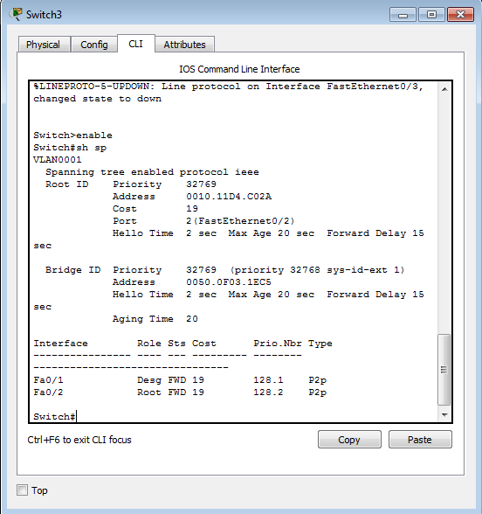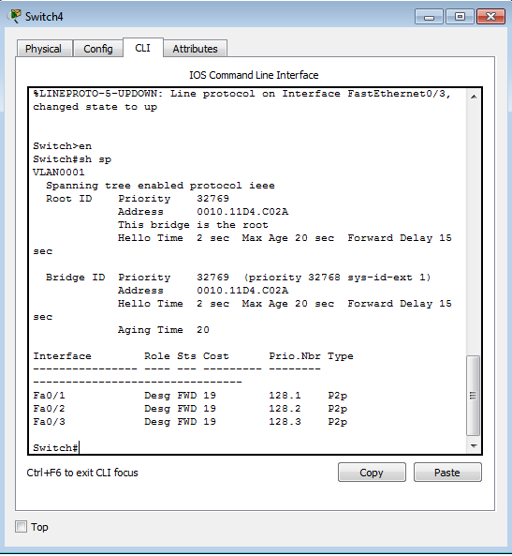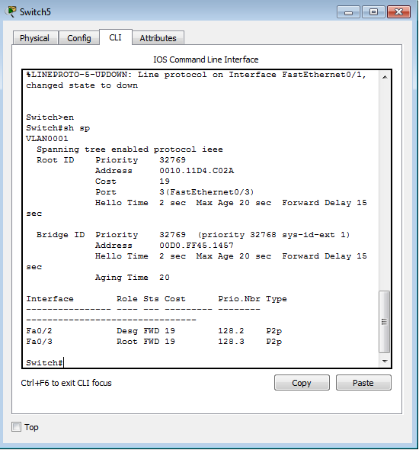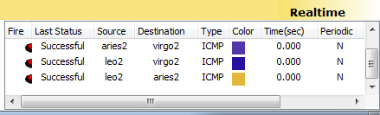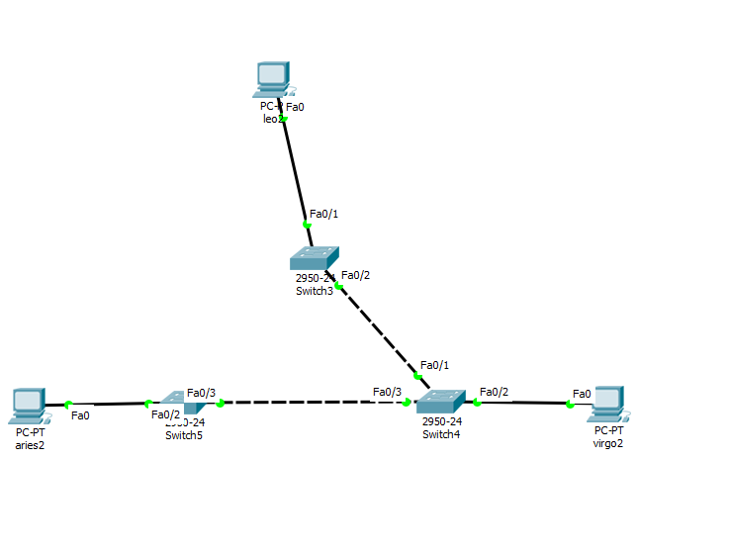

Topology 1

SW 1

|  |  |  |
| --- | --- | --- |
| No. | Variable | Nilai |
| 1. | Root ID |  |
| 2. | Priority | 32769 |
| 3. | MAC Address | 0001.0924.1351 |
| 4. | Bridge ID |  |
| 5. | Cost(0/1;0/2;0/3) | 19 |
| 6. | Hello time | 2 sec |
| 7. | MaxAge | 20 sec |
| 8. | Forward Delay | 15 sec |

SW 2

|  |  |  |
| --- | --- | --- |
| No. | Variable | Nilai |
| 1. | Root ID |  |
| 2. | Priority | 32769 |
| 3. | MAC Address | 0001.C924.1351 |
| 4. | Bridge ID |  |
| 5. | Cost(0/1;0/2;0/3) | 19 |
| 6. | Hello time | 2 sec |
| 7. | MaxAge | 20 sec |
| 8. | Forward Delay | 15 sec |

SW 3

|  |  |  |
| --- | --- | --- |
| No. | Variable | Nilai |
| 1. | Root ID |  |
| 2. | Priority | 32769 |
| 3. | MAC Address | 0001.0924.1351 |
| 4. | Bridge ID | 32769 |
| 5. | Cost(0/1;0/2;0/3) | 19 |
| 6. | Hello time | 2 sec |
| 7. | MaxAge | 20 sec |
| 8. | Forward Delay | 15 sec |

SW 4

|  |  |  |
| --- | --- | --- |
| No. | Variable | Nilai |
| 1. | Root ID |  |
| 2. | Priority | 32769 |
| 3. | MAC Address | 0010.1104.C02A |
| 4. | Bridge ID |  |
| 5. | Cost(0/1;0/2;0/3) | 19 |
| 6. | Hello time | 2 sec |
| 7. | MaxAge | 20 sec |
| 8. | Forward Delay | 15 sec |

SW 5

|  |  |  |
| --- | --- | --- |
| No. | Variable | Nilai |
| 1. | Root ID |  |
| 2. | Priority | 32769 |
| 3. | MAC Address | 0010.1104.C02A |
| 4. | Bridge ID | Root bridge |
| 5. | Cost(0/1;0/2;0/3) | 19 |
| 6. | Hello time | 2 sec |
| 7. | MaxAge | 20 sec |
| 8. | Forward Delay | 15 sec |

Topology 1

Forwarding : fa 0/2, fa 0/3 [switch 1], fa 0/1, fa 0/2 , fa 0/2, fa 0/3 [switch], fa 0/1 , fa 0/2, fa0/3[switch 2]

Blocking : fa 0/1[switch]

Root bridge : switch 2

Designated bridge : switch 0

Designared port : fa 0/2

Root port : fa 0/3 [switch1], fa 0/3[switch 2]

Topology 2

Forwarding : switch 5: fa 0/3 , fa 0/2

Switch 4 : fa 0/3 , fa 0/1, fa 0/3

Switch 3 : fa 0/1 , fa 0/3

Root bridge : switch 4

Root port : fa 0/2 , fa 0/3

Designated port : switch 3 [fa 0/3, fa 0/1, fa 0/2]

Designated bridge : switch 3 & switch 5

Blocking : non