4.

a)

Yes, if we use the perspective projection, we do not need to render a, d, f, I,e, since they were blocked from the eye view.

b)

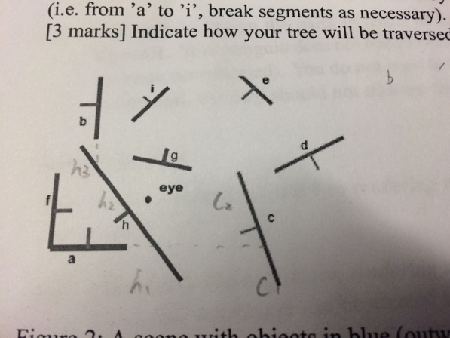

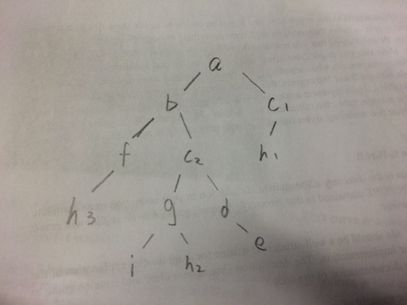

c)

The order should be $c_{1}$, $h_{1}$, a, f, $h_{3}$, b, d, e, $c_{2}$, I, g, $h_{2}$