Cloud Computing Project Phase-1 Report
Nischal V Pattedar – BL.EN.U4AIE23021
Punav Anirudh Potluri – BL.EN.U4AIE23025
Raunak Choudhury – BL.EN.U4AIE23027
Title: Blockchain-Driven Agricultural Supply Chain Management for Equitable Stakeholder Participation
Introduction to the Problem Statement
The agricultural supply chain in many developing and developed regions faces inefficiencies, a lack of transparency, and unequal participation among stakeholders. Farmers, distributors, retailers, and consumers often work within disconnected systems where data on production, pricing, logistics, and product quality is hard to access or manipulated. This lack of clarity leads to unfair pricing, exploitation of small-scale farmers, food fraud, and loss of consumer trust. Traditional centralized management systems do not ensure accountability or fair profit sharing because they can be tampered with and often exclude certain groups. There is a strong need for a decentralized, transparent, and secure system that guarantees fair participation for all stakeholders, builds trust, and improves traceability across the agricultural supply chain. Blockchain technology, with its key features of immutability, transparency, and decentralized governance, provides a promising solution to these ongoing issues.

Objectives of the Problem Statement
- Secure Product Origination: Allow farmers to securely register new products, including details like origin, quantity, and price, on the blockchain. This creates a permanent initial record.
- Verifiable Proof: Make sure each product registration and any follow-up actions have a verifiable transaction hash on the blockchain, such as through Etherscan.
- On-Chain State & Ownership Tracking: Set up a smart contract system to manage the product's lifecycle, including stages like Harvested, Shipped, Received, and For Sale. This system will also track ownership transfers among stakeholders like Farmers, Wholesalers, and Retailers.
- Enforced Process Flow: Use smart contract logic to ensure products move through the supply chain based on set rules and states.
- Role-Based Access & Simulation: Create a user interface that simulates the roles of different stakeholders (Farmer, Wholesaler, Retailer, Consumer). This interface provides views and actions specific to each role, authorized by on-chain ownership.
- End-to-End Traceability: Enable consumers and other stakeholders to see the complete, verifiable history of a product's journey from its origin to the potential point of sale.

Literature Survey
Paper-1: Blockchain Technology Characteristics Essential for the Agri-Food Sector
Journal: Food Control (2024) (Q1 Journal) https://www.sciencedirect.com/science/article/pii/S0956713524003785
Summary
- This study looks at what information stakeholders need for transparency in sustainable food supply chains, especially alternative ones.
- It uses a mix of methods: a literature review, interviews, a survey with 135 participants, Principal Component Analysis (PCA), and the Best-Worst Method (BWM) with experts.
- The research identified 14 key information needs, grouping them into: a) product and quality details, b) production and processing information, and c) sustainability information.
- Experts emphasized the importance of information about quality and safety. They also prioritized product origin and nutrition/ingredients according to BWM.
- The study suggests that blockchain technology can effectively support transparency and help consumers make informed decisions by meeting these important needs.
- It is based on Stakeholder Theory and Organizational Information Processing Theory (OIPT).

Gaps and Challenges
- Many applications remain pilot projects or proof-of-concept. They lack large-scale deployment and validation.
- Technical limitations include scalability, energy consumption with Proof of Work consensus—and interoperability between different blockchains and old systems.
- Data integrity at the source is an issue. Blockchain ensures data cannot be changed after entry, but it cannot guarantee the initial data is correct.
- Smart contract limitations include the lack of full legal recognition, the potential for bugs, and reliance on external data oracles.
- Implementation barriers consist of high costs, the need for technical expertise, stakeholder resistance, and the absence of standardized regulations.
- Environmental concerns about energy use require more research and solutions.

Paper-2: Blockchain-based fresh food quality traceability and dynamic monitoring
Journal: Computers and Electronics in Agriculture (2024) (Q1 Journal)
https://www.sciencedirect.com/science/article/abs/pii/S0168169924005829
Summary
- A review paper looks at how blockchain can work with modern sensing technologies to trace fresh food quality and monitor it in real time.
- It shows how blockchain's decentralized, unchangeable, and clear ledger solves the problems of traditional centralized traceability systems.
- The paper suggests a layered system architecture that integrates IoT and sensing data into the blockchain.
- It reviews traceability technologies, which are data sources for origin and authenticity. These include spectroscopy methods like NIR and FT-IR, mass spectrometry techniques such as SIRA and ICP-MS, DNA methods like DNA barcoding, and electronic labels including RFID, QR codes, and NFC.
- It also examines dynamic monitoring technologies, which are data sources for real-time quality. This includes sensors that monitor gas, pH, and temperature/humidity, intelligent packaging with color-changing films, and intelligent detection methods like E-nose, E-tongue, and computer vision.
- Finally, it explains how smart contracts can automate processes based on events detected by sensors.
Gaps and Challenges
- Security Risks: The blockchain could be broken by future technologies, such as quantum computing.
- Efficiency and Cost: Blockchain can be less efficient and more expensive, concerning energy and computation, compared to standard cloud technologies. It also struggles with large-scale data transactions.
- Lack of Uniform Standards: There are no consistent technical standards for blockchain in the food industry, causing confusion and interoperability problems.
- Commercial Implementation: Transitioning from concept to real-world use is challenging. It requires integrating systems, changing business processes, and extensive training for staff.
- Infrastructure: A reliable information system and strong IoT infrastructure are necessary for data collection.

Paper-3: Information needs for transparency in blockchain-enabled sustainable food supply chains
Journal: International Journal of Information Management Data Insights (2024) (Q1 Journal)
https://www.sciencedirect.com/science/article/pii/S0956713524003207
Summary
- This report looks at what information stakeholders need for transparency in sustainable food supply chains, especially in alternative ones.
- It uses a mixed-methods approach, which includes a literature review, interviews, a survey with 135 participants, Principal Component Analysis (PCA), and the Best-Worst Method (BWM) with experts.
- The study identified 14 key information needs, grouped into:
- product and quality details
- production and processing information
- sustainability information.
- Experts placed a high priority on information about quality and safety. They followed that with details on product origin and nutrition/ingredients, using BWM.
- The report suggests that blockchain technology can effectively support transparency and help consumers make informed choices by addressing these important needs.
- It references Stakeholder Theory and Organisational Information Processing Theory (OIPT).

Gaps and Challenges
- Focus is mainly on alternative food supply chains in the Netherlands. This may limit its applicability to global or traditional chains.
- Gathering and confirming specific information needs, like social sustainability, is still difficult, even with blockchain.
- Stakeholders' knowledge and ability to use blockchain effectively can pose a barrier.
- There is a risk of expert bias or a false sense of agreement during the consolidation phase.
- More empirical validation is necessary from a business-level perspective to assess implementation and performance impact.

Paper-4: Agri-food traceability today: Advancing innovation towards efficiency, sustainability, ethical sourcing, and safety in food supply chains
Journal: Trends in Food Science & Technology (2025) (Q1 Journal)
https://www.sciencedirect.com/science/article/pii/S0924224425002900
Summary
- Provides a clear roadmap of modern agri-food traceability. It covers legal requirements, analytical methods, and digital technologies.
- Defines key concepts: traceability, tracing (backward), tracking (forward), provenance, authentication, and curation.
- Reviews major international regulatory frameworks from the EU, US, and China that support traceability.
- Introduces a new two-dimensional system for classifying traceability systems. This system is based on Trackability Level (1-Basic, 2-Enhanced, 3-AI-driven) and Information Granulometry (Micro-Molecular, Meso-Batch, Macro-Shipment).
- Details new analytical technologies such as Omics (like proteomics, metabolomics, genomics), SIRA, and Elemental Analysis for collecting micro-level data.
- Explores new digital technologies including Chemometrics, AI/ML, RFID/NFC/Barcodes, IoT, FCM, and Blockchain for processing and tracking data at micro and macro levels.
- Uses case studies involving wine, garlic, and coffee to demonstrate practical applications.
Gaps and Challenges
- Achieving complete and smooth farm-to-table traceability is still challenging because of the complexities and fragmentation in the supply chain.
- There are limitations with specific analytical tools, such as DNA degradation in processed foods, the cost and expertise needed for omics, and the impact of environmental factors on SIRA.
- Digital technology faces several hurdles, including IoT connectivity issues, the initial reliability of blockchain data (which can lead to "garbage in, garbage out"), scalability challenges, energy consumption, and high implementation costs.
- We need standardization across technologies and data formats to ensure a smooth flow of information.
- It is important to balance transparency with data privacy and the sensitivity of commercial information.
- Must ensure that all participants, including small farmers in various regions, are digitally unified.

Paper-5: A review of smart contract adoption in agriculture and food industry
Journal: Computers and Electronics in Agriculture (2024) (Q1 Journal)
https://www.sciencedirect.com/science/article/pii/S0168169924004526
Summary
- Reviews the adoption and applications of smart contracts on blockchain in the agriculture and food industry, going beyond just supply chain traceability.
- Explains the basics of smart contracts, their life cycle (Creation, Deployment, Execution, Completion), and compares popular development platforms (Ethereum, Hyperledger Fabric, Iroha, Sawtooth, Corda, Cardano, Polygon, Solana) based on features like permission type, consensus, and TPS.
- Discusses various smart contract applications: Decentralized Finance (DeFi) for insurance and credit, secure data logging (sensor data, authenticity), supply chain traceability, agricultural input traceability (seeds, chemicals), decentralized marketplaces, government remittances and services, contract farming automation, and quality assurance in food processing.
- Summarizes real-world implementations by private companies (such as IBM Food Trust, Agri Digital, VeChain) and global government initiatives (in China, India, the USA, the EU, and African nations) that use smart contracts.
Gaps and Challenges
- Reliance on Off-Chain Resources: Smart contracts often require external data through oracles or large file storage via IPFS or Swarm. This introduces potential weaknesses or failure points.
- Immutability: Once deployed, fixing errors in smart contract code is difficult and costly. It usually requires redeployment.
- Consensus Mechanisms: Energy use in Proof of Work (PoW) and security risks, such as 51% attacks, are concerns. Newer methods like Proof of Stake (PoS) and Proof of Authority (PoA) aim to reduce these issues.
- Participating Nodes: The security of the network and consensus depend on having enough active and honest nodes.
- Legal & Regulatory Uncertainty: The absence of global standards and the difference in legal policies around smart contracts and cryptocurrencies create confusion.
- Bureaucratic Impediments: Government scepticism and a lack of clear guidelines on cryptocurrencies, often used for fees or staking, slow down adoption.
- Cost & Accessibility: Implementing these technologies requires expensive hardware and software, which can exclude small farmers.

Paper-6: Comparing blockchain and DAG technologies for smart agriculture traceability in terms of efficiency and latency
Journal: Simulation Modelling Practice and Theory (2025) (Q1 Journal)
https://www.sciencedirect.com/science/article/pii/S1569190X25000668
Summary
- Compares the performance, which includes efficiency defined by latency and handling network load, of Bitcoin, Ethereum, and DAG (Directed Acyclic Graph, specifically the IOTA Tangle model) for smart agriculture traceability applications.
- Uses simulation tools, BlockSim for Bitcoin and Ethereum, and DAGSim for DAG, to model transaction inclusion times under the same conditions.
- Varies key parameters: transaction generation rate (1, 24, 60 per day), network latency (10ms, 60ms, 120ms), and the DAG tip selection algorithm (random versus weighted with different alpha values).
- Proposes a detailed coding scheme to represent various agricultural data, such as crop type, fertilization, harvesting, and GPS, within a fixed transaction size of 512 bytes.
- Results show DAG significantly outperforms Bitcoin and Ethereum, achieving much lower transaction inclusion times, with examples ranging from 4 to 22 seconds compared to 13 to 36 seconds for Ethereum and 542 to 828 seconds for Bitcoin, especially under heavy load and latency.
- Ethereum demonstrates better adaptability and lower inclusion times than Bitcoin. Bitcoin is very sensitive to latency and load, often exceeding the expected 10 minutes for inclusion times.
- For DAG, the weighted tip selection algorithm, particularly with α=0.8, proves to be the most efficient and consistent.
Gaps & Challenges
- Bitcoin Limitations: Low TPS (~7), high energy use (PoW), long confirmation times, and high fees make it unsuitable for high-volume, real-time IoT applications.
- Ethereum Limitations: Moderate TPS (~15-20), high energy use (PoW pre-Merge), and potentially high gas fees during congestion limit its suitability for IoT microtransactions. However, PoS and Layer 2 solutions aim to improve this.
- DAG Limitations: Data search and retrieval can be complex in the graph structure. There are potential security issues, such as double-spending, along with higher design complexity and less mature tools and adoption compared to blockchains.
- Study Limitations: The focus is only on inclusion time (latency/load). It excludes energy, storage, and detailed security analysis. The study simulates low to moderate loads, assumes honest nodes, uses simplified network and hardware models, and relies on data from a single crop cycle.

Paper-7: Smart agriculture assurance: IoT and blockchain for trusted sustainable produce
Journal: Computers and Electronics in Agriculture (2024) (Q1 Journal)
https://www.sciencedirect.com/science/article/pii/S0168169924005751
Summary
- Proposes an integrated IoT and Blockchain solution to ensure sustainable agricultural practices and verify food certifications, such as Organic, Non-GMO, and Global G.A.P.
- Addresses issues of consumer trust, greenwashing, and the need for clear, verifiable proof of sustainable practices and product origin.
- Uses various IoT sensors, including moisture, pH, nutrients, microbial, and crop health sensors from drones, deployed by authorized AgTech companies to continuously monitor farm conditions.
- Sensor data is processed by registered Oracles, which act as MQTT brokers. These Oracles use machine learning and artificial intelligence for analysis and report anomalies or confirm compliance data to a permissioned Ethereum blockchain.
- Utilizes smart contracts to register participants, including farmers, AgTech, government, certifiers, and oracles. It also manages farm status and the planting process, reports and resolves anomalies, requests and approves certifications, and tracks produce lots.
- Employs decentralized off-chain storage with IPFS for large files, such as sensor logs, images, and reports, while storing only hashes on-chain.
- Consumers can scan a QR code on the final product to access the immutable blockchain record. This verifies certifications, origin, and the history of farm practices, including how anomalies were handled.
Gaps & Challenges
- Cost and Scalability: There are potential high costs for IoT sensor deployment and maintenance, along with blockchain transaction fees, though a permissioned chain reduces gas fees. Scalability can become a problem as transaction volume increases.
- Smart Contract Security: Weaknesses in smart contract code could be taken advantage of. This is addressed in the paper through Slither analysis and Re-entrancy Guard.
- Storage Limitations: This is managed by using IPFS for large data.
- Interoperability: Merging the blockchain solution with existing farm management or supply chain legacy systems can be difficult.
- Regulatory Framework: The absence of clear rules for blockchain in agriculture might slow down adoption.

Paper-8: Assessing blockchain and IoT technologies for agricultural food supply chains in Africa: A feasibility analysis
Journal: Heliyon (2024) (Q2 Journal)
https://www.sciencedirect.com/science/article/pii/S2405844024106159
Summary
- Evaluates the possibility of using Blockchain and IoT technologies in agricultural food supply chains in Africa.
- Uses real examples of food safety and fraud incidents in countries like South Africa, Ghana, Nigeria, and Tanzania to emphasize the urgent need for better traceability and safety systems.
- Conducts a systematic literature review following the PRISMA approach, reviewing 37 relevant studies, including several focused on Africa.
- Applies a modified TELO feasibility framework, which includes Technical, Economic, Legal, and Operational aspects, while omitting 'Scheduling,' to assess the reviewed implementations.
- Identifies various blockchain platforms like Ethereum, Hyperledger Fabric, Algo rand, IOTA, Polygon, and OurSQL, along with IoT components such as RFID/NFC, sensors, and GPS used in the studies.
- Presents findings through mappings and a heatmap that summarizes the TELO feasibility scores (High, Moderate, Low) for each study, highlighting strengths and weaknesses.
- Notes that Ghana and South Africa show higher implementation activity compared to other regions in Africa.
- Discusses ongoing issues, such as network topology flexibility, data upload speed, consensus optimization, and finding a balance between public access and privacy. Suggests Blockchain as a Service (BaaS) as a potential solution to reduce entry barriers.
Gaps & Challenges (Specific to Africa)
- Technical Feasibility: Significant infrastructural limitations (inconsistent electricity, poor internet connectivity) impede reliable deployment, especially in rural areas. Need for adaptive technologies suited to resource-limited conditions.
- Economic Feasibility: High implementation costs (hardware, software, expertise) are major barriers for smallholder farmers and SMEs who dominate African agriculture. Unclear ROI and access to credit complicate adoption.
- Legal Feasibility: Diverse and often underdeveloped regulatory landscapes across different African countries create uncertainty and compliance challenges. Lack of specific blockchain regulations.
- Operational Feasibility: Low levels of digital literacy among farmers, need for extensive training, potential resistance to adopting new technologies, and difficulty integrating with existing (often manual or informal) systems hinder usability.
Paper-9: Transforming agricultural supply chains: Leveraging blockchain-enabled java smart contracts and IoT integration
Journal: ICT Express (2024) (Q1 Journal)
https://www.sciencedirect.com/science/article/pii/S2405959524000316
Summary
- Proposes a framework that combines IoT and Blockchain, using Java source code as the basis for smart contracts and data analysis.
- Aims to address the problems of centralized databases, such as data silos, lack of transparency, and security issues, in agriculture.
- IoT sensors collect real-time environmental data, including soil pH, light, temperature, and humidity.
- The Blockchain ledger securely stores and verifies this sensor data.
- Java-based smart contracts and application code serve as the treatment layer or data analyzer, automating decisions based on sensor readings.
- Details a 17-table database structure for managing all stakeholders, products, orders, and sensor data.
- Includes a Java application with a user interface featuring login, menus, tables, and charts for stakeholders to visualize data and track products.
- Uses the optimal growth conditions for tomatoes in Morocco as a specific use case.
Gaps & Challenges
- Traditional centralized databases struggle with data silos, single points of failure, lack of transparency, and inefficiencies.
- Many academics ignore agriculture and mainly focus blockchain research on the financial industry.
- Integrating IoT brings various security risks, such as eavesdropping, DoS, jamming, and man-in-the-middle attacks, that need to be managed.
- Smart contracts can have programming flaws, like integer overflows, which create security risks.
- Farmers face technological and financial challenges, especially small-scale farmers with limited resources or little technical knowledge.
- We need infrastructure solutions, like localized data hubs, for deployment in areas with scarce resources.
- Energy use of the blockchain and sensor network is an ongoing environmental concern.

Paper-10: Blockchain and Smart Contracts Based Agricultural Supply Chain (Base Paper)
Journal: Procedia Computer Science (2024) (Q2 Journal)
https://www.sciencedirect.com/science/article/pii/S1877050924011657
Summary
- Proposes a framework for an agricultural supply chain DApp using the Ethereum blockchain and smart contracts.
- Aims to ensure traceability of product safety and quality, and verify food origins.
- The system allows stakeholders, such as farmers, packers, and customers, to register and view product details, like origin and quality status, on the blockchain without changes.
- Developed with Remix IDE (Solidity), Ganache (a personal Ethereum blockchain for testing), and MetaMask (a browser wallet and bridge).
- Highlights key benefits, including data integrity, security against tampering, lower costs from reduced gas fees in Ethereum, and the removal of intermediaries.
- Suggests that smart contracts can automate processes like crop insurance claims based on weather data.
Gaps & Challenges
- Focuses on recording data points, less on enforced process flow.
- Paper's implementation figures don't explicitly show on-chain ownership transfer between different stakeholders
- Paper shows separate forms but less focus on dynamic UI based on role/ownership.
- There is no proper categorization of products sold as processed or organic food.

Paper 11: Blockchain-based traceability framework for agri-food supply chain: a proof-of-concept
Journal: Operations Management Research (2024) (Q1 Journal)
https://link.springer.com/article/10.1007/s12063-024-00529-6
Summary
- This paper presents a proof-of-concept (POC) for a blockchain-based traceability framework, developed in collaboration with an Indian agri-food organization, Himmotthan Society, and a technology provider, CropIn.
- The framework is shown through a real-world case for tracking honey and coriander powder supply chains in Uttarakhand, India.
- It describes the system architecture and data flow. The system uses digital applications, SmartFarm and Smartware, for collecting field-level data, such as geo-tagging and harvest details.
- This data is secured through smart contracts on a Cosmos blockchain that uses a Proof-of-Stake consensus mechanism. It is linked to a QR code for the final product.
- A key contribution is the creation of a detailed cost framework. This framework breaks down both developmental costs, including hardware, software, and training, and operational costs, such as maintenance and licenses, related to implementing the POC.
- The paper also discusses stakeholders' views on the practical benefits, such as security and data authenticity, along with the real-world challenges of implementation faced during the pilot.
Gaps & Challenges
- The practical use of blockchain in agri-food supply chains (AFSC) is still not fully explored. Most research is either conceptual or lacks data from real-world applications.
- There is a major gap in research about the total costs, both for development and operation, involved in setting up blockchain traceability systems.
Several practical challenges surfaced during the proof of concept (POC):
- There are difficulties in identifying and standardizing traceability points and data formats between organizations and technology providers.
- Geo-tagging poses challenges due to the small and widely scattered nature of farm plots.
- Coordinating between technology providers and the field staff of use-case organizations is problematic.
- The pilot study had limitations, such as a small dataset, an inability to simulate high transaction volumes, and results that apply only to this specific case and region.
- The study found that one smart contract is not enough for widespread use. Multiple contracts are necessary to keep information confidential at scale.

Summarized Table of Literature Review
Paper Name | Year of Publication | Name of the Journal | Work Done in the Paper | Research Gaps and Challenges | Research Domain
Blockchain Technology Characteristics Essential for the Agri-Food Sector | 2024 | Food Control  (Q1 Journal)  Paper Link  https://surl.li/oxljvi | Reviews 41 empirical articles to identify, categorize, and evaluate the essential characteristics of blockchain (immutability, decentralization, and automation) | Implementation barriers consist of high costs.  Need for technical expertise, stakeholder resistance  The absence of standardized regulations. | Agriculture and Blockchain
Blockchain-based fresh food quality traceability and dynamic monitoring | 2024 | Computers and Electronics in Agriculture (2024) (Q1 Journal)  Paper Link  https://shorturl.at/oIzf5 | Reviews how blockchain technology can be integrated with new traceability techniques (like spectroscopy and DNA) and dynamic monitoring sensors (like gas sensors and e-nose) to ensure fresh food quality and safety. | Efficiency and Cost  Lack of Uniform Standards  Commercial Implementation | Agriculture and Blockchain
Information needs for transparency in blockchain-enabled sustainable food supply chains | 2024 | International Journal of Information Management Data Insights (2024) (Q1 Journal)  Paper Link  https://shorturl.at/7D9IJ | Identified 14 key information needs, grouped into:  Product and quality details.  Production and processing information.  Sustainability information. | The study’s focus on Dutch alternative food chains, data verification challenges, limited stakeholder blockchain expertise, potential expert bias, and lack of business-level validation constrain its global applicability and practical impact. | Agriculture and Blockchain
Agri-food traceability today: Advancing innovation towards efficiency, sustainability, ethical sourcing, and safety in food supply chains | 2025 | Trends in Food Science & Technology (2025) (Q1 Journal)  Paper Link  https://shorturl.at/9j8gJ | The paper offers a comprehensive roadmap for modern agri-food traceability, defining key concepts, reviewing global regulations, proposing a two-dimensional classification system, detailing advanced analytical and digital technologies, and demonstrating applications through case studies on wine, garlic, and coffee. | Key challenges include fragmented supply chains, analytical tool limitations, digital technology hurdles (like blockchain reliability and IoT issues), lack of standardization, data privacy concerns, and the need for digital inclusion of all participants, especially small farmers. | Agriculture
A review of smart contract adoption in agriculture and food industry | 2024 | Computers and Electronics in Agriculture (2024) (Q1 Journal)  Paper Link  https://shorturl.at/FG6qa | The paper comprehensively reviews smart contract adoption in agriculture and food sectors, outlining their life cycle, comparing major blockchain platforms, exploring diverse applications from DeFi to traceability and automation, and highlighting real-world implementations by companies and governments worldwide. | Key limitations include dependence on off-chain data, difficulty correcting immutable code, energy and security issues in consensus mechanisms, reliance on active nodes, legal and regulatory uncertainty, bureaucratic barriers, and high implementation costs limiting accessibility for small farmers. | Agriculture and Blockchain
Comparing blockchain and DAG technologies for smart agriculture traceability in terms of efficiency and latency | 2025 | Simulation Modelling Practice and Theory (2025) (Q1 Journal)  Paper Link  https://shorturl.at/xGi2w | The study compares Bitcoin, Ethereum, and DAG (IOTA Tangle) for smart agriculture traceability, showing that DAG—especially with a weighted tip selection (α=0.8) achieves far lower transaction times and higher efficiency than Ethereum and Bitcoin under varying loads and latencies. | Key limitations include Bitcoin’s low TPS and high energy use, Ethereum’s gas fees and scalability constraints (partly mitigated by PoS and Layer 2), and DAG’s complexity, security risks, and limited maturity; the study itself only analyses inclusion time under simplified, low-load conditions with assumed honest nodes. | Blockchain
Smart agriculture assurance: IoT and blockchain for trusted sustainable produce | 2024 | Computers and Electronics in Agriculture (2024) (Q1 Journal)  Paper Link  https://shorturl.at/nxpzr | The study presents an integrated IoT–Blockchain framework using sensors, AI-driven oracles, smart contracts, and IPFS storage to verify sustainable farming certifications, enhance consumer trust, and provide transparent farm-to-table traceability accessible via QR codes. | Key limitations include high IoT and blockchain costs, scalability challenges, potential smart contract vulnerabilities, integration difficulties with legacy systems, and unclear regulatory frameworks that may hinder widespread adoption. | Agriculture, IoT, Blockchain
Assessing blockchain and IoT technologies for agricultural food supply chains in Africa: A feasibility analysis | 2024 | Computers and Electronics in Agriculture (2024) (Q1 Journal)  Paper Link  https://tinyurl.com/56sb7xt5 | The study assesses Blockchain and IoT feasibility in African agri-food supply chains using a PRISMA-based review and a modified TELO framework, revealing higher activity in Ghana and South Africa, key technical and operational challenges, and proposing Blockchain-as-a-Service to lower adoption barriers. | Key limitations include infrastructural constraints, high implementation costs and unclear ROI, fragmented or lacking blockchain regulations, and low digital literacy with resistance to change—collectively hindering widespread adoption in Africa’s agricultural sector. | Agriculture, IoT, Blockchain
Transforming agricultural supply chains: Leveraging blockchain-enabled java smart contracts and IoT integration | 2024 | ICT Express (2024) (Q1 Journal)  Paper Link  https://tinyurl.com/4hu2b4ku | The study introduces an IoT–Blockchain framework with Java-based smart contracts and data analytics to enhance transparency and automation in agriculture, featuring real-time sensor monitoring, a structured database system, and a user interface demonstrated through a Moroccan tomato case study. | Key limitations include centralized database inefficiencies, limited agricultural blockchain research, IoT security vulnerabilities, smart contract coding risks, technological and financial barriers for small farmers, infrastructure constraints in resource-poor areas, and high energy consumption of blockchain and sensors. | Agriculture, IoT, Blockchain
Blockchain and Smart Contracts Based Agricultural Supply Chain | 2024 | Procedia Computer Science (2024) (Q2 Journal)  Paper Link  https://tinyurl.com/258v3rnz | The study presents an Ethereum-based DApp framework for agricultural supply chains that enhances product traceability, data integrity, and security through smart contracts, enabling transparent stakeholder interactions, cost reduction, and process automation such as weather-based crop insurance. | Key limitations include limited focus on process enforcement, lack of explicit on-chain ownership transfer, minimal role-based dynamic UI, and absence of product categorization between processed and organic foods. | Agriculture and  Blockchain
Blockchain-based traceability framework for agri-food supply chain: a proof-of-concept  (BASE Paper) | 2024 | Operations Management Research (Q1 Journal)  Paper Link  https://tinyurl.com/crt9un9z | The paper presents a blockchain-based traceability proof-of-concept for honey and coriander supply chains in India, using SmartFarm and Smartware apps with Cosmos blockchain smart contracts and QR codes, while also providing a detailed cost framework and stakeholder insights on benefits and implementation challenges. | limited real-world blockchain applications in agri-food supply chains, lack of comprehensive cost analysis, difficulties in standardizing data and traceability points, geo-tagging small scattered farms, coordination issues between tech providers and field staff, limited pilot scale and data scope, and the need for multiple smart contracts to ensure confidentiality at scale. | Agriculture and  Blockchain

Overall Gaps and Challenges
- Scalability and Cost Issues
- Technical and Infrastructure Limitations
- Data Reliability and Quality
- Security and Privacy Concerns
- Lack of Standardization and Interoperability
- Regulatory and Legal Uncertainty
- Limited Empirical Validation and Business-Level Evidence
- Digital Literacy and Adoption Barriers
- Energy Consumption and Sustainability
- Incomplete System Design and Usability Gaps

Sustainable Development Goals (SDGs)
- SDG 2: Zero Hunger
- SDG 8: Decent Work and Economic Growth
- SDG 9: Industry, Innovation, and Infrastructure
- SDG 12: Responsible Consumption and Production

Phase-1 Implementation
The Phase-1 implementation focused on the transparency aspect in the blockchain network containing Farmers, Wholesalers, Retailers, and Consumers.
Core Idea: Replace opaque, centralized systems with a shared, trustworthy digital ledger and provides end-to-end visibility of a product's journey from farm to consumer
Main Aim: Enhance transparency, trust, and traceability in the agricultural supply chain via a blockchain prototype, enabling farm-to-table tracking with verifiable, immutable records accessible to all stakeholders.

Proposed Methodology (Phase-1)
- Develop a Decentralized Application (DApp) prototype.
- Blockchain: EVM-compatible network (e.g., Sepolia testnet).
- Smart Contract: Core logic in Solidity (SupplyChain.sol).
- Frontend: React framework with ethers.js.
- Identity & Signing: External wallets (MetaMask).
- Process: Simulate roles using placeholder addresses (config.js).
- Use browser localStorage for off-chain persistence of initial transaction hashes (prototype simplification).

Flow Diagram of Phase-1 Implementation
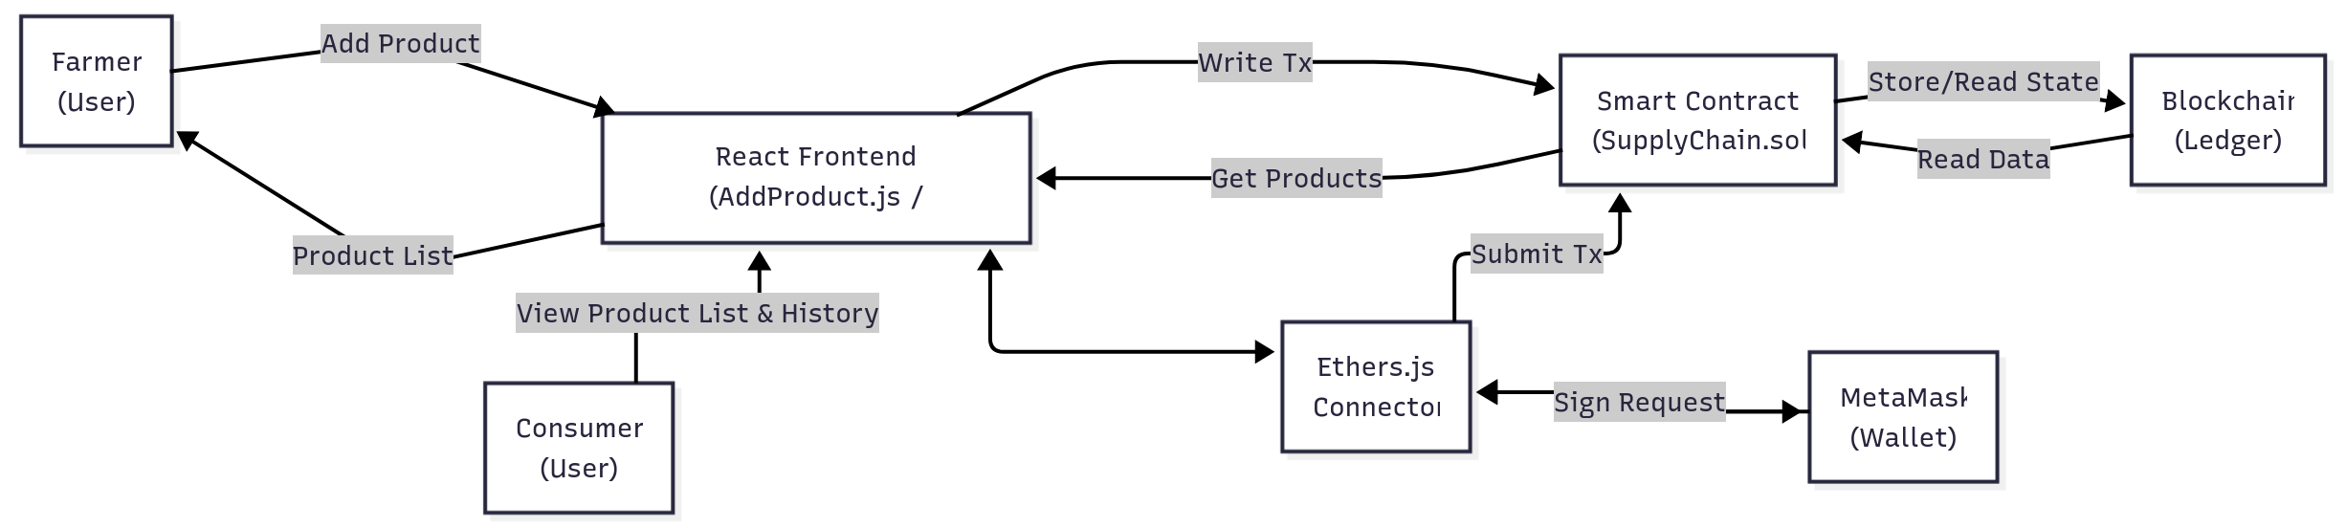

System Architecture
- Presentation (UI): React (Home, View, Dashboard).
- Interaction: ethers.js & User Wallet (MetaMask).
- Blockchain: Deployed Smart Contract (SupplyChain.sol) & Ledger.
- Persistence (Off-Chain): Browser localStorage (for initial hashes).
- Identity: User Wallets (Key Management & Signing).

Farmer to Consumer Journey (Phase-1)
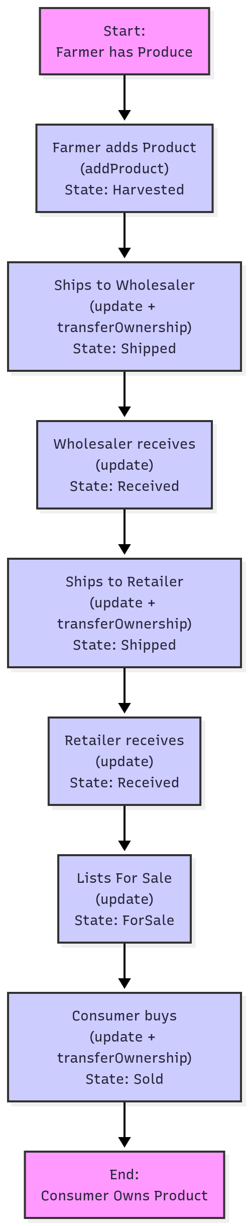
Screenshots of Phase-1 Implementation

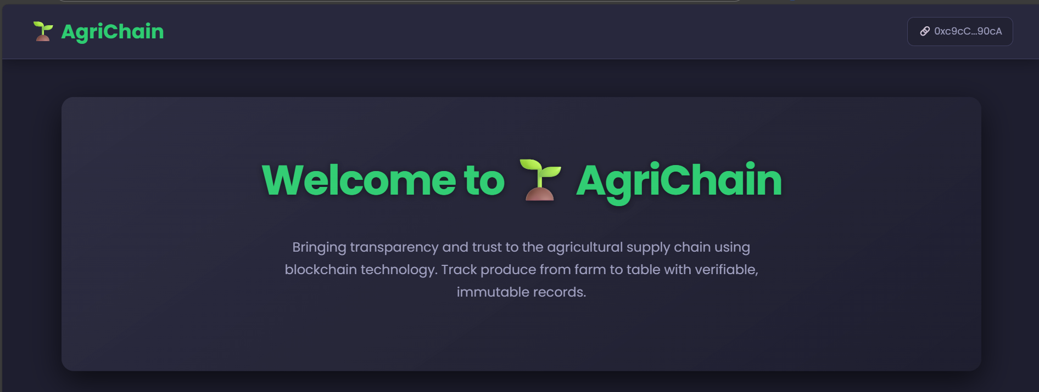

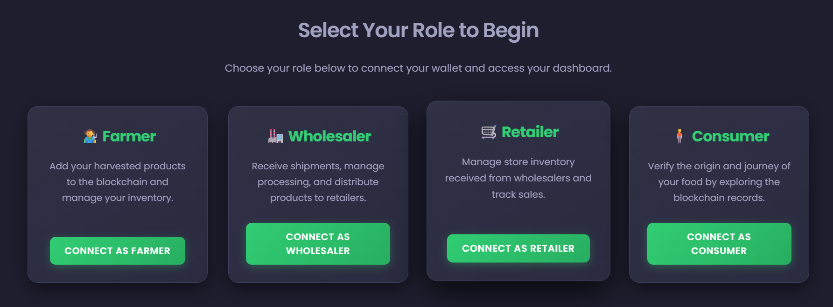

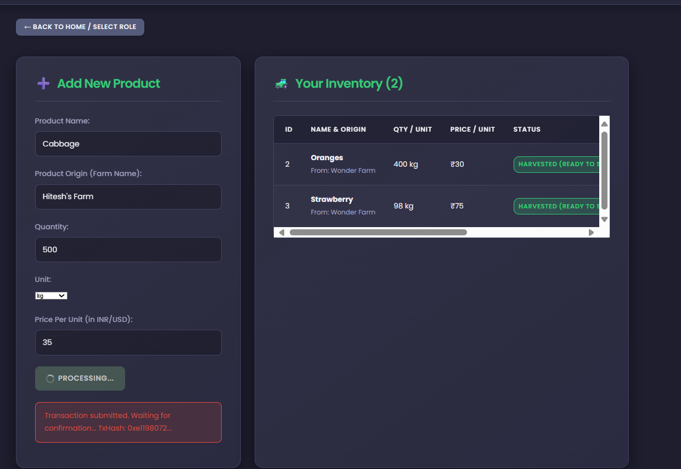

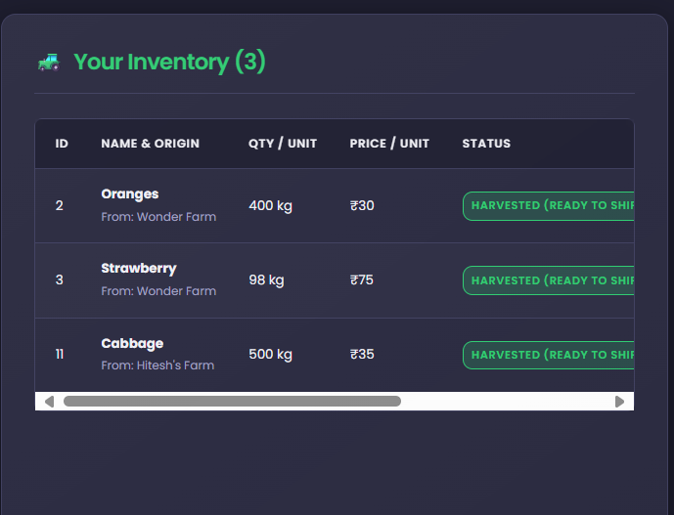
Farmer’s Inventory

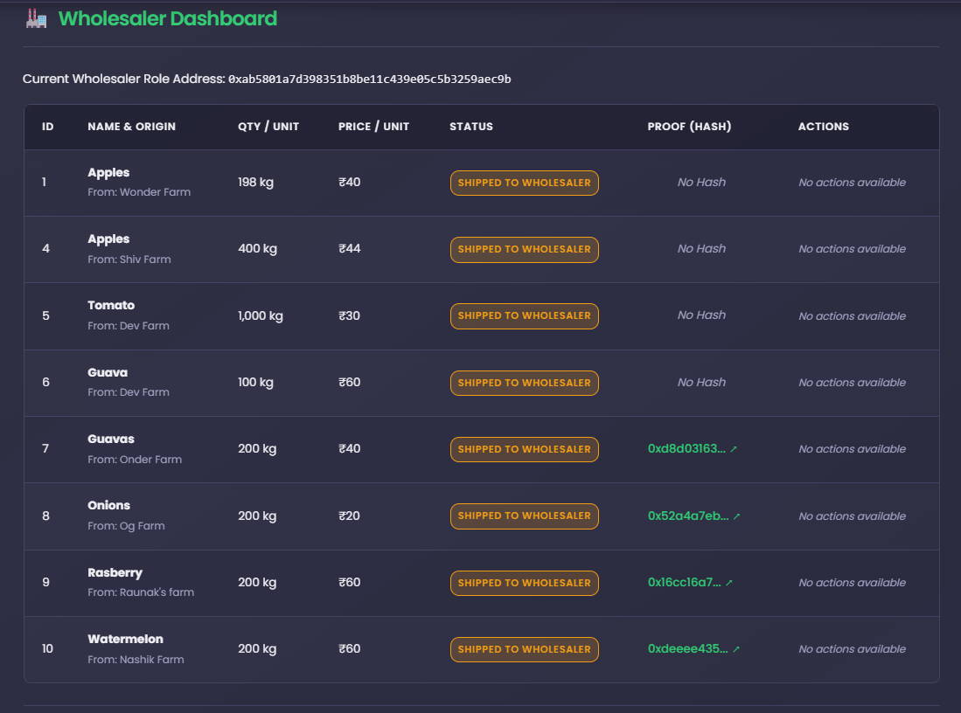
Ownership transfer to Wholesaler

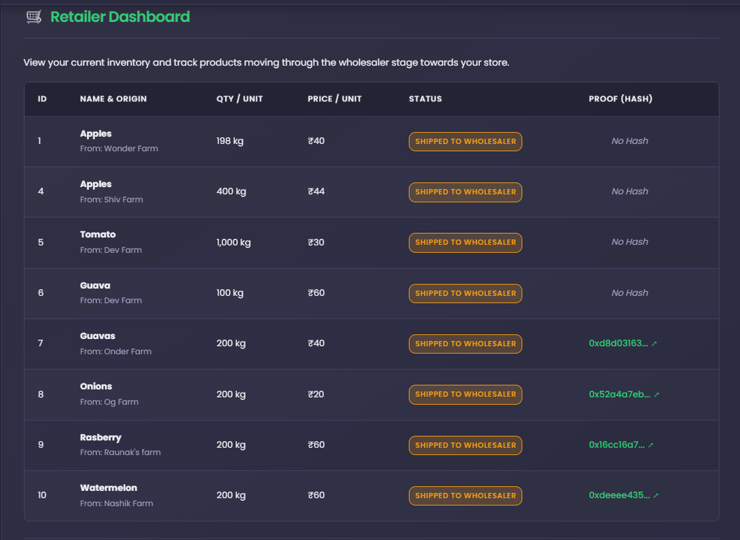
Retailer’s Dashboard (Products available for sale under Wholesaler)

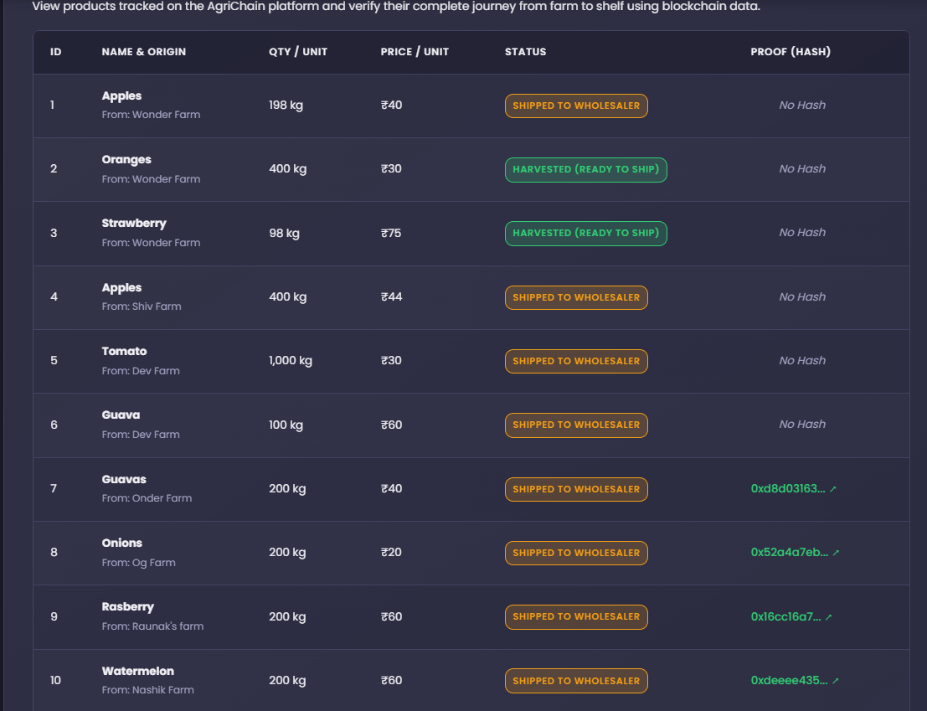
Consumer’s View of all Products

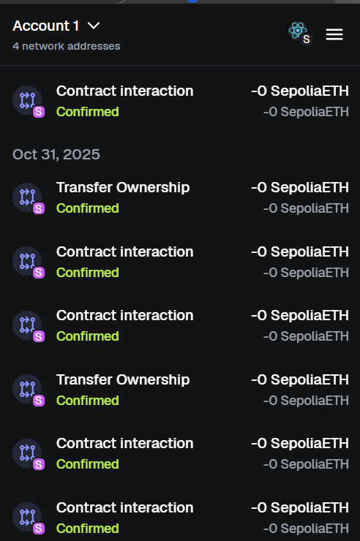
MetaMask Ownership Transfer and Contract Creation

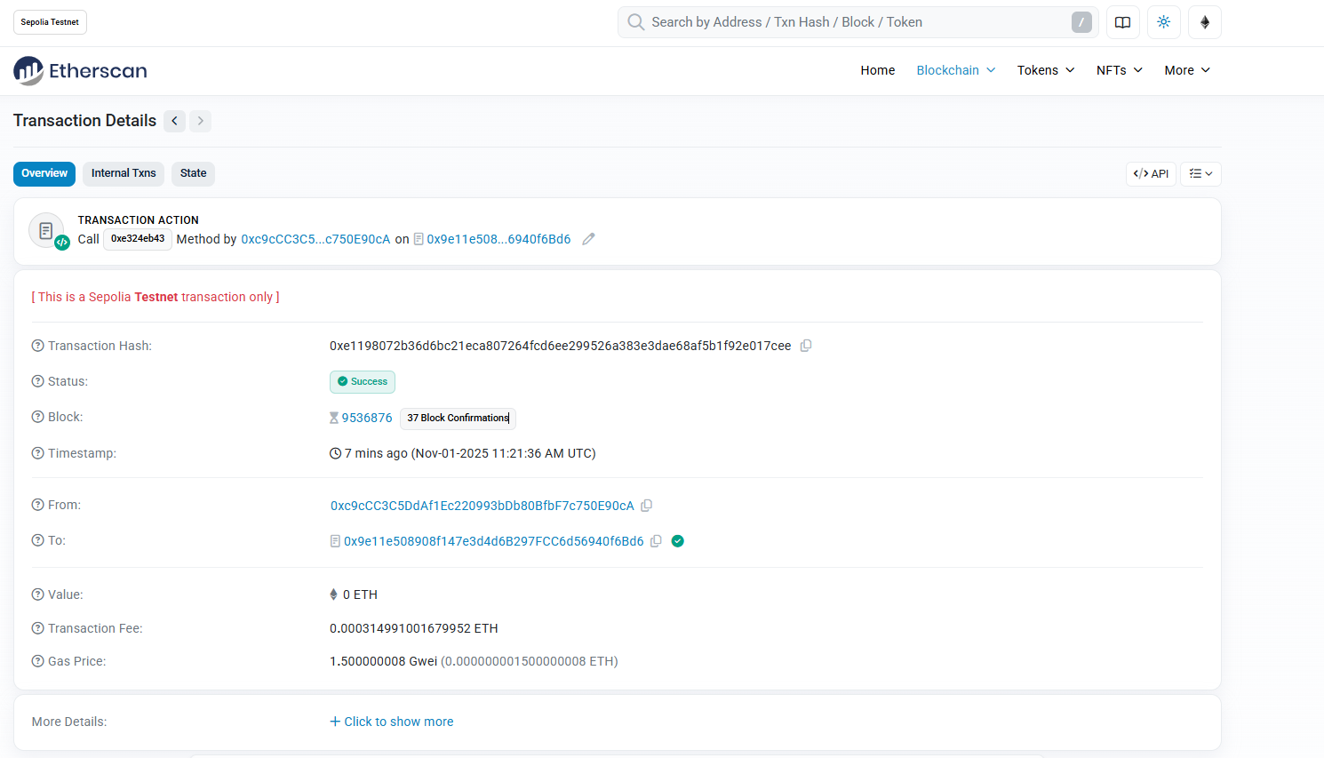
Transaction Proof Created using Etherscan

