@startuml
hide footbox

actor Socket
actor RACC
actor Transmitter
actor ObjectManager
actor PowerPlugN1

->Socket : couper prise 1
Socket ->RACC : receiveOrder()
RACC->Transmitter : executOrder()
activate Transmitter
Transmitter->Transmitter : extractOrder()

Transmitter->ObjectManager:powerOffPlug(1)
deactivate Transmitter
ObjectManager->PowerPlugN1:stop()
PowerPlugN1 -->ObjectManager
ObjectManager-->Transmitter
Transmitter-->RACC
RACC-->Socket

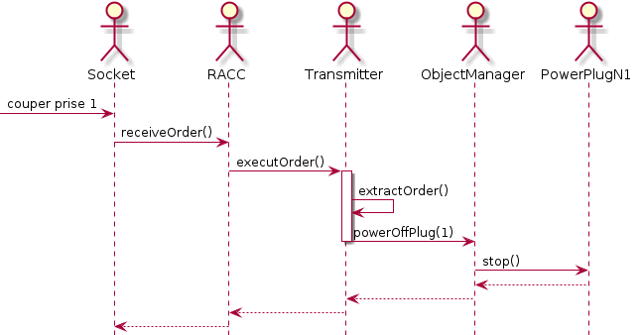
@enduml

